**Assignment #2**

Introduction to R: Isoelastic Demand Functions

We are interested in estimating the demand function for two products from The J.M. Smucker Company: An 18oz jar of Creamy JIF peanut butter and an 18oz jar of Extra Crunchy peanut butter. The files “Creamy.csv” and “Crunchy.csv” contain sales and price information for 52 weeks in the Los Angeles market. The rows of both files are in the same order, thus each row in a file corresponds to the same week of sales in the other file. Examine the files and get acquainted with their content.

1. (5 pts.) Use a regression model to estimate an isoelastic demand function for the Creamy 18oz JIF peanut butter. Report the fit statistics.

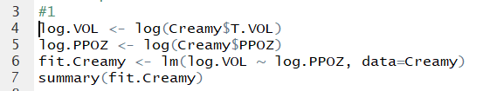

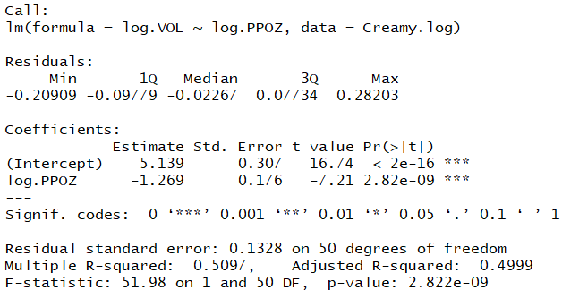

1. (5 pts) Create a plot of the Log-Log data and overlay the fitted regression line.

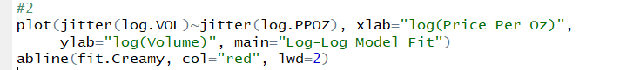

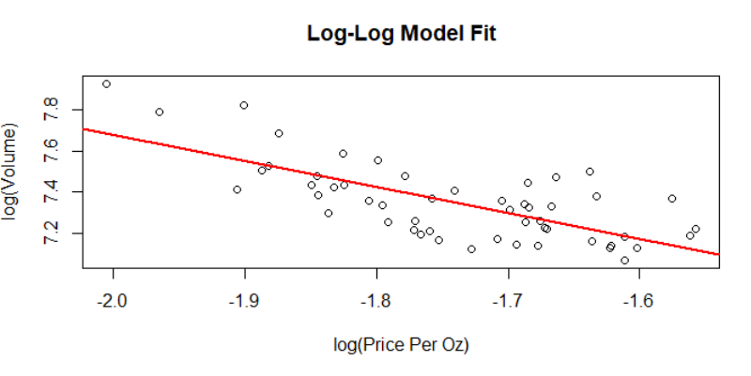

1. (5 pts) Create a plot of the residuals of the Log-Log model in the logarithmic scale and draw a horizontal line at zero.

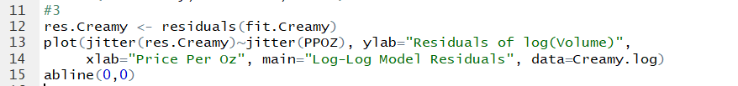

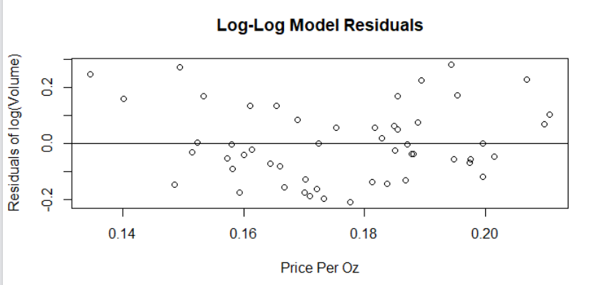

1. (5 pts.) Use a regression model to estimate an isoelastic demand function for the Crunchy 18oz JIF peanut butter. Report the fit statistics.

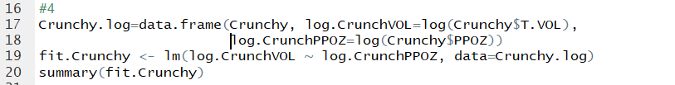

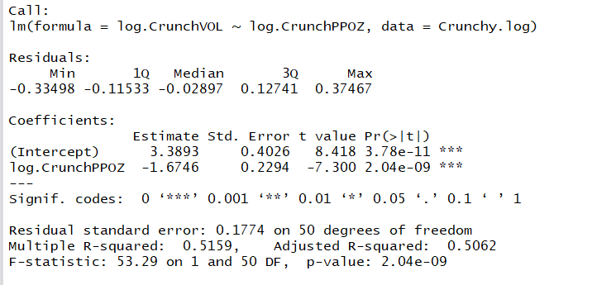

1. (5 pts) Create a plot of the Log-Log data for the Crunchy product and overlay the fitted regression line.

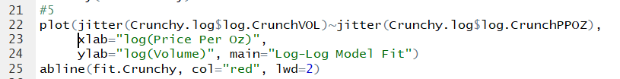

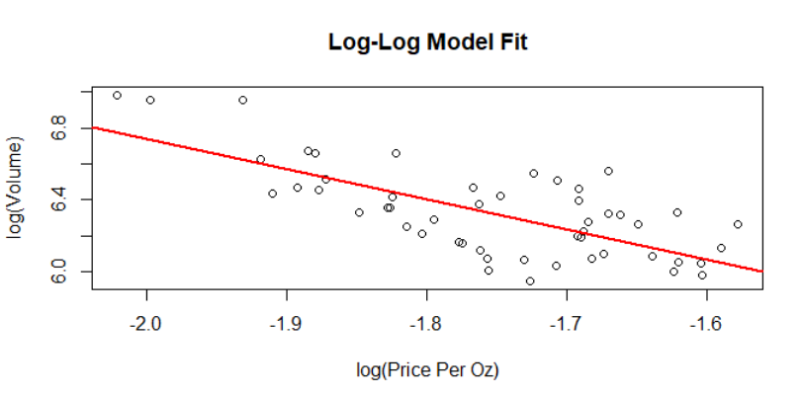

1. (5 pts) Create a plot of the residuals of the Log-Log model in the logarithmic scale and draw a horizontal line at zero.

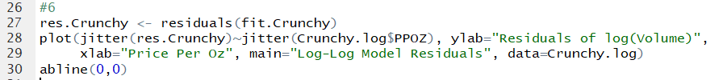

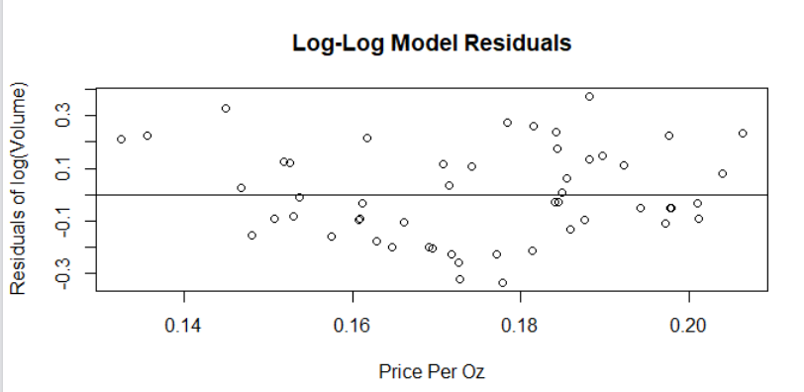

1. (5 pts) Are the elasticities of the Crunchy and Creamy products significantly different? Justify your answer.

The elasticities of the Crunchy and Creamy products are not significantly different. The Creamy model has a slope of -1.269 while the Crunchy has a slope of -1.6746. As these are not very steep slopes, we see that both types of peanut butter have a very elastic demand. This means that if the price of JIF Creamy or Crunchy peanut butter rises, the demand will go down a lot, as there are a lot of other brands with cheaper prices that people will choose instead. The Crunchy peanut butter has a slightly more inelastic demand than the Creamy. This may be caused by fewer selection of Crunchy brands, so if the price of JIF Crunchy goes up, it will be a little less likely for the consumer to switch. However, these elasticities are **not** significantly different, as their slopes are nearly the same, meaning the elasticities will be close.

1. (5 pts.) Create a single chart showing the two streams of data as well as the two fitted demand models using the original data scale (NOT log-Log).

