Tomcat native 2

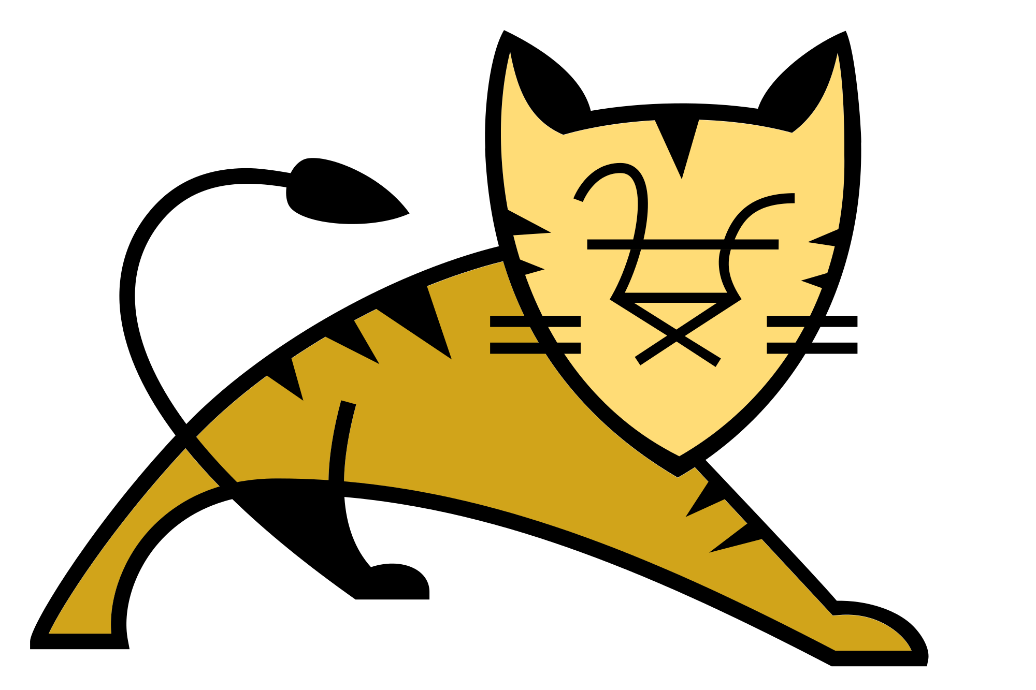

03/20/16

Version 1.0

Supervised by Jean-Frederic Clere (Red Hat)
Project Coordinator: Dr. Hugues Mercier
Co-instructor: Pr. Jacques Savoy and Pr. Peter Kropf

TEAM AND CONTACT INFORMATION:
Jocelyn Thode (jocelyn.thode@unifr.ch)
Simon Brulhart (simon.brulhart@unifr.ch)

Table of contents
1. Project description 4
1.1. Project context 4
1.2. Goals and objectives of the project 4
2. Project organization 5
2.1. Responsibility distribution 5
2.2. Interactions with the client 5
3. Methodology 6
3.1. State of the art 6
4. Constraints and elements of risk 7
5. Deliverable goods 8
6. Efforts and schedule 9

Version monitoring
Monitoring of the version in this project organization document enables following modification activities progress within the project. The version is changed only if a major change takes place. Otherwise, only a decimal is changed (1.0 to 1.1)
Version | Update date | Page modified
1.0 | 20.03.16 | 1-8

Project description
For this project we are working with Red Hat which is a multinational software company that provides open-source software and technical support to enterprises.
At the moment, the two biggest Java web servers are Tomcat and Undertow. Both rely on TLS/SSL to encrypt and secure communications between a client and a server. To achieve good performance Tomcat-native provides access to OpenSSL in Tomcat. It uses Apache Portable Runtime (APR) to do so.
Unfortunately, Undertow isn’t compatible with Tomcat Native at the moment.
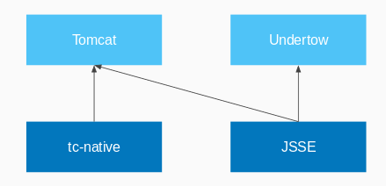
Figure 1: Which SSLEngine works with which web server

Until last year, the APR would manage the encrypted sockets by itself. However this implied a lot of C code to maintain. To ease maintenance, some work has been done to use OpenSSL APIs directly instead. This works well enough despite some acceptable performance penalty. However the APR still provides the bindings to these APIs.
We now want to strip the current solution of the APR and make the result compatible with Undertow.

Goals and objectives of the project
Our project aims to refactor Tomcat Native to drop APR and only rely on our own JNI wrapper to interface with OpenSSL. This should make Tomcat Native much more maintainable while keeping great performance when using TLS/SSL. The project also aims to make the resulting Tomcat Native usable in Undertow while keeping the compatibility with Tomcat.
This means we need to :
- Write a JNI wrapper for OpenSSL
- Remove all APR code present in Tomcat Native
- Abstract Tomcat Native to be used in Tomcat and Undertow
- Provide good documentation so that the open-source community can use the project
- Run benchmarks to test the implementation
Another goal is to add JNIs to use more features from OpenSSL in Tomcat Native.

Project organization
This project requires us to read some documentation and source code. We also need to write reports and presentations. To keep the code base clean, we decided to adopt the same strategy as Numa de Montmollin last year and split our work in two different repositories on Github.

tomcat-native2-doc is the repository documenting the progress of our project. We put every report and presentation in the repo. This repo also contains a wiki which hosts the logbook, work plan and our different articles. The articles are useful to share our findings and more importantly not to forget about them.

tomcat-native2 is the repository dedicated to the code. This repo includes our implementation, and the documentation directly concerning it. For example, it should contain the Javadoc and a readme describing the building process and the main purpose of the project.

Responsibility distribution
As our project involves reading a lot of source code and removing code. We usually work together, sharing our findings. We meet most of the time using VoIP software and assign the tasks of the day from there. If we have any question we can always contact each other on the spot.

Interactions with the client
As we have to work with Stuart Douglas for Undertow who lives in Australia, Rémy Maucherat for Tomcat who lives in France and Jean-Frederic Clere who works in Neuchâtel we usually interact by email, or Hangout if we want a spoken conversation.

We also write a logbook of our daily activity as well as some articles on our understanding of the project on Github, so that Jean-Frederic Clere and Rémy Maucherat can follow our progress.

Methodology
For this project we do not have any choice in the technology used. We work with Java and specifically JNI. We have to modify Tomcat Native so that it works with both Tomcat and Undertow without APR.

As stated earlier, we almost always get together on a VoIP chat room so that we can easily and quickly share our findings and ask questions to each other. Otherwise we try to make a work plan for the day and then split the tasks evenly from there.

We mostly use Intellij Idea for our development environment. We use git coupled to Github as the source version control. We may also use Github issues in the future to track problems we may encounter during the implementation.

Every tool we use is free (as in freedom). They are licensed under the Apache License 2.0. Our work is completely open-source as required by Red Hat and will probably be under the Apache Licence 2.0 as it is a fork of Tomcat Native.

State of the art
Our project is not related to any paper. However there is documentation available for each code base we use. Namely:
- Tomcat (http://tomcat.apache.org/)
- Tomcat Native (http://tomcat.apache.org/native-doc/)
- Undertow (http://undertow.io/documentation.html)

Constraints and elements of risk
We have three main risks in our project:
- Having to understand projects such as Tomcat, Tomcat Native and Undertow is a big task. We could get lost reading code and documentation for hours without really understanding anything.
However, we can always ask Rémy, Jean-Frederic and Stuart for help if we are stuck on a particular problem as we already did multiple times. Since the projects are open source we can also rely on the community to provide us documentation and help.
- Evaluating the time needed to adapt Tomcat can be deceptive as we have to remove code instead of writing it. This could lead to some conflicts where we remove too much or not enough or we simply don’t know what to remove to make it effective.
Stuart has already done some experiments with Undertow which can help us visualize what to remove. Having our work plan checked by Rémy and Jean-Frederic can also help us in that regard.
- Adapting Tomcat Native to work with both Undertow and Tomcat might not be the best solution. An other approach could be to use the code written by Stuart Douglas for Undertow and modify it to work with Tomcat. This would require us to write a lot more code than the Tomcat Native route and could make us lose a lot of time if we don’t choose the right alternative at the beginning.
Rémy and Jean-Frederic think that the Tomcat Native route is the easiest and we agree. Removing code is almost always easier than writing it.

Deliverable goods
We will deliver an OpenSSL wrapper using JNI calls based on Tomcat Native and working with both Tomcat and Undertow as well as documentation for this wrapper.

These will be delivered on Github in the repository presented in chapter 2. This should help the community understand our project and continue working on it.

Efforts and schedule
This work plan is extracted from here (https://github.com/jocelynthode/tomcat-native2-doc/wiki/Workplan)
This isn’t a definitive work plan and may change over time.

Credits
The Tomcat logo is from: https://upload.wikimedia.org/wikipedia/commons/thumb/7/7b/Tomcat-logo.svg/2000px-Tomcat-logo.svg.png (Consulted on 20.03.2016)

The Undertow logo is from:
https://avatars3.githubusercontent.com/u/2001898?v=3&s=400 (Consulted on 20.03.2016)

