**Stroke MRI Project**

**Experimental protocol (5th February 2024)**

**Administration:**

|  |  |  |  |  |
| --- | --- | --- | --- | --- |
| **Participant Group** | **Participant and Scanning fees** | **Demographics Data Collection** | **MRI Data Collection** | **MRI Data Preprocessing** |
| Subcortical stroke | Professor Marco Pang | Gianna & Sabrina | Gianna & Sabrina | JJ & Jocelyn |
| Cortical stroke | Professor Marco Pang | Gianna & Sabrina | Gianna & Sabrina | JJ & Jocelyn |
| Matched healthy controls | Dr. Bolton Chau | Gianna & Sabrina | JJ & Jocelyn | JJ & Jocelyn |
| Additional healthy young adults | Dr. Bolton Chau | Gianna & Sabrina | JJ & Jocelyn | JJ & Jocelyn |

**Participants:**

|  |  |  |  |
| --- | --- | --- | --- |
| **Participant Group** | **Pre-intervention** | **Post-intervention** | **Follow-up** |
| Subcortical stroke   * Inclusion: * A diagnosis of stroke confirmed by brain scan reports; * Stroke onset more than 6 months; * Age ≥ 50; * MoCA ≥ 22; * Modified Rankin scale 1–3; * Capable of following verbal and visual instructions; * Ability to walk for 1 min independently with or without a walking aid; * Not receiving formal rehabilitation elsewhere; * Community-dwelling;   Exclusion:   * Take any psychoactive or vasoactive medication (except blood pressure medications); * Have other neurological disorders; * Have Pain or other comorbidities that seriously affect the ability to walk; * Have contraindications to exercise (e.g., angina); * Have contraindications to MRI; * Have color blindness. | 81  (64 for Gianna) | 81  (27+27+27) | 81  (27+27+27) |
| Cortical stroke   * A diagnosis of stroke confirmed by brain scan reports; * Stroke onset more than 6 months; * Age ≥ 50; * MoCA ≥ 22; * Modified Rankin scale 1–3; * Capable of following verbal and visual instructions; * Ability to walk for 1 min independently with or without a walking aid; * Not receiving formal rehabilitation elsewhere; * Community-dwelling;   Exclusion:   * Take any psychoactive or vasoactive medication (except blood pressure medications); * Have other neurological disorders; * Have Pain or other comorbidities that seriously affect the ability to walk; * Have contraindications to exercise (e.g., angina); * Have contraindications to MRI; * Have color blindness. | About 20 (based our previous experience, maybe no more than 20 cortical stroke participants can meet the inclusion criteria. | About 20 | About 20 |
| Matched healthy controls  Inclusion:   * Not have any history of stroke. * Age ≥ 50; * MoCA ≥ 22; * Capable of following verbal and visual instructions; * Ability to walk for 1 min independently with or without a walking aid; * Not receiving formal rehabilitation elsewhere; * Community-dwelling;   Exclusion:   * Take any psychoactive or vasoactive medication (except blood pressure medications); * Have other neurological disorders; * Have Pain or other comorbidities that seriously affect the ability to walk; * Have contraindications to exercise (e.g., angina); * Have color blindness. | 64 | 64 | 64 |
| Additional healthy young adults (for Bolton’s project)   * Age = 18-40 | ~30 |  |  |

**Scans:**

|  |  |
| --- | --- |
| **Scans** | **Duration** |
| T1 | ~7 minutes |
| Field map | ~2 minutes |
| Resting-state | ~7 minutes |
| N back task | Trial duration:   * 2.5s instructions (0 back or 2 back) before each block * 2 runs of 8 task blocks (25s) and 4 fixation blocks (15s) * 10 trials per block   + 2s stimulus (and response)   + 0.5s ITI   Total duration:  [(2.5+25)*8 + (15)*4 ]*2 =  ~9.5 minutes |
| Stroop test | Trial duration:   * 2.5s instructions before each block * 3 run of 3 task blocks (30s) + 3 fixation (30s) * Following each task block, a fixation cross was displayed before the presentation of the next stimulus. * 12 trials per block * 2 s (+response time); * 0.5s ITI   Total duration:  3*(3*30s + 3*30s) +2.5*9 = 562.5s  ~9.5 minutes |
| Decision making | Each trial will consist of  (1) an inter-trial-interval (ranged from 1.3s to 1.9s);  (2) a fixation (ranged from 2s to 4s);  (3) a stimulus onset (<=4s);  (4) a response indication (ranged from 1.3s to 2.3s);  (5) a random drawing phase (ranged from 1.3s to 1.8s); and  (6) a reward delivery (ranged from 1.5s to 2s).  As a result, each trial will take approximately 10s. The complex choice task will involve 70 trials in total and it will take approximately 12 minutes to finish.  ~12 minutes |
| Visual clock task | Trial duration:   * 2.5s instructions before each block * 8 run of 1 task blocks (30s) + 1 fixation (30s) * Following each task block, a fixation cross was displayed before the presentation of the next stimulus. * 10 trials per block * 2.5 s (+response time); * 0.5s ITI   Total duration:  2.5s*8+(1*30+1*30s) *8 = 500s  ~8.5 minutes |
| Motor task | Task Duration:   * 2.5s instructions before each block * 8 run of 1 task blocks (30s) + 1 fixation (30s) * Following each task block, a fixation cross was displayed before the presentation of the next stimulus. * Task block: continuedly stepping the peddle at a self-frequency.   Total duration:  2.5s*8+(1*30+1*30s) *8 = 500s ~8.5 minutes |
| Dual task (N back task) | Dual task:  The dual-task duration is equal to the single cognitive task duration.  ~9.5 minutes  ~9.5 minutes  ~12 minutes  ~8.5 minutes |
| Dual task (Stroop test) |
| Dual task (Decision making) |
| Dual task (Clock test) |

**Total Duration:** ~111min (Complete all tasks)

**Procedures:**

The participants will do the MRI scan twice. The MRI scan duration is about 60 minutes every time. Participants will complete two randomized single cognitive tasks, a single motor task, and the matched dual tasks every time (e.g., Stroop task, Clock task, Motor task, Dual-task (Stroop test), Dual-task (Clock task)). The MRI scan duration is about 60 minutes every time.

Subjects need to come three times.

1. The first part: MRI safety screening, MoCA, Mini-BEST, FAC (for stroke participants), MRS (for stroke participants), and 10-meter waking test. If the participants meet the inclusion criteria, we will ask for some demographics and some cognitive and motor assessments. **(0.5-1h)**
2. The second part: the first MRI scan, demographics, and assessments. **(1.5-2h)**
3. The third part: the second MRI scan, demographics, and assessments. **(1.5-2h)**

Each MRI Session will be organized as follows:

|  |  |
| --- | --- |
| **Session 1** | **Session 2** |
| Randomise:  Task 1 (Dual) | Randomise:  Task 3 (Single) |
| Task 2 (Dual) | Task 4 (Single) |
| Motor |  |
| Field Map | Field Map |
| Resting-state | Resting-state |
| Randomise:  Task 1 (Single) | Randomise:  Task 3 (Dual) |
| Task 2 (Single) | Task 4 (Dual)  Motor |
| T1 |  |

Tasks 1-4 refers to any 4 cognitive tasks (N-Back, Stroop, Decision Making, Clock; randomized across participants).

Each session will consist of 2 main randomize sections related to: (1) the individual cognitive tasks; and (2) the motor related tasks. We propose this to reduce confusion for the participants when performing the tasks.

|  |  |  |  |  |  |  |  |  |  |  |  |  |
| --- | --- | --- | --- | --- | --- | --- | --- | --- | --- | --- | --- | --- |
| Example 1 | **Session 1** | | |  | **Timing** | | **Session 2** | |  | | | **Timing** |
|  | Task 1 | | | N-back (Dual) | 9.5 | | Task 3 | | Clock | | | 8.5 |
|  | Task 2 | | | Stroop (Dual) | 9.5 | | Task 4 | | Decision Making | | | 12 |
|  | Motor | | | | 8.5 | | Field Map | | | | | 2 |
|  | Field Map | | | | 2 | | Resting | | | | | 7 |
|  | T1 | | | | 7 | | Motor | | | | | 8.5 |
|  | Task 1 | | | N-back | 9.5 | | Task 3 | | Clock (Dual) | | | 8.5 |
|  | Task 2 | | | Stroop | 9.5 | | Task 4 | | Decision Making (Dual) | | | 12 |
|  | Resting | | |  | 7 | |  | |  | | |  |
|  | **TOTAL** | | | | **62.5** | | **TOTAL** | | | | | **58.5** |
|  |  | | | |  | |  | | | | |  |
| Example 2 | | **Session 1** |  | | | **Timing** | | **Session 2** | |  | **Timing** | |
|  | | Task 1 | Stroop | | | 9.5 | | Task 3 | | N-back (Dual) | 9.5 | |
|  | | Task 2 | Decision Making | | | 12 | | Task 4 | | Clock (Dual) | 8.5 | |
|  | | Field Map | 2 | | |  | | Motor | | | 8.5 | |
|  | | Resting | 7 | | |  | | Field Map | | | 2 | |
|  | | Motor | 8.5 | | |  | | T1 | | | 7 | |
|  | | Task 1 | Stroop (Dual) | | | 9.5 | | Task 3 | | N-back | 9.5 | |
|  | | Task 2 | Decision Making (Dual) | | | 12 | | Task 4 | | Clock | 8.5 | |
|  | |  |  | | |  | | Resting | |  | 7 | |
|  | | **TOTAL** | **60.5** | | |  | | **TOTAL** | | | **60.5** | |

The demographics and assessments will be divided into three parts to ensure each duration is not too long.

**Assessments outside scanner:**

|  |  |  |  |  |
| --- | --- | --- | --- | --- |
| **Name** | **Duration** | **Purpose/Inclusion or Exclusion Criteria** | **Participant Group** | **Assessment time** |
| The Mini-Balance Evaluation Systems Test | Healthy:  5-10 min  Stroke:  10-15 min | * Balance; Mobility; Fall risk | Both | Pre, Post, and 6 weeks after training |
| HK Version of Montreal Cognitive Assessment | 5-10 min | * Global cognitive | Both | Pre |
| Activities-specific Balance Confidence Scale | ~5 min | * Balance confidence | Both | Pre, Post, and 6 weeks after completing training |
| Geriatric Depression Scales | ~5 min | * Depression | Both | Pre |
| Trail Making Test | 5-10 min | * Attention & Executive functions | Both | Pre, Post, and 6 weeks after completing training |
| Digital memory test | 5 min | * Working memory | Both | Pre, Post, and 6 weeks after completing training |
| 10-meter walking test | 1-5 min | * Mobility | Both | Pre, Post, and 6 weeks after completing training |
| Forward walking (1min) + Serial 3 subtractions | ~10 min | * Collect the dual-task performance on the overground walking | Both | Pre, Post, and 6 weeks after completing training |
| Fugl-Meyer Assessment (Lower Extremities) | 5-10 min | * Impairment index | Stroke | Pre |
| Functional Ambulance Classification | 1-3 min | * Ambulation ability | Stroke | Pre |
| Modified Rankin Scale | 1-3 min | * The degree of disability or dependence in the daily activities | Stroke | Pre |
| The incident of falls and fall-related injuries | 5 min | * Collecting the number of falls and fall-related injuries | Stroke | Follow up; (after completing the last assessment);  Recorded monthly for 12 months via telephone interviews by blinded researchers. |

**Total Duration:**Healthy: ~40 min  
Stroke: ~60 min

**Ethics and research safety**

* Stroke and matched healthy controls => Marco’s ethics, safety, UBSN project
* Additional healthy young adults => Bolton’s ethics, safety, UBSN project

**APPENDIX**

N back task:

|  |  |  |
| --- | --- | --- |
| N back task | Trial duration:   * 2.5s instructions (0 back or 2 back) before each block * 2 runs of 8 task blocks (25s) and 4 fixation blocks (15s) * 10 trials per block   + 2s stimulus (and response)   + 0.5s ITI   Total duration:  [(2.5+25)*8 + (15)*4 ]*2 =  ~9.5 minutes | “The category specific representation task and the working memory task are combined into a single task paradigm. Participants were presented with blocks of trials that consisted of pictures of places, tools, faces and body parts (non-mutilated parts of bodies with no “nudity”). Within each run, the 4 different stimulus types were presented in separate blocks. Also, within each run, ½ of the blocks use a 2-back working memory task and ½ use a 0-back working memory task (as a working memory comparison). A 2.5 second cue indicates the task type (and target for 0-back) at the start of the block. Each of the two runs contains 8 task blocks (10 trials of 2.5 seconds each, for 25 seconds) and 4 fixation blocks (15 seconds). On each trial, the stimulus is presented for 2 seconds, followed by a 500 ms inter-task interval (ITI).”  Task = 2 back  Control = 0 back |

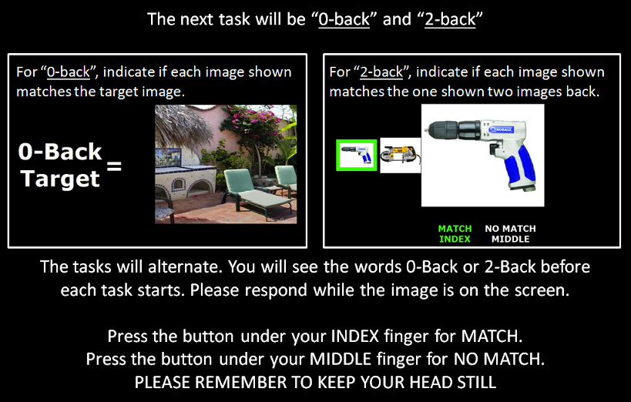

The Stroop task:

|  |  |  |
| --- | --- | --- |
| Stroop test | Trial duration:   * 2.5s instructions before each block * 3 run of 3 task blocks (30s) + 3 fixation (30s) * Following each task block, a fixation cross was displayed before the presentation of the next stimulus. * 12 trials per block * 2 s (+response time); * 0.5s ITI   Total duration:  3*(3*30s + 3*30s) +2.5*9 = 562.5s  ~9.5 minutes | Subjects were informed that two rows of letters would appear on the screen, and they were to click a button (Yes or No) to determine if the color of the letters in the top row matched the color name printed in the bottom row. Each run included blocks presenting the four separate stimulus types (Neutral, Congruent, Incongruent).  **1)** In “neutral” trials, the letters in the top row were characters (see below) printed in red, green, blue, or yellow, and the bottom row consisted of the color words “RED,” “GREEN,” “BLUE,” and “YELLOW” printed in black.  **2)**For “congruent” trials, the top row consisted of the color words “RED,” “GREEN,” “BLUE,” and “YELLOW” printed in the congruent color.  **3)**The “incongruent” condition was identical to the “congruent” condition, except that the color word was printed in an incongruent color (e.g., “green” printed in red) to produce an interference between the color word and color name.  “Hits” and “foils” were presented in random order to prevent subjects from developing response tendencies. One block consisted of 12 trials, each lasting 2s. The stimulus will not disappear until 2s passed, whether a response was given or not, then given a fixed interstimulus interval of 0.5s. Subjects completed 36 trials of each type during the three runs.  To prevent subjects from focusing on the lower word and blurring out the top word, the top word was presented 100 ms before the lower word. |

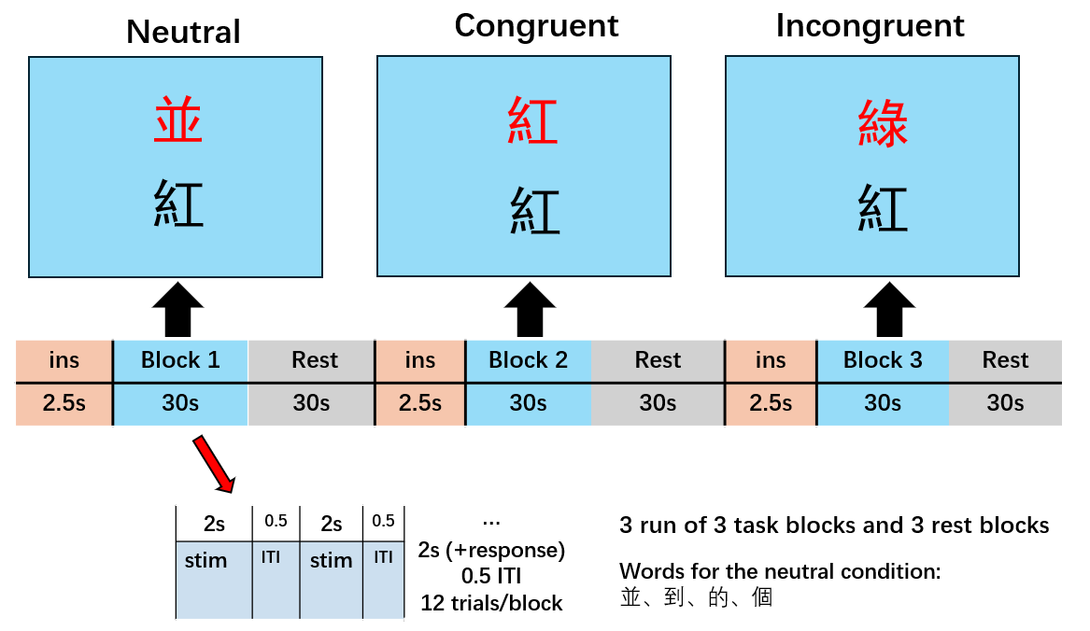

The Clock test:

|  |  |  |
| --- | --- | --- |
| Visual clock task | Trial duration:   * 2.5s instructions before each block * 8 run of 1 task blocks (30s) + 1 fixation (30s) * Following each task block, a fixation cross was displayed before the presentation of the next stimulus. * 10 trials per block * 2.5 s (+response time); * 0.5s ITI   Total duration:  2.5s*8+(1*30+1*30s) *8 = 500s ~8.5 minutes | The visual clock task requires subjects to imagine the analog clock faces based on the randomized times that were presented visually by the screen (e.g., 10:20) and click a button (Yes or No) to determine if the location of the direction of the minute hand of the time in the top row matched the word in the bottom row.  “Hits” and “foils” were presented in random order to prevent subjects from developing response tendencies. One block consisted of 10 trials, each lasting 2.5s, then given a fixed interstimulus interval of 0.5s. |

Decision Making task:

|  |  |  |
| --- | --- | --- |
| Decision making | Each trial will consist of  (1) an inter-trial-interval (ranged from 1.3s to 1.9s);  (2) a fixation (ranged from 2s to 4s);  (3) a stimulus onset (<=4s);  (4) a response indication (ranged from 1.3s to 2.3s);  (5) a random drawing phase (ranged from 1.3s to 1.8s); and  (6) a reward delivery (ranged from 1.5s to 2s).  As a result, each trial will take approximately 10s. The complex choice task will involve 70 trials in total and it will take approximately 12 minutes to finish. | The complex choice task is a binary decision making task that requires the participants to choose between complex options or simple options. A simple option will be associated with a probabilistic reward. While a complex option will be a collection of twenty probabilistic rewards. |

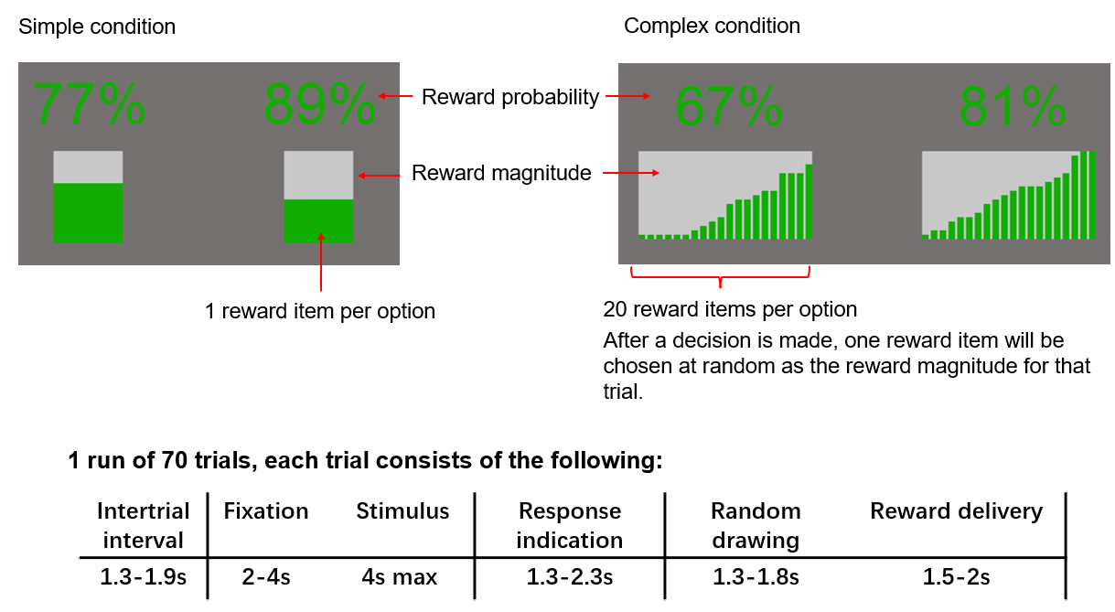

|  |  |  |
| --- | --- | --- |
| Motor task | Task Duration:   * 2.5s instructions before each block * 8 run of 1 task blocks (30s) + 1 fixation (30s) * Following each task block, a fixation cross was displayed before the presentation of the next stimulus. * Task block: continually stepping the peddle at a self-frequency.   Total duration:  2.5s*8+(1*30+1*30s) *8 = 500s ~8.5 minutes | The pedal task required participants to pedal (alternating dorsiflexion and plantarflexion), each foot in the opposite phase at a self-selected frequency, on a purpose-built apparatus while lying on their backs in the scanner. An image of a moving foot was presented on the screen, and participants were asked to pedal until the foot image disappeared from the screen. |