Project Integration  
Functional Design

Jochem Arends  
495637  
Group 1

Academic Year: 2023-2024

# Fall Detection

While classifying a fall might be a trivial task for humans, the concept of a fall is difficult to describe, making it hard to express in the form of a compter algorithm (Noury et al. 2007). When developing a fall detection system, an important choice that has to be made is what sensor(s) to use. When sensors do not provide sufficient data, a system may not be able to distinguish between a fall and normal activities. Several fall detection techniques were identified and their pros and cons are weighed below.

## Gyroscope and Accelerometer

Wearable devices commonly use a gyroscope, an acceleration meter, or a combination of both for fall detection (Delahoz and Labrador 2014). A gyroscope is a type of sensor that measures angular velocity (Passaro et al. 2017). By integrating this angular velocity, the orientation of an object can be obtained. This data can be used by a wearable system to determine whether the user is in a lying position. An acceleration meter (also known as an accelerometer) is a sensor that measures linear velocity. By observing both the orientation and acceleration of an object, falls can be detected. However, false positives may occur when the wearer participates in activities that produce similar sensor readings to those of a fall, such as sports.

## Barometric Pressure Sensor

A barometric pressure sensor measures atmospheric pressure. Atmospheric pressure increases as altitude decreases, observing this data can be used in fall detection systems (Sun et al. 2019). Barometric pressure sensors require a lower sampling rate compared to when using a gyroscope and accelerometer. (Sun et al. 2019). Advantages of barometric pressure sensors are that they do not consume much power and provides the data regardless of its orientation. However, a barometric pressure sensor can only provide information along the vertical axis. while some gyroscopes and accelerometers are capable of providing data along three axes.

## Impact Sensor

A sensor capable of measuring impacts may be used to detect falls, but it only provides limited information about a fall compared to the two previous mentioned techniques. As not every fall impacts the same location, deciding on the placement of this sensor may be a challenge.

## Conclusion

After researching the different techniques, there was decided on using a gyroscope and accelerometer as sensors for the fall detection system. This because these sensor provide the the most data and they are already used in many systems.

# Data Storage

Having concrete ideas about where and how data will be stored is crucial for the design of the product. In this section, the concern is not only about dynamic data such as user data and sensor readings, but also about firmware and credentials. Several data storage options were identified and their pros and cons are weighed below.

## Relational Database

In a relational database, data is organized into rows and columns, which together form a table (IBM, n.d.). SQL is often used for interacting with a relational database, offering a widely known syntax for querying data. When working with relational databases, one is often not concerned about the underlying format the database uses for storing the data. Relational databases are a suitable option for storing dynamic data such as user data and sensor readings.

## Non-Relational Database

In a non-relational database, data is not organized into rows and columns (Microsoft, n.d.). Instead, data may be stored as JSON, XML, graphs, or other formats (Microsoft, n.d.). In some cases, data can be stored more efficiently when using a non-relational database. Some non-relational databases provide a query language, while other offer an api.

## Non-Volatile Memory

Non-volatile memory is a type of computer memory that retains stored data when power is disconnected, making it suitable for storing data that should remain constant over time, such as credentials and firmware. Non-volatile memory generally provides slower write speeds and has a reduced write endurance compared to volatile memory (Cintra and Linkewitsch 2013).

### Flash Memory

Flash memory is a type of non-volatile computer memory that can be electrically programmed or erased. Advantage of flash memory are that it is relatively cheap and does not comsume that much power (Yasar 2023).

### F-RAM

fram Is a type of non-volatile random access memory that similar to dram, provides high access speeds. (Electronics Notes, n.d.). fram offers a higher write endurance compared to flash memory, but it comes at a higher cost and lower storege density.

## PS-RAM

psram is a volatile type of memory that has features of both sram and dram (Winbond, n.d.). What to put here ...?

## Conclusion

After conducting research, there was decided on using the combination of fram and psram. This because fram of the high access speed and high write endurance. psram will also be used since it is already on the microcontroller that is going to be used.

# Software

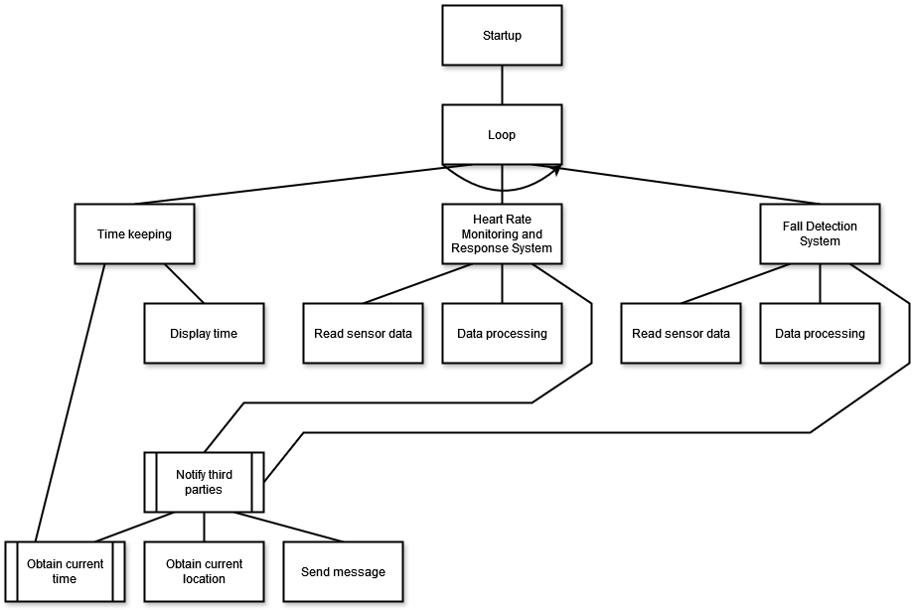

## Heart Rate Monitor System

The heart rate monitor system will as its name suggest monitor heart rate and seek for abnormalities in heart rate pattern. This module consist out of three submodules: a moduel for retrieving data; model for processing data and a module for acting accordingly on data.

## Fall Detection System

The fall detection system module consists out of three submodules. First, data has to be obtained by reading the gyroscope and accelerometer. Most likely, the data must first undergo some processing before it can be determined if a fall took place.

## Time Keeping

Time keeping is a relative simple task that does not need much

## Notify Third Parties

## Language and Environment

## State Diagram

To fill in later.

Cintra, Marcelo, and Niklas Linkewitsch. 2013. “Characterizing the Impact of Process Variation on Write Endurance Enhancing Techniques for Non-Volatile Memory Systems.” In *Proceedings of the Acm Sigmetrics/International Conference on Measurement and Modeling of Computer Systems*, 217–28.

Delahoz, Yueng Santiago, and Miguel Angel Labrador. 2014. “Survey on Fall Detection and Fall Prevention Using Wearable and External Sensors.” *Sensors* 14 (10): 19806–42.

Electronics Notes. n.d. “What Is Fram Memory: Ferroelectric Ram.” <https://www.electronics-notes.com/articles/electronic_components/semiconductor-ic-memory/fram-ferroelectric-ram-memory.php>.

IBM. n.d. “What Is a Relational Database?” <https://www.ibm.com/topics/relational-databases>.

Microsoft. n.d. “Non-Relational Data and Nosql.” <https://learn.microsoft.com/en-us/azure/architecture/data-guide/big-data/non-relational-data>.

Noury, N., A. Fleury, P. Rumeau, A. K. Bourke, G. O Laighin, V. Rialle, and J. E. Lundy. 2007. “Fall Detection - Principles and Methods.” In *2007 29th Annual International Conference of the Ieee Engineering in Medicine and Biology Society*, 1663–6. <https://doi.org/10.1109/IEMBS.2007.4352627>.

Passaro, Vittorio MN, Antonello Cuccovillo, Lorenzo Vaiani, Martino De Carlo, and Carlo Edoardo Campanella. 2017. “Gyroscope Technology and Applications: A Review in the Industrial Perspective.” *Sensors* 17 (10): 2284.

Sun, Yingnan, Frank P-w Lo, Surapa Thiemjarus, and Benny Lo. 2019. “Wearable Fall Detection System Using Barometric Pressure Sensors and Machine Learning.” In *SENSORCOMM 2019: The Thirteenth International Conference on Sensor Technologies and Applications*.

Winbond. n.d. “Pseudo Sram.” <https://www.winbond.com/hq/product/mobile-dram/pseudo-sram/?__locale=en>.

Yasar, Kinza. 2023. “What Is Flash Memory?: Definition from Techtarget.” *Storage*. TechTarget. <https://www.techtarget.com/searchstorage/definition/flash-memory>.