**The online checker game**

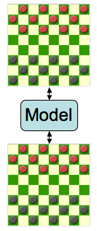A user should be able to click on the pieces that belong to him. When clicked on a piece, it should be selected and the click should highlight the squares that the piece can be moved to. The user should be able to click the highlighted squares and after that the piece should move to the selected square. That is the end of a turn. When a turn ends, the data should be sent to the network server. The state will be update to the new state.

If User 1 makes a move, by clicking on a piece and after that clicking on one of the highlighted squares, the state on the network server should be updated.

Now it is User 2’s turn, his computer device must automatically update the state by downloading the state from the network server. This is an updated state with all the recent information. If everything goes as planned, User 2 should be able to see a change in his interface, because User 1 moved a piece.

This is a kind of loop that keeps going on until the game ends.

So, the **actions** are:clicking on pieces and moving them by clicking on highlighted squares. The **state** contains all the information of the game; how many pieces left, on what squares are the pieces, who’s turn it is, etc. The **state** gets updates *after* a move is made. At the beginning of a turn, the state must be downloaded from the network server. The **feedback** consists of the changing of the state and the highlighted area’s after selecting a piece.