Executive Summary
This document packages the baseline, target, and gap analysis for <insert>.

Version History
Date | Version | Comments
Table of Contents
1 Scope 2
2 Goals, Objectives, and Constraints 2
3 Architecture Principles 2
4 Baseline Architecture 2
4.1 Business Architecture Models 2
4.2 Data Architecture Models 2
4.3 Application Architecture Models 2
4.4 Technology Architecture Models 2
5 Target Architecture 2
5.1 Architecture Vision 2
5.2 Business Architecture Models 2
5.3 Data Architecture Models 3
5.4 Application Architecture Models 3
5.5 Technology Architecture Models 3
6 Gap Analysis 3
7 Impact Assessment 3

< This template shows “typical” contents of an Architecture Definition Document and can be adapted to align with any TOGAF adaptation being implemented.>

Scope
<Describe the scope of your project: doing an assignment for the AIS 2013-2014 course, which consists of writing a report for the board of the BriteLite organization. The report touches on important decisions regarding BriteLite’s future, based on architectural modelling and analysis according to TOGAF’s ADM and using ArchiMate.>

Goals, Objectives, and Constraints
<May reference the business goals and drivers documentation. Here the documentation consists of the case description for the BriteLite organization.>

Architecture Principles
The BriteLite organization can be typically characterized as a hierarchical organization with Board of Directors as the top level. BriteLite consists of three business lines: Production, Engineering and Consultancy, which can be externally referred as BriteLite, BriteLite Engineering Solutions and BriteLite Ideas respectively.
At enterprise-level, the organization has two staff departments: a marketing department and a Sales and Account management department. Staffs in these two departments use a CRM solution from the Arocle vendor to support their daily work. There is also a graphical web based front end which can be accessed by other employees in BriteLite via HTTP connections.
For each business line, they have their own Finance & Accounting department. Staffs here can use OrderPRO system to support their administrative tasks, such as ordering, billing and payment processing and customer relationship management.
For Production business line, it exists of a small ITC department, a production department and a customer support team with a small call centre. For the production department, it has two sub departments (distribution and inventory) and two sub visions (Veghel and Dordrecht). Employees in Production business line use L-Info system to store specifications of all ever developed lighting productions and fittings. Besides, ZAP ERP system was introduced to replace the old system for inventory management, production planning, production quality control and shipment tracing and tracking. Each of the two locations in the Netherlands has a copy of ZAP solution which is synchronized constantly. The maintenance of ERP has been outsourced to ZAP. For the production of the filament and base, an OTOMATIC controller has been used to process production schedule and keep production logs. Regarding production quality control, BriteLite uses a QPlus system to scan the barcode of products and update quality information in OrderPRO system as well.
For Engineering business line, it consists of four teams responsible for different products: corporate lighting, industrial and public lighting, complex circuitry and modern lighting products. They use E-support system for handling workload. E-support system receives orders for ERP system and send back finished records in return. Beside, E-support system has interfaces with ERP and L-Info systems for looking up inventory information and accessing specifications of lighting products separately.
For Consultancy business line, it consists of 11 consultants and a secretary. Employees in this business line use a document management system called TeilPunk to provide solutions for their customers.
Moreover, BriteLite has a webshop integrating to BriteLite website and connecting to L-Info and OrderPro systems so that clients can get access to different products and track and trace their products.

Baseline Architecture
The current situation of BriteLite is illustrated by the baseline architecture. It consists of business architecture models, data architecture models, application architecture models, and technology architecture models. Each model is explained in detail in the next sections.
The general overview of the architecture is depicted in Figure 1. It shows the high-level interaction between business roles, business functions, products, and applications involved in BriteLite business process.
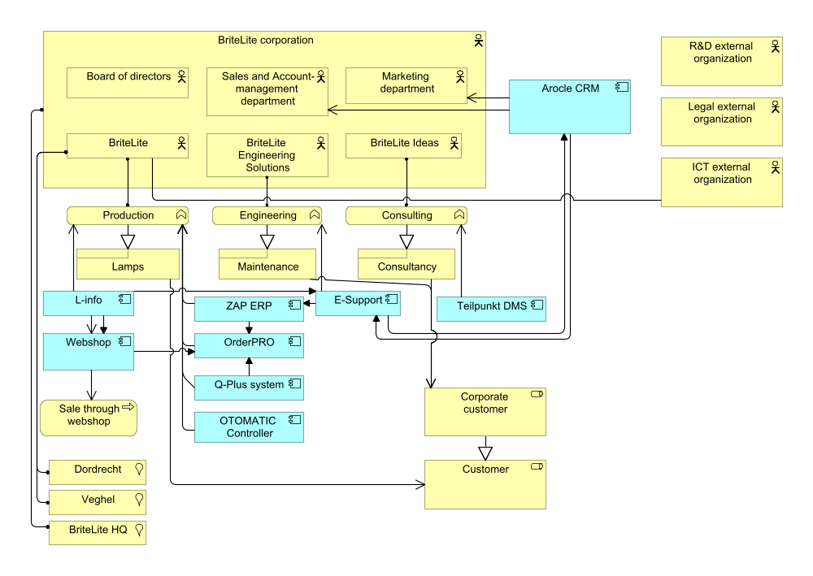
Figure 1 Total view

Business Architecture Models
The business architecture models are divided into three parts: organization structure, product architecture, and process architecture.

Organization structure
The organization structure of BriteLite is depicted in Figure 2. At the top level, there is Board of Directors. There are three business line: Production (BriteLite), Engineering (BriteLite Engineering Solutions), and Consultancy (BriteLite Ideas). At the enterprise level, there are Marketing department and Sales & Account-management department.
The production business line has the largest structure. It consists of production department, customer support team, ICT department, and Finance and Accounting department. The production department itself has inventory department and distribution department. There are two production sites, Dordrecht and Veghel. Each site has their own site manager and subdivision.

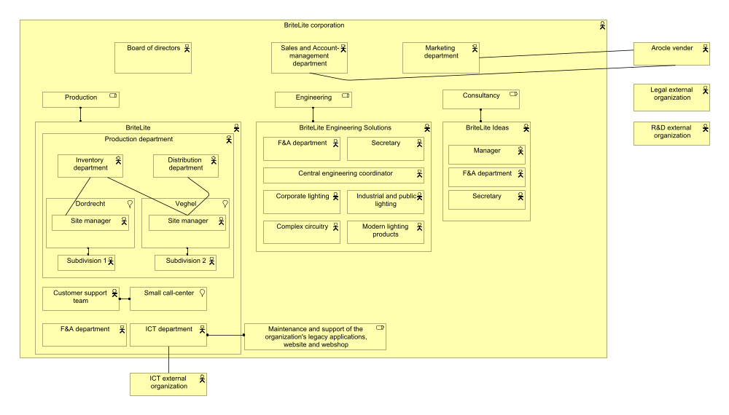
Figure 2 BriteLite organization structure
In engineering business line, there are four teams responsible for different products: corporate lightning, complex circuitry, industrial and public lightning and modern lightning products. All this teams are managed by the central engineering coordinator equipped with a secretary. Besides, there is also a Finance and Accounting department in engineering business line.
Consultancy business line has smaller hierarchical structure consisting of a manager, 11 consultants, a secretary, and also a Finance and Accounting department.
There are relationships with external entities, especially for organizations which performing the outsourced business functionalities. Those are external legal organization, external Research and Development organization, and ICT support. There is also vendor Arocle, which support the CRM application used by Sales and Account-management and marketing departments.

Product architecture
In general, BriteLite provides their customers with two things: lamp products and services. The lamp products can be divided into two categories: incandescent light bulb, and sodium-vapor lamp. The former one consists of various models and series targeted for various consumer segments. Sodium-vapor lamp consists of two series; power and extreme, and is intended for large customers.
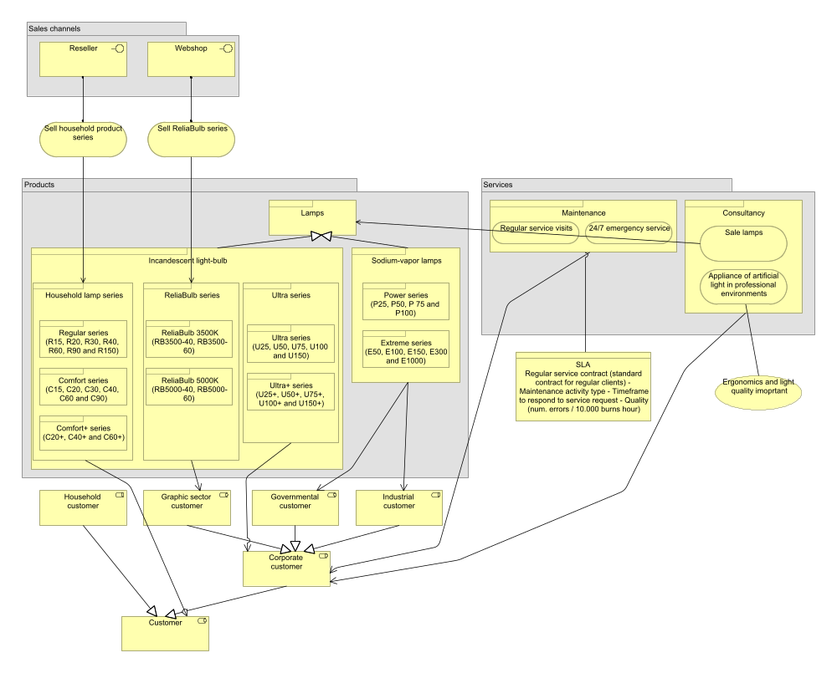
Figure 3 BriteLite product architecture
The sales of the lamp product are conducted through two ways: using normal distribution channel (via resellers), and directly to the customer by using web application.
BriteLite offers two types of services: maintenance and consultancy. The detailed illustration of BriteLite product is provided by Figure 3.

Process architecture
BriteLite business process is depicted in Figure 4. The processes are related with the appropriate entities from the organization structure (see Figure 2).
As can be seen, the business process is largely dominated in the production business line, especially the process for daily production. The business process of engineering and consultancy business lines are running in parallel with the production business line.

Data Architecture Models
Regarding data assets and data management resources, we can consider that all data assets in BriteLite are managed by enterprise systems. The total data resources can be viewed in figure 5. We will describe data assets and their management resources based on different business lines.
First of all, we will introduce data assets and management resources in production business line as it uses most data resources. For ERP system, which replaced the old production system in production department, it manages 4 types of information and data assets: inventory management, production planning, production quality control and shipment tracing and tracking. For inventory management, it can be divided into outtakes and intakes, which can be furtherly divided into outtakes of raw materials, outtakes of products, intakes of raw materials and intakes of products. For production planning, it can be divided into outstanding production runs& priorities and productions schedule. The latter one is support and stored by OTOMATIC controller and shared by ERP. Besides, OTOMATIC controller also store the throughput time per batch as production logs in the machine itself. For production quality control, these data assets can be divided into status of quality control and quality control codes, which are processed and stored by QPlus system and shared by ERP system as well. For shipment tracing and tracking, these data assets can be represented by delivery status of orders, which are supported by OrderPRO system and share by ERP system as well. Besides, OrderPRO system also supports management of payment processing, order processing and billing data assets. Moreover, ERP system also manages the data asset of acquisition of raw materials.
Besides, there are some other data management resources and data assets in production business line. At the enterprise level, employees use CRM system to manage customer information and marketing campaigns while L-Info system stores specifications of all ever developed lighting products.
Secondly, engineering business line supports workload handling and keeps activities in itself as data resources by using E-support system. Besides, E-support system receives work orders from Arcole system and sends back finished case records to it. Moreover, E-support also has interfaces to ERP system and L-Info system for accessing relevant data information.
Thirdly, consultancy business line applies TeilPunkt system to manage consultant activities and data resources. TeilPunkt manages two types of data resources: Sketches information and real information for production solutions. For sketches information, it can be furtherly divided into solutions, photos&

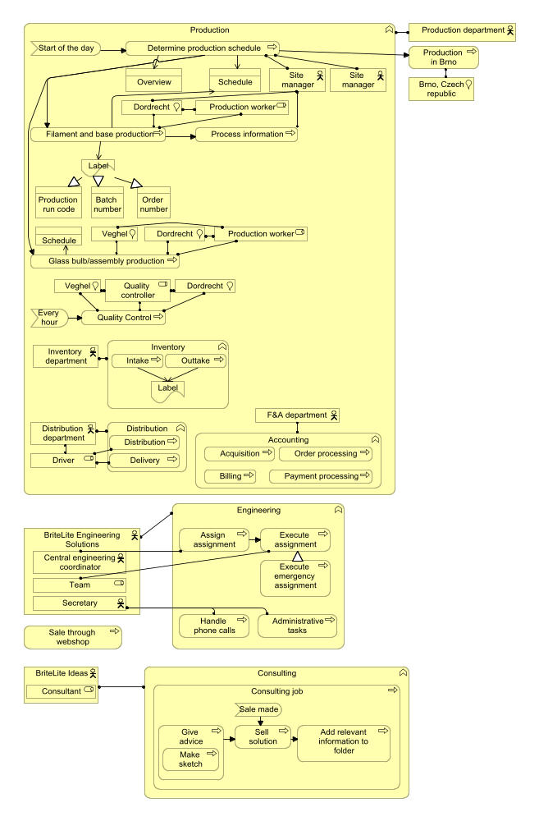
Figure 4 BriteLite business process
drawings of client locations and materials received from customers. These kinds of information are all kept in TeilPunkt system.

Application Architecture Models
Current existing application systems in BriteLite can be listed as follows: Arocle CRM system, E-support system, ZAP ERP system, L-Info system, OrderPRO system, QPlus system, TeilPunkt system, OTOMATIC controller and a web shop. To better illustrate how these systems support business functions, we first explain interactions and relations between these systems. And then we will link these systems with business processes in BriteLite. Founctions of these systems are listed in table 1.
First of all, there is an exchange of information between CRM system and E-support system. Working staff in engineering business line receive work orders from CRM system via E-support system. As a response, E-support will send back a record to CRM system after a case is finished.
Secondly, E-support system used by engineering business line have links with both systems in production business line. It has an interface with L-Info system so that it can access to specifications of lighting solutions directly. Moreover, it has an interface with ERP system so that engineers can access information like product inventory, product prices and so on.
Thirdly, ERP system and L-Info system in production business line are separately linked to OrderPRO system and a web shop as well. In that case, inventory management information can be exchanged between ERP system and OrderPRO system. And customers can achieve specifications of lighting products at the client side.
Moreover, E-support also has interfaces to ERP system and L-Info system for accessing relevant data information.
Thirdly, consultancy business line applies TeilPunkt system to manage consultant activities and data resources. TeilPunkt manages two types of data resources: Sketches information and real information for production solutions. For sketches information, it can be furtherly divided into solutions, photos& drawings of client locations and materials received from customers. These kinds of information are all kept in TeilPunkt system
Figure 5 illustrates the information structure view of BriteLite, and Figure 6 demonstrates the correlation between the information with the relevant application.
Application | Functions
CRM system | Send orders to ERP and receive records from it;  Hold customer information and support campaigns;
E-Support system | Send records to CRM and receive orders from it;  Record daily activities of engineers;  Provide interfaces with ERP and L-Info systems;
ERP system | Support inventory management, production planning, quality control and shipment tracing and tracking;  Provide a connection with OrderPRO system;  Provide an overview of production runs and their priorities;
L-Info system | Store specification of ever developed products;  Share information with other systems;
TeilPunk system | Store sketches and other information of solutions;  Allow consultants to create actual solution information for customers ;
OrderPRO system | Access the delivery status of shipment;  Process order and billing information
QPlus system | Scan barcodes of products and keep quality information;  Send status of production quality to OrderPRO;
OTOMATIC system | Process and keep production schedule and production logs;  Provide services for other applications to access information;
Web Shop system | Provide channels for employees to access specification of lighting products;  Provide channels for customers to trace and track their products;
Table 1 Applications and their functions

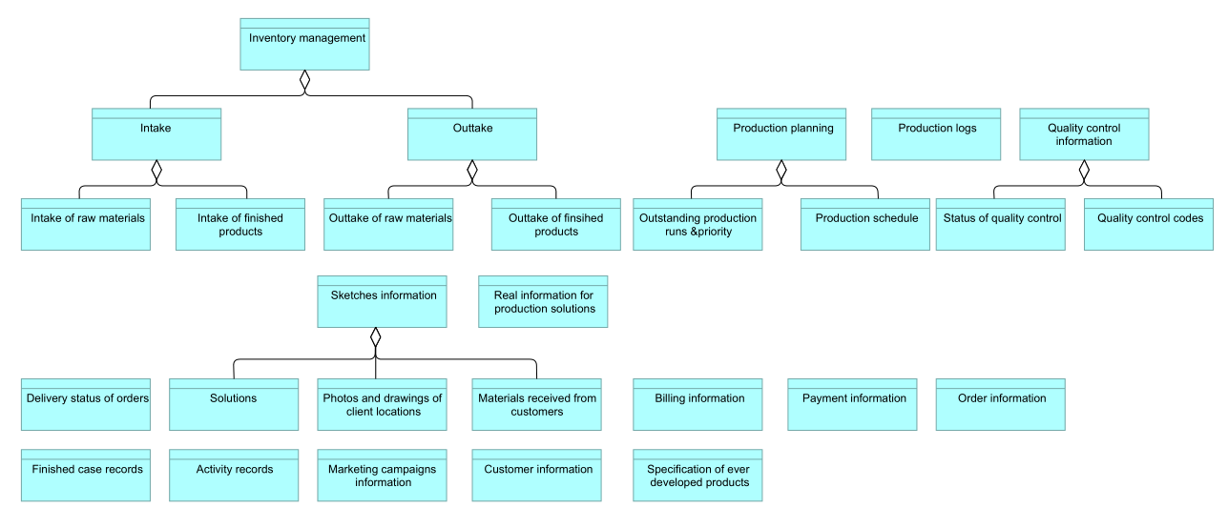
Figure 5 Information structure view

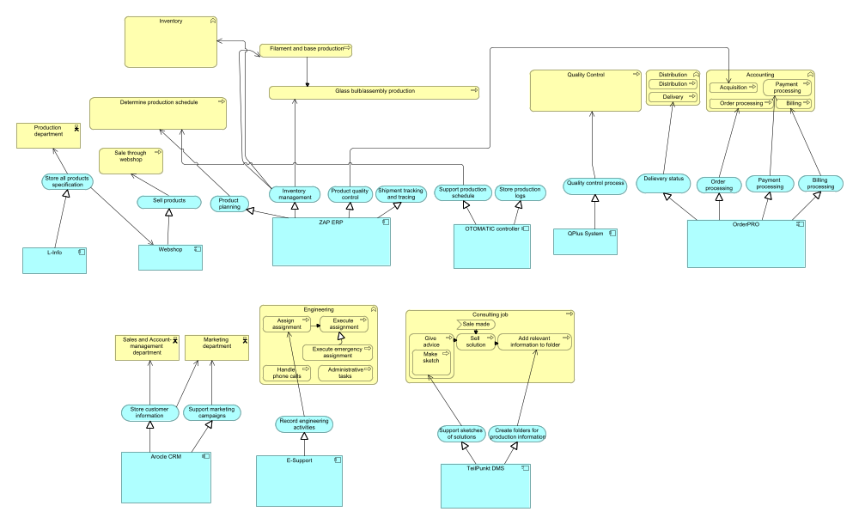
Figure 6 Application usage view
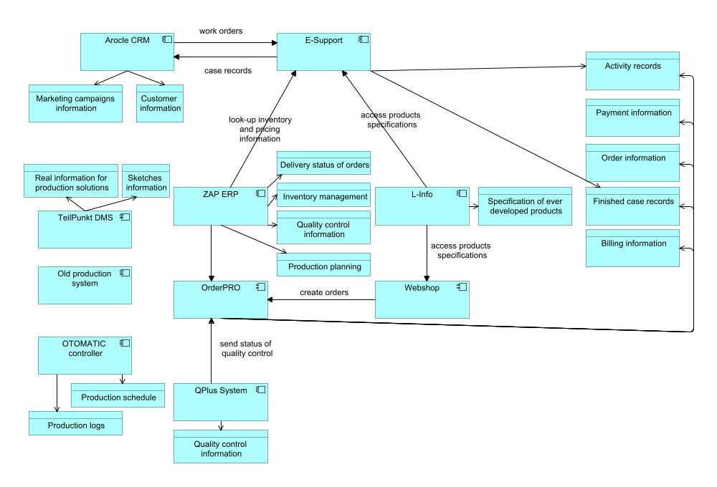
Figure 7 BriteLite application structure view

Technology Architecture Models
The current IT infrastructure used by BriteLite is spread in several locations. The configuration is shown in Figure 1

IT Infrastructure in BriteLite Headquarter
Most of the infrastructure are located in BriteLite Headquarter. There is a CRM server which is used to host Arocle CRM application, with an internal Oracle database application in the same machine. For BriteCampaign application, an HP blade server is used, with an Oracle Virtual Server is installed to run the BriteCampaign.
For BriteLite department, there are two servers available. AS400 mainframe is used to run the L-Info application, while a UNIX server cluster is used to run ZAP ERP application.
In BriteLite Ideas, a DMS server is present to run TeilPunkt application, with a simple proprietary database running on the same machine. All of the servers are connected to the Headquarter LAN, which is connected to firewall before facing the Internet. A VPN device is also available, to accommodate consultants accessing corporate network during their business travel.

IT infrastructure in Veghel Site
In Veghel site, there are two running servers. The first one, a UNIX server running OrderPRO application. Another one is a Windows 2000-based computer running QPlus System with a database application installed in the same computer. Both are connected to Veghel LAN, which connected to the Internet.

IT Infrastructure in Dordrecht Site
Similar to Veghel site, there is also a Windows 2000-based computer running a QPlus system. In addition, there is a computer running OTOMATIC controller. This computer also runs a MySQL database to support the OTOMATIC controller. Both of them are connected to the Dordrecht LAN, which is connected to the Internet.
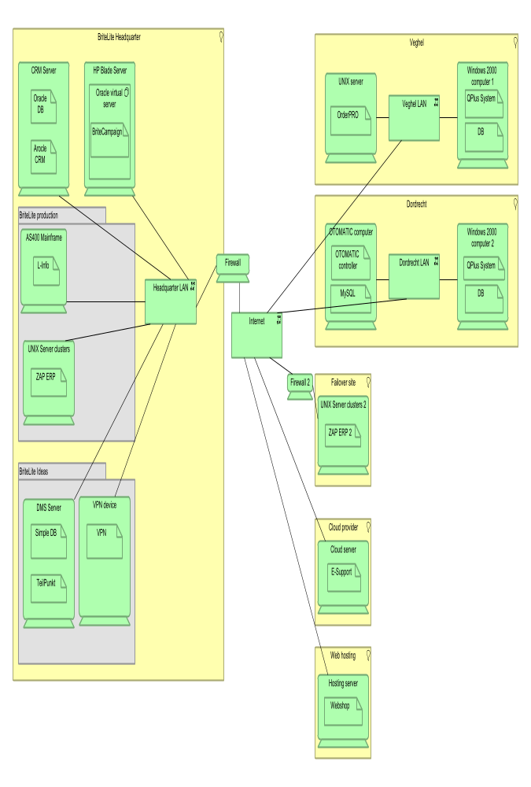
Figure 8 Infrastructure view

IT Infrastructure in Other Locations
Aside from the main locations of BriteLite mentioned before, there are also other locations used. A remote site is used to host ZAP ERP server similar to the one in BriteLite headquarter. This is intended as a failover mechanism, where the remote machine serves as a backup if the main server fails. Data between both servers are continuously synchronized, and the connection between both of them is secured by using firewall which is installed in each site.
BriteLite uses cloud technology to run the E-Support application. Hence, this application is running somewhere in the cloud infrastructure of the cloud service provider used by BriteLite. On the other hand, an external hosting company is used to host the web-based application Webshop.

Infrastructure Role in Supporting BriteLite IT
The current IT infrastructure of BriteLite supports the applications in sparse manner, in the sense that each applications has their own servers and their own database application in each machine. The technology used to run the applications also widely varies. Some of them use UNIX server, for example ZAP ERP and OrderPRO server, some of them uses Windows 2000. There is even application which uses AS400 mainframe.
The security aspect is implemented by using VPN to allow consultants accessing corporate network from the outside world, and by using firewall to filter communication traffic between the main ZAP ERP system and the backup one. However, the internal network of Veghel and Dordrecht sites are not secured with firewall yet.

Target Architecture
<Insert architecture models for the four architecture domains. Make sure you provide the information requested by the management, as formulated in part 2 of the the assignment.>

Architecture Vision
<Define the stakeholders, their goals, and derived requirements using the Light version of ArchiMate Motivation Extension.>

Business Architecture Models
<Includes organization and key business processes, as considered in phase B of ADM.>

Data Architecture Models
<Includes the organization’s data assets and data management resources, as considered in phase C of ADM.>

Application Architecture Models
<Includes the application systems, their interactions, and their relationships to the core business processes of the organization, as considered in phase C of ADM.>

Technology Architecture Models
<Includes the organization’s software and hardware capabilities to support business, data and applications, as considered in phase D of ADM.>

Gap Analysis
<The gap analysis identifies the gaps between the baseline architecture and the target architecture. If a gap is identified that is unintended (i.e., that is introduced by accident), then you should discuss the necessary revision to the target architecture.>

Impact Assessment
<The impact assessment discusses how the target architecture will affect the organization if it would be implemented in practice. It comments on the expected intended and unintended, positive and negative impacts, and considers these in the light of the architecture requirements that were previously identified.>

