BriteLite Architecture Definition
project report
By:
João Moreira
Jochem Verburg
Muhammad Arif Wicaksana
Quan Wang
Executive Summary
This document packages the baseline, target, and gap analysis for <insert>.

Version History
Date | Version | Comments
26 May 2015 | 1 | First version: the baseline
Table of Contents
1 Scope 3
2 Goals, Objectives, and Constraints 3
3 Architecture Principles 3
4 Baseline Architecture 3
4.1 Business Architecture Models 4
4.1.1 Organization structure 4
4.1.2 Product architecture 5
4.1.3 Process architecture 6
4.2 Data Architecture Models 8
4.3 Application Architecture Models 8
4.4 Application Architecture Models 12
4.5 Technology Architecture Models 13
4.5.1 IT Infrastructure in BriteLite Headquarter 13
4.5.2 IT infrastructure in Veghel Site 14
4.5.3 IT Infrastructure in Dordrecht Site 14
4.5.4 IT Infrastructure in Other Locations 16
4.5.5 Infrastructure Role in Supporting BriteLite IT 16
5 Target Architecture 16
5.1 Architecture Vision 16
5.2 Business Architecture Models 16
5.3 Data Architecture Models 16
5.4 Application Architecture Models 16
5.5 Technology Architecture Models 17
6 Gap Analysis 17
7 Impact Assessment 17

< This template shows “typical” contents of an Architecture Definition Document and can be adapted to align with any TOGAF adaptation being implemented.>

Scope
TBA

Goals, Objectives, and Constraints
TBA

Architecture Principles
TBA

Baseline Architecture
The current situation of BriteLite is illustrated by the baseline architecture. It consists of business architecture models, data architecture models, application architecture models, and technology architecture models. Each model is explained in detail in the next sections.
The general overview of the architecture is depicted in Figure 1. It shows the high-level interaction between business roles, business functions, products, and applications involved in BriteLite business process.
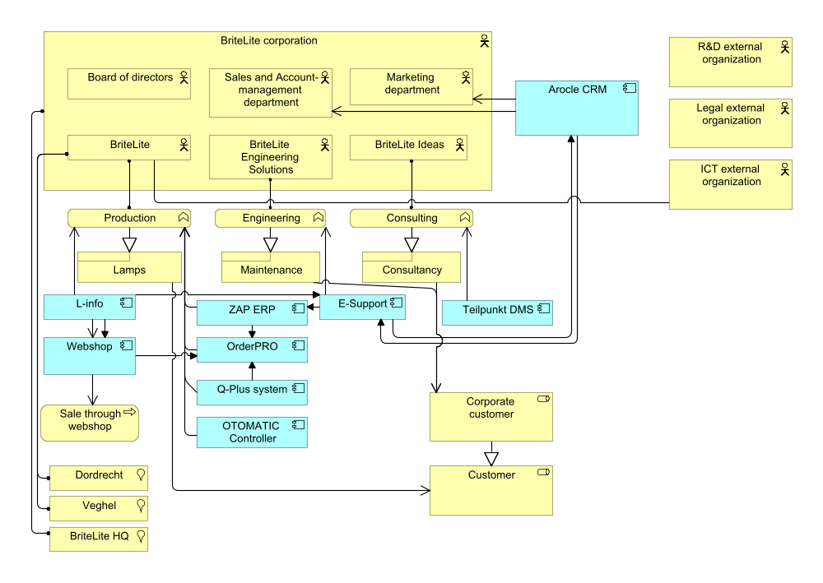
Figure 1 Total view

Business Architecture Models
The business architecture models are divided into three parts: organization structure, product architecture, and process architecture.

Organization structure
The organization structure of BriteLite is depicted in Figure 2. At the top level, there is Board of Directors. There are three business line: production (BriteLite), engineering (BriteLite Engineering Solutions), and consultancy (BriteLite Ideas). At the corporate level, there are Marketing department and Sales and Account-management department.
The production business line has the largest structure. It consists of production department, customer support team, ICT department, and Finance and Accounting department. The production department itself has inventory department and distribution department. There are two production sites, Dordrecht and Veghel. Each site has their own site manager and subdivision.

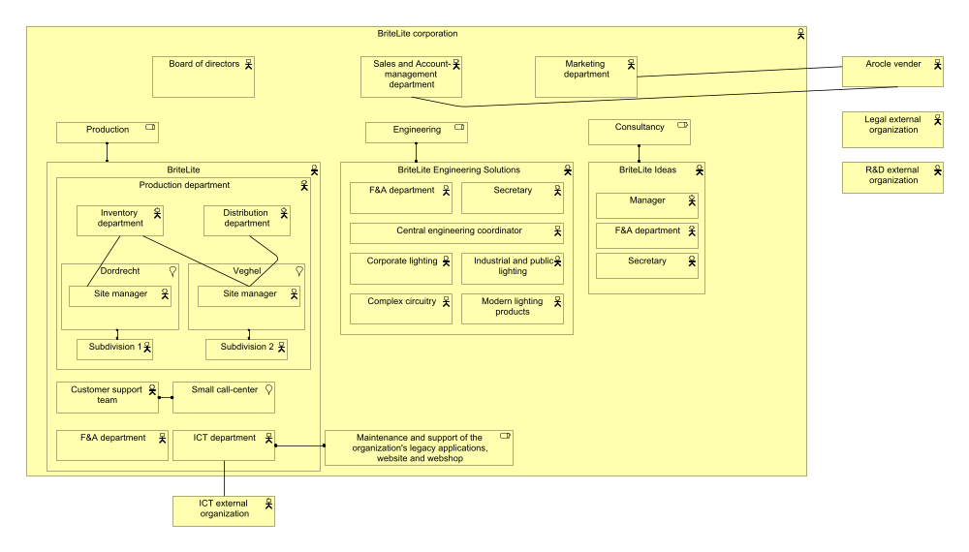
Figure 2 BriteLite organization structure
In engineering business line, there are several units: Finance and Accounting department, secretary, central engineering coordinator, corporate lightning, complex circuitry, industrial and public lightning, and modern lightning products.
Consultancy business line has smaller hierarchical structure consisting of a manager, 11 consultants, a secretary, and Finance and Accounting department.
There are relationships with external entities, especially for organizations which performing the outsourced business functionalities. Those are external legal organization, external Research and Development organization, and ICT support. There is also vendor Arocle, which support the CRM application used by Sales and Account-management and marketing departments.

Product architecture
In general, BriteLite provide their customers two things: lamp products and services. The lamp products itself can be divided into two categories: incandescent light bulb, and sodium-vapor lamp. The former one consists of various models and series targeted for various consumer segments. Sodium-vapor lamp consists of two series; power and extreme, and is intended for large customers.
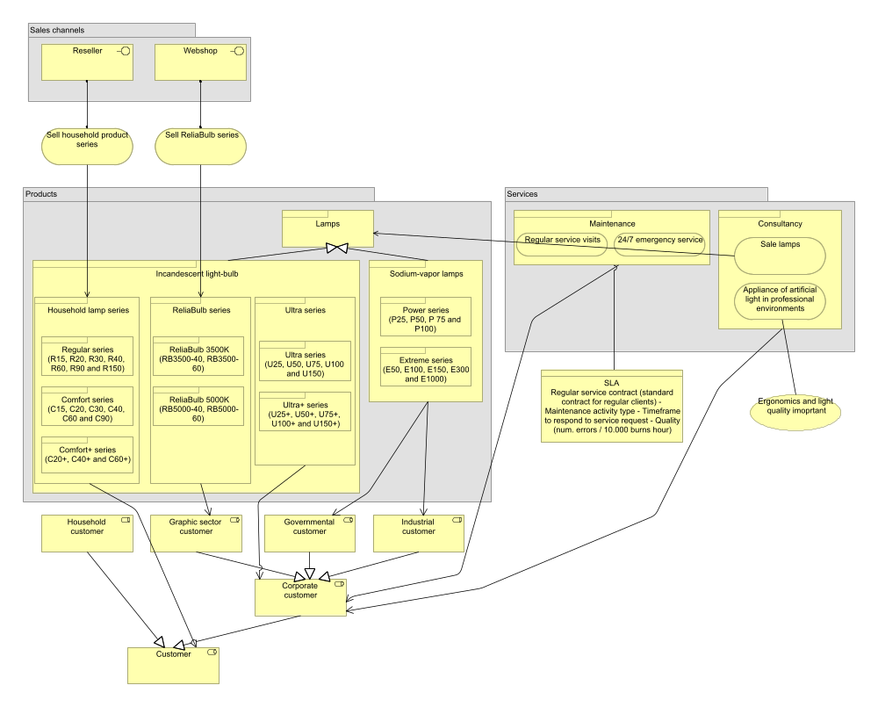
Figure 3 BriteLite product architecture
The sales of the lamp product are conducted through two ways: using normal distribution channel (via resellers), and directly to the customer by using web application.
BriteLite offer two types of services: maintenance and consultancy. The detailed illustration of BriteLite product is provided by Figure 3.

Process architecture
BriteLite business process is depicted in Figure 4. The processes are related with the appropriate entities from the organization structure (see Figure 2).
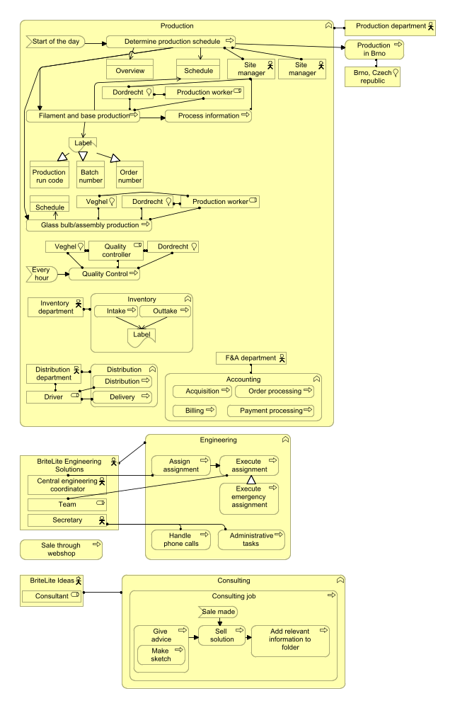
Figure 4 BriteLite business process
As can be seen, the business process is largely dominated in the production business line, especially the process for daily production. The business process of engineering and consultancy business lines are running in parallel with the production business line.

Data Architecture Models
Regarding data assets and data management resources, we can consider that all data assets in BriteLite are managed by enterprise systems. We will describe data assets and their management resources based on different business lines.
First of all, we will introduce data assets and management resources in production business line as it has most data resources. For ERP system, which replaced the old production system in production department, it manages 4 types of information and data assets: inventory management, production planning, production quality control and shipment tracing and tracking. For inventory management, it can be divided into outtakes and intakes, which can be furtherly divided into outtakes of raw materials, outtakes of products, intakes of raw materials and intakes of products. For production planning, it can be divided into outstanding production runs& priorities and productions schedule. The latter one is support and stored by OTOMATIC controller and shared by ERP. Besides, OTOMATIC controller also store the throughput time per batch as production logs in the machine itself. For production quality control, these data assets can be divided into status of quality control and quality control codes, which are processed and stored by QPlus system and shared by ERP system as well. For shipment tracing and tracking, these data assets can be represented by delivery status of orders, which are supported by OrderPRO system and share by ERP system as well. Besides, OrderPRO system also supports management of payment processing, order processing and billing data assets. Moreover, ERP system also manages the data asset of acquisition of raw materials.
Besides, there are some other data management resources and data assets in production business line. At the enterprise level, employees use CRM system to manage customer information and marketing campaigns while L-Info system stores specifications of all ever developed lighting products.
Secondly, engineering business line supports workload handling and keeps activities in itself as data resources by using E-support system. Besides, E-support system receives work orders from Arcole system and sends back finished case records to it. Moreover, E-support also has interfaces to ERP system and L-Info system for accessing relevant data information.
Thirdly, consultancy business line applies TeilPunkt system to manage consultant activities and data resources. TeilPunkt manages two types of data resources: Sketches information and real information for production solutions. For sketches information, it can be furtherly divided into solutions, photos& drawings of client locations and materials received from customers. These kinds of information are all kept in TeilPunkt system.

Application Architecture Models
Current existing application systems in BriteLite can be listed as follows: Arocle CRM system, E-support system, ZAP ERP system, L-Info system, OrderPRO system, QPlus system, TeilPunkt system, OTOMATIC controller and a web shop. To better illustrate how these systems support business functions, we first explain interactions and relations between these systems. And then we will link these systems with business processes in BriteLite.
First of all, there is an exchange of information between CRM system and E-support system. Working staff in engineering business line receive work orders from CRM system via E-support system. As a response, E-support will send back a record to CRM system after a case is finished.
Secondly, E-support system used by engineering business line have links with both systems in production business line. It has an interface with L-Info system so that it can access to specifications of lighting solutions directly. Moreover, it has an interface with ERP system so that engineers can access information like product inventory, product prices and so on.
Thirdly, ERP system and L-Info system in production business line are separately linked to OrderPRO system and a web shop as well. In that case, inventory management information can be exchanged between ERP system and OrderPRO system. And customers can achieve specifications of lighting products at the client side.
Moreover, E-support also has interfaces to ERP system and L-Info system for accessing relevant data information.
Thirdly, consultancy business line applies TeilPunkt system to manage consultant activities and data resources. TeilPunkt manages two types of data resources: Sketches information and real information for production solutions. For sketches information, it can be furtherly divided into solutions, photos& drawings of client locations and materials received from customers. These kinds of information are all kept in TeilPunkt system
Figure 5 illustrates the information structure view of BriteLite, and Figure 6 demonstrates the correlation between the information with the relevant application.

Figure 5 Information structure view
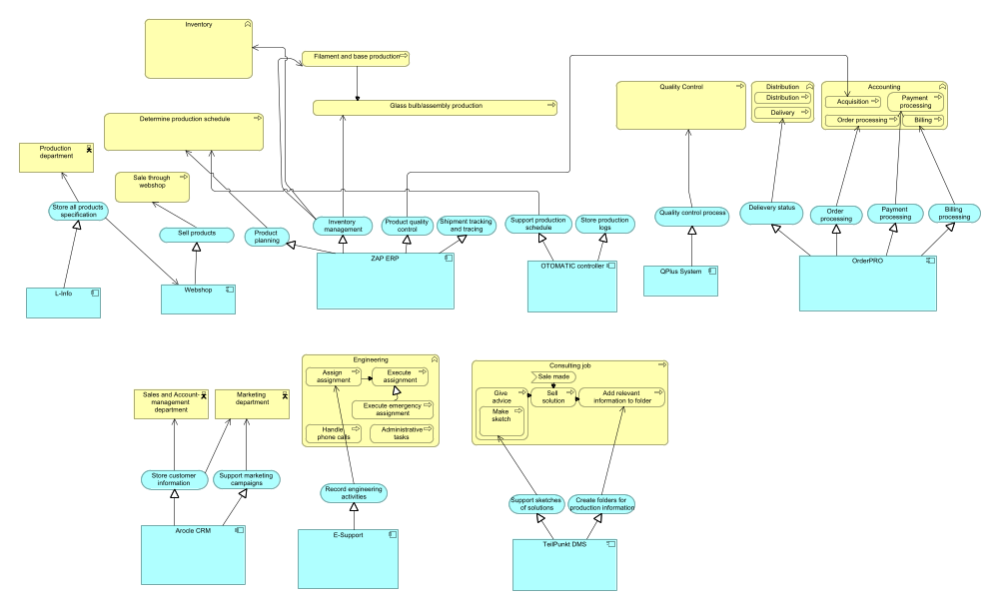
Figure 6 Application usage view

Application Architecture Models
First of all, there is an exchange of information between CRM system and E-support system. Working staff in engineering business line receive work orders from CRM system via E-support system. As a response, E-support will send back a record to CRM system after a case is finished.
Secondly, E-support system used by engineering business line have links with both systems in production business line. It has an interface with L-Info system so that it can access to specifications of lighting solutions directly. Moreover, it has an interface with ERP system so that engineers can access information like product inventory, product prices and so on.
Thirdly, ERP system and L-Info system in production business line are separately linked to OrderPRO system and a web shop as well. In that case, inventory management information can be exchanged between ERP system and OrderPRO system. And customers can achieve specifications of lighting products at the client side through a web page.
Fourthly, customers in the client side can use the web shop page to create orders and send them to OrderPRO system.
Fifthly, as QPlus system has the function to control quality of products. Hence, there is a connection between QPlus system and OrderPRO system. The status of quality control is sent from QPlus system to OrderPRO system and furtherly to ERP system.
Besides, TeilPunkt system has currently no connection with other systems. And the old production system is not used at all now.
After the brief explanation of interactions between systems, we will also describe how these systems support our business processes. As the production business line is the most important one in BriteLite, we will focus on business processes in this line.
First of all, team managers of the production lines determine production schedules at the start of the day via the service of production planning provided by ERP system. Then, two kinds of lighting fittings are produced in parallel: Filament and base production, Glass bulk/ assembly production, which are supported by the service of inventory management provided by ERP as well. Next, quality control is going to be carried out, which is supported by QPlus system and the status of quality control is sent to OrderPRO system and furtherly to ERP as illustrate above. Finally, distribution and delivery are supported by OrderPRO system and ERP system. Besides, for payment processing, order processing and billing, which are carried out in Accounting department, OrderPRO system provides relevant services for supporting them representatively. And for online business, the wen shop provides sell products online service for customers.
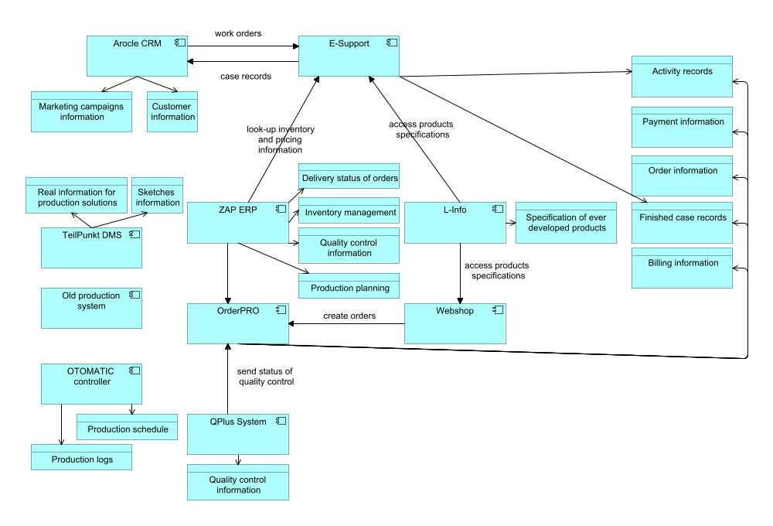
Figure 7 BriteLite application structure view
For engineering business line, E-support system supports different engineering activities, which includes assignment assign and execution, emergency assignment assign, phone calls handling and administrative tasks.
For consultancy business line, TeilPunkt provides services of drawing sketches of solutions and creating folders of production information. These two services support the whole consulting process, which contains the following sub processes: advice providing (including making sketches), solution making and creation of solution information.

Technology Architecture Models
The current IT infrastructure used by BriteLite is spread in several locations. The configuration is shown in Figure 1

IT Infrastructure in BriteLite Headquarter
Most of the infrastructure are located in BriteLite Headquarter. There is a CRM server which is used to host Arocle CRM application, with an internal Oracle database application in the same machine. For BriteCampaign application, an HP blade server is used, with an Oracle Virtual Server is installed to run the BriteCampaign.
For BriteLite department, there are two servers available. AS400 mainframe is used to run the L-Info application, while a UNIX server cluster is used to run ZAP ERP application.
In BriteLite Ideas, a DMS server is present to run TeilPunkt application, with a simple proprietary database running on the same machine. All of the servers are connected to the Headquarter LAN, which is connected to firewall before facing the Internet. A VPN device is also available, to accommodate consultants accessing corporate network during their business travel.

IT infrastructure in Veghel Site
In Veghel site, there are two running servers. The first one, a UNIX server running OrderPRO application. Another one is a Windows 2000-based computer running QPlus System with a database application installed in the same computer. Both are connected to Veghel LAN, which connected to the Internet.

IT Infrastructure in Dordrecht Site
Similar to Veghel site, there is also a Windows 2000-based computer running a QPlus system. In addition, there is a computer running OTOMATIC controller. This computer also runs a MySQL database to support the OTOMATIC controller. Both of them are connected to the Dordrecht LAN, which is connected to the Internet.
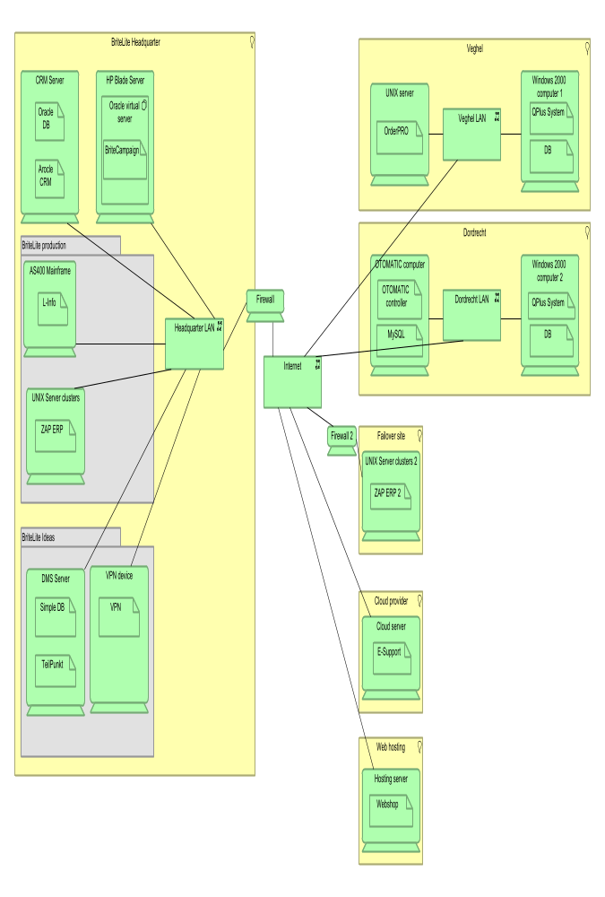
Figure 8 Infrastructure view

IT Infrastructure in Other Locations
Aside from the main locations of BriteLite mentioned before, there are also other locations used. A remote site is used to host ZAP ERP server similar to the one in BriteLite headquarter. This is intended as a failover mechanism, where the remote machine serves as a backup if the main server fails. Data between both servers are continuously synchronized, and the connection between both of them is secured by using firewall which is installed in each site.
BriteLite uses cloud technology to run the E-Support application. Hence, this application is running somewhere in the cloud infrastructure of the cloud service provider used by BriteLite. On the other hand, an external hosting company is used to host the web-based application Webshop.

Infrastructure Role in Supporting BriteLite IT
The current IT infrastructure of BriteLite supports the applications in sparse manner, in the sense that each applications has their own servers and their own database application in each machine. The technology used to run the applications also widely varies. Some of them use UNIX server, for example ZAP ERP and OrderPRO server, some of them uses Windows 2000. There is even application which uses AS400 mainframe.
The security aspect is implemented by using VPN to allow consultants accessing corporate network from the outside world, and by using firewall to filter communication traffic between the main ZAP ERP system and the backup one. However, the internal network of Veghel and Dordrecht sites are not secured with firewall yet.

Target Architecture
<Insert architecture models for the four architecture domains. Make sure you provide the information requested by the management, as formulated in part 2 of the the assignment.>

Architecture Vision
<Define the stakeholders, their goals, and derived requirements using the Light version of ArchiMate Motivation Extension.>

Business Architecture Models
<Includes organization and key business processes, as considered in phase B of ADM.>

Data Architecture Models
<Includes the organization’s data assets and data management resources, as considered in phase C of ADM.>

Application Architecture Models
<Includes the application systems, their interactions, and their relationships to the core business processes of the organization, as considered in phase C of ADM.>

Technology Architecture Models
.

Gap Analysis
<The gap analysis identifies the gaps between the baseline architecture and the target architecture. If a gap is identified that is unintended (i.e., that is introduced by accident), then you should discuss the necessary revision to the target architecture.>
(Assignment 2, part 1)

Impact Assessment
<The impact assessment discusses how the target architecture will affect the organization if it would be implemented in practice. It comments on the expected intended and unintended, positive and negative impacts, and considers these in the light of the architecture requirements that were previously identified.>
- How the target architecture will affect the organization:
  - Expected impacts (changes found in the gap analysis):
Adopt an Integration Suite that includes a BPM tool and an Enterprise Service Bus (ESB):
http://www.infoq.com/articles/ESB-Integration
Expose main functions of the applications as services:
“Migration plan”: List the BPs by migration priority. For each BP, list the business functions and the related applications that realize the business function. List the applications “parts” to be exposed as services – “mock” each service (skeleton design). For each BP, design it (BPMN), design its services composition linked to the mocked service. Develop each service (one-by-one) so the migration runs smoothly.

  - Requirements realization (assignment 2, part 2 and 3):

- Regarding the options to be considered about overhaul the IT landscape, we listed advantages, disadvantages and general issues:
- Outsourcing all IT-related work:
Outsourcing, in general, brings the need of enhancing the governance of the IT services. A set of practices (guidelines) is part of the governance, as ITIL (Information Technology Infrastructure Library) and ALM (Application Lifecycle Management) procedures. They should standardize the documentation necessary, as well as code quality measures, deployment and monitoring procedures.
Outsourcing the hardware assets can lower the costs related to deterioration (e.g. of servers and network links), licensing and staff’s specific knowledge (e.g. configuration of a DBMS and deployment of DB and log files in the right type of hard-drive considering network issues). Cloud-computing can realize the outsourcing of the data-centers (?) through cloud-based services (e.g. AWS). The major issue in this choice must include the internet connection link – if it fails the entire company stops. Hybrid approaches can be considered, such as mirroring (real-time synchronizing) the infrastructure that supports (realizes?) the main business processes (but it brings additional costs) or selecting only one set of assets to be cloud-based. Other issues to be considered is: security (authentication and authorization) as well as performance and scalability – this last usually increases when using cloud technologies (known as elasticity).
The outsourcing of the development of new applications is recommended, once developing in-house can have higher cost, lower quality and “bad-practices”. This is due to the necessity of a software engineering team with specific specializations (e.g. requirements analyst, application designer, programmers and testers) and development “environment” issues, such as software licenses (e.g. OS, IDEs, DBMS) and hardware (workstations).
An hybrid approach for maintenance is recommended, where small and urgent maintenances can be made in-house and the rest can be outsourced.

- Replacing the entire IT landscape with a centralized system:
Replacing the entire IT landscape can be interpreted as:
- Rewriting all the applications in one unique system; or
- Providing an unique user interface to a service bus (e.g. ESB) that integrates the existing applications, focusing on business processes integration.
Rewriting or evolving the existing applications is a common issue due to business changes. As section 1.4 of the book describes, in long term, rewriting is not a good strategy, but it is required (sometimes) to support the business needs. When technology is too old and is hard to make changes (takes long time and/or is expensive) it is better to rewrite, as well as when business functionalities changes so much that it is easiest to write it from sketch. Definitely, rewriting all the applications in this case is not recommended due to the high cost and possible problems with this “big bang” change – the migration process turns extremely complex and error prone.
We suggest the integration of the applications to support the business processes through an integration pattern following the SOA paradigm. This can be realized through a process integration layer that can be accessed by the unique interface (at the access layer) and calls the services layer, which exposes the applications functionalities as services. Figure XX describes this architecture (from the book, Fig.16-2):
