Title:
Applying Dynamic Programming and Reinforcement Learning in Dynamic Pricing of Products to Improve Profit and Reduce Product Waste.

Abstract
Customers prefer fresher products over older products. As a result, daily demand is often met without selling products close to their expiratory age, and these products are wasted. Currently, clerks often set a fixed discount for the oldest products in a category to entice customers into buying these instead of the fresher products. This improves overall profit and reduce waste. However, perhaps an even more efficient method could be applied. By dynamically setting the discount each day uniquely for that day’s inventory state, a more adequate discount could be applied. With Dynamic Programming (DP) and Temporal Difference (TD), policies are derived from a modelled reality where the best action is set out for each possible inventory state. In this research, Value Iteration (VI) and Iterative Policy Evaluation (IPE) with Policy Improvement (PI) are used, as well as Sarsa and Q-learning. The analyses show an insignificant improvement in waste reduction and profit gain from all methods. Hence, in current setting DP and RL have not improved the status quo. Future research could model the consumer’s behaviour more accurately, by including environmentally conscious behaviour into the reward function, or by not letting the total demand depend on the discounted old product demand.

Introduction
Products close to the expiratory age are less attractive to customers than fresher units. This preference is called Least Expiratory First Out (LEFO), which is the opposite of First Expiratory First Out (FEFO). Because of LEFO behaviour, stock that is left-over due to a lower daily demand than total inventory, is eventually thrown out. Stimulating FEFO facilitates less waste and would ultimately improve profit that way. By reducing a product’s price, customers that would otherwise choose the fresher product could decide on the older alternative. For example, because they would use the product on the day itself for a culinary experience already. The disadvantage however, is that the daily demand could be partially fulfilled with the discounted products, and in turn less fresh products are sold for the regular price.
The balance between the discount to give and number of items to set a discount for has to be established. The easiest (both practically and computationally) way to do so is by placing a fixed discount on all products when they reach their day of expiration. Alternatively, the discount could depend on the day’s inventory state. If there the majority of products are old, the discount should not be excessively high for instance, because most old products would be bought that day anyway due to the daily demand. In contrast, when there are more fresh than older units, perhaps a higher profit is justified.
This inventory state dependent discount decision process is perfect for machine learning models. More specifically, Dynamic Programming (DP) and Temporal Difference (TD) model a reward function that mimics consumer’s behaviour in search for an optimal policy. The difference is that DP prepares a full probability matrix for what the next inventory state could be given today’s action and inventory state, whereas TD simply gathers data and selects the best decision through experience.
The main question remains whether dynamically pricing the products or choosing a fixed discount is the better option. In order to find that answer, the deficits if each model will be mapped out as well. Hence, each model is evaluated individually to determine which is best. Besides waste reduction and profit improvement, computational time is an important factor here. Ultimately, this research could improve the status quo that is either not setting a discount, or using a fixed discount for the oldest products in the assortment.

Methods

Computing the Probability Matrix and Reward Matrix
Both TD and DP require a reward function. This equation includes all metrics to reward the model’s actions with. Positive scores reward the model for their chosen action, and negative scores vice versa. The product’s inventory state, S, contains of a number of days a product could be of age, M. Only when the product reaches the oldest age, the product is considered adequate for a discount. The maximum number of items per day depends on the base stock policy level, $BSPlvl,$ i.e. the highest number of items inventoriable. The possible number of inventory states is therefore $M^{BSPlvl}$. The probabilities of a daily demand depend on $μ$. The maximum probability was set to three times $μ$, where the daily demand probabilities follow a Poisson distribution, and all probabilities for a demand higher than the maximum daily demand were summed. The actions were defined as discount levels that increment with 5%, between 0-50%.
For each action state combination, and for every demand, each action was multiplied by the discount increment, and the difference between the base stock level and that particular inventory space was ordered as new stock, or nothing if that value was negative. That way, the number of items to order could never pass the base stock policy. The FEFO demand was calculated by taking the smallest value; either all of the oldest products in the current inventory, or the discount multiplied by the daily demand. Successively, the FEFO demand could never be higher than the number of oldest items. What is more, with an elevated discount, statistically a higher FEFO demand would come about. The LEFO demand is what remains of the original demand when subtracting the FEFO demand. The items with the youngest age are chosen first, and the items of the later age categories are chosen until the full daily demand is met. The metric of customer dissatisfaction when the demand is higher than the summed inventory is ignored in this model.
The items left in the oldest age category after meeting the daily demand are considered as waste. The items roll over to the next age class, and the newly ordered items are added to the youngest age class. That way, a new inventory state is created, $s'$. This process is defined as a step. Performing a number of these steps is called an episode. The probabilities for every demand were added to the probability matrix. The probability matrix contains the probabilities for every next state, $S'$, given the action taken in a particular inventory state; $P\left(A, S, S^{'}\right)$.
Finally, the reward matrix, $R$, was computed with the structure $R(A,S)$, and received for each action state combination the value of multiplying the next state probabilities with the profit function. In this model, the profit function includes the order costs, $c$, the units to order, $Order$, the discount, $aa$, units sold with a discount, $DeltaF$, units sold without a discount, $DeltaL$ and purchase price, $r$:
$$R\left(A,S\right)=r∙DeltaL+r∙\left(1-aa\right)∙DeltaF-c∙Order$$

Fixed Discount Control
This elaborate algorithm is a reflection of consumer’s behaviour, and therefore assumes a role in evaluating the machine learning models as well. During computing these matrices, all possible state action demand combinations are artificially implied and the next state is not considered for a next step. However, running this algorithm for an episode that consists of 36500 steps while only the action is predefined, the average profit and waste for that action can be established. In that sense, the Fixed Discount Control (FDC) is chosen by maximizing the profit by iteratively running episodes over discounts increments by 5% between 0-50%. The initial inventory state is empty, and after ten steps the profits are included in the statistics. The waste associated with this profit is not minimized. The reason for this, is that the higher a discount is given, more customers would assume FEFO behaviour, limiting the profit at some point. The main goal of supermarkets remains increasing profit, waste reduction is a by-product that is modelled in this solution, but should not dominate the outcome.

Dynamic Programming

Iterative Policy Evaluation and Policy Improvement
In this paper, the DP models Value Iteration (VI), and Iterative Policy Evaluation (IPE) with Policy Improvement (PI) are used, as well as the TD models Sarsa and Q-learning. IPE takes policy $π$, freezes it (the policy does not change), and calculates the state value vector $V_{π}(s)$ according to Bellman’s equation until convergence. This state value vector is then frozen while the previous policy is thawed (the policy can change again). Then, $q$-values are calculated in the PI algorithm, by computing each possible action, $a$, and state, $s$, in Bellman’s equation using the beforementioned frozen state value vector, to evaluate whether a better policy exists. If that is indeed true, the policy is frozen once more, the state value vector is thawed, and the algorithm is run again until an optimal policy is found.

Value Iteration
In VI, all possible actions for each state are computed into Bellman’s equation, where the best state value is saved in the state value vector. The policy the led to that value is saved in an updating policy. Only when the state value vector converges, the algorithm ends, and the remaining policy is the optimal policy. These models are chosen, as they are considered the optimal solution for the presented problem; a reward function is known as well as the probabilities of customers buying products. These algorithms model the probability matrix, $P$, of a next inventory state, $s'$, given the current action, $a$, and current inventory state, $s$. The model takes these probabilities into account when calculating the profit and waste, and that makes finding an exact solution with DP reliable.

Reinforcement Learning
(outline for now)
Another approach to try to find the best policy (π) for setting the discount for perishable products is using Reinforcement Learning (RL). Learning π directly from the environment instead of using the full transition probabilities. Two approaches that were used in this report where SARSA and Q-learning.

Q-learning
Q-learning applies an off-policy TD control, updating the q-table with the best action possible for that state. Updating rule:
$$Q(s,a) ← Q(s,a) + α[r + γ·max_a' Q(s',a') - Q(s,a)]$$

SARSA
Sarsa uses an on-policy TD control, where a’ is the action actually selected next. In contrast with Q-learning it is more conservative near costly states, Q-learning converges faster but can be riskier during learning. Updating rule:
$$Q(s,a) ← Q(s,a) + α[r + γ·Q(s',a') - Q(s,a)]$$

The environments
Every episode in the Environment simulated 100 years (36500 days), the model was evaluated every 5000 iterations, when convergence occurred, defined as a change <1% at the next evaluation iteration, the simulation was stopped. Epsilon was initialised with a decay, learning rate (alpha) and discount factor (gamma) were fixed. Before every run an empty Q-table was initialised of size (UBI+1)^M.

Hyperparameter tuning
To select the best parameters in the available time a manual sweep of a few parameters was performed. The algorithm was tuned for alpha and gamma. The tuning was repeated over 3 seeds and The results with the highest average profit were selected as model with the best parameters.
TABLE WITH SETTINGS AND RESULTS

Results
First, the main algorithm was run for a singular episode on $μ=3, M=5$, to establish the FDC (Figure 1). The profit increases from 0- until 20% discount. There is a linear decline in profit after that with increasing discount. The proportion of waste linearly consistently decreases in similar fashion. Hence, the assumption that a higher reduction in waste in the extreme discount zone would reduce the profit as well is validated here.
(A) | (B)
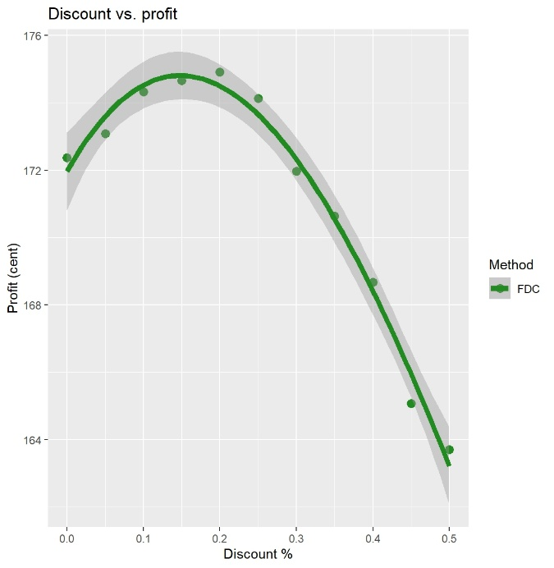 | 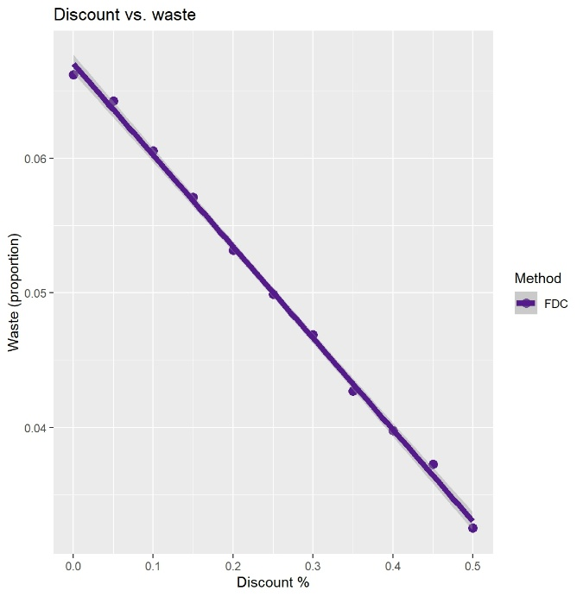

Figure 1. Fixed Discount Control (FDC). (A) Profit increases between 0-20% discount on product’s price, then declines. (B) Waste linearly declines as discount levels up. Each discount is measured once. Dark gray area is standard error, number of episodes $=1$, $μ=3, M=5.$
The $z$-value, $M$, $μ$ and machine learning methods were set as variables, all other settings were kept constant. To determine which variable were most important, a one-way ANOVA was performed. The combination of sum of squares and $p$-value showed that the $z$-value ($p=1.7∙{10}^{-8},$sum of squares$=20$) was least relevant compared to $M$ ($p=2.0∙{10}^{-16},$sum of squares$=5.1∙{10}^{5}$), $μ$ ($p=2.0∙{10}^{-16},$sum of squares$=3.7∙{10}^{-5}$) and the methods ($p=2.0∙{10}^{-16},$sum of squares$=180)$. Especially the lower sum of squares (squared distance of data to mean, indication of variance in data) indicates that the $z$-value is of lower relevance, and is therefore not looked further into during the analyses. All interactions between variables were insignificant.
All machine learning models show a similar negative exponential decline in waste as profit increases (Figure 2A). These data come about by measuring profit while differing the shelf life ($M$) and inventory state space. The decline suggests that wasting less products due to old age improves the profit directly, which supports that same assumption. The DP models’ computing times increase when both the shelf life (Figure 2B) and inventory state space (Figure 2C) increase. For the TD models, there is not a noticeable difference in computing time when the possible number of inventory states expand. Overall, the DP models have a higher computational burden than the TD models, while not performing better than the FDC at first sight.

(A) | (B) | (C)
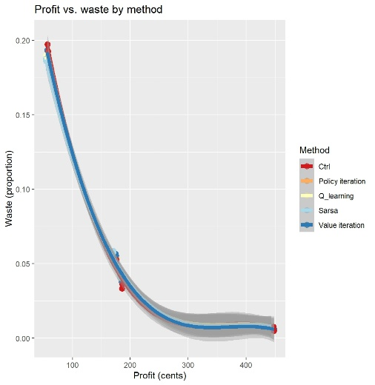 | 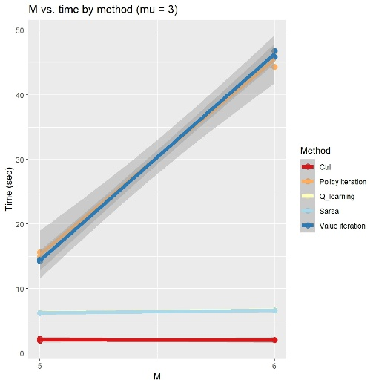 | 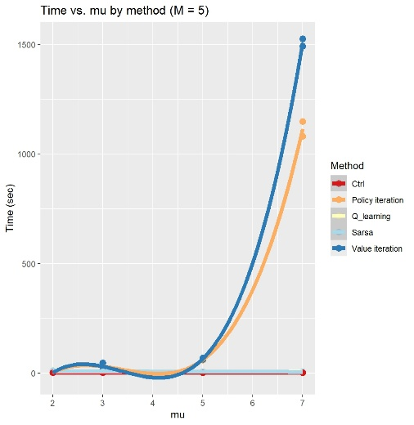
Figure 2. Overall trends between profit, waste and state space. (A) All functions show a similar decline in waste when profit improves. (B) Computing time increases for the DP models when the shelf life increases. (C) There is a near-exponential trend between computing time and increasing inventory size for the DP models. Note; $z$-values were not standardized while computing these graphs. (A) and (C) were modelled with a polynomial curve at a third degree, (B) is a linear model. Due to this polynomiality, (C) has a lower extreme below 0, which is an unrealistic value as time cannot assume a negative value during computation.
That is why a Tukey’s Honest Significant Difference post hoc analysis was performed. This analysis calculates statistical significance between conditions in the same cohort while controlling the family-wise error rate for all pairwise comparisons. The statistical test assumes equal group variances, and for most instances that is indeed true. The differences between FDC and the DP models are insignificant, and despite a statistical difference showing between the FDC and TD models, the TD models retrieve a lower profit (Figure 3). Statistically, the two DP models are indifferent, similar to the two TD models, when evaluating their performance on profit.
TD is has a statistical lower waste production than the FDC in lower inventory state space, though this advantage is lost when the number of inventoriable items increase. DP does not show a significant difference with the FDC in any combination of parameters, and TD overall produces more waste. Thus, these machine learning methods are also not an improvement over FDC when considering waste reduction.
Lastly, evaluating which model is best requires computational burden evaluation as well. The trend seen in Figure 2 is also statistically relevant. While in low inventory state space the TD models are take a few more seconds to compute than the DP models, in higher state space the TD models underscore the computational needs of DP. Implementing TD in practice may therefore be more favourable as computing the models takes less recourses and could be used earlier than DP.

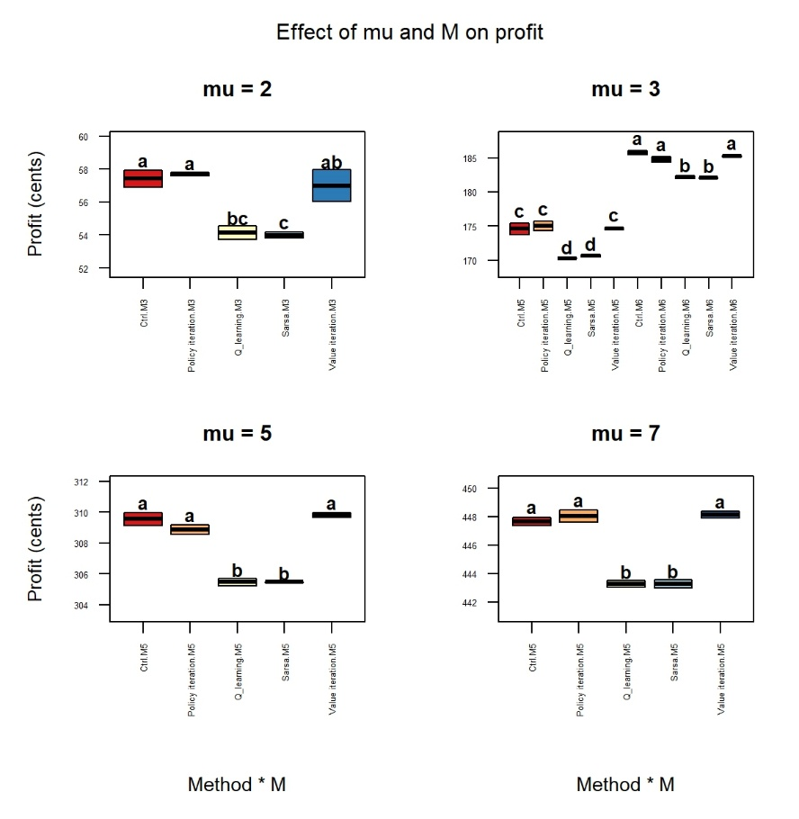
Figure 3. Changes in profit in increasing inventory state space. Significance between conditions is indicated with letters; similar letters symbolise insignificance. Double letters should be interpreted as insignificant with another condition if that other condition also contains any of these letters. Otherwise, there is a significant difference between the conditions. Each consecutive plot shows an expanded inventory space and with that also a higher profit.

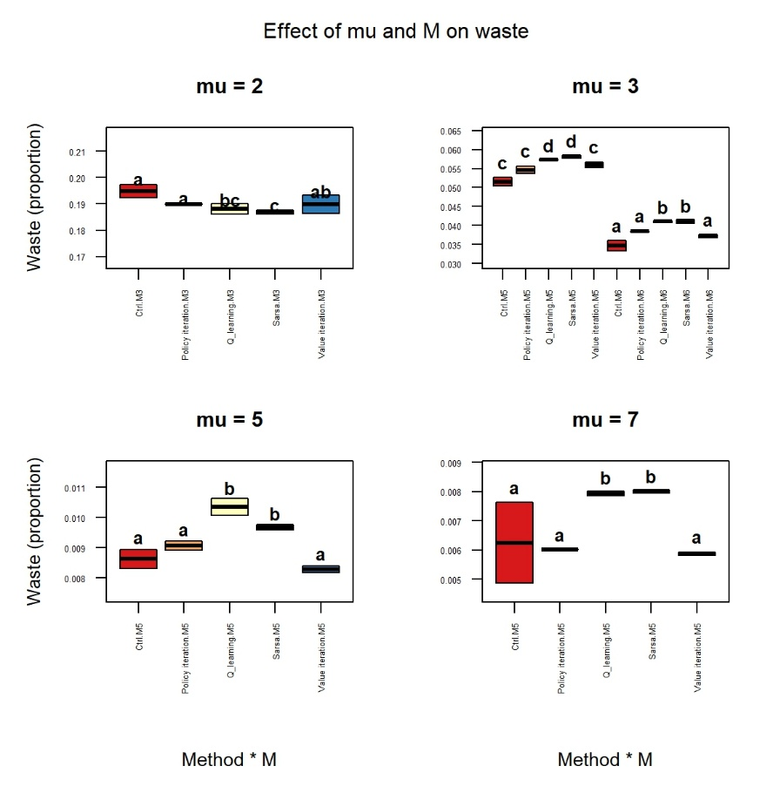
Figure 4. Changes in waste during inventory state space expansion. Significance between conditions is indicated with letters; similar letters symbolise insignificance. Double letters should be interpreted as insignificant with another condition if that other condition also contains any of these letters. Otherwise, there is a significant difference between the conditions. Each consecutive plot shows an expanded inventory space and with that also a lower waste.
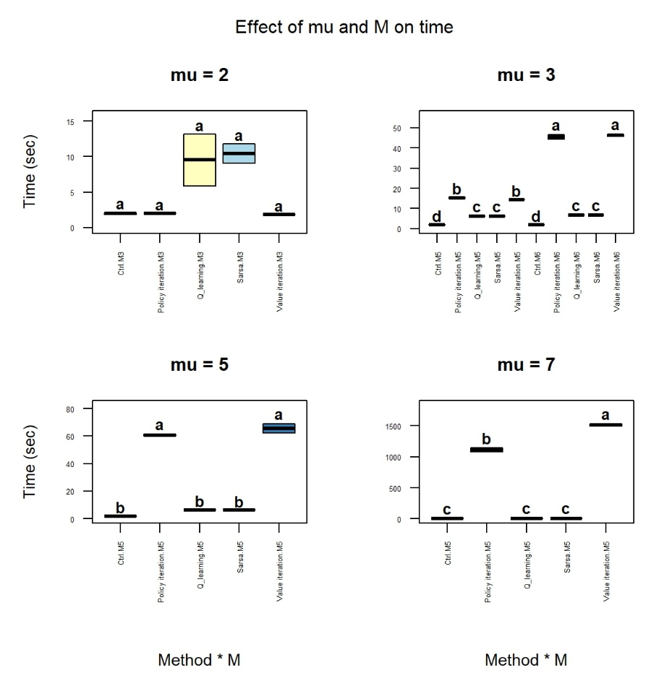
Figure 5. Changes in model computation time with increasing inventory state space. Increasing inventory space results in exponential longer computation time for DP, while reinforcement learning is overall as quick as the FDC. Significance between conditions is indicated with letters; similar letters symbolise insignificance. Double letters should be interpreted as insignificant with another condition if that other condition also contains any of these letters. Otherwise, there is a significant difference between the conditions. Each consecutive plot shows an expanded inventory space.

Discussion

Conclusion

Statement use of Artificial Intelligence

Data Repository

References

