Applying Dynamic Programming and Temporal Difference in Dynamic Pricing to Improve Profit and Reduce Waste
Authors: Jochem Widdershoven (student number: 1598228) and Chris Ambagtsheer (student number: 1216414)

Abstract
Customers prefer fresher products over older products. As a result, daily demand is often met without selling products near expiration and these products are wasted. Retailers routinely implement a fixed discount on the aging inventory to incentivize customers to select older products instead of the fresher alternative. This improves overall profit and reduces waste. Perhaps this mechanism can be improved even further. By dynamically setting the discount each day’s inventory state, a more adequate discount could be applied. With Dynamic Programming (DP) and Temporal Difference (TD), policies are derived from a modelled reality where the best action is selected for each possible inventory state. In this research, Value Iteration (VI) and Iterative Policy Evaluation (IPE) with Policy Improvement (PI) are used, as well as State-Action-Reward-State-Action (SARSA) and Q-learning. The analyses show an insignificant improvement in waste reduction and profit gain from all methods. Hence, in current setting DP and TD have not improved the status quo. Future research could model the consumer’s behaviour more accurately, by including environmentally conscious behaviour into the reward function, or by reducing the influence the demand for old products has on the total fresh alternative demand.

Introduction
Products near expiration are less attractive to customers than fresher units (Tsiros & Heilman, 2005). This preference is called Last Expiry First Out (LEFO), which is the opposite of First Expiry First Out (FEFO). Because of LEFO behaviour, left-over stock (due to a lower daily demand than total inventory) is eventually thrown out. In 2026 for example, (Kok et al., 2026) showed that the total food loss / waste between 2019 and 2022 lay between 3-7% of total product volume due to expiration. Stimulating FEFO facilitates less waste and would ultimately improve profit that way. By reducing a product’s price, customers that would otherwise choose the fresher product could decide on the older alternative. For example, because they would use the product on the day itself for a culinary experience already. The disadvantage however, is that the daily demand could be partially fulfilled with the discounted products, and in turn fewer fresh products are sold for the regular price. Inventorying product’s age is not profitable for all items, but major perishable products could be a great target, such as meat (especially beef), cheese, fruit and vegetables, dairy and deli. Reducing a retailers waste therefore not only improves profit, but is directly environmentally beneficial (Scholz et al., 2015).
The balance between the discount to give and number of items to set a discount for has to be established. The easiest (both practically and computationally) way to do so is by placing a fixed discount on all products approach expiration, such as on the same day or the day before (Loss, 2024). Alternatively, the discount could depend on the day’s inventory state. To put this concept into perspective, if the majority of products are old, the discount should not be excessively high for instance, because most old products would be bought that day anyway due to the daily demand. In contrast, when there are more fresh than older units, perhaps a higher profit is justified. Recently, (Haijema et al., 2026) dynamically modelled product discount that way with Dynamic Programming (DP) models for products that could be categorized in several age classes, with two standard price options and multiple restocks. This paper will continue with their work, yet limits itself by dynamically pricing the oldest item with a singular standard price and restock.
The inventory state dependent discount decision process is perfect for machine learning models. More specifically, DP and Temporal Difference (TD) model a reward function that mimics consumer’s behaviour in search for an optimal policy. The difference is that DP prepares a full probability matrix for what the next inventory state could be given today’s action and inventory state, whereas TD simply gathers data and selects the best decision through experience. In essence, TD learns the discount policy through simulated experience, whereas DP predefines what reward to receive given a certain state and discount. Their strengths and weaknesses as well as a tutorial have been reviewed in (Wang et al., 2025).
That leads to the main research question of this study:
What are the profit and waste benefits if perishable inventory is dynamically priced, compared to a fixed discount?
To answer this question three approaches are evaluated and directly compared: a Fixed Discount Control (FDC), DP and TD. This comparison raises two sub-questions:
- Does any model produce a statistically and practically meaningful improvement in profit and waste reduction over the FDC?
- Among models that derive comparable policies, which is preferable once computational time is taken into account?
The ultimate goal is to find the algorithm that minimizes waste close to zero, while improving retailer’s profits. Finding such solution would encourage other areas that contain perishable inventory as well, limiting the carbon footprint caused by food spillage.

Methods

The Environment
Both TD and DP require a reward / profit function. This equation includes all metrics to reward the model’s actions with. The product’s inventory state, S, includes a number of days a product could be of age, M. Only when the product reaches the oldest age, the product is considered adequate for a discount. The maximum number of items per day depends on the base stock policy level, $BSPlvl,$ i.e. the highest number of items inventoriable. The possible number of inventory states is therefore:
$$S=\{s=(q_{1},q_{2},…,q_{M})|0≤q_{i}≤BSPlvl\}$$
The probabilities of a daily demand depend on $μ$, following a Poisson distribution. The maximum demand was set to three times $μ$, and all probabilities for higher demand were summed.
The actions, $A,$ are defined as discount levels that increment with 5%, between 0-50%.
$$A=\{0.05, 0.10,…0.50\}$$
For each action state combination, the items to order were defined as the difference between the base stock level and inventory space, or nothing if that value was negative. That way, the number of items to order could never pass the base stock policy level. The FEFO demand was computed by taking the smallest value; either all of the oldest products in the current inventory state, or the discount multiplied by the daily demand. Successively, the FEFO demand never exceeds the number of expiring items. What is more, with an elevated discount, statistically a higher FEFO demand would come about, which reduces waste. The LEFO demand is defined as the remainder of the original demand when subtracting the FEFO demand. The items with the youngest age are bought first, and the items of the later age categories are picked until the full daily demand is met. The metric of customer dissatisfaction when the demand is higher than the summed inventory is ignored in this model.
The items left in the oldest age category after meeting the daily demand are considered as waste. The remaining items move over to the next age class, and the newly ordered items are added. That way, a new inventory state is created, $s'$. This process is defined as a step. Performing a number of these steps is called an episode. Finally, the profit function, $r$, includes the order price, $c$, the units to order, $O$, the discount, $aa$, units sold with a discount, $∆_{F}$, units sold without a discount, $∆_{L}$ and selling price, $e$, which composes the following equation:
$$r(s,a)= e∆_{L}+e∆_{F}\left(1-aa\right)-cO$$
The initial inventory state is empty, and after ten steps the profits are included in the statistics. This process is called the regular algorithm.

Probability and Reward Matrix
The probability and reward matrix were computed by finding the next state for each state action demand, $D,$ combination and calculating the corresponding direct profit.
$$D=\{0, 1,…, 3μ\}$$
The probability matrix contains the probabilities for every next state, $S'$, given the action taken in a particular inventory state; $P\left(A, S, S^{'}\right)$. To compute the transition dynamics, each possible state was set as the initial inventory, after which one step was performed per action per demand. The probability for that particular demand that leads to a next state, given the action and the current state taken, were then added to the probability matrix. Hence, the probabilities for each action state combination always sum up to 1. The reward matrix, $R$, was computed with the structure $R(S,A)$, and received for each action state combination the summed product of the next state probabilities and profit function over each demand, and state and action taken.
$$R\left(S,A\right)=\sum_{d∈D}{P(s^{'}|s,a,d)∙r(a,s)}$$

Fixed Discount Control
Running the regular algorithm for an episode of 35,510 (100 years and 10 model initialisation days) steps for each action without using the reward and probability matrices gives an estimate of the average profit and waste for that action. The FDC is chosen by maximizing the profit through iteratively running episodes over the action range mentioned beforehand. The waste associated with this profit is not actively minimized, i.e. the optimal discount is not chosen by selecting the action that results in the lowest waste proportion. Otherwise, the majority of customers would assume FEFO behaviour, limiting the profit as most of the demand is satisfied with discounted products.

Dynamic Programming

Iterative Policy Evaluation and Policy Improvement
In this paper, the DP models Value Iteration (VI), and Iterative Policy Evaluation (IPE) with Policy Improvement (PI) are used, as well as the TD models State-Action-Reward-State-Action (SARSA) and Q-learning. IPE takes policy $π$, freezes it (the policy does not change), and calculates the state value vector $V_{π}(s)$ according to Bellman’s equation until convergence (Bellman, 1966). This state value vector is then frozen while the previous policy is thawed (the policy can change again). Then, $q$-values are calculated in the PI algorithm, by computing each possible action, $a$, and state, $s$, in Bellman’s equation using the before mentioned frozen state value vector, to evaluate whether a better policy exists. If that is indeed true, the policy is frozen once more, the state value vector is thawed, and the algorithm is run again until an optimal policy is found.

Value Iteration
In VI, all possible actions for each state are computed into Bellman’s equation, where the best state value is saved in the state value vector. The action leading to that value in that state is saved into an updating policy. Only when the state value vector converges, the algorithm ends, and the remaining policy is the optimal policy. These DP models are chosen, as they are considered the optimal solution for the presented problem; a reward matrix is computed as well as the probabilities of possible next inventory states. The model takes these probabilities into account when calculating the profit and waste, and that makes finding an exact solution with DP reliable.

Temporal Difference
Whereas IPE/PI and VI require the full probability matrix and reward matrix, to compute an exact solution, Temporal Difference (TD) algorithms learn a policy directly from the environment without ever constructing these matrices. This makes TD model-free. It does not require the full transition matrix to be known or computed in advance. As a consequence, TD does not guarantee convergence to the optimal policy the way that DP does, but it scales better as the number of inventory states grows. TD cannot outperform DP in terms of reward performance. However, since RL is model free it can be applied to different types of problems and is less sensitive to the exponential growth of state spaces, making it a more computationally efficient alternative as the inventory space grows.

Q-learning
Q-learning is an off-policy TD control algorithm, updating the $Q(S,A)$using the value of the next best available action in the next state, regardless of which action is actually selected next. Actions during training are chosen with an ε-greedy policy with a $1-ε$ probability to pick the greedy action and select a random value otherwise, to balance the exploration of the state-action space. The updating rule is:
$$Q(s,a) ← Q(s,a) + α[r + γ·max_a' Q(s',a') - Q(s,a)]$$

State-Action-Reward-State-Action
SARSA is an on-policy TD control algorithm, where $Q(S,A)$ is updated using the value of the actual selected action $(a’)$ under the $ε$-greedy. The updating rule is:
$$Q(s,a) ← Q(s,a) + α[r + γ·Q(s',a') - Q(s,a)]$$
Since SARSAs updating rule includes exploration itself it tends to learn more conservative behaviour near costly states. Actions that lead to poor results under exploration are penalised more directly. Q-learning can converge faster but may learn a policy that performs worse during exploration.

Running Temporal Difference Models
Each training run consisted out of episodes with the same size as explained in Fixed Discount Control. The model was evaluated every 5000 iterations. Training stopped when the average profit was below 1% between successive evaluations per period. The exploration rate $ε$ was initialised at 1.0 and decayed by 0.9999 towards an $ε$-min of 0.05. Before every run an empty Q-table was initialised of size ${\left(BSPlvl+1\right)}^{M}$.

Hyperparameter tuning
Given the time available, a manual sweep was performed over $α$ (0.5, 0.3 and 0.1) and$γ$ (0.8, 0.95 and 0.99), repeated across three random seeds (1, 2 and 3) per setting to account for the variance. For each combination, the average profit at convergence was recorded and the setting with the highest average profit across seeds was selected as the final configuration for the algorithm. No hyperparameter tuning for the $ε$-decay was applied. This was set at 0.9999, to reach the minimal $ε$ (0.05) at approximately 30,000 steps.

Results
All runs were performed on a laptop with a 13th Gen Intel Core i7-13700H CPU (2.40 GHz), 64 GB RAM, and an NVIDIA RTX 2000 Ada Generation Laptop GPU, running 64-bit Windows. The hyperparameter tuning resulted in an $α$ of 0.1 and $γ$ of 0.95 as the best overall result. Therefore, these settings were applied for the TD approaches. First, the main algorithm was run for a singular episode on $μ=3, M=5$, to establish the FDC (Figure 1). The profit increases from 0- until 20% discount, indicating that tempting FEFO customers is more favourable than not giving a discount for the oldest products at these discount levels. There is a linear decline in profit for the subsequent discount increments. The proportion of waste consistently decreases in similar fashion. Hence, the assumption that a higher reduction in waste in the discount extremes would reduce the profit, is validated here, and therefore not desired.
(A) | (B)
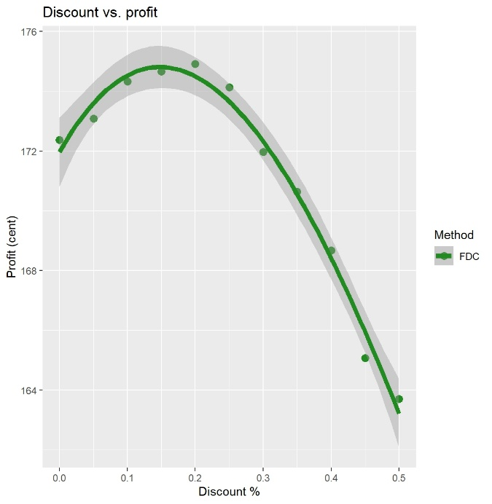 | 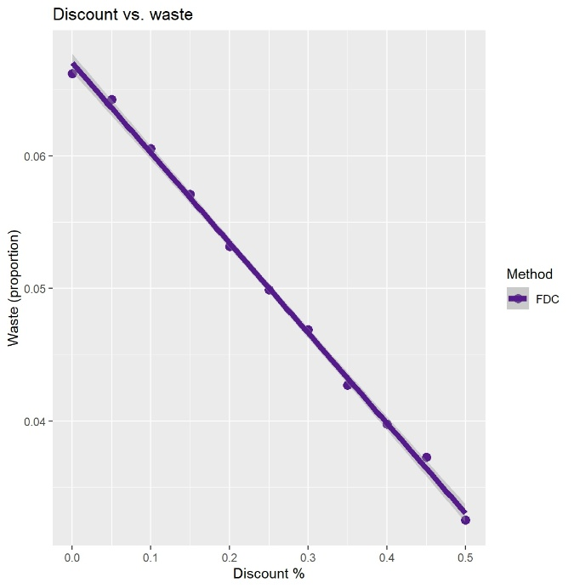

Figure 1. Fixed Discount Control (FDC). (A) Profit increases between 0-20% discount on product’s price, then declines. (B) Waste linearly declines as the discount magnitude increases. Each discount is measured once. Dark grey area is the standard error, number of episodes $=1$, $μ=3, M=5.$
The $z$-value (value used to control the base stock policy level), $M$, $μ$ and machine learning methods were set as variables, all other settings were kept constant. To determine which variable were most important, a one-way ANOVA was performed. The combination of sum of squares and $p$-value showed that the $z$-value ($p=1.7∙{10}^{-8},$sum of squares$=20$) was least relevant compared to $M$ ($p=2.0∙{10}^{-16},$sum of squares$=5.1∙{10}^{5}$), $μ$ ($p=2.0∙{10}^{-16},$sum of squares$=3.7∙{10}^{5}$) and the methods ($p=2.0∙{10}^{-16},$sum of squares$=180)$. Especially the lower sum of squares suggests that the $z$-value is of lower relevance and is therefore not looked further into during the analyses. Hence, the subsequent analyses collapse the $z$-value into the variables of interest. There are no significant interactions between variables.
All machine learning models show a similar negative exponential decline in waste as profit increases (Figure 2A). These data come about by measuring profit while varying the maximum shelf life ($M$) and with that, inventory state space. The decline suggests that wasting less products due to old age improves the profit directly when the optimal discount is chosen, confirming that same assumption. The DP models’ computing times increase when both the shelf life (Figure 2B) and inventory state space (Figure 2C) increase. Conversely, TD remained relatively invariant as state spaces expand. Overall, the DP models incurred a significantly higher computational burden than the TD models, while not performing better than the FDC.

(A) | (B) | (C)
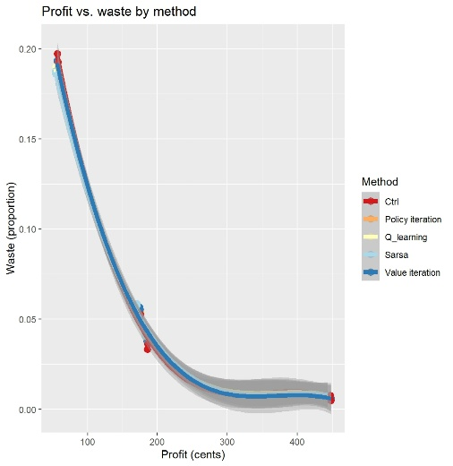 | 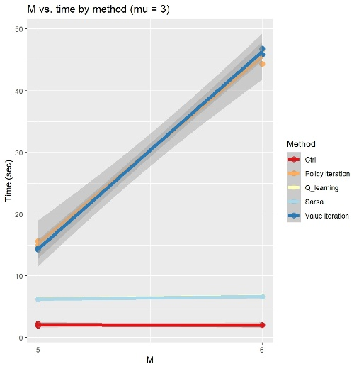 | 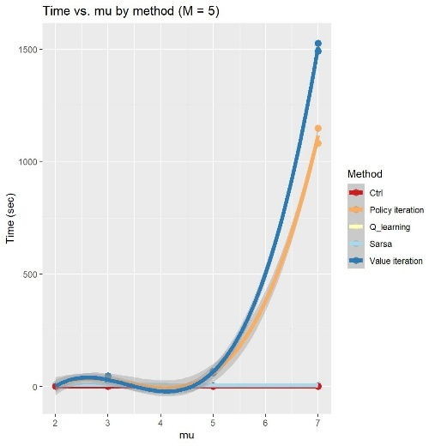
Figure 2. Overall trends between profit, waste and state space. (A) All functions show a similar decline in waste when profit improves. (B) Computing time increases for the DP models when the shelf life increases. (C) There is a near-exponential trend between computing time and increasing inventory size for the DP models. Note; $z$-values were not standardized while computing these graphs. (A) and (C) were modelled with a polynomial curve at a third degree, (B) is a linear model. Due to this polynomiality, (C) has a lower extreme below 0, which is an unrealistic value as time cannot assume a negative value during computation.
Hence, a Tukey’s Honest Significant Difference post hoc analysis was performed. This statistical test assumes equal group variances, and for most instances that is indeed true. The differences between FDC and the DP models are insignificant (they share the same letter in the same conditions), and despite a statistical difference showing between the FDC and TD models (the same letter is not shared), the TD models retrieve a lower profit (Figure 3). Statistically, the two DP models are indifferent, similar to the two TD models, when evaluating their performance on profit. TD has a statistical lower waste production than the FDC in lower inventory state space, though this advantage is lost when the number of inventoriable items increase (Figure 4). DP does not show a significant difference with the FDC in any combination of parameters, and TD overall produces more waste. Thus, these machine learning methods are also not an improvement over FDC when considering waste reduction.
Lastly, evaluating which model is best requires computational burden evaluation as well. The trend seen in Figure 2B is also statistically relevant. While in low inventory state space the TD models are take a few more seconds to compute than the DP models, in higher state space the TD models are overshadowed by the computational needs of DP (Figure 5). Implementing TD in practice may therefore be more favourable as computing the models takes less recourses and could be used earlier than DP.

Discussion
Across the parameter range tested, none of the modelled approaches produced a statistically or practically meaningful improvement over the fixed discount approach. Dynamic Programming (DP) has no statistical improvement over Fixed Discount Control (FDC) on both profit and waste. Temporal Difference (TD) achieved a significantly lower profit than FDC while only waste performance depends on demand rate, being better at low $μ$ and worse at a higher value of $μ$. These findings are at first sight a contradiction to the findings in the paper that motivated this study of (Haijema et al., 2026). However, the restriction that this paper only includes a one-day discount corresponds to the paper’s D1 policy, which consistently yielded smaller profit gains. The finding that DP could not outperform FDC is therefore consistent with literature.

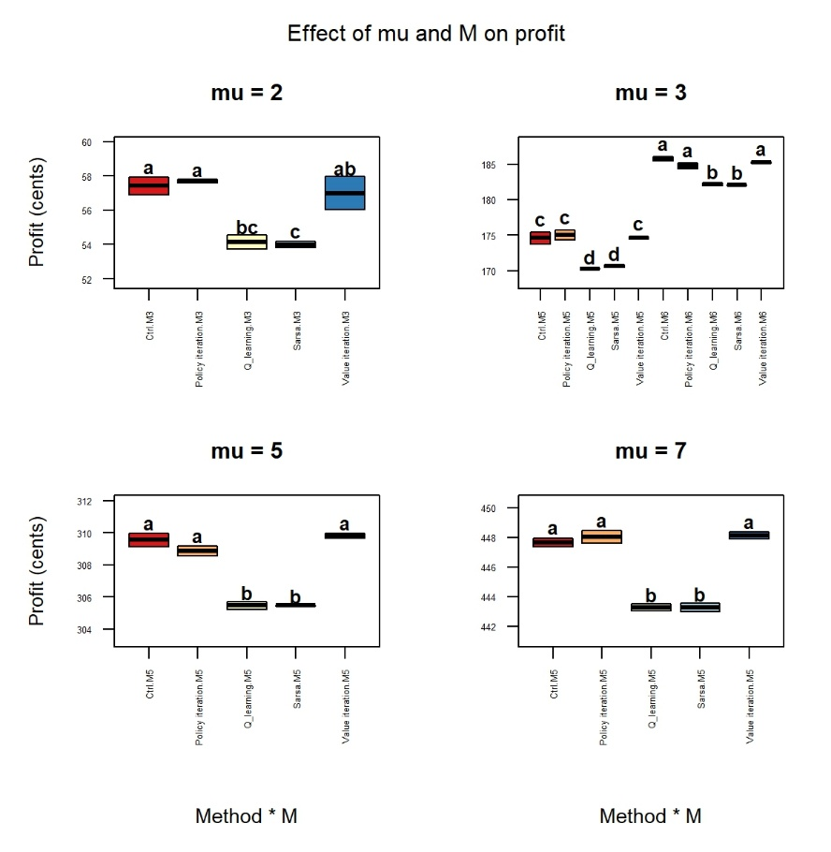
Figure 3. Changes in profit in increasing inventory state space. Significance between conditions is indicated with letters; similar letters symbolise insignificance. Double letters should be interpreted as insignificant with another condition if that other condition also contains any of these letters. Otherwise, there is a significant difference between the conditions. Each consecutive plot shows an expanded inventory space and with that also a higher profit.

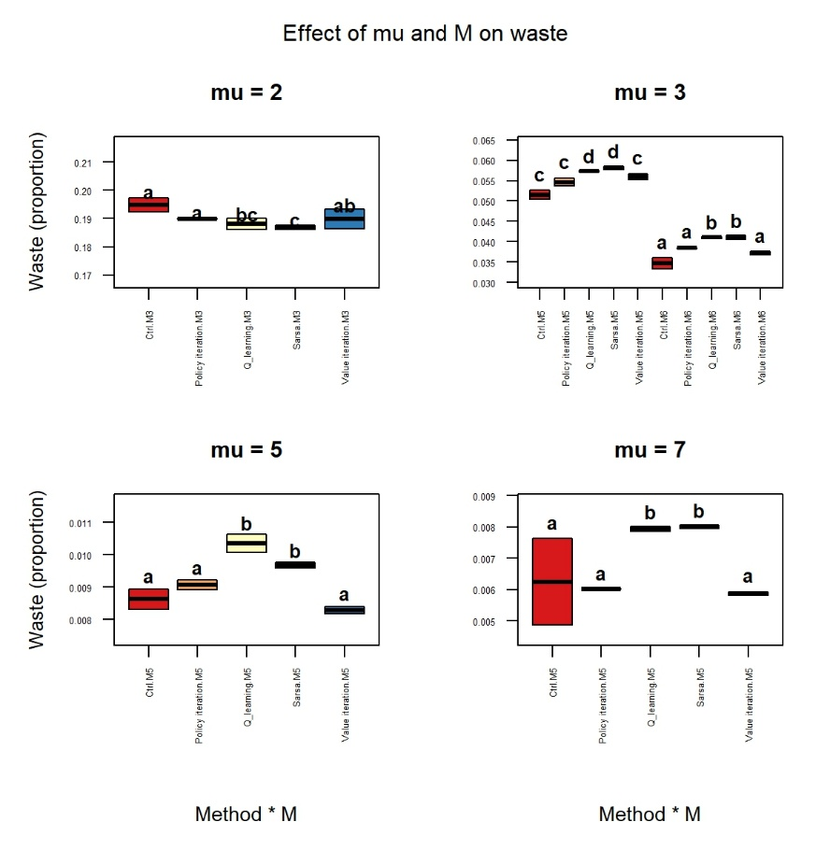
Figure 4. Changes in waste during inventory state space expansion. Significance between conditions is indicated with letters; similar letters symbolise insignificance. Double letters should be interpreted as insignificant with another condition if that other condition also contains any of these letters. Otherwise, there is a significant difference between the conditions. Each consecutive plot shows an expanded inventory space and with that also a lower waste.
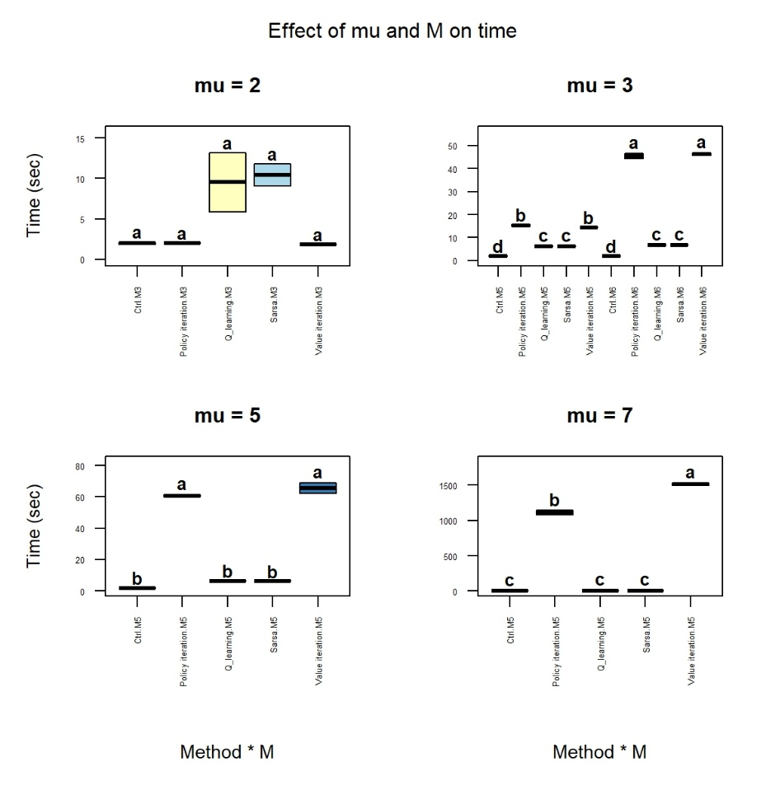
Figure 5. Changes in model computation time with increasing inventory state space. Increasing inventory space results in exponential longer computation time for DP, while reinforcement learning is overall as quick as the FDC. Significance between conditions is indicated with letters; similar letters symbolise insignificance. Double letters should be interpreted as insignificant with another condition if that other condition also contains any of these letters. Otherwise, there is a significant difference between the conditions. Each consecutive plot shows an expanded inventory space.

The consumer behaviour model oversimplifies how customers respond to discounts. The environment treats every customer as a LEFO buyer. Once a discount is applied, the amount of FEFO buyers is proportional to the amount of items that is given a discount. In the paper of (Haijema et al., 2026) the model instead introduces a sensitivity parameter, governing what fraction of LEFO customers respond to the price reduction. The absence of such parameter in our model means that discount responsiveness is uniform across all LEFO customers, which is unlikely to hold in practice.
Discount-induced demand is limited at the regular demand level, excluding new customers that are only attracted to discounted products. Demand attracted by a discount can never exceed the regular daily demand for a product in this model, since the discount can only reallocate the existing demand towards FEFO stock. However, in real world markets a sufficiently high discount could attract customers that would otherwise have not bought this product. The absence of a price-elasticity parameter such as the one in (Haijema et al., 2026) imposes a structural ceiling on the profit and waste reduction any discounting policy can achieve.
TD’s contribution lies in computational efficiency rather than policy quality. Although TD did not outperform FDC, it approached its profit and waste metrics closely and could possibly prove its usefulness in more challenging environments where DP run times would grow beyond the available resources. These findings are consistent with (Yavuz & Kaya, 2024), who reported that Deep Q-learning and Soft Actor Critic approaches reached ~95% of DP’s reward while requiring substantially less computation as the state space grows. This indicates that TD is the more practical choice with a policy that was both nearly as optimal as DP, and significantly faster.
The strength of this study is the direct comparison method of an exact DP approach against model free approximated approaches, SARSA and Q-learning, while comparing this to a practical baseline (FDC) under identical environment assumptions. Furthermore, isolated computation time as the deciding factor between DP and TD once their policy quality is shown to be statistically equivalent. The biggest weakness of this study is the single day discount restriction, the uniform LEFO response assumption and the extra demand mechanism. Each of these constrains the profit and waste improvements achievable in any method and could have shown the real strengths of TD performance over the FDC. Additionally, only ten steps were used to reach an initial state for the models to be evaluated from. Because the shelf life ranges between three and five days, this warm-up period may have been too short to reach an unbiased state of initialisation. Hence, future research should extend the initialisation of the models with 100 or more steps.
Another limitation is the manual hyperparameter tuning and the small amounts of seeds that were tested. A more exhaustive or automated search might have narrowed the gap between TD and DP.
Three extensions follow directly from the limitations above. First, extending the action space to two simultaneous discount levels. Second, introducing a sensitivity parameter governing what fraction LEFO customers respond to discount level would test whether the assumption of a uniform discount responsiveness is itself responsible for the limited gains observed here. Third introducing a price-elasticity term that generates demand proportional to the discount level, independent of the regular demand level, would test if absence of new discount-attracted customers is responsible for the limited profit ceiling observed in this study. All three extensions can be implemented in the existing environment without modifying the Environment class, allowing to subsequently study the separate effects.

Conclusion
To answer the main research question; " What are the profit and waste benefits if perishable inventory is dynamically priced, compared to a fixed discount?", within the scope of this study, there are no benefits in dynamically pricing products. Neither DP nor TD produced statistical or practically meaningful improvements over FDC in profit or waste. Secondly, to answer the first sub question; “Does any model produce a statistically and practically meaningful improvement in profit and waste reduction over FDC?”, DP showed no statistically significant improvement over FDC, TD performed significantly worse on profit, with its waste advantage reversing from a significant advantage to a significant disadvantage at large state spaces. Lastly, to answer the second sub-question; “Among models that derive comparable policies, which is preferable once computational time is taken into account?”, while underperforming slightly, TD proved to be computationally more efficient, making it a contender for more challenging environments.

Statement use of Artificial Intelligence
Artificial intelligence (AI) was used to optimize code, bug fixes and improve text. For instance, AI was utilised to improve a basic .R script’s figure code to formalize its style and make the figure more attractive. No AI generated content was pasted directly in this report. All AI-assisted output was critically reviewed and checked against literature or gathered results.

Data Repository
All code can be found at https://github.com/jochemwi/Dynamic-Pricing.git. To create the exact figures and data used in this paper the code should be run on a local system as the data is too large to post into Git. The README.md gives full instructions for the models. All data used is synthetically generated within the scripts.

References
Bellman, R. (1966). Dynamic Programming. Science, 153(3731), 34–37. https://doi.org/10.1126/science.153.3731.34
Haijema, R., Duijvestijn, L., Akkerman, R., & Cruijssen, F. (2026). Dynamic expiration date-based discounting of fresh food products. International Journal of Production Economics, 292, 109824. https://doi.org/10.1016/j.ijpe.2025.109824
Kok, M. G., Guo, X., Soethoudt, J. M., & Vollebregt, H. M. (2026). Food loss and waste in the primary production in the Netherlands and its environmental impact and nutritional losses. Environmental Challenges, 24, 101530. https://doi.org/10.1016/j.envc.2026.101530
Loss, E. R. (2024, December 16). Food surplus management in retail: Global perspective. ECR Retail Loss. https://ecrloss.com/research-paper/food-surplus-management-in-retailing/
Scholz, K., Eriksson, M., & Strid, I. (2015). Carbon footprint of supermarket food waste. Resources, Conservation and Recycling, 94, 56–65. https://doi.org/10.1016/j.resconrec.2014.11.016
Tsiros, M., & Heilman, C. M. (2005). The Effect of Expiration Dates and Perceived Risk on Purchasing Behavior in Grocery Store Perishable Categories. Journal of Marketing, 69(2), 114–129. https://doi.org/10.1509/jmkg.69.2.114.60762
Wang, Y., Zhu, X., & Wu, Z. (2025). A tutorial review of policy iteration methods in reinforcement learning for nonlinear optimal control. Digital Chemical Engineering, 15, 100231. https://doi.org/10.1016/j.dche.2025.100231
Yavuz, T., & Kaya, O. (2024). Deep reinforcement learning algorithms for dynamic pricing and inventory management of perishable products. Applied Soft Computing, 163, 111864. https://doi.org/10.1016/j.asoc.2024.111864

