Title:
Applying Dynamic Programming and Reinforcement Learning in Dynamic Pricing of Products to Improve Profit and Reduce Product Waste.

Abstract
Customers prefer fresher products over older products. As a result, daily demand is often met without selling products close to their expiratory age, and these products are wasted. Clerks may set a fixed discount for the oldest products to entice customers into buying these instead of the fresher alternative. This improves overall profit and reduce waste. However, perhaps an even more efficient method could be applied. By dynamically setting the discount each day uniquely for that day’s inventory state, a more adequate discount could be applied. With Dynamic Programming (DP) and Temporal Difference (TD), policies are derived from a modelled reality where the best action is set out for each possible inventory state. In this research, Value Iteration (VI) and Iterative Policy Evaluation (IPE) with Policy Improvement (PI) are used, as well as Sarsa and Q-learning. The analyses show an insignificant improvement in waste reduction and profit gain from all methods. Hence, in current setting DP and TD have not improved the status quo. Future research could model the consumer’s behaviour more accurately, by including environmentally conscious behaviour into the reward function, or by reducing the influence the demand for old products has on the total fresh alternative demand.

Introduction
Products close to the expiratory age are less attractive to customers than fresher units. This preference is called Last Expiratory First Out (LEFO), which is the opposite of First Expiratory First Out (FEFO). Because of LEFO behaviour, stock that is left-over due to a lower daily demand than total inventory, is eventually thrown out. Stimulating FEFO facilitates less waste and would ultimately improve profit that way. By reducing a product’s price, customers that would otherwise choose the fresher product could decide on the older alternative. For example, because they would use the product on the day itself for a culinary experience already. The disadvantage however, is that the daily demand could be partially fulfilled with the discounted products, and in turn less fresh products are sold for the regular price.
The balance between the discount to give and number of items to set a discount for has to be established. The easiest (both practically and computationally) way to do so is by placing a fixed discount on all products when they reach their day of expiration. Alternatively, the discount could depend on the day’s inventory state. If there the majority of products are old, the discount should not be excessively high for instance, because most old products would be bought that day anyway due to the daily demand. In contrast, when there are more fresh than older units, perhaps a higher profit is justified.
This inventory state dependent discount decision process is perfect for machine learning models. More specifically, Dynamic Programming (DP) and Temporal Difference (TD) model a reward function that mimics consumer’s behaviour in search for an optimal policy. The difference is that DP prepares a full probability matrix for what the next inventory state could be given today’s action and inventory state, whereas TD simply gathers data and selects the best decision through experience.
The main research question of this study is:
What are the profit and waste benefits if expiratory products are dynamically priced, compared to a fixed discount?
To answer this question three approaches are evaluated and directly compared: FDC, DP and TD. This comparison raises two sub-questions:
- Does any model produce a statistically and practically meaningful improvement in profit and waste reduction over FDC?
- Among models that derive comparable policies, which is preferable once computational time is taken into account?

Methods

The Environment
Both TD and DP require a reward / profit function. This equation includes all metrics to reward the model’s actions with. Positive scores reward the model for their chosen action, and negative scores vice versa. The product’s inventory state, S, contains of a number of days a product could be of age, M. Only when the product reaches the oldest age, the product is considered adequate for a discount. The maximum number of items per day depends on the base stock policy level, $BSPlvl,$ i.e. the highest number of items inventoriable. The possible number of inventory states is therefore $M^{BSPlvl}$. The probabilities of a daily demand depend on $μ$. The maximum probability was set to three times $μ$, where the daily demand probabilities follow a Poisson distribution, and all probabilities for a demand higher than the maximum daily demand were summed. The actions are defined as discount levels that increment with 5%, between 0-50%.
For each action state combination, each action was multiplied by the discount increment, and the difference between the base stock level and that particular inventory space was ordered as new stock, or nothing if that value was negative. That way, the number of items to order could never pass the base stock policy. The FEFO demand was calculated by taking the smallest value; either all of the oldest products in the current inventory, or the discount multiplied by the daily demand. Successively, the FEFO demand could never be higher than the number of oldest items. What is more, with an elevated discount, statistically a higher FEFO demand would come about. The LEFO demand is what remains of the original demand when subtracting the FEFO demand. The items with the youngest age are chosen first, and the items of the later age categories are chosen until the full daily demand is met. The metric of customer dissatisfaction when the demand is higher than the summed inventory is ignored in this model.
The items left in the oldest age category after meeting the daily demand are considered as waste. The remaining items roll over to the next age class, and the newly ordered items are added. That way, a new inventory state is created, $s'$. This process is defined as a step. Performing a number of these steps is called an episode. Finally, the profit function includes the order costs, $c$, the units to order, $Order$, the discount, $aa$, units sold with a discount, $DeltaF$, units sold without a discount, $DeltaL$ and purchase price, $r$, which composes the following equation:
$$Profit= r∙DeltaL+r∙\left(1-aa\right)∙DeltaF-c∙Order$$

Probability and Reward Matrix
The probability and reward matrix were computed by finding the next state for each state action demand combination and calculating the corresponding direct profit. The probability matrix contains the probabilities for every next state, $S'$, given the action taken in a particular inventory state; $P\left(A, S, S^{'}\right)$. Artificially, each possible state was set as the initial inventory, after which one step was performed per action per demand. The probability for that particular demand that leads to a next state given the action and current state taken, were the probabilities added to the probability matrix. Hence, the probabilities for each action state combination always sum up to 1. The reward matrix, $R$, was computed with the structure $R(A,S)$, and received for each action state combination the product of the next state probabilities and profit function given the current state and action taken.

Fixed Discount Control
Running the regular algorithm for an episode without using the reward and probability matrices gives an estimate of the average profit and waste per that action. The Fixed Discount Control (FDC) is chosen by maximizing the profit through iteratively running episodes over discounts increments by 5% between 0-50%. The initial inventory state is empty, and after ten steps the profits are included in the statistics. The waste associated with this profit is not actively minimized, i.e. the optimal discount is not chosen by lowest waste. The reason for this, is that the higher a discount is given, more customers would assume FEFO behaviour, limiting the profit at some point. The main goal of supermarkets remains increasing profit, waste reduction is a by-product that is modelled in this solution, but should not dominate the outcome.

Dynamic Programming

Iterative Policy Evaluation and Policy Improvement
In this paper, the DP models Value Iteration (VI), and Iterative Policy Evaluation (IPE) with Policy Improvement (PI) are used, as well as the TD models Sarsa and Q-learning. IPE takes policy $π$, freezes it (the policy does not change), and calculates the state value vector $V_{π}(s)$ according to Bellman’s equation until convergence. This state value vector is then frozen while the previous policy is thawed (the policy can change again). Then, $q$-values are calculated in the PI algorithm, by computing each possible action, $a$, and state, $s$, in Bellman’s equation using the beforementioned frozen state value vector, to evaluate whether a better policy exists. If that is indeed true, the policy is frozen once more, the state value vector is thawed, and the algorithm is run again until an optimal policy is found.

Value Iteration
In VI, all possible actions for each state are computed into Bellman’s equation, where the best state value is saved in the state value vector. The policy the led to that value is saved in an updating policy. Only when the state value vector converges, the algorithm ends, and the remaining policy is the optimal policy. These models are chosen, as they are considered the optimal solution for the presented problem; a reward function is known as well as the probabilities of customers buying products. These algorithms model the probability matrix, $P$, of a next inventory state, $s'$, given the current action, $a$, and current inventory state, $s$. The model takes these probabilities into account when calculating the profit and waste, and that makes finding an exact solution with DP reliable.

Temporal Difference
Whereas IPE/PI and VI require the full probability matrix, P and reward matrix R, to compute an exact solution, Temporal Difference (TD) algorithms learns a policy (π) directly from the environment without ever constructing P or R. This makes RL model-free. It does not require the transition matrix to be known or computed in advance. As a consequence, TD does not guarantee convergence to the optimal policy the way that DP does, but it scales better as the number of inventory states $M^{BSPlvl}$ grows. Two approaches that were applied in this report: Q-learning and SARSA.
Reinforcement learning cannot outperform DP in terms of reward performance. However, since RL is model free it can be applied to different types of problems and is less sensitive to the exponential growth of state spaces, making it a more computationally efficient alternative as the inventory space grows.

Q-learning
Q-learning is an off-policy TD control algorithm, updating the Q(s,a) using the value of the next best available action in the next state, regardless of which action is actually selected next. Actions during training are chosen with an ε-greedy policy with a 1-ε probability to pick the greedy action and select a random value otherwise, to balance the exploration of the state-action space. The updating rule is:
$$Q(s,a) ← Q(s,a) + α[r + γ·max_a' Q(s',a') - Q(s,a)]$$

SARSA
SARSA (State-Action-Reward-State-Action) is an on-policy TD control algorithm, where Q(s, a) is updated using the value of the actual selected action (a’) under the ε-greedy. The updating rule is:
$$Q(s,a) ← Q(s,a) + α[r + γ·Q(s',a') - Q(s,a)]$$
Since SARSA’s updating rule includes exploration itself it tends to learn more conservative behaviour near costly states. Actions that lead to poor results under exploration are penalised more directly. Q learning can converge faster but may learn a policy that performs worse during exploration.

The environments
Each training run consisted out of episode where one episode simulated 36500 iterations. The model was evaluated every 5000 iterations training stopped when the average profit per period between successive evaluations was below 1% (convergence). The exploration rate ε was initialised at 1.0 and decayed by 0.998 towards an ε-min of 0.05. Before every run an empty Q-table was initialised of size (M+1)^BSPlvl.

Hyperparameter tuning
Given the time available, a manual sweep was performed over α (0.5, 0.3 and 0.1) and γ (0.8, 0.95 and 0.99), repeated across three random seeds (0, 1 and 2) per setting to account for the variance. For each combination, the average profit at convergence was recorded and the setting with the highest average profit across seeds was selected as the final configuration for the algorithm.

Results
The hyperparameter tuning resulted in an α of 0.1 and a γ of 0.95 as the best overall result. Therefore, these settings were applied for the TD approaches.
First, the main algorithm was run for a singular episode on $μ=3, M=5$, to establish the FDC (Figure 1). The profit increases from 0- until 20% discount, indicating that tempting FEFO customers is more favourable than not giving a discount for the oldest products. There is a linear decline in profit for the consequent discount increments. The proportion of waste linearly consistently decreases in similar fashion. Hence, the assumption that a higher reduction in waste in the discount extremes would reduce the profit is validated here, and therefore not desired.
(A) | (B)
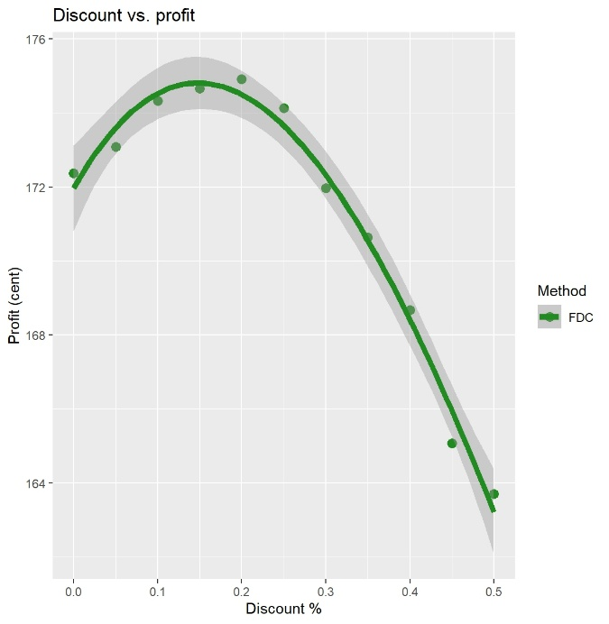 | 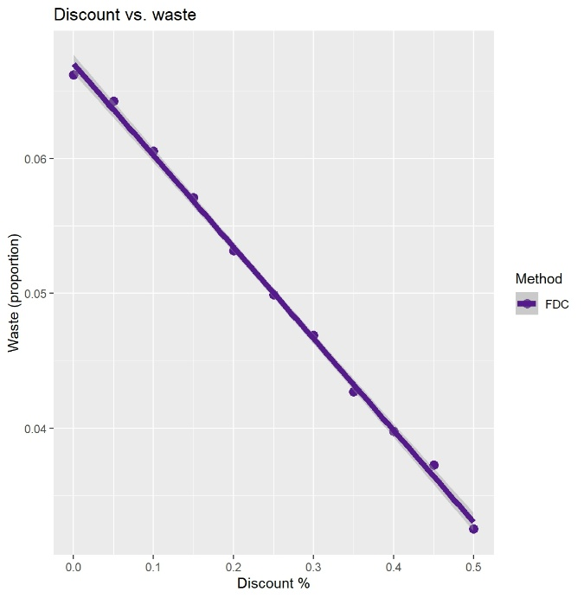

Figure 1. Fixed Discount Control (FDC). (A) Profit increases between 0-20% discount on product’s price, then declines. (B) Waste linearly declines as discount levels up. Each discount is measured once. Dark gray area is standard error, number of episodes $=1$, $μ=3, M=5.$
The $z$-value (value used to control the base stock policy level), $M$, $μ$ and machine learning methods were set as variables, all other settings were kept constant. To determine which variable were most important, a one-way ANOVA was performed. The combination of sum of squares and $p$-value showed that the $z$-value ($p=1.7∙{10}^{-8},$sum of squares$=20$) was least relevant compared to $M$ ($p=2.0∙{10}^{-16},$sum of squares$=5.1∙{10}^{5}$), $μ$ ($p=2.0∙{10}^{-16},$sum of squares$=3.7∙{10}^{-5}$) and the methods ($p=2.0∙{10}^{-16},$sum of squares$=180)$. Especially the lower sum of squares (squared distance of data to mean, indication of variance in data) suggests that the $z$-value is of lower relevance, and is therefore not looked further into during the analyses. All interactions between variables were insignificant.
All machine learning models show a similar negative exponential decline in waste as profit increases (Figure 2A). These data come about by measuring profit while differing the shelf life ($M$) and inventory state space. The decline suggests that wasting less products due to old age improves the profit directly, which supports that same assumption. The DP models’ computing times increase when both the shelf life (Figure 2B) and inventory state space (Figure 2C) increase. For the TD models, there is not a noticeable difference in computing time when the possible number of inventory states expand. Overall, the DP models have a higher computational burden than the TD models, while not performing better than the FDC at first sight.

(A) | (B) | (C)
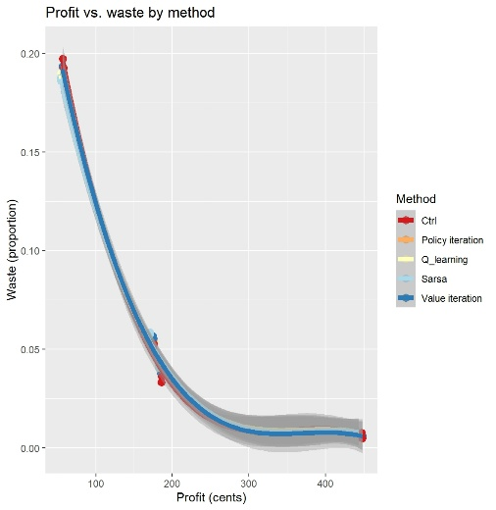 | 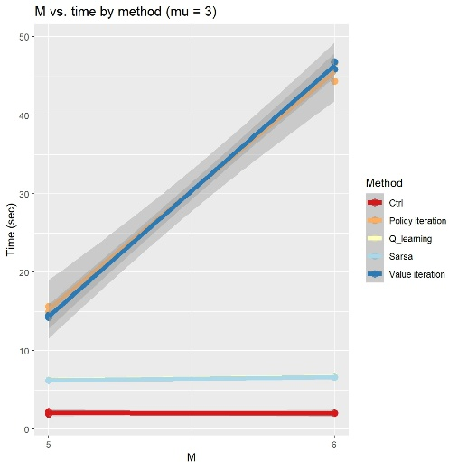 | 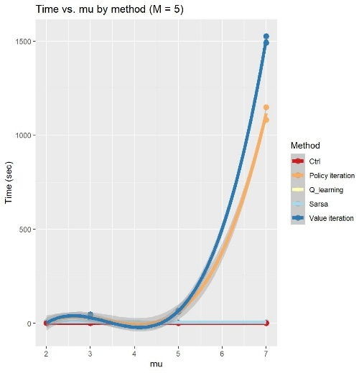
Figure 2. Overall trends between profit, waste and state space. (A) All functions show a similar decline in waste when profit improves. (B) Computing time increases for the DP models when the shelf life increases. (C) There is a near-exponential trend between computing time and increasing inventory size for the DP models. Note; $z$-values were not standardized while computing these graphs. (A) and (C) were modelled with a polynomial curve at a third degree, (B) is a linear model. Due to this polynomiality, (C) has a lower extreme below 0, which is an unrealistic value as time cannot assume a negative value during computation.
That is why a Tukey’s Honest Significant Difference post hoc analysis was performed. This analysis calculates statistical significance between conditions in the same cohort while controlling the family-wise error rate for all pairwise comparisons. The statistical test assumes equal group variances, and for most instances that is indeed true. The differences between FDC and the DP models are insignificant, and despite a statistical difference showing between the FDC and TD models, the TD models retrieve a lower profit (Figure 3). Statistically, the two DP models are indifferent, similar to the two TD models, when evaluating their performance on profit.
TD is has a statistical lower waste production than the FDC in lower inventory state space, though this advantage is lost when the number of inventoriable items increase. DP does not show a significant difference with the FDC in any combination of parameters, and TD overall produces more waste. Thus, these machine learning methods are also not an improvement over FDC when considering waste reduction.
Lastly, evaluating which model is best requires computational burden evaluation as well. The trend seen in Figure 2 is also statistically relevant. While in low inventory state space the TD models are take a few more seconds to compute than the DP models, in higher state space the TD models underscore the computational needs of DP. Implementing TD in practice may therefore be more favourable as computing the models takes less recourses and could be used earlier than DP.

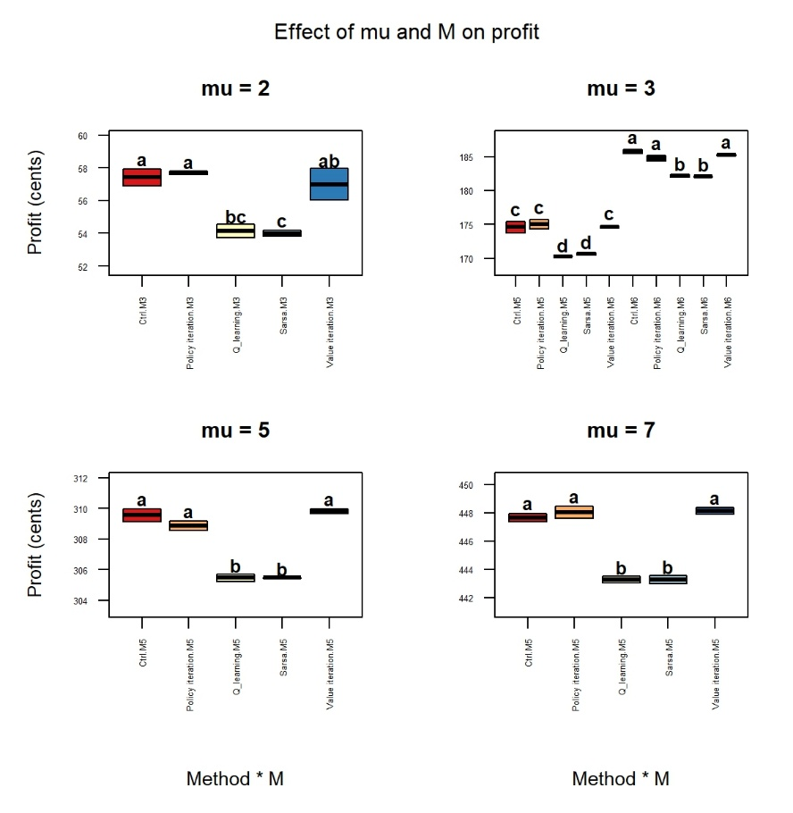
Figure 3. Changes in profit in increasing inventory state space. Significance between conditions is indicated with letters; similar letters symbolise insignificance. Double letters should be interpreted as insignificant with another condition if that other condition also contains any of these letters. Otherwise, there is a significant difference between the conditions. Each consecutive plot shows an expanded inventory space and with that also a higher profit.

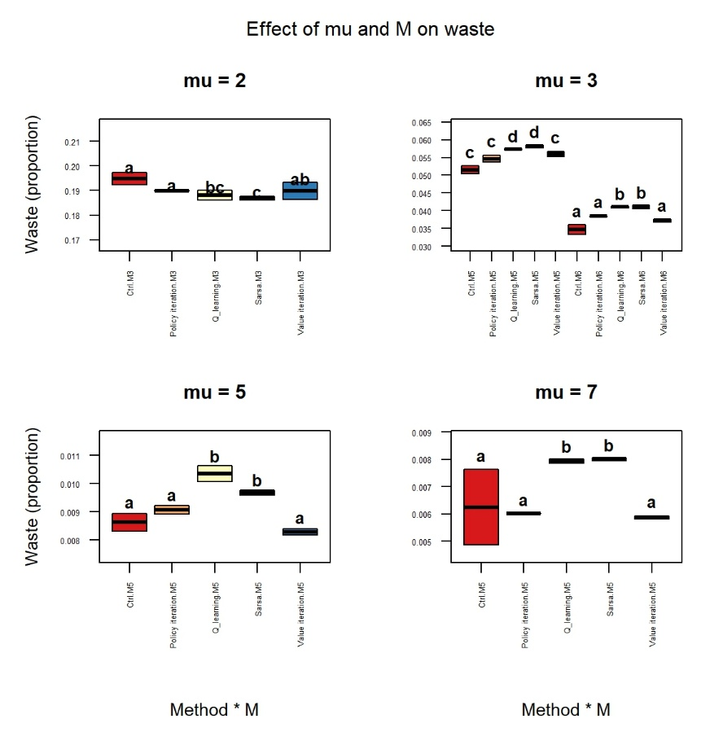
Figure 4. Changes in waste during inventory state space expansion. Significance between conditions is indicated with letters; similar letters symbolise insignificance. Double letters should be interpreted as insignificant with another condition if that other condition also contains any of these letters. Otherwise, there is a significant difference between the conditions. Each consecutive plot shows an expanded inventory space and with that also a lower waste.
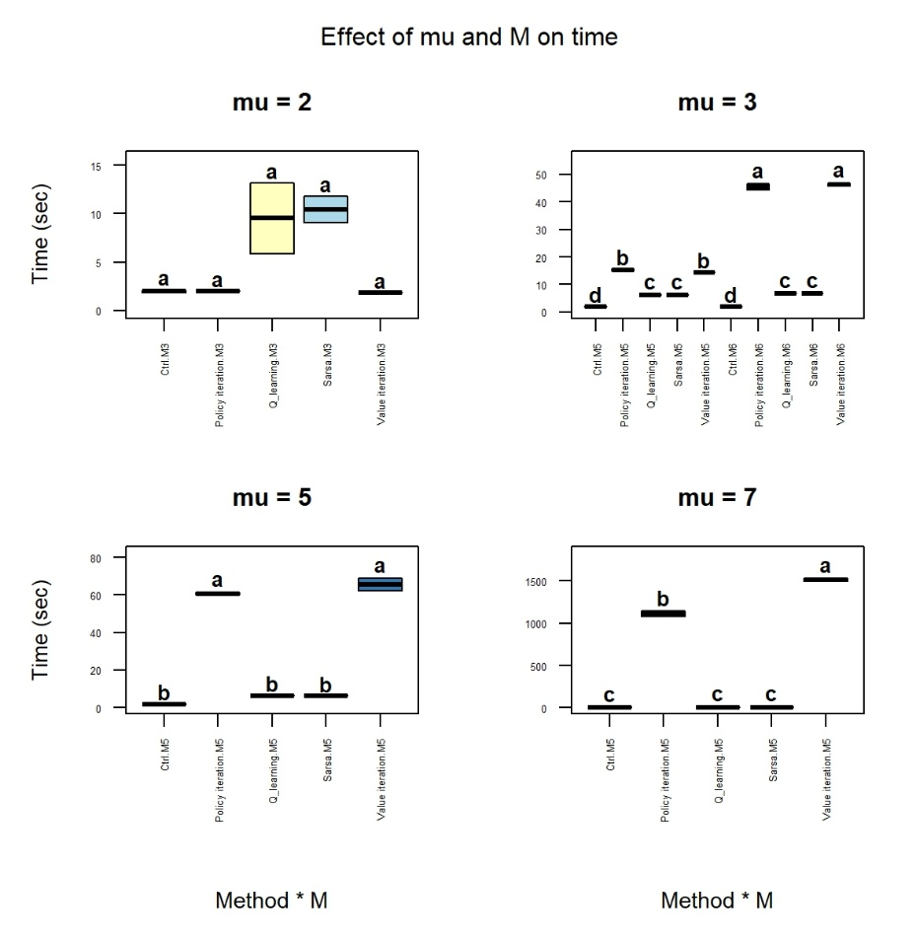
Figure 5. Changes in model computation time with increasing inventory state space. Increasing inventory space results in exponential longer computation time for DP, while reinforcement learning is overall as quick as the FDC. Significance between conditions is indicated with letters; similar letters symbolise insignificance. Double letters should be interpreted as insignificant with another condition if that other condition also contains any of these letters. Otherwise, there is a significant difference between the conditions. Each consecutive plot shows an expanded inventory space.
Why

Discussion
Across the parameter range tested, none of the modelled approaches produced a statistically or practically meaningful improvement over the fixed discount approach. Dynamic Programming (DP) has no statistical improvement over Fixed Discount Control (FDC) on both profit and waste. Reinforcement learning (RL) achieved a significantly lower profit than FDC while only matching waste reduction at small inventory states. These findings are a contradiction to the findings in the paper that motivated this study of Haijema et al.
The paper of Haijema et al. formulated the discounting decision around two discount rates x1 and x2, applied to products expiring at the end of the current day and the following day respectively. In contrast, this research applied a single day discount. This restriction correspondents to Haijema’s D1 policy, which consistently yielded smaller profit gains. The finding that DP could not outperform FDC is therefore consistent with literature.
The consumer behaviour model oversimplifies how customers respond to discounts. The environment treats every customer a LEFO buyer. Once a discount is applied, the amount FEFO buyers is proportional to the amount of discount given. In the paper of Haijema et al. the model instead introduces a sensitivity parameter, governing what fraction of LEFO customers respond to a given discount level. The absence of such parameter in the model provided in the paper, means that discount responsiveness is uniform across all LEFO customers, which is unlikely to hold in practice.
Discount-induced demand is capped at the regular demand level, excluding new customers that are only attracted to discounted products. In this model demand attracted by a discount can never exceed the regular daily demand for a product, since the discount can only reallocate the existing demand towards FEFO stock. However, in real world markets a sufficiently high discount could attract customers that would otherwise have not bought this product. The absence of an price-elasticity parameter such as the one in Hajima et al imposes a structural ceiling on the profit and waste reduction any discounting policy can achieve.
TD’s contribution lies in computational efficiency rather than policy quality. Although TD did not outperform FDC, it approached the values closely and could possibly proof its usefulness in more challenging environments where DP run times would grow exponentially and FDC approaches could potentially be outperformed. These findings are consistent with Yavuz and Kaya (2024), who reported that Deep Q-learning and Soft Actor Critic approaches reached ~95-97% of DP’s reward while requiring substantially less computation as the state space grows. This indicates that TD is the more practical choice with a policy that was almost as good as DP, but much faster.
The strength of this study is the direct comparison method of an exact DP approach against model free approximated approaches, SARSA and Q-learning, while comparing this to a practical baseline (FDC) under identical environment assumptions, which isolated computation time as the deciding factor between DP and TD once their policy quality is shown to be statistically equivalent. The biggest weakness of this study was the single day discount restriction, the uniform LEFO response assumption and the extra demand mechanism, each of these constrains the profit and waste improvements achievable in any method and could have shown the real strengths of TD performance over the FDC. Another limitation was the manual hyperparameter tuning and the small amounts of seeds that was tested. A more exhaustive or automative search might have narrowed the gap between TD and DP.
Three extensions follow directly from the limitations above. First, extending the action space to two simultaneous discount levels. Second, introducing a sensitivity parameter governing what fraction LEFO customers respond to discount level would test whether the assumption of a uniform discount responsiveness is itself responsible for the limited gains observed here. Third introducing a price-elasticity term that generates demand proportional to the discount level, independent of the regular demand level, would test if absence of new discount-attracted customers is responsible for the limited profit ceiling observed in this study. All three extensions can be implemented in the existing environment without modifying the Environment class, allowing to subsequently study the separate effects.

Conclusion
To answer the main research question, "What are the profit and waste benefits if expiratory products are dynamically priced, compared to a fixed discount?", within the scope of this study, there are no benefits in dynamically pricing products. Neither DP or TD produced statically practically meaningful improvements over FDC in profit or waste
To answer the first sub question, “Does any model produce a statistically and practically meaningful improvement in profit and waste reduction over FDC?” DP showed no statistically significant improvement over FDC on either matric and TD performed significantly worse on profit, with its waste advantahe limited to small inventory state spaces.
To answer the second sub-question, “Among models that derive comparable policies, which is preferable once computational time is taken into account?” While underperforming a little, TD proved to be computationally more efficient.

Statement use of Artificial Intelligence

Data Repository

References

