**Investigating Osmotic Potential in Potato Cell Sap**

Joakim D. Hertzberg

The International Section, Kungsholmens Gymnasium/ Stockholms Musikgymnasium

BIOBIO02: Biology 2

Ms. Felicia Dinnètz

2024-01-25

# Investigating Osmotic Potential in Potato Cell Sap

## 1.1: Background

This lab is going to investigate the chemiosmosis which takes place between a solution of sucrose and the cells of a potato. This is to find what concentration of water is representative of that inside the cells.

## 1.2: Theory

Chemiosmosis acts to even out the concentrations of particles on two sides of a *semi-permeable membrane* (see *1.2.5: Semi-permeable membranes* ). In chemiosmosis, if water is present, it is nearly always the water that moves to even out the concentrations.

### 1.2.1: Hypertonic Solutions

A hypertonic solution is a solution which has a higher concentration of a non-permeating solute, causing the permeating solvent (in this case water) to move into it through the gradient.

### 1.2.2: Hypotonic Solutions

Hypotonic solutions are the opposite of hypertonic solutions. I.e., a solution which has a lower concentration of the non-permeating solute, causing the permeating solvent (water) to move through the gradient, to the other solution as to even out the gradient.

### 1.2.3: Isotonic Solutions

All solutions affected by chemiosmosis eventually reach *isotonicity*, i.e., become isotonic solutions. An isotonic solution is a solution in which the concentration of non-permeating solute is equal on both sides of the gradient. The net movement of the permeating solvent is then 0.

### 1.2.4: Osmotic Potential (also osmotic pressure)

The osmotic potential represents the pressure which osmosis exerts on a gradient, represented as units of pressure, Pa. The concentration with a higher concentration of non-permeating solute then has a lower osmotic potential.

### 1.2.5: Semi-permeable Membranes

A semi-permeable membrane is a membrane which only allows certain particles to *permeate*, i.e., pass through it. An example of this is the cell wall of the potato cells.

## 1.3: Aim

The aim of this lab is to deduce the osmotic potential of potato cell sap, and investigate the mechanism of osmosis.

## 1.4: Hypothesis

The values of weight in different concentrations will give a regression, where the point at which it intercepts the x-axis represents the concentration at which isotonicity is achieved.

# 2: Results

## 2.1: Tables

Table 1. Final weight and percentual change in weight of different potato samples in petri dish, sorted by concentration of sucrose in the solution. All samples had an initial weight of 0.47 ± 0.01g.

|  |  |  |  |  |  |  |  |  |
| --- | --- | --- | --- | --- | --- | --- | --- | --- |
| **Concentration (*mol/dm3)*** | | Potato Sample # | | | | | | **X̅ ± σ** |
| 1 | 2 | 3 | 4 | 5 | 6 |
| **0.0** | Weight (g) | 0.59 | 0.61 | 0.58 | 0.59 | 0.59 | 0.59 | 0.59 ± 0.01 |
| Change (%) | 25.53% | 29.79% | 23.40% | 25.53% | 25.53% | 25.53% | 25.89 ± 1.91 % |
| **0.2** | Weight (g) | 0.51 | 0.52 | 0.51 | 0.51 | 0.51 | 0.5 | 0.51 ± 0.01 |
| Change (%) | 8.51% | 10.64% | 8.51% | 8.51% | 8.51% | 6.38% | 8.51 ± 1.23 % |
| **0.4** | Weight (g) | 0.43 | 0.43 | 0.45 | 0.44 | 0.46 | 0.47 | 0.45 ± 0.01 |
| Change (%) | -8.51% | -8.51% | -4.26% | -6.38% | -2.13% | 0.00% | -4.96 ± 3.17 % |
| **0.6** | Weight (g) | 0.34 | 0.4 | 0.36 | 0.36 | 0.37 | 0.36 | 0.37 ± 0.02 |
| Change (%) | -27.66% | -14.89% | -23.40% | -23.40% | -21.28% | -23.40% | -22.34 ± 3.84 % |
| **0.8** | Weight (g) | 0.3 | 0.31 | 0.3 | 0.3 | 0.3 | 0.32 | 0.31 ± 0.01 |
| Change (%) | -36.17% | -34.04% | -36.17% | -36.17% | -36.17% | -31.91% | -35.11 ± 1.63 % |
| **1.0** | Weight (g) | 0.25 | 0.27 | 0.28 | 0.27 | 0.28 | 0.24 | 0.27 ± 0.02 |
| Change (%) | -46.81% | -42.55% | -40.43% | -42.55% | -40.43% | -48.94% | -43.62 ± 3.19 % |

## 2.2: Charts & Figures

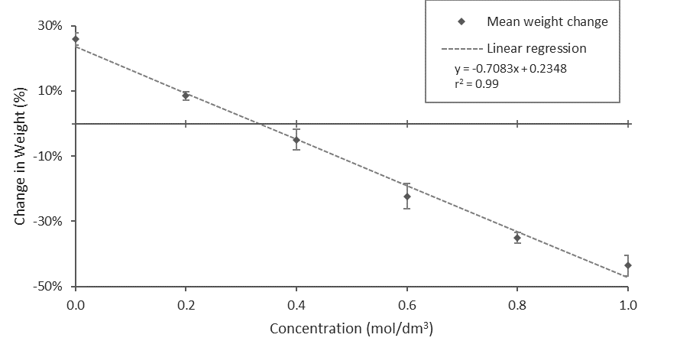

Figure 1. A scatter plot representing data points for mean percentual weight change at different concentrations of sucrose, as well as the linear regression of best fit.

# 3: Discussion & Conclusion

## 3.1: Charts, Tables & Figures

Figure 2. The relationship between concentration and osmotic pressure represented as a line (see *Tab. 2* ).

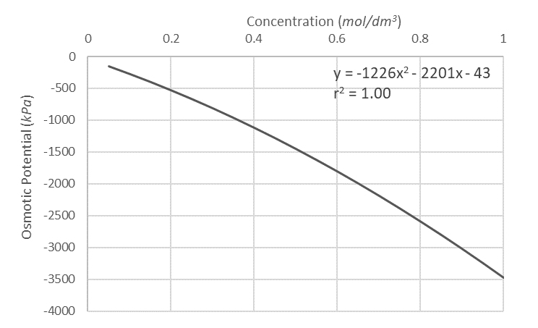

Table 2. The relationship between molarity (also called *concentration*) of the non-permeating solute and the osmotic potential, using data provided by Ms. Dinnètz.

|  |  |  |  |
| --- | --- | --- | --- |
| **Molarity (mol/dm3)** | **Osmotic potential**  **(kPa)** | **Molarity (mol/dm3)** | **Osmotic potential**  **(kPa)** |
|  |
| 0.05 | -130 | 0.55 | -1620 |  |
| 0.10 | -260 | 0.60 | -1800 |  |
| 0.15 | -410 | 0.65 | -1980 |  |
| 0.20 | -540 | 0.70 | -2180 |  |
| 0.25 | -680 | 0.75 | -2370 |  |
| 0.30 | -860 | 0.80 | -2580 |  |
| 0.35 | -970 | 0.85 | -2790 |  |
| 0.40 | -1120 | 0.90 | -3000 |  |
| 0.45 | -1280 | 0.95 | -3250 |  |
| 0.50 | -1450 | 1.00 | -3500 |  |

## 3.2: Analysis

*Fig. 1* shows a negative linear regression, implying that increasing the concentration of non-permeating solute causes the osmotic potential to decrease, as the weight change is due to a difference in osmotic potential on the two sides of the membrane. The regression has an r2-value of 0.99, taking the square root of this, we get r = -0.995, which is negative since the regression is decreasing. An r value this close to ±1 implies a strong correlation.

At 0 weight change, isotonicity is achieved, which means that the concentrations, and consequently osmotic potential, are equal as this provides a net movement of 0. This provides that following equation is satisfied:

$0= -0.7083x+0.2348$ (where $x$ is concentration)

Solving for $x$, $x=0.33$.

As the r2 value of the equation in *Fig. 2* is 1.00, and consequently r = -1.00, it can hence be deemed as accurate. Using said equation, we can find osmotic pressure by concentration, so the osmotic pressure at isotonicity can be found by plugging in $0.33$ as $x$.

$$\left\{\begin{aligned}x=0.33 \\ y= -1226x^{2} - 2201x - 43\end{aligned}\right.$$

$$y≈-903$$

(osmotic pressure cannot be greater than 0, hence the negative answer is chosen)

Since isotonicity implies that osmotic pressure is equal on both sides of the membrane, it can be concluded that the osmotic pressure inside the potato cells is also approximately $-903kPa$.

## 3.3: Conclusion

The hypothesis was: The values of weight in different concentrations will give a regression, where the point at which it intercepts the x-axis represents the concentration at which isotonicity is achieved.

The hypothesis is accepted due to the very strong correlation found between molarity of sucrose (therefore also osmotic pressure) and weight change in the potato cells. The osmotic pressure in the sucrose solution has been concluded as $\sim -903kPa$ at the isotonic molarity by regression analysis. The osmotic pressure inside the potato cells can hence be concluded as equal to this due to the implications of isotonicity.

## 3.4: Evaluation

The experiment has generally shown results with strong correlations and small deviations, however, to find the osmotic pressure more accurately, there are some elements that can be further improved upon.

Primarily, although the regression found for the provided values of osmotic potential was found as highly accurate, a mathematical function describing the relationship would have provided better accuracy.

Additionally, a higher accuracy of the sucrose solution would have allowed use of more significant figures, which would give a more accurate input into the equation for osmotic potential, consequently giving a more accurate final value.

Finally, an additional control variable of temperature could have been added, as it may affect the rate of chemiosmosis taking place.

## 3.5: Additional assignment

Following assignment was provided: *Briefly explain what would happen if you drank salt water if stranded at sea*.

The human kidneys create urine from water which is less salty than salt water. To lower the concentration of the water to be urinated, the water would have to be diluted with water already in the body. This causes you to urinate more water than was consumed, which gives a net loss in water, leading to dehydration.