Title, Lorem Ipsum Dolor Sit Amet.

Doe, John M. Doe, Jane N. (Authors)

Department, Institution

COURSE NUMBER: Course Name

Instructor Name

YYYY-MM-DD (date)

# 1: Introduction

## 1.1: Background

Lorem Ipsum Dolor Sit Amet, ipsum sit lorem.

## 1.2: Theory

### 1.2.1: Theory Item 1

Lorem Ipsum Dolor Sit Amet, ipsum sit lorem.

### 1.2.3: Theory Item 3

Lorem Ipsum Dolor Sit Amet, sit amet lorem ipsum

## 1.3: Aim

Lorem Ipsum Dolor Sit Amet, ipsum sit lorem.

## 1.4: Hypothesis

Lorem Ipsum Dolor Sit Amet, ipsum sit lorem.

# 2: Method

## 2.1: Materials

1. Number 1

2. Number 2

3. Number 3

4. Number 4

5. Number 5

## 2.2: Chemicals

1. Number 1

2. Number 2

3. Number 3

4. Number 4

5. Number 5

## 2.3: Variables

### 2.3.1: Independent Variables.

Lorem Ipsum Dolor Sit Amet, sit amet lorem ipsum

### 2.3.2: Dependent Variables.

Lorem Ipsum Dolor Sit Amet, sit amet lorem ipsum

### 2.3.3: Control Variables

Lorem Ipsum Dolor Sit Amet, sit amet lorem ipsum

## 2.4: Methodology

Lorem Ipsum Dolor Sit Amet, sit amet lorem ipsum

# 3: Results

## 3.1: Tables

Table 1. Scores of grade school children of different demographics, with and without homework (EXAMPLE)

|  |  |  |  |  |  |  |  |
| --- | --- | --- | --- | --- | --- | --- | --- |
| Grade | Girls | | | Boys | | | |
| With | Without | | With | | Without | |
| Wave 1 | | | | | | | |
| 3 |  |  | |  | |  | |
| 4 |  |  | |  | |  | |
| 5 |  |  | |  | |  | |
| Total: |  |  | |  | |  | |
| Wave 2 | | | | | | | |
| 3 |  | |  | |  | |  |
| 4 |  | |  | |  | |  |
| 5 |  | |  | |  | |  |
| Total: |  | |  | |  | |  |

## 3.2: Charts & Figures

Chart 1. Scores of grade school children of different demographics, with and without homework (EXAMPLE)

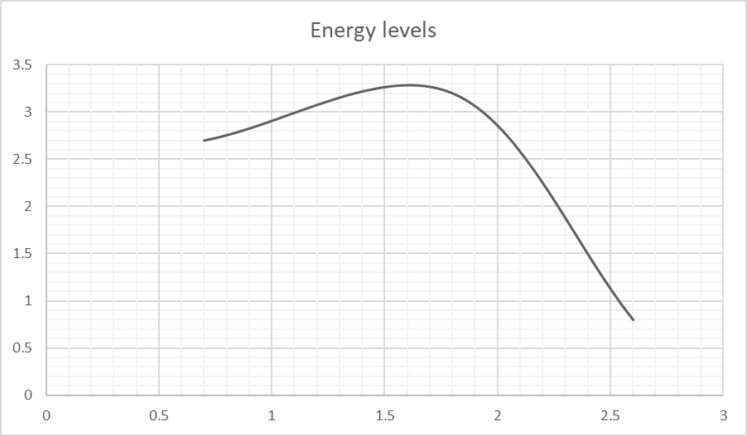

# 4: Discussion & Conclusion

## 4.1: Analysis

Lorem Ipsum Dolor Sit Amet, sit amet lorem ipsum

## 4.2: Conclusion

Lorem Ipsum Dolor Sit Amet, sit amet lorem ipsum

## 4.3: Evaluation

Lorem Ipsum Dolor Sit Amet, sit amet lorem ipsum

# 5: References