

**UNCLASSIFIED**

ActivClient 6.2 Air Force Release  
V1.2.0.0

***User Guide for the Air Force Home Use Middleware Package***

Deliverable No.   
OE-11-48-028

**Prepared for the U.S. Air Force**

**Public Key Infrastructure**

**System Program Office**

**HANDLING AND DESTRUCTION NOTICE:** Handle in compliance with distribution statement and destroy by any method that prevents disclosure of contents or reconstruction of the document.

**DISTRIBUTION C:** Distribution authorized to U.S. Government agencies and their contractors only for Administrative and Operational Use, 8 February 2010. Other requests for this document shall be referred to ESC\HNCDP, ([210] 925-2521 or DSN 945-2521; FAX [210] 925-2644 or DSN 945-2644).

September 2011

**Implementation, Training, and Technical Support of the**

**Department of Defense Public Key Infrastructure (PKI)**

***AIR FORCE***

**PUBLIC KEY INFRASTRUCTURE**

**SYSTEM PROGRAM OFFICE**

**UNCLASSIFIED**

Contents

CHAPTER 1 Introduction 1

1.1 Purpose 1

1.2 Terms of Use 1

1.3 Risks 1

1.4 Disclaimer of Liability 1

CHAPTER 2 Middleware and Reader Installation Instructions 2

2.1 Required Items 2

2.1.1 System requirements: 2

2.2 Existing Middleware Installations 2

2.3 64-bit Operating Systems 2

2.4 Middleware Installation Instructions 2

2.5 Smart Card Reader Installation Instructions 8

2.6 Verify Installation Success 9

2.7 How to Manually Install Components in AC v6.2 AFR Home Use Package 10

2.7.1 For x86 (32-bit) Operating Systems: 10

2.7.2 For x64 (64-bit) Operating Systems: 11

CHAPTER 3 Uninstall Instructions 12

3.1 Uninstall Home Use Middleware 12

3.1.1 Uninstall Using Control Panel 12

3.1.2 Uninstall using Installer File 14

3.2 Uninstall Home Use Middleware-related Components 14

3.2.1 Removal of OWA S/MIME Utility 14

3.2.2 Removal of DOD PKI Trust 14

CHAPTER 4 Technical Support 16

APPENDIX A Acronyms A-1

# Introduction

## Purpose

This document provides instructions on how to install and uninstall the *Home Use Middleware* [(ActivClient v6.2, Air Force Release (AFR)]and information regarding smart card readers and technical support.

***Read all installation instructions prior to installing the Home Use Middleware and a smart card reader and drivers.***

## Terms of Use

The *Home Use Middleware* you are about to install is the property of the United States Air Force (USAF) and is provided for use on a personal, non-government furnished computer. This product is distributed under licenses restricting its use, duplication, and distribution. It is intended For Official Use Only (FOUO) for accessing Department of Defense (DoD) and USAF Web sites, systems, and networks with the Common Access Card (CAC). It is authorized for use by active duty, Air National Guard (ANG), Air Force Reserve (AFRES), civil service, Non-Appropriated Fund (NAF), and DoD contractor personnel.

***Distribution to non-AF employees is not authorized.***

By installing and using this *Home Use Middleware*, you signify your agreement to the terms and conditions set forth. If you do not agree to these terms, do not install or use this product.

## Risks

There are potential risks associated with installing this package. It is not possible to test this middleware with all software, games, and/or applications that are commercially available and that may be on your home computer. Therefore, it is possible that the *Home Use Middleware* could conflict with other applications or software residing on your home computer.

According to best security practices, you should never leave your CAC in the smart card reader when not actively in use.

***Always remove your CAC from the smart card reader when not actively in use.***

## Disclaimer of Liability

With respect to installing and using *Home Use Middleware*, neither the DoD nor USAF, nor any units or employees within, provide any warranty, expressed or implied, or assume any legal or financial liability or responsibility for your non-government computer system and/or damages or repairs that may result from system incompatibilities with *Home Use Middleware*.

# Middleware and Reader Installation Instructions

## Required Items

* CAC
* Smart Card Reader

### System requirements:

|  |  |  |  |
| --- | --- | --- | --- |
| **Component** | **Version** | **Minimum** | **Supported** |
| Operating System | Windows XP (Home or Professional) | SP 2 | Service Pack (SP)2 and above (does not support Windows Media) |
| Operating System | Vista (all editions) | Original | 32-bit version or 64-bit version |
| Operating System | Windows 7 (all editions) | Original | 32-bit version or 64-bit version |
| Browser | Internet Explorer | 6.0 | Original and higher |

Important: Anti-virus software is highly recommended although it is not required to install or run the Home Use Middleware.

## Existing Middleware Installations

In most cases, this installation package will automatically detect and upgrade previous versions of ActivClient software, including ActivCard Gold 3.0 and ActivClient v6.1 AFR. You do not need to uninstall these versions first. However, if you have a 32-bit version of ActivClient v6.1 AFR installed on a 64-bit operating system, AC 6.1 must be uninstalled before AC 6.2 can be installed. The installation package will automatically detect and uninstall AC 6.1 for you if necessary, however after AC 6.1 is uninstalled you will be asked whether you wish to restart your computer now. You must select ‘No’ at the prompt in order to continue with the AC 6.2 installation.

## 64-bit Operating Systems

This installation package includes two different AC v6.2 AFR packages; one for 32-bit operating systems and one for 64-bit operating systems. The installation package will automatically detect which operating system your workstation is using and install the correct version for you.

## Middleware Installation Instructions

**Important***: Before installation, deactivate your virus scanning software and anti-spyware!* You should disconnect your computer from the Internet prior to deactivating your virus scanning software.

**Note**:

Depending on the operating system in use, the screen shots may vary but the information should be the same.

1. Right click the .zip file and select ***Extract All*** from the dropdown menu. Follow the prompts to “extract” all files in order to initiate the install.

**Vista Screenshot (*XP and* *Windows 7 Screenshots are similar*)**

1. With the following prompt, select a destination for the files, or accept the default and click ***Extract.***

**Vista Screenshot (*Windows 7 Screenshot is similar*)**

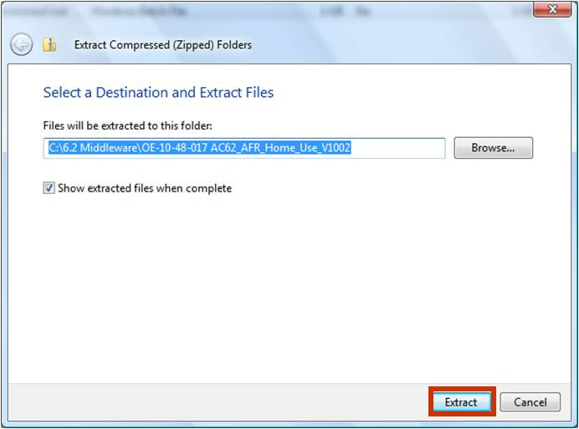

1. When file extraction is complete, you are presented with the following window. You will notice a file titled “***UseThisFiletoInstallorUninstall****.*” Windows XP users should double-click the file to begin installing *ActivClient v6.2 AFR Home Use Middleware*. Vista and Windows 7 users should right click the file*,* and select ***Run as administrator*** from the dropdown menu. (See screenshots below).

**Windows XP Screenshot**

**Vista Screenshot (Windows 7 Screenshot is similar)**

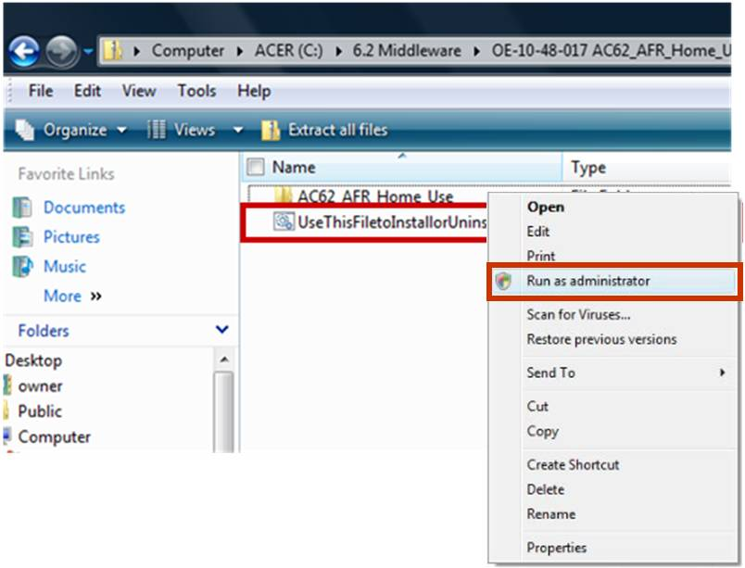

1. Next, you will see a blue installation screen***.*** Select the first option… ***Install ActivClient 6.2 Air Force Release.*** Click ***Submit.***

**Note**:

If a smart card reader is not already installed, you may receive a prompt indicating you have not yet installed a smart card reader. Click ***OK*** and continue installing the middleware.

1. The ***AC v6.2 Air Force Release User Agreement*** will pop up. Carefully read the User agreement. Select the first option to accept the agreement, and click ***Submit***. If you choose to not accept the agreement, the installation will stop.

**Note**:

In **Vista and Windows 7,** when the Windows Installer begins installing, you may receive a warning prompt stating “*An unidentified program wants access to your computer*.” You are presented with two options; “Cancel” or “Allow.” Select ***Allow***.

1. All users: A prompt appears indicating *“Preparing to install…”*

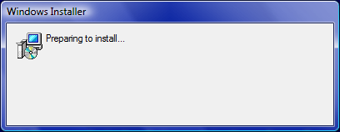

**Note**:

In Vista and Windows 7: a warning prompt may appear indicating “*A program needs your permission to continue;*” Select ***Continue.***

1. The *Install/Uninstall Utility* screen installation is in process.

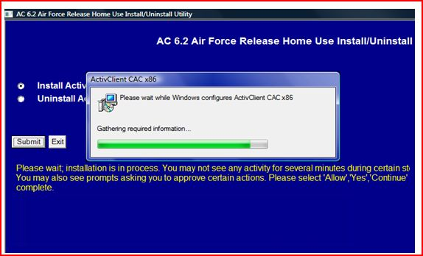

1. After the required information is gathered (previous step), steps 1 through 3 will quickly complete, and step 4 will indicate “***in progress.***” You will also receive a prompt indicating a reboot is required to complete the setup. Click **OK**.

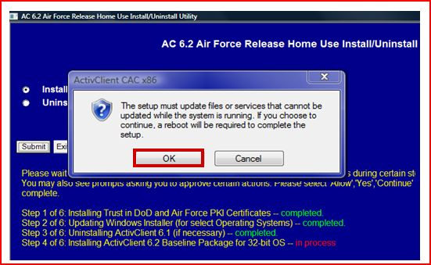

**Note**:

In a **Vista and** **Windows 7** a warning prompt may appear stating “*An unidentified program wants access to your computer*.” Select ***Allow***.

1. Next, a prompt appears advising you to wait while Windows configures Microsoft Outlook Web Access (OWA); you will also notice Step 4 was completed. No action is required – just wait.

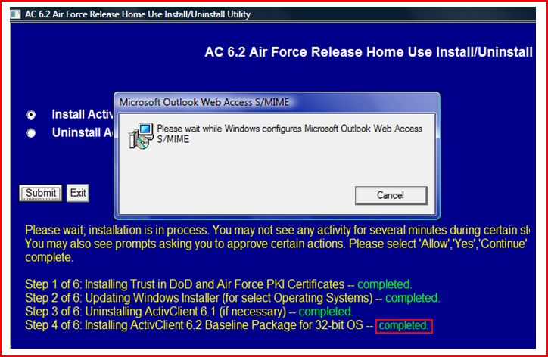

1. A prompt will appear indicating the install is complete. It will instruct you to reboot the workstation when practical in order to access all ActivClient v6.2 AFR features. Click ***OK*** and reboot the computer; it will not automatically reboot.

**Windows XP Screenshot**

**Vista Screenshot (*Windows 7 Screenshot is similar*)**

## Smart Card Reader Installation Instructions

It is best to shut down the computer before installing a smart card reader. With the computer turned off, plug in the smart card reader and then start the computer.

If the computer automatically detects and installs the smart card reader drivers, no further action is necessary. Smart card reader drivers already exist on many computers. However, the computer may seek smart card reader drivers via the Internet and provide prompts to install them when found.

If the computer did not detect and install the smart card reader, accomplish the installation using instructions and smart card reader drivers that come with the smart card reader when purchased. If you do not have instructions or drivers for the smart card reader, you may be able to obtain them from the smart card reader vendor’s Web site or via an Internet search. If you obtained the smart card reader from a military source, and do not have installation instructions or drivers, consult your Client Support Administrator (CSA).

Reboot your computer after installing the smart card reader and its drivers.

Table 2-1 lists some of the most common smart card reader vendors and links to their Web sites. This list is not all-inclusive, and the AF does not recommend one over another. There are many other sources from which to purchase smart card readers (local and online retailers and online auctions).

Table 2‑1: Smart Card Readers

|  |  |
| --- | --- |
| **Smart Card Reader** | **Vendor Web Site Links** |
| Schlumberger/Axalto | [www.readers.slb.com](http://www.readers.slb.com) |
| SCM SCR | <http://www.scmmicro.com/security/secure_card.html> |
| GoldTouch Keyboard | <http://www.keyovation.com/> |
| Infineer | <http://www.mako-tech.com/pands/reader_sol.cfm> |
| Dell | [www.dell.com](http://www.dell.com) |
| ActivCard or ActivIdentity | <http://www.actividentity.com/products/smart_cards_readers__home.php> |

USB smart card readers are the preferred smart card readers.

* Personal Computer Memory Card International Association (PCMCIA) smart card readers work on most laptops. However, many laptops have only one PCMCIA slot, often already used for other purposes such as a wireless Local Area Network (LAN) card. A Universal Serial Bus (USB) smart card reader is often a better choice, even for laptops.
* Serial smart card readers are not recommended, but will operate on most workstations. For the middleware to function properly, install the serial smart card readers on COM port 1.

## Verify Installation Success

After the computer reboots, insert your CAC into the smart card reader. Double click the ***ActivClient v6.2*** AFR icon located in the system tray (lower right-hand corner of the desktop).

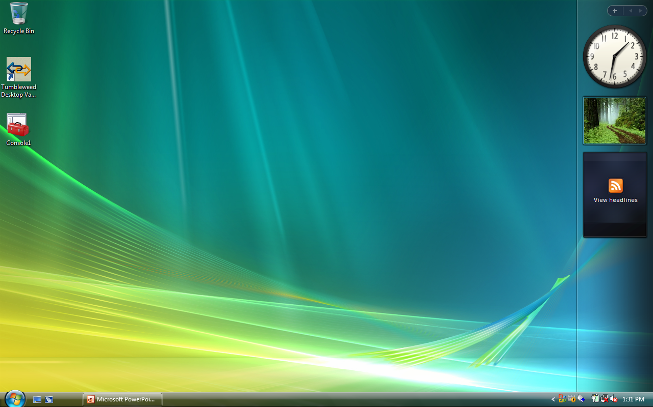

Double clicking the ActivClient icon should produce the following window, indicating you can successfully access your CAC.

According to best security practices, you should never leave your CAC in the smart card reader when not actively in use.

***Always remove your CAC from the smart card reader when not actively in use.***

## How to Manually Install Components in AC v6.2 AFR Home Use Package

These instructions are only for situations where the automated installation package did not run successfully. The files referenced below are in the AC v6.2 AFR Home Use folder.

### For x86 (32-bit) Operating Systems:

1. If you are using Windows XP SP2, double click on the WindowsInstaller-KB893803-v2-x86.exe file. This will upgrade the version of Windows Installer to the required version. If you are using XP SP3, Vista or Windows 7 skip this step and go to Step 2.
2. Double click on NIPRDoDCerts_v5500.msi file. This will install trust in the DoD and AF PKI.
3. Double click on the ActivClient_CAC_6.2_AFR_x86_HU.msi file and follow instructions in the following windows. This will install the ActivClient v6.2 AFR initial middleware package.
4. Double-click on the ActivClient_ 6.2_x86_Build_119.msp file and follow instructions in the following windows. This will install the latest hotfix (Build 119) for ActivClient v6.2 AFR.
5. Double-click on the setupmcl.exe file. This will install the module needed to support S/MIME (signing and encrypting capability) in OWA.
6. Restart the workstation.

### For x64 (64-bit) Operating Systems:

1. Double click on NIPRDoDCerts_v5500.msi file. This will install trust in the DoD and AF PKI.
2. Double click on the ActivClient_CAC_6.2_AFR_x64_HU.msi file and follow instructions in the following windows. This will install the ActivClient v6.2 AFR initial middleware package.
3. Double click on the ActivClient_ 6.2_x64_Build_119.msp file and follow instructions in the following windows. This will install the latest hotfix (Build 119) for ActivClient v6.2 AFR.
4. Double click on the setupmcl.exe file. This will install the module needed to support S/MIME (signing and encrypting capability) in OWA.
5. Restart the workstation.

# Uninstall Instructions

## Uninstall Home Use Middleware

The following instructions explain how to uninstall *Home Use Middleware* from your computer. There are two options to uninstall the middleware.

### Uninstall Using Control Panel

The first option is to use ***Add/Remove Programs*** on the ***Control Panel***.

1. Click the ***Start*** button. (Note: If you are using Windows XP or the classic view, you will need to click on ***Settings*** after clicking the ***Start*** button).

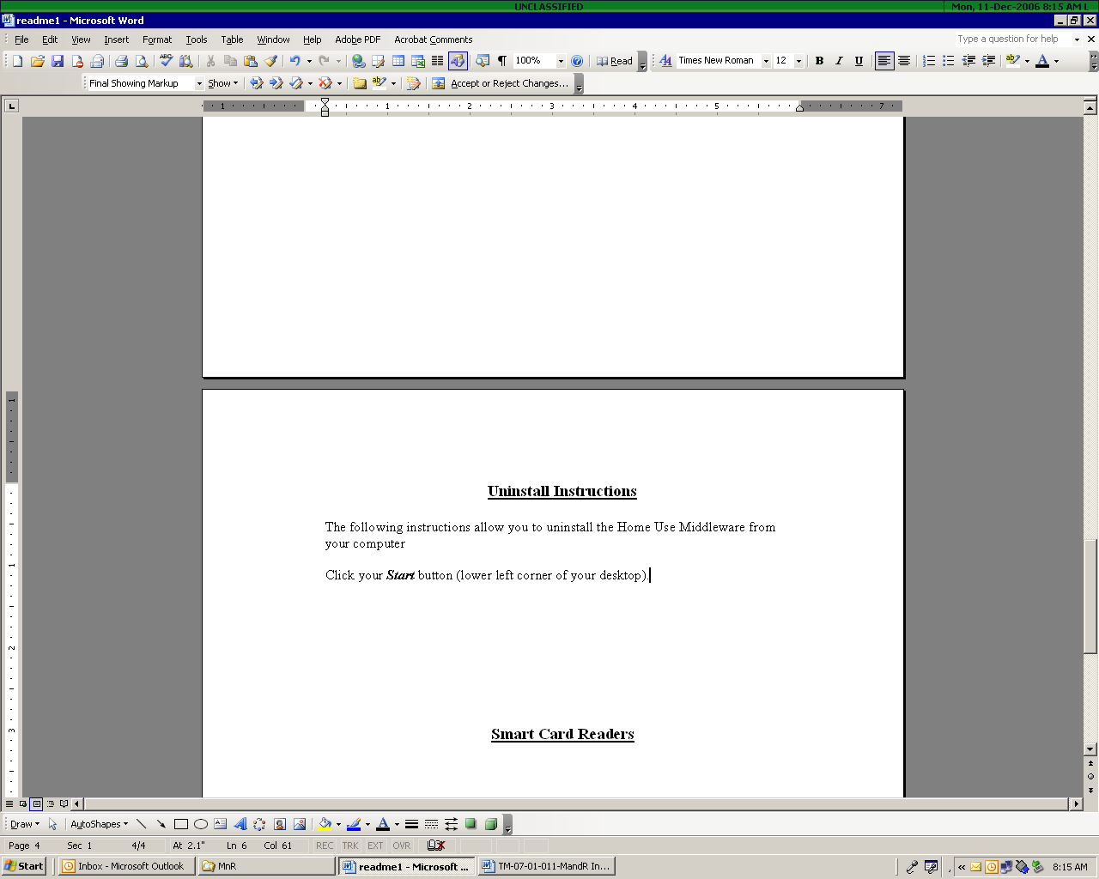 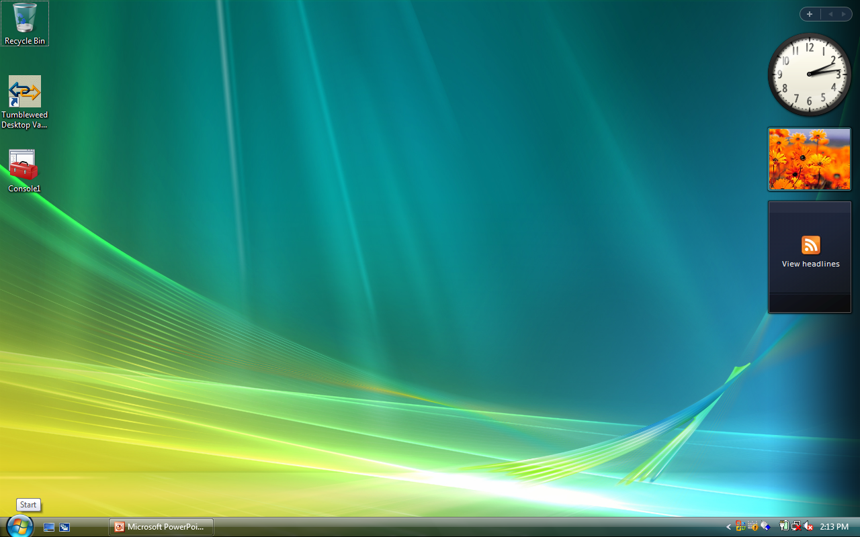

**Windows XP** **Vista or Windows 7**

1. Click ***Control Panel*** from the menu.

**Windows XP** **Vista or Windows 7** 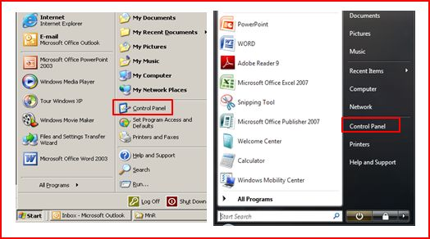

1. In Windows XP, click ***Add or Remove Programs***. When the list of programs installed on your computer appears, highlight the ***ActivClient v6.2 AFR Home Use for Air Force*** program and click ***Remove***.

**(Windows XP Screenshots)**

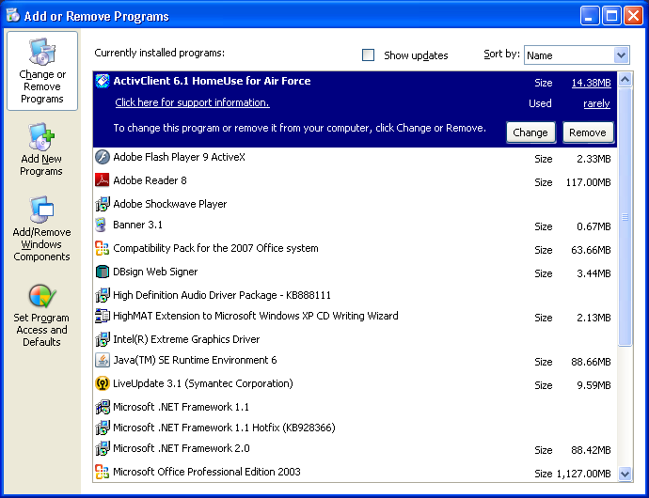

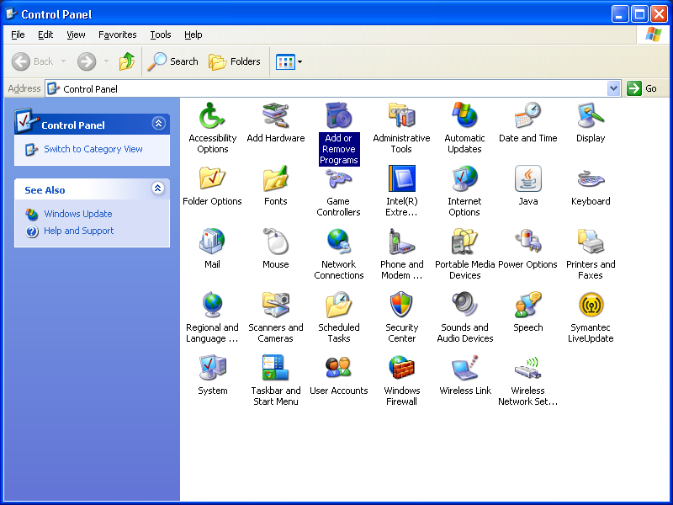

***OR***

1. In Vista or Windows 7, click ***Uninstall a Program***. When the list of programs installed on your computer appears, select ***ActivClient v6.2 AFR Home Use for Air Force*** program, and click ***Uninstall.***

**Vista Screenshots (Windows 7 Screenshots are similar)**

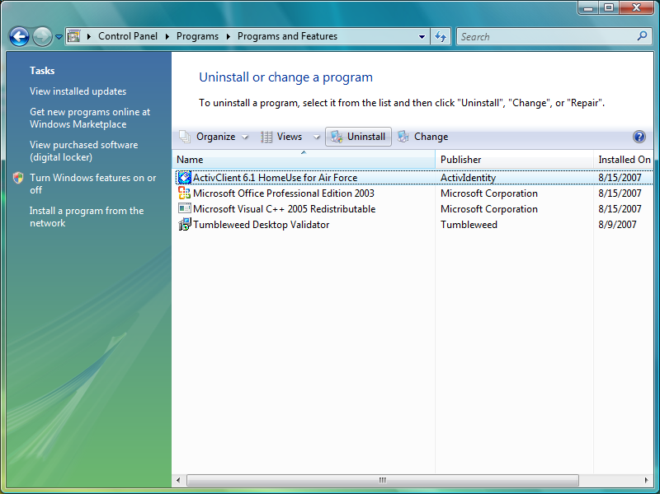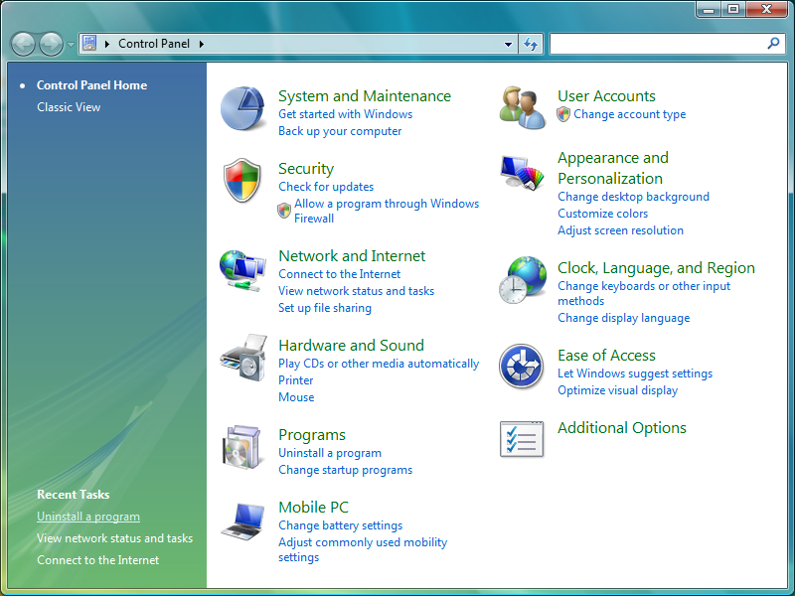

1. A prompt will appear asking if you want to uninstall AC v6.2 AFR. Click ***Yes*** to remove the program and follow the prompts.
2. Windows will provide a progress indicator, reflecting that the middleware is being uninstalled.
3. Reboot your computer when prompted; click ***Yes*** (in XP) or ***OK*** (in Vista and Windows 7).

**Note**:

In **Vista and Windows 7,** when ActivClient v6.2 AFR begins to uninstall, a warning prompt appears stating “*An unidentified program wants access to your computer*.” There are two options; “Cancel” or “Allow.” Select ***Allow***.

### Uninstall using Installer File

Another option to uninstall the middleware is to go to the folder where the middleware file “*UseThisFiletoInstallorUninstall*” is located. Double click on that file to uninstall, just as you did when you initially installed the middleware.

## Uninstall Home Use Middleware-related Components

The Home Use Middleware installation package installs some components in addition to the ActivClient middleware that a Home User would typically need when using their CAC to access government web sites and e-mail. The components may be left on the machine without harm if the middleware is uninstalled, however the instructions below can be followed to remove them if the user desires.

### Removal of OWA S/MIME Utility

The OWA Secure/Multipurpose Internet Mail Extensions (S/MIME) utility allows the use of digital signature and encryption when using accessing OWA with Internet Explorer. To remove this utility, follow the instructions in Section 3.1 to Add or Remove Programs (for Windows XP) or Uninstall a Program (for Windows Vista or Windows 7) through the Control Panel. The program to uninstall will be listed as “Microsoft Outlook Web Access S/MIME”.

### Removal of DOD PKI Trust

Trust in the DoD PKI is established by placing copies of the DoD Certification Authorities’ certificates in various trust stores in the workstation. It is not necessary to remove the trust if the middleware is installed, however you can use the steps below to remove the trust if desired:

1. In the **Start** menu, click **Run**, and then type **mmc**. Click **Enter**. This starts the Microsoft Management Console (MMC).
2. In the console, click the **File** menu and then click **Add/Remove Snap-in**.
3. In the **Add/Remove Snap-in** window, click the **Add** button.
4. On the **Snap-in** list, select **Certificates** and then click **Add**.
5. In the **Certificates Snap-in** window, select Computer account, and then click Next.
6. In the **Select Computer** window, select **Local computer** and then click **Finish**. This adds the Certificates Snap-in to the list. Close the window.
7. In the **Add/Remove** snap-in window, click **OK**. This adds the Certificates snap-in to the mmc console.
8. Expand the **Certificates (Local Computer)** node to see the different types of certificate stores, which are listed as folders.
9. Open the **Certificates** folder under **Trusted Root Certification Authorities**. The list of trusted certificates will appear on the right. Click on the **Issued By** column header to sort by the Issuing CA.
10. Highlight all entries that have the following in the “Issued By” column: AF Medium Assurance Root CA, DoD CLASS 3 Root CA, DoD Root CA 2, ECA Root CA, ECA Root CA 2. Then right-click on the highlighted entries and select **Delete**. Click **Yes** at the warning prompt to delete the certificates. **IMPORTANT**: Be careful to delete ONLY those certificates described above. Deleting other certificates could impact the operation of your workstation.
11. Open the **Certificates** folder under **Intermediate Certification Authorities**. The list of trusted certificates will appear on the right. Click on the **Issued By** column header to sort by the Issuing CA.
12. Using the same steps and criteria in Step 10, delete any entries that were issued by the specified CAs.
13. Close the MMC window.

# Technical Support

If you experience difficulty installing or uninstalling *Home Use Middleware* or a smart card reader, please contact your local Client Support Administrator or your local Communications Help Desk. The AF PKI SPO does not provide technical support for Home Users.

##### Acronyms

|  |  |
| --- | --- |
| AC | ActivClient |
| AF | Air Force |
| AFR | Air Force Release |
| AFRES | Air Force Reserve |
| ANG | Air National Guard |
| CAC | Common Access Card |
| CSA | Client Support Administrator |
| DoD | Department of Defense |
| FOUO | For Official Use Only |
| LAN | Local Area Network |
| MMC | Microsoft Management Console |
| OWA | Outlook Web Access |
| PCMCIA | Personal Computer Memory Card International Association |
| PKI | Public Key Infrastructure |
| S/MIME | Secure/Multipurpose Internet Mail Extensions |
| SP | Service Pack |
| SPO | System Program Office |
| USAF | United States Air Force |
| USB | Universal Serial Bus |