Grazioso Salvare Dashboard
  - CS-340 Project Two
Edwin Martinez

1. Overview
This project consists of developing a web-based dashboard application for Grazioso Salvare, a company that identifies dogs suitable for search-and-rescue training. The dashboard connects to a MongoDB database containing Austin Animal Center Outcomes data and allows users to interact with and visualize the data.
The dashboard includes the following functionality:
- Interactive filtering options:
  - Water Rescue
  - Mountain or Wilderness Rescue
  - Disaster or Individual Tracking
  - All (returns all data)
- Dynamic data table:
  - Displays animal records from the MongoDB database
  - Updates automatically based on selected filters
  - Includes sorting, filtering, and pagination
- Geolocation chart:
  - Displays the location of the selected animal
  - Updates dynamically based on table selection
- Pie chart:
  - Displays breed distribution of filtered data
  - Updates dynamically based on filter selection

2. Proof of Functionality
Water Rescue Filter Applied
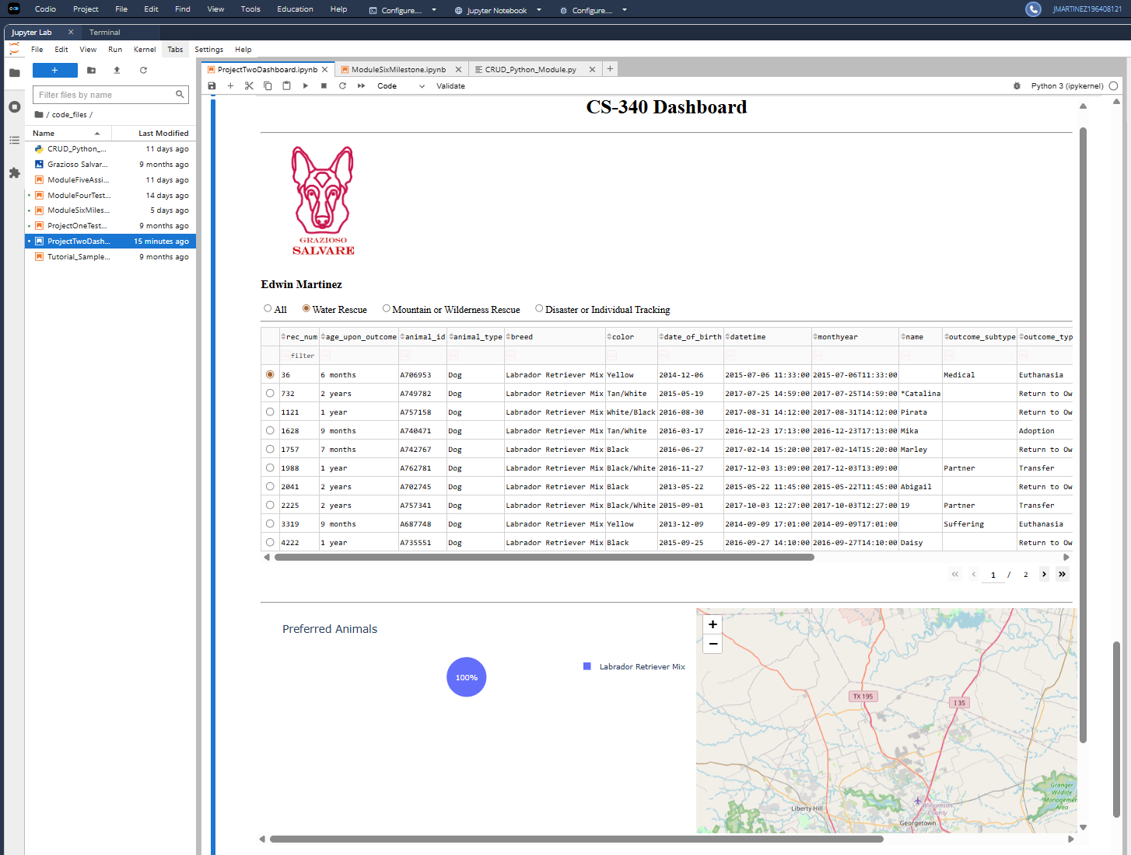

Mountain or Wilderness Rescue Filter Applied
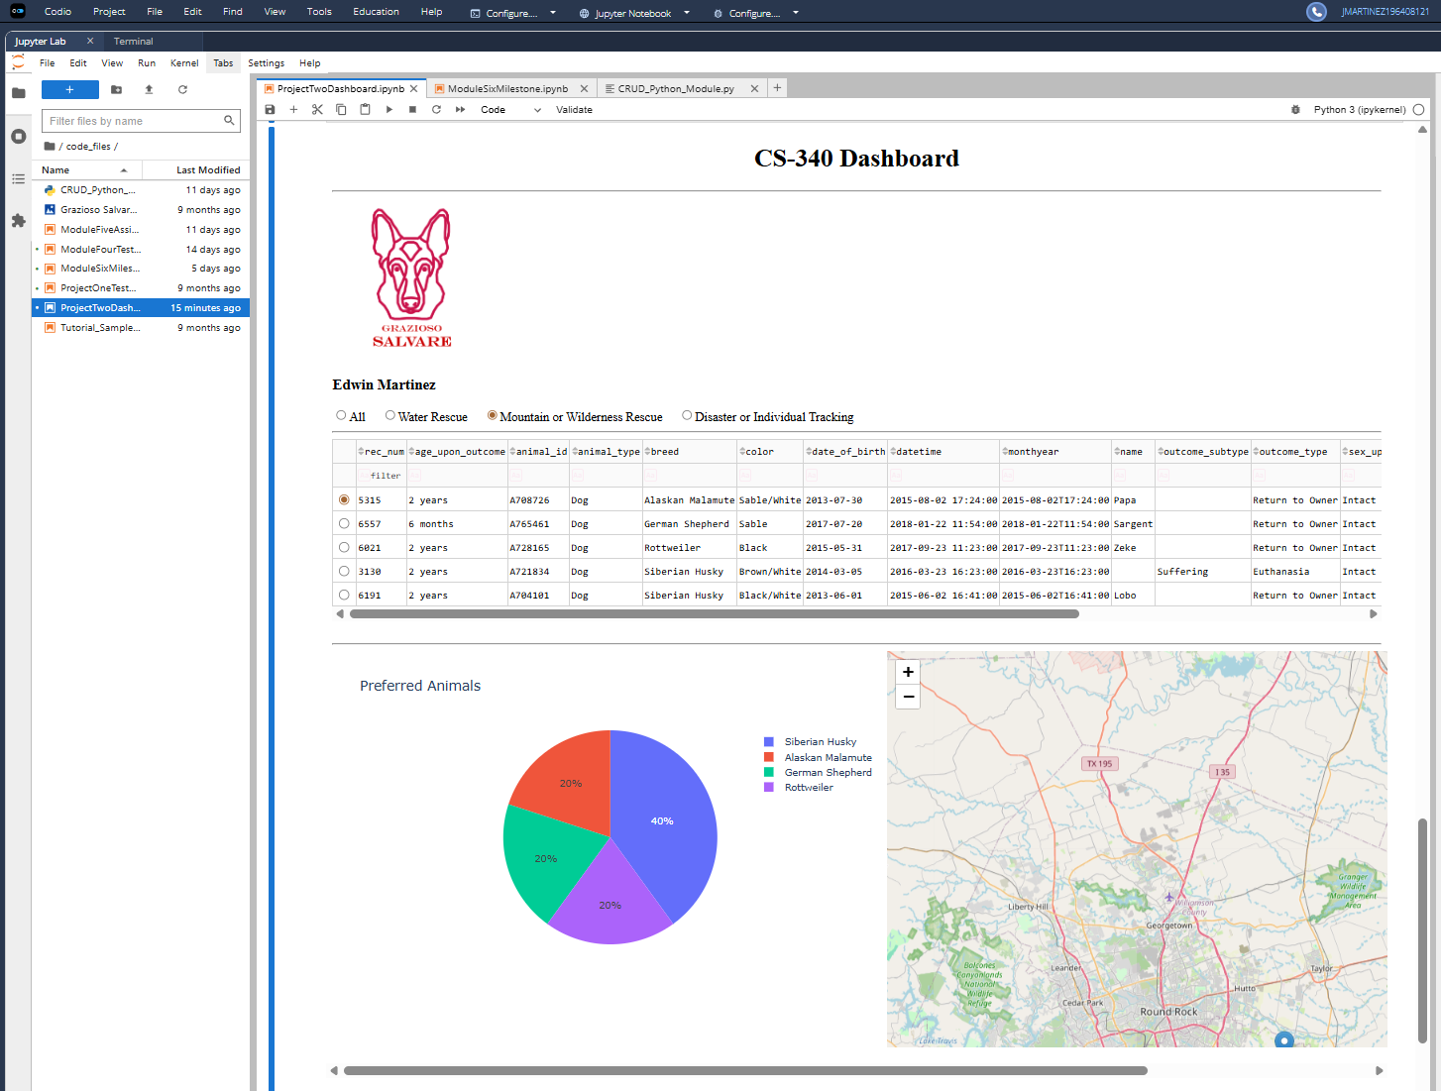

Disaster or Individual Tracking Filter Applied
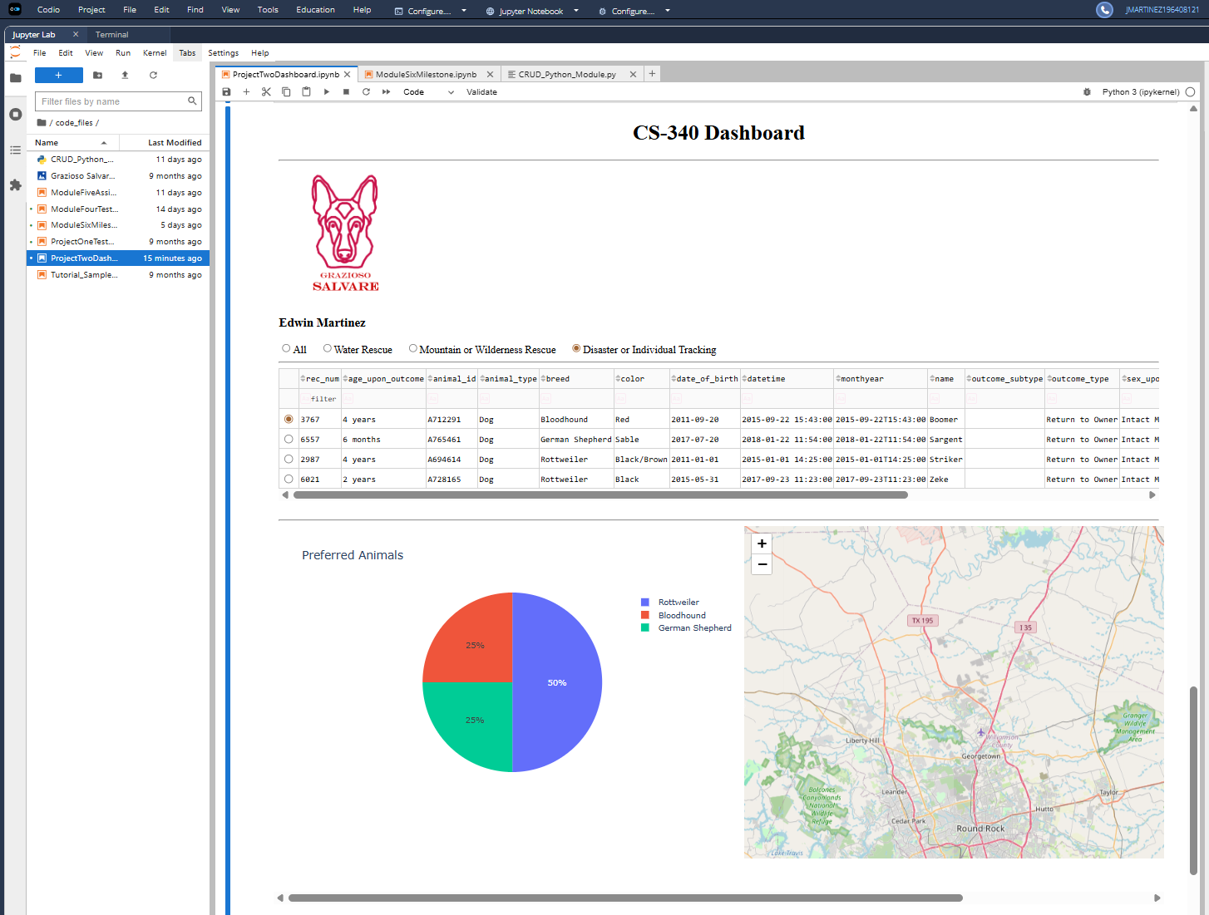

All State (Return to Full Dataset)
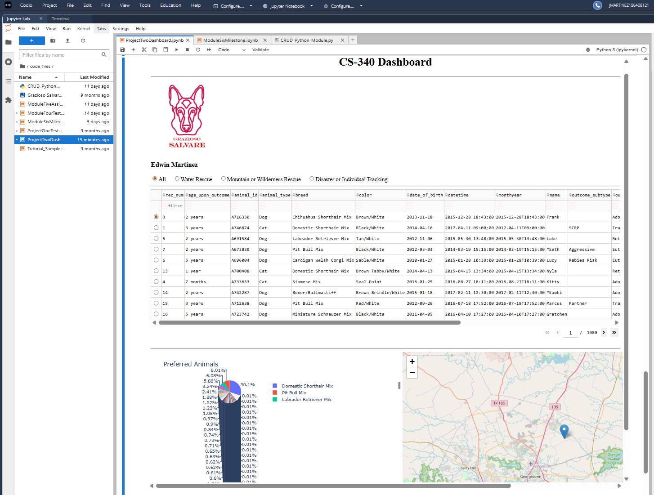

3. Tools and Technologies Used

MongoDB
MongoDB was used as the database system to store and manage the animal shelter data.

Why MongoDB:
- NoSQL document-based structure allows flexible data storage
- Easily integrates with Python using pymongo
- Efficient querying using JSON-like syntax
- Scalable and well-suited for semi-structured data

Python
Python was used as the primary programming language to:
- Implement CRUD operations
- Process and manipulate data using Pandas
- Connect backend logic to the dashboard

Dash Framework
Dash was used to build the web-based dashboard.

Why Dash:
- Allows building interactive web apps entirely in Python
- Provides built-in components (tables, charts, inputs)
- Uses callbacks to connect user input (controller) with data updates (view)

Plotly Express
Used to create the pie chart visualization.

Why Plotly:
- Easy-to-use API for creating interactive charts
- Integrates seamlessly with Dash

Dash Leaflet
Used to create the geolocation map.

Why Dash Leaflet:
- Provides map rendering and marker support
- Allows dynamic updates based on selected data

Additional Libraries
- Pandas: data manipulation
- NumPy: numerical operations
- Base64: encoding the logo for display in the dashboard

4. Steps Taken to Complete the Project
- Developed a CRUD Python module to interact with MongoDB
- Connected the dashboard to MongoDB using the CRUD module
- Retrieved all data and displayed it in a data table
- Implemented interactive filtering using radio buttons
- Created MongoDB queries based on rescue type requirements
- Connected filters to the data table using Dash callbacks
- Created a pie chart that updates based on filtered data
- Implemented a geolocation map that updates based on selected table row
- Added Grazioso Salvare logo and developer identifier
- Tested all components and captured screenshots for documentation

5. Challenges and Solutions

Challenge 1: Handling MongoDB _id Field
MongoDB returns an _id field with an ObjectId type that is incompatible with Dash tables.

Solution:
Removed the _id column using Pandas before displaying data.

Challenge 2: Linking Components
Ensuring all dashboard components updated dynamically based on user input.

Solution:
Used Dash callbacks to connect:
- Filters -> Data Table
- Data Table -> Charts
- Data Table Selection -> Map

6. How to Run
- Install required dependencies:
  - Python 3.x
  - pymongo
  - dash
  - dash-leaflet
  - plotly
  - pandas
- Ensure MongoDB is running locally:
  - Database: aac
  - Collection: animals
  - User: aacuser
  - Password: pass123
- Place the following files in the same directory:
  - ProjectTwoDashboard.ipynb
  - CRUD_Python_Module.py
  - Grazioso Salvare Logo.png
- Open the notebook in Jupyter or Codio
- Run all cells
- The dashboard will display inline

7. Resources
- https://dash.plotly.com/dash-core-components
- https://plotly.com/python/pie-charts/
- https://dash-leaflet-docs.onrender.com/docs/getting_started

