Voltage Curve Player

Table of Contents
1. Purpose 1
2. Usage 2
2.1 Standalone usage 2
2.2 Usage with PROVEtech TA 5
3. Troubleshooting 5

Purpose
The purpose of this application is replaying voltage curves from text files using a Digital Acquisition hardware tool (DAQ). The application is created to replay voltage curves generated by ArbNet software tool. The ArbNet tool generates a text file, which describes each point of the voltage curve. The Voltage Curve Player reads this text file and take all voltage points and the appropriate times needed and process them to the connected DAQ.
The voltage curve generated by the DAQ’s Analog Output can be used for simulation of Crank curves or another voltage curves. Note: The above mentioned method cannot be used without an amplifier.

Usage

Standalone usage

First of all, you need a National Instruments DAQ connected and properly installed to your system. The Voltage Curve Player was tested using NI PXI-6229 and NI USB-6259, however it should be working correctly with all National Instruments DAQs, containing Analog Outputs.

The Voltage Curve Player has several hardcoded variables that you should follow in order to be able to use it correctly. The first limitation is the physical name of the DAQ. You should rename the DAQ from NI MAX in the following way:
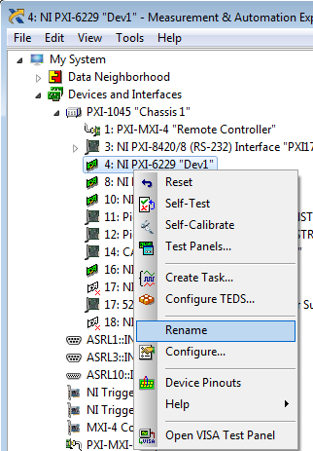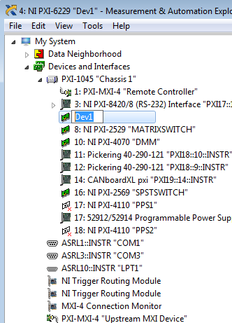

The DAQ name shall be “Dev1”, otherwise the application will not recognize the DAQ.
The second limitation is the Analog Output used. The Voltage Curve Player is hardcoded to use Analog Output 1 “Ao1”. So the output of your DAQ hardware shall be connected to “AO1”.

When the above steps are done, you can proceed to calling the VoltageCurvePlayer.exe .
The executable file needs 2 input parameters in order to be functional.
The first parameter is the full path to the text file of the desired curve.
Note that using the command prompt everywhere in the path, the directories are written with “\\”.
The second parameter is allowed to be “0” or “1”. This parameter is used for:
“1” – generate the curve just once
“0” – generate the curve continuously until the user press “Enter “.

Note: When the Voltage Curve Player.exe is used with Test Stand, the input path to the voltage curve text file needs to be set as shown:
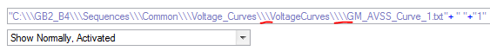
Note that the path contains “\\\” for directories and “\\\\” for the text file used.

If the file is found the console will print:
Note: The path and the file together should not be longer than 70 characters. A very long path and name will cause unhandled failure.

When the file is found the application will read the necessary data and will start “sending” the voltage curve through the DAQ.
Note: The DAQ will “play” the voltages stored in the read text file divided by 4. This is hardcoded in this version, because the current used amplifier “TOELLNER 8805” multiplies the voltage by 4.

Usage with PROVEtech TA
Dim PathS As String
Dim Ubatt As Double

Ubatt = 12 ‘Crank Curve Specific Value

PathS = System.GetGVar("CurrentCFG_Path")+"\ _StartVoltageCurves\VoltOut.exe"
Util.ShellAndWaitCMD(PathS & " " & CStr(Ubatt))

Synch.TimeWait(TimeBeforeSVP_ms)

PathS = System.GetGVar("CurrentCFG_Path")+"\_StartVoltageCurves\VoltageCurvePlayer.exe"
Util.ShellAndWaitCMD(PathS & " " & System.GetGVar("CurrentCFG_Path") & "\_StartVoltageCurves\VoltCurve_4.txt" & " " & CStr(NumRepeats))

Troubleshooting
- If the file was not found:

How it can be seen: the application prints that the file passed through the parameter, was not found. Please check the correct path to the folder and file.

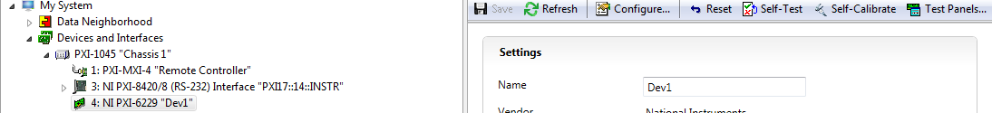
- If the application is displaying “Generating voltage continuously” and no error messages are printed, but the DAQ does not “play” the selected curve. In this case in NI MAX :

press Reset, wait until it is done, press Self-Test, wait until it is done and press Self-Calibrate . When the Self-Calibrate is done, try again executing the Voltage Curve Player.
- If the application is displaying:
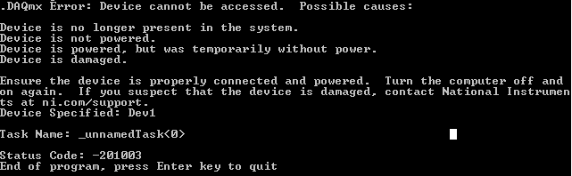

How it can be seen: the DAQ hardware cannot be accessed and the possible causes are explained.

