Test document Page 1

Page 1
 | Page 1 |  |  |  | Page 1
 |  | Page 1 |  | Page 1
 |  |  | Page 1

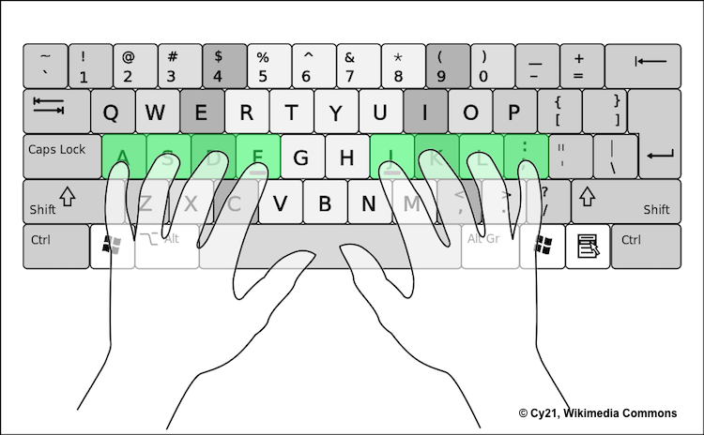

Test document Page 2

Page 2
 | Page 2 |  |  |  | Page 2
 |  | Page 2 |  | Page 2
 |  |  | Page 2

Test document Page 3

