**PRACTICAL 4**

**AIM:** Using Nmap scanner to perform port scanning of various forms – ACK, SYN, FIN, NULL, XMAS.

**NOTE:** Install Nmap for windows and install it. After that open cmd and type “nmap” to check if it is installed properly. Now type the below commands.

* Nmap

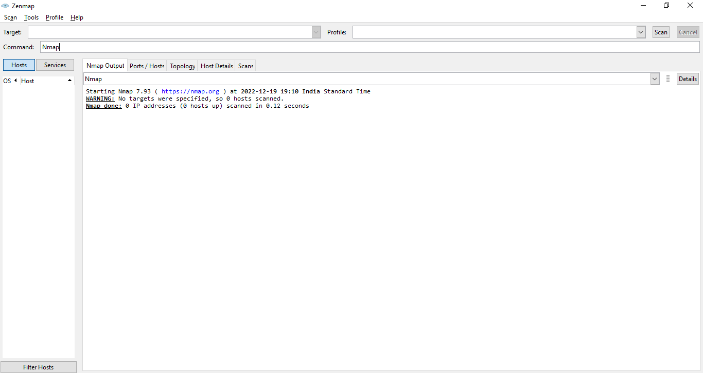

* Working of nmap

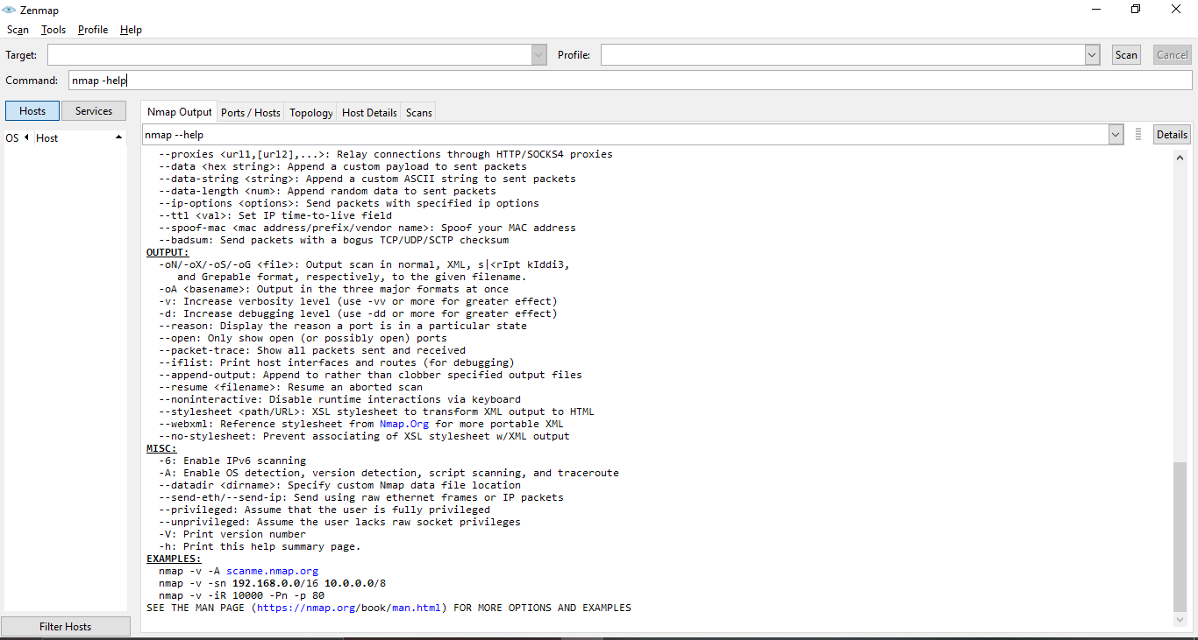

* Syn scan

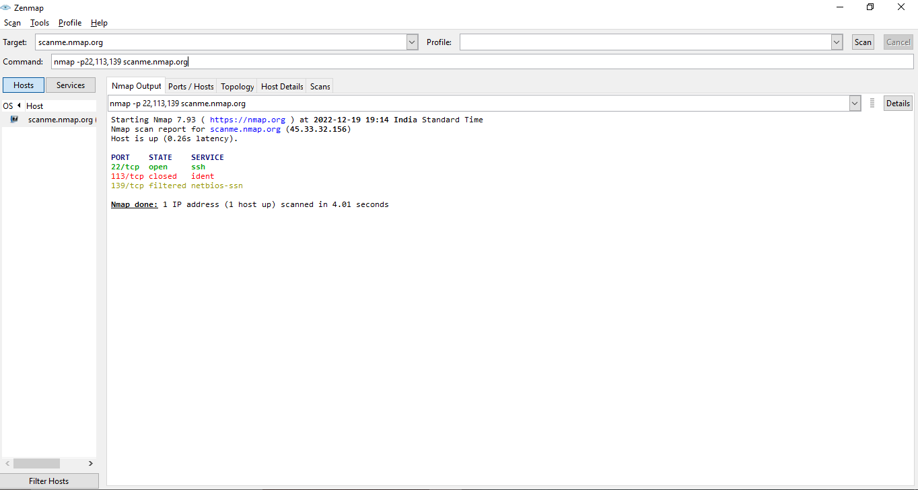

* ACK scan (-sA)

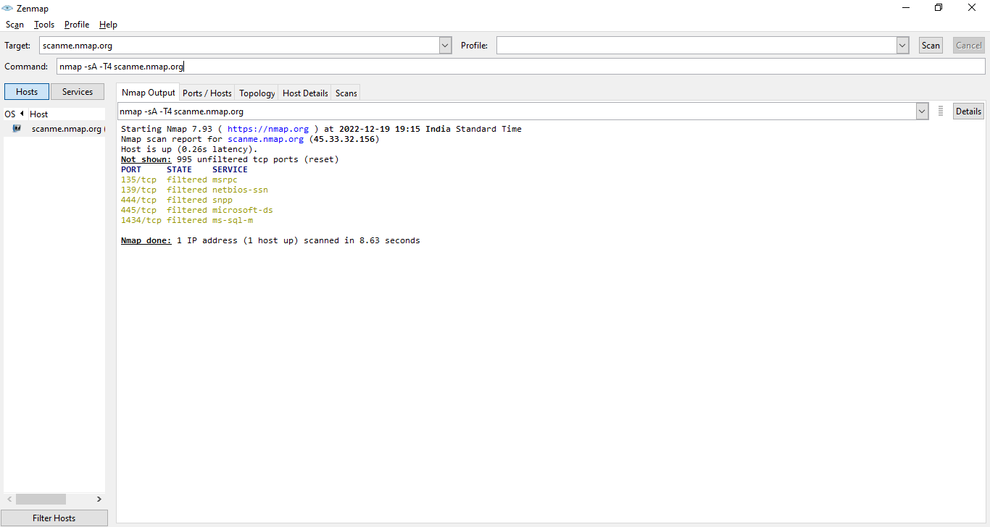

* FIN scan (-sF)

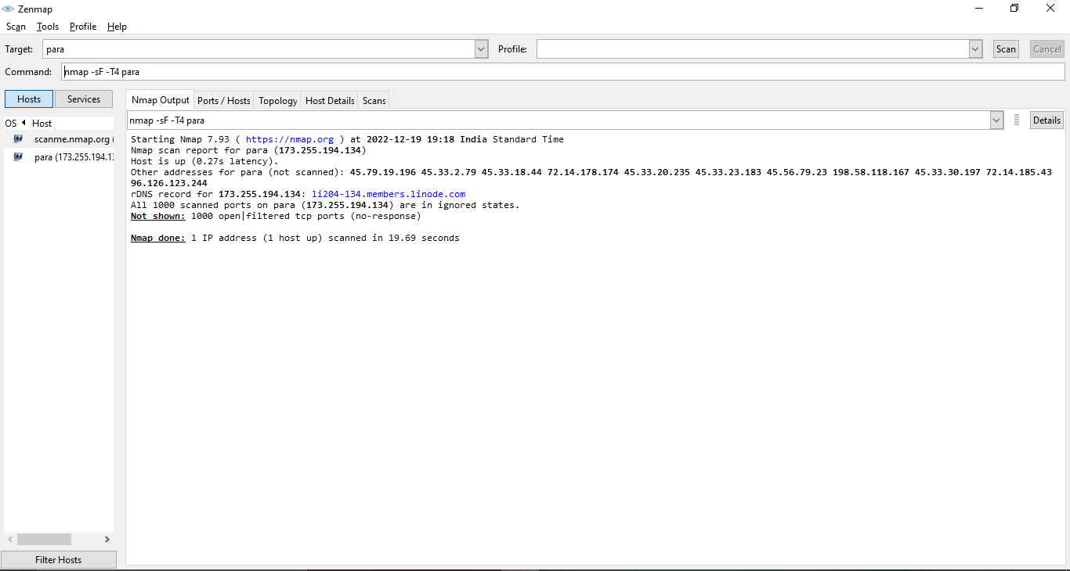

* NULL scan (-sN)

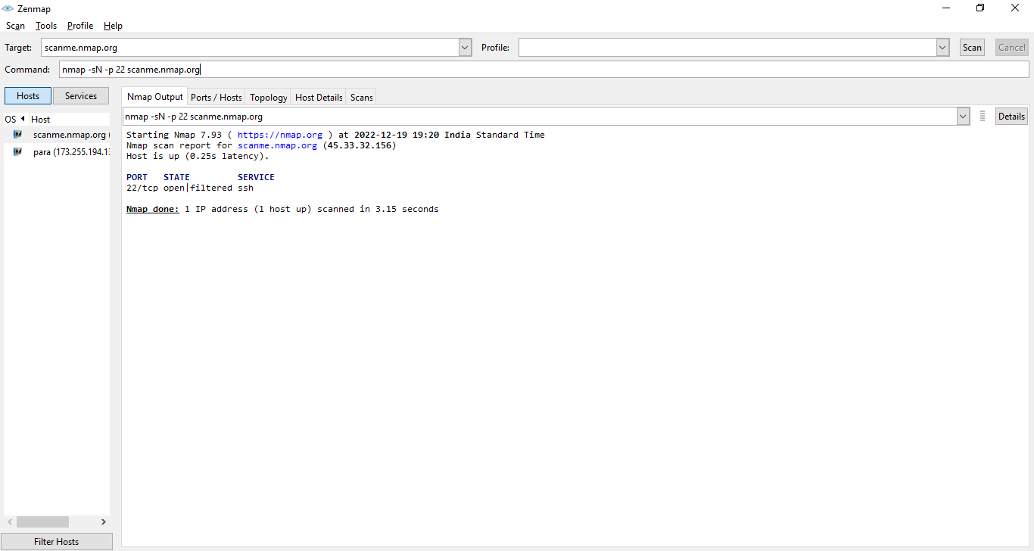

* XMAS Scan (-sX)

