Multi-objective optimization of hot-dip galvanizing operating conditions under uncertainty: a simulation-based sustainability framework with coating quality constraints
Jose D. Hernandez-Betancur^{a,b}
ª Faculty of Mines, Universidad Nacional de Colombia, Medellín 050041, Colombia
^{b} Department of Chemical Engineering, Universidad de Salamanca, Salamanca 37008, Spain
*Corresponding Author: jodhernandezbe@unal.edu.co

Abstract
[Abstract to be written once the final optimization results are available. It should state the decision addressed, the framework, the headline numbers for the baseline and the selected design, and their implications.]
Keywords: Hot-dip galvanizing; optimization under uncertainty; multi-objective optimization; GREENSCOPE; fuzzy analytic hierarchy process; Zinc

Nomenclature
Symbol | Description
c_{Fe,pick} | Peak iron concentration in the normal pickling bath (g/L)
COM | Annual cost of manufacture (USD)
E[·] | Expected value over the N simulated years
F(x) | Vector of the four objectives
f_{k}(x) | Value of objective k for design x
f_{k}^{nadir}, f_{k}^{utopia} | Nadir and utopia values of objective k in the Pareto set
g₁(x), g₂(x) | Inequality constraints on the defect fraction and the iron concentration
G_{i,j} | Score of indicator i in unit process j (0 to 100)
i | Index of the GREENSCOPE indicators (1 to 17)
j | Index of the unit processes (1 to m)
k | Index of the objectives
L_{MP} | Sustainability threshold of the utility (0.8 U_{max})
m | Number of unit processes (m = 7)
m_{s} | Mass of piece s (kg)
N | Number of simulated years per candidate (N = 100)
N(μ, σ²) | Normal distribution with mean μ and variance σ²
P_{sustainable} | Probability that the process is sustainable
Q | Quality score based on ISO 1461 (0 to 100)
s | Index of the pieces
U(a, b) | Uniform distribution between a and b
U_{max} | Maximum process utility (µm)
U_{P} | Additive sustainability utility of the process (µm)
V_{l-poll} | Annual volume of polluted liquid waste (m³)
V_{WT} | Annual water consumption (m³)
W_{k} | Weight of objective k in the compromise selection
x | Decision vector (x₁ to x₇, Table 2)
x_{i,j} | Value of indicator i in unit process j
x_{best,i,j}, x_{worst,i,j} | Best and worst reference values of indicator i in unit process j
x̄_{std} | Mean coating thickness required by ISO 1461 over the pieces of the year (µm)
δ | Coating thickness (µm)
δ_{s} | Coating thickness of piece s (µm)
δ_{ISO,s} | Coating thickness required by ISO 1461 for the gauge of piece s (µm)
λ_{i} | Relative weight of indicator i
λ_{Q} | Weight of the quality category
μ_{k}(x) | Fuzzy satisfaction membership of objective k
μ_{overall}(x) | Weighted additive membership of design x
φ_{δ} | Fraction of the pieces of a year whose coating is thinner than required by ISO 1461

Introduction
Steel is the backbone of modern infrastructure, and its main weakness is corrosion. World crude steel production reached 1,882.6 million tonnes in 2024, of which China produced 1,005.1 million tonnes (53%), India 149.6, Japan 84.0, and the United States 79.5 (World Steel Association, 2025). The global cost of corrosion has been estimated at US$2.5 trillion per year, about 3.4% of the global gross domestic product, and applying corrosion management best practices could avoid 15 to 35% of that cost (Koch et al., 2016). Among the available protection methods, hot-dip galvanizing (HDG), which coats steel by immersion in a molten zinc bath at about 450 °C to form a zinc-iron alloy layer, is one of the most common, and it is used on structural steel, reinforcing bars, and other infrastructure components (Hegyi et al., 2015; Hernandez-Betancur, 2018).
Galvanizing is also the largest single use of zinc, accounting for 60% of the zinc used by first-use application, and construction (50%), transport (20%), and infrastructure (15%) are the largest end-use sectors of zinc (International Lead and Zinc Study Group, 2024). Continuous galvanizing of steel coil is carried out by large integrated steel producers, whereas batch (general) HDG is a fragmented industry of many small plants located close to their markets (International Lead and Zinc Study Group, 2024). World zinc mine production was an estimated 13.0 million tonnes in 2025, led by China (4.1 million tonnes), Peru (1.5 million tonnes), and Australia (1.1 million tonnes) (U.S. Geological Survey, 2026). Supply security has made zinc a policy concern in steel-consuming economies: the United States, whose net import reliance for refined zinc was 73% in 2025, retained zinc in its 2025 List of Critical Minerals (U.S. Geological Survey, 2025, 2026). The efficient use of zinc in galvanizing lines is therefore a resource question for large steel producers and consumers such as China and the United States, as well as for galvanizers in developing economies, and every kilogram of zinc lost as dross, ash, or spent flux in the line is a kilogram that must be mined, smelted, and paid for again.
The galvanizing line also generates waste. Degreasing, pickling, and fluxing produce spent solutions, rinse wastewater, and sludge, and the molten bath produces dross, ash, and zinc splash, in addition to gaseous emissions (Hernandez-Betancur et al., 2019). The literature on the sustainability of HDG has approached these burdens from separate angles: cleaner production and zero-emission strategies in plants in China and Austria (Kong & White, 2010; Fresner et al., 2007), the environmental impacts of steel production and its galvanizing stage (Tongpool et al., 2010), the management of solid wastes and spent pickling solutions (Lobato et al., 2015), and the economics of zinc consumption (Akamphon et al., 2012). Studies that combine economic and environmental dimensions mostly assess the galvanized product, for example reinforcing bars in concrete, rather than the production process (Hegyi et al., 2015), and Fresner et al. (2007) found that environmental solutions can be technically feasible without being economically viable, which shows that cost and environmental objectives may conflict and that a single-objective view is insufficient.
To assess the process rather than the product, Hernandez-Betancur et al. (2019) proposed a framework that combines 17 process-oriented indicators of the GREENSCOPE methodology (Ruiz-Mercado et al., 2012) with a coating quality indicator based on ISO 1461, weights the indicators and their categories (environment, efficiency, energy, economy, and quality) with a fuzzy analytic hierarchy process (FAHP) applied to a survey of ten experts (Chang, 1996), aggregates them into an additive utility (Smith & Ruiz-Mercado, 2014), and represents the random nature of the steel lots, the operating conditions, and the surroundings with a kinetic Monte Carlo simulation. Applied to a Colombian galvanizing line that processes about 180 tonnes of steel per month, the framework identified pickling and fluxing as the critical stages, which together explained 88.7% of the variation in process sustainability, and estimated a probability of only 45.26% that the process reaches the sustainability threshold of 80% utility. The authors concluded that these stages could not be improved without a significant change in the process configuration (Hernandez-Betancur et al., 2019).
That conclusion was reached by diagnosing one fixed set of operating conditions. It does not show whether the controllable conditions of the critical stages, such as the acid concentration and dipping time in pickling or the salt concentration and pH of the flux, can improve the process without changing its configuration, nor which trade-offs among sustainability utility, manufacturing cost, polluted liquid waste, and water consumption appear when they are changed together, and any improvement has to hold under the variability of steel lots and ambient conditions that the line faces every day. Answering these questions requires using the framework prescriptively instead of diagnostically, that is, as the evaluator of an optimization in which every candidate set of operating conditions is assessed under uncertainty.
Multi-objective evolutionary algorithms, and the Non-dominated Sorting Genetic Algorithm II (NSGA-II) in particular, suit this task because they return a set of non-dominated trade-off solutions in a single run (Deb et al., 2002). When the model is stochastic, the expected value of each objective can be estimated by Monte Carlo sampling, i.e., the sample average approximation (Kleywegt et al., 2002), and evaluating all candidates with the same random draws (i.e., common random numbers) reduces the sampling noise in the comparison between candidates (Law, 2015). GREENSCOPE indicators have already served as objectives in the optimization of production chains (Vyhmeister et al., 2018). In the galvanizing literature, optimization has been applied to the air-knife parameters that set the coating thickness in continuous lines (Wang, 2018), to the heat treatment of continuous galvanizing of dual-phase steels with multi-objective genetic algorithms (Costa et al., 2019; Reséndiz-Flores et al., 2021), and to the operation of steel pickling baths (Crișan et al., 2023), while sustainability studies of batch HDG have examined the recovery of zinc and iron from spent pickling acids with life cycle assessment (Arguillarena et al., 2022, 2023; Lorenz et al., 2023). A search of the literature (Supporting Information SI-5) found no study that optimizes the operating conditions of the stages of a galvanizing line jointly against several sustainability objectives under uncertainty.
This study couples the framework developed by Hernandez-Betancur et al. (2019) with NSGA-II to find robust operating conditions for the HDG line. Seven controllable variables (the temperature of degreasing, the HCl concentration and dipping time in pickling, the temperature, pH, and salt concentration of the flux, and the temperature of the zinc bath) are optimized for four expected-value objectives (process utility, manufacturing cost, polluted liquid waste, and water consumption), subject to constraints on the probability of failing the ISO 1461 thickness requirement and on the accumulation of iron in the pickling bath. A fuzzy compromise based on the FAHP weights obtained by Hernandez-Betancur et al. (2019) selects one design from the Pareto set, the sensitivity of that selection to the objective weights and to raw-material prices is tested, and the selected design is compared with a baseline design through 1,000 simulated years of production for each. Section 2 describes the methodology, Section 3 presents and discusses the results, and Section 4 gives the conclusions.

Methodology

Overview of the approach
Figure 1 summarizes the approach. A candidate set of operating conditions (the decision vector x) and a random draw of the uncertain inputs (steel lots, composition, contamination, and ambient temperature) feed a stage-resolved simulation of one year of production of the HDG line (Section 2.2). The resulting inventory is converted into indicator scores and a process utility (Section 2.3). Repeating the simulation for N random years gives the expected values of the objectives and of the constraint quantities of that candidate (Section 2.4), and NSGA-II searches for non-dominated candidates (Section 2.5). The Pareto set is then re-evaluated at full-year scale, a compromise design is selected with a fuzzy decision rule, and the sensitivity of that choice to weights and prices is tested (Section 2.6). Finally, the selected design and a baseline design are compared through 1,000 simulated years each (Section 2.7).
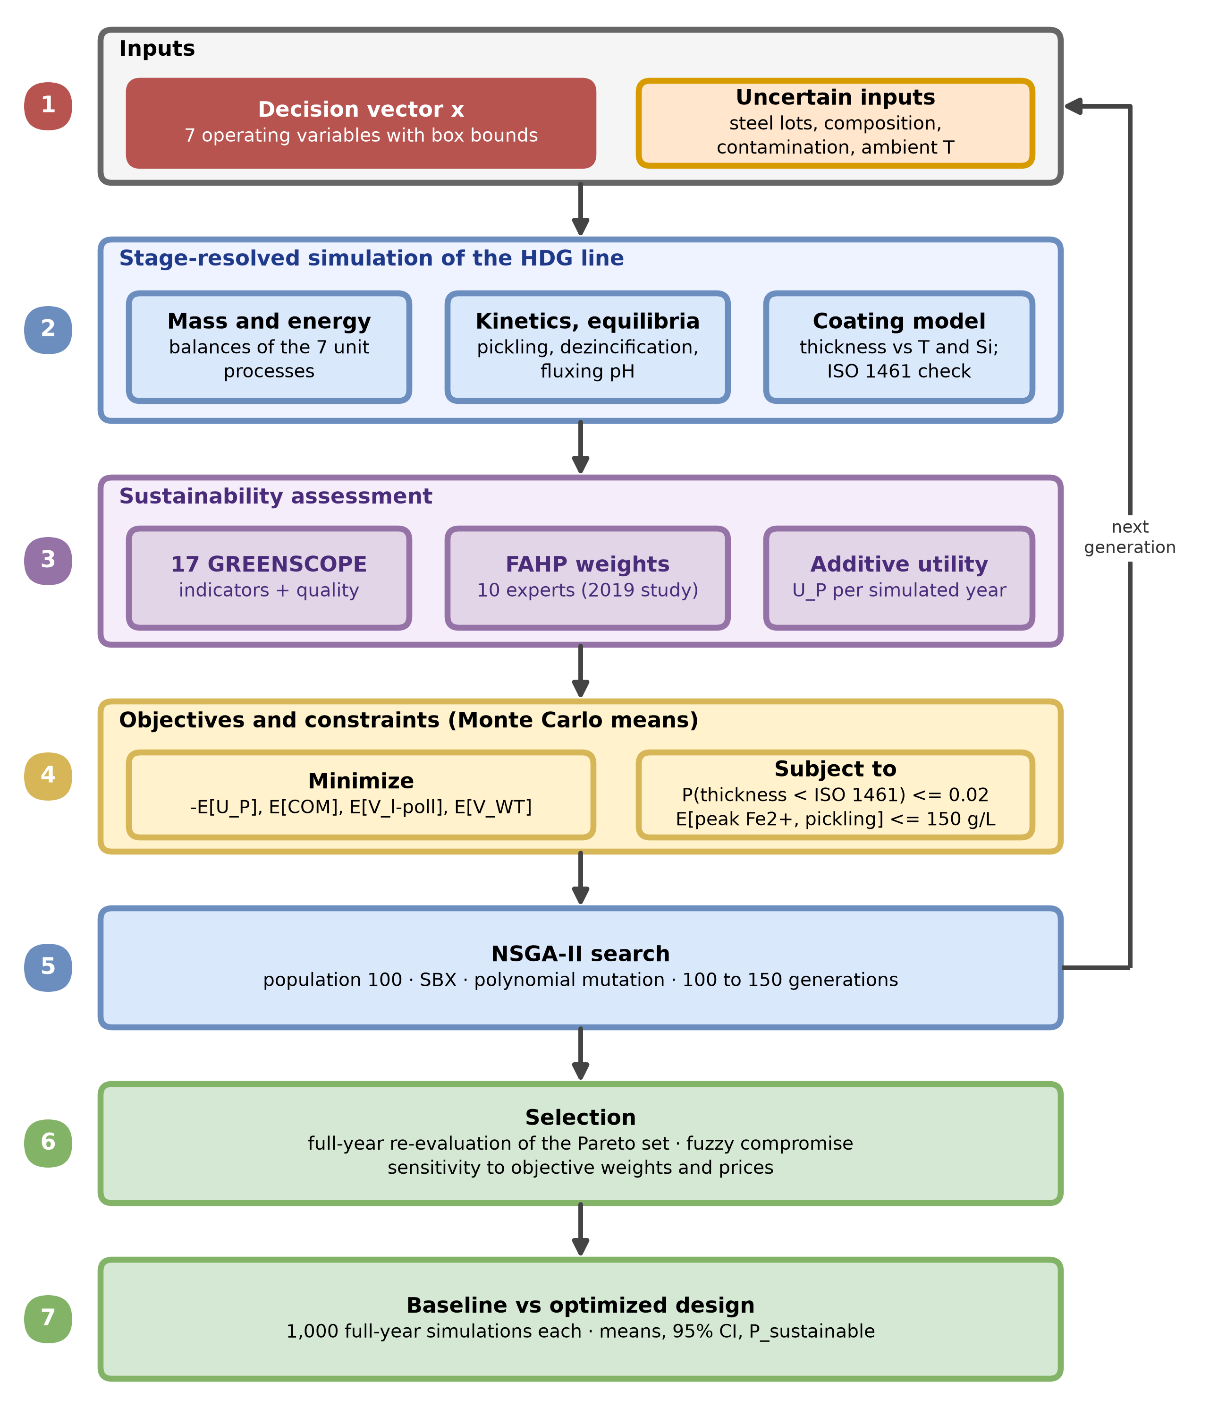
Figure 1. Framework for the robust multi-objective optimization of the hot-dip galvanizing (HDG) line. Operating conditions (decision vector) and random inputs feed a stage-resolved simulation; indicator scores and the process utility give the objectives and constraints as Monte Carlo means; NSGA-II proposes new candidates until it terminates; the Pareto set is re-evaluated at full-year scale, a compromise design is selected, and it is compared with the baseline design. FAHP = fuzzy analytic hierarchy process; SBX = simulated binary crossover; CI = confidence interval; E[·] = expected value.

Process model and sources of uncertainty
The line modeled is the one analyzed in the Hernandez-Betancur et al. (2019) study: a galvanizer that processes about 180 tonnes of steel per month, represented as 41,379,264 pieces per year (Figure 2). Pieces are degreased in a NaOH solution, rinsed, pickled in HCl to remove rust, rinsed again, immersed in a ZnCl₂/NH₄Cl flux solution, dried, and dipped in molten zinc. A random 2% of the pieces is re-processed: their coating is removed in a dilute HCl bath (dezincification) before they re-enter rinsing, fluxing, and galvanizing.
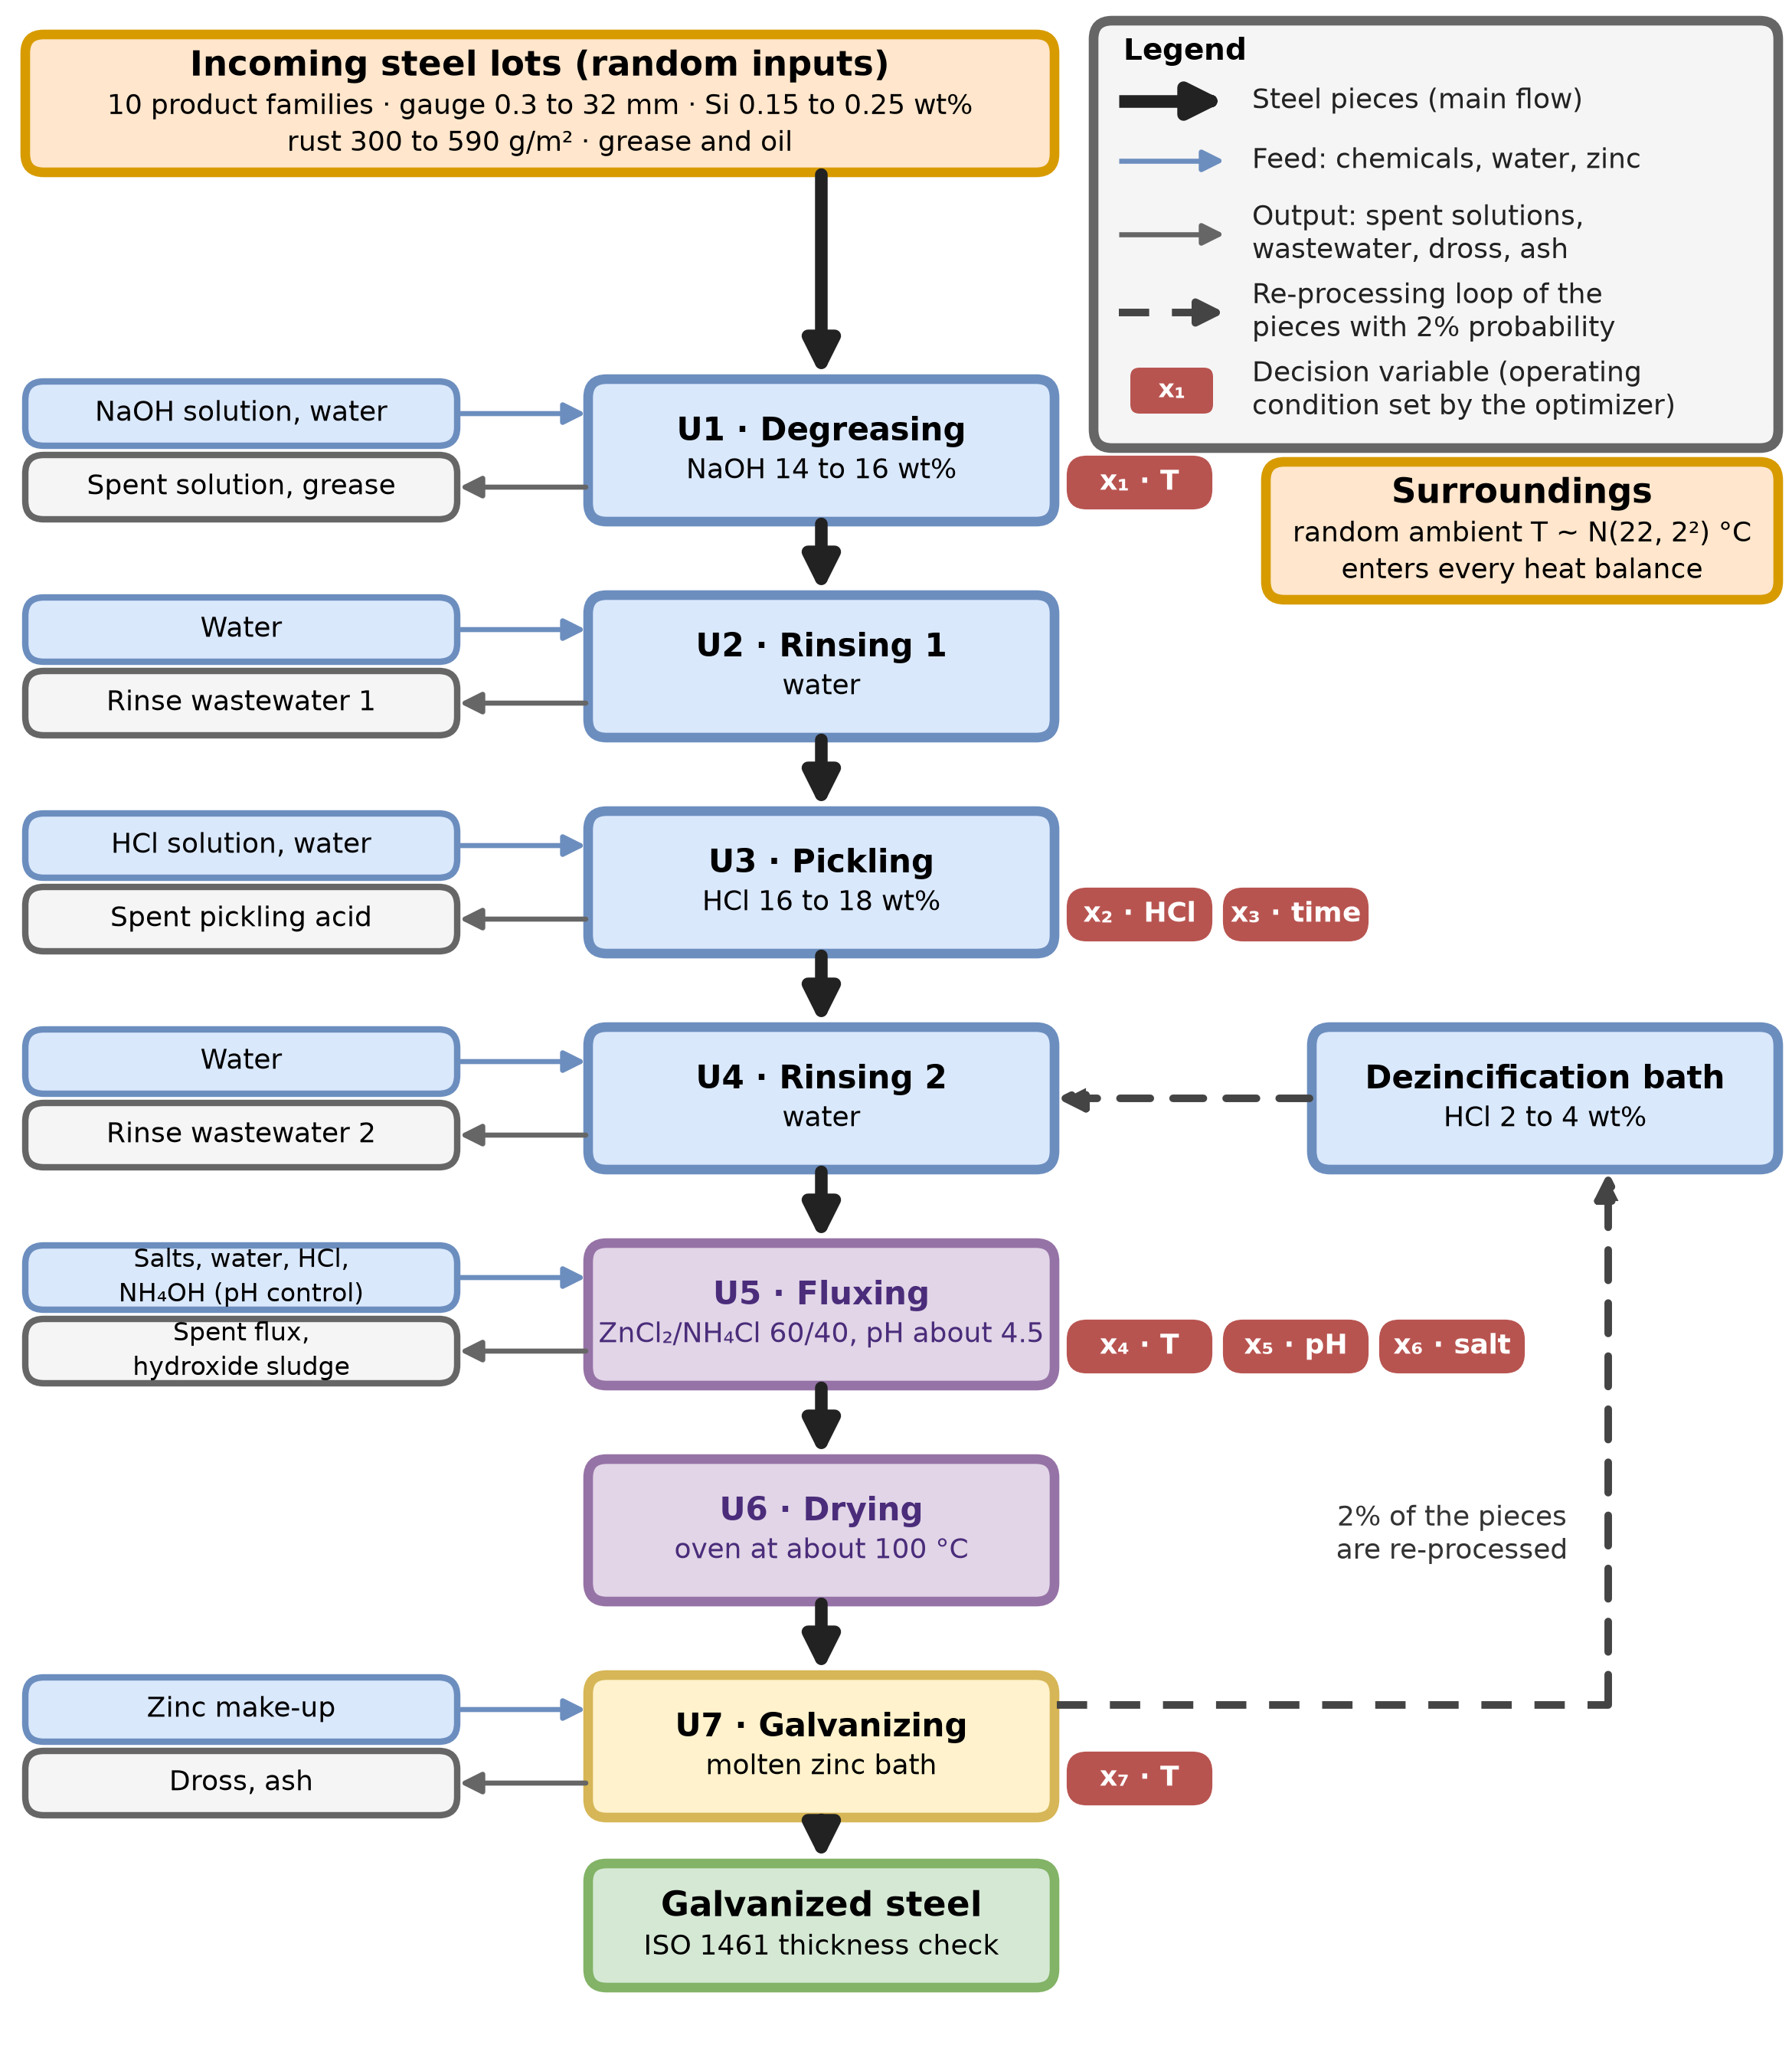
Figure 2. Process flow diagram of the hot-dip galvanizing line simulated (units U1 to U7). Thick black arrows: flow of the steel pieces through the line. Thin blue arrows: feeds of chemicals, water, and zinc to each unit. Thin gray arrows: outputs of each unit (spent solutions, rinse wastewater, hydroxide sludge, dross, and ash), which the 17 GREENSCOPE indicators account for. Dashed arrows: re-processing loop, in which 2% of the pieces leave galvanizing, pass through the dezincification bath, and re-enter the line at rinsing 2. Red blocks x1 to x7: the decision variables, that is, the operating conditions of the unit they touch that the optimizer sets within the bounds of Table 2 (T = temperature). Orange boxes: random inputs of the simulation (Table 1).
Each stage is described by mass and energy balances of its bath and of the pieces, together with the phenomena that govern it: saponification of grease in the degreasing bath; dissolution of iron oxide (FeO) and of steel in the pickling bath, with rate equations integrated numerically over the dipping time; Butler-Volmer kinetics for the dissolution of zinc in the dezincification bath (Hernandez-Betancur, 2018); ionic equilibria of Zn(OH)₂, NH₄OH, and Fe(OH)₂ and regulation of the pH with HCl and NH₄OH in the flux bath; the heat duties of the heated baths and of the dryer; and a regression of the coating thickness δ on the zinc bath temperature and the silicon content of the steel. Baths are renewed when they reach operating limits (an iron concentration of 150 g/L in the normal pickling bath, an HCl concentration below 10 g/L in the dezincification bath, and an iron concentration of 5 g/L in the flux bath); the degreasing bath is renewed once a year and the rinsing tanks 54 times a year. The coating thickness required for each piece depends on its gauge and is the local minimum thickness of ISO 1461 (35, 45, 55, or 70 µm for gauges below 1.5 mm, from 1.5 to 3 mm, from 3 to 6 mm, and above 6 mm; International Organization for Standardization, 2009).
Randomness enters through the steel lots, the state of the fresh baths, and the surroundings (Table 1). In each simulated year, lots are drawn until the annual number of pieces is reached; the ambient temperature is drawn for every lot and affects the heat losses of all open tanks. The variables that the optimization controls replace the corresponding random draws of the 2019 study (Table 2); all other inputs keep the distributions of Table 1.
Table 1. Stochastic inputs of the simulation (Hernandez-Betancur, 2018; Hernandez-Betancur et al., 2019). U(a, b) = uniform distribution; N(μ, σ²) = normal distribution. The fresh-bath temperatures, the HCl concentration of the normal pickling bath, the flux pH and salt concentration, the dipping time, and the zinc bath temperature are drawn in the 2019 study but are decision variables here (Table 2).
Input | Distribution or range | Note
Product family of each lot | 10 families, probabilities 0.054 to 0.291 | Lot size 46 to 111,600 pieces and piece mass 0.009 to 0.123 kg, uniform within each family
Gauge of each piece | U(0.3, 32) mm | Sets the ISO 1461 thickness requirement
Silicon content of the steel | U(0.15, 0.25) wt% | Controls the thickness of the zinc coating
Rust load | U(300, 590) g/m² | Per unit of piece surface
Pieces that need degreasing | 30% of the pieces | Grease and oil: 10 g per tonne of steel
Ambient temperature | N(22, 2²) °C | Drawn for every lot
Fresh bath volume | U(12.6, 14.0) m³ | Degreasing, pickling, and flux tanks
NaOH, fresh degreasing bath | U(14, 16) wt% | Temperature is x₁ (Table 2)
HCl, fresh dezincification bath | U(2, 4) wt% | Normal pickling bath: x₂
Dross and ash | N(0.75, 0.083²) wt% of the dipped steel each | Zinc content: 95 wt% in dross and 72.5 wt% in ash (normal)
Re-processing | 2% of the pieces | Pieces pass through the dezincification bath

The original MATLAB models (Hernandez-Betancur, 2018) were re-implemented and verified against the 2019 results. In 2019 mode, the re-implementation reproduces the behavior of the original listings, including a few defects of those listings that change the numbers, so that published results can be recovered: for 100 simulated years it gave a 95% confidence interval of the mean process utility of 16,408 to 16,988 µm (16,406 to 16,987 µm in the 2019 study) and a probability of sustainability of 0.453 (0.4526), with fluxing and pickling again as the critical stages (Supporting Information SI-2). In corrected mode, which is used for every optimization run, the ammonium and volume balances of the flux bath conserve mass and the bath volume is limited to the tank capacity by withdrawing the excess as a side stream, as industrial flux baths are maintained instead of being dumped (Supporting Information SI-2). In a 20-year comparison with the same random numbers, corrected mode changed the mean process utility from 16,694 to 16,710 µm and the probability of sustainability from 0.452 to 0.456, and the critical stages did not change.

Sustainability assessment
Following the 2019 study, the inventory of each simulated year is converted into the 17 GREENSCOPE indicators selected there (11 environmental, four efficiency, one energy, and one economic indicator) for each of the seven unit processes (degreasing, rinsing 1, pickling, rinsing 2, fluxing, drying, and galvanizing), plus a quality indicator based on ISO 1461. Every indicator value x_{i,j} is converted into a score between its worst and best reference values with Eq. (1) (Ruiz-Mercado et al., 2012).
 | $$G_{i,j}=100\frac{x_{i,j}-x_{worst,i,j}}{x_{best,i,j}-x_{worst,i,j}}$$ | (1)
The quality score Q, given by Eq. (2), compares the thickness δ_{s} of each piece s with the thickness δ_{ISO,s} required for its gauge, weighted by the piece mass m_{s}.
 | $$Q=100\frac{\sum_{s}{m_{s}\min\left(1 , {δ_{s}}/{δ_{ISO,s}}\right)}}{\sum_{s}{m_{s}}}$$ | (2)
The relative weights λ_{i} of the 17 indicators and of the quality category λ_{Q} are those obtained in the 2019 study with the FAHP applied to ten experts: 0.1433 (environment), 0.1770 (efficiency), 0.1163 (energy), 0.2500 (economy), and 0.3134 (quality) for the categories, with the weights of the individual environmental and efficiency indicators given in the 2019 study. The additive utility of the process for a simulated year is given by Eq. (3) (Smith & Ruiz-Mercado, 2014).
 | $$U_{P}={\overline{x}}_{std}\left[Q+\frac{1}{mλ_{Q}}\sum_{j=1}^{m}{\sum_{i=1}^{17}{λ_{i}G_{i,j}}}\right]$$ | (3)
In Eq. (3), m = 7 is the number of unit processes and x̄_{std} is the mean thickness required by the standard over the pieces of the year, which gives U_{P} the scale of a thickness (µm), as in the 2019 study. If all scores equal 100, the utility reaches its maximum U_{max} = 100 x̄_{std} / λ_{Q}. The process is considered sustainable in a simulated year if U_{P} ≥ L_{MP} = 0.8 U_{max}, and the probability of being sustainable, P_{sustainable}, is estimated as the fraction of simulated years that satisfy this condition. The 2019 study approximated this probability with a normal distribution of U_{P}; the empirical fraction avoids that assumption. In the formulation of the 2019 study the score of the manufacturing cost indicator is the same for every unit process (64.39%), because its best and worst reference values are fixed multiples of the cost itself; prices therefore change the cost in USD but not U_{P}.

Optimization problem
Seven operating variables are controlled (Table 2). The temperature of the degreasing bath (x₁), the temperature, pH, and total salt concentration of the flux (x₄, x₅, x₆; ZnCl₂/NH₄Cl fixed at 60/40), and the HCl concentration of the normal pickling bath (x₂) define the state of the fresh bath at the start of the year and at every renewal, after which the state follows the balances; the dipping time in the normal pickling bath (x₃) and the set-point temperature of the zinc bath (x₇) apply to every piece. The bounds contain the values used in the 2019 study (for example 16 to 18 wt% HCl and 10 to 20 min of dipping). The baseline design holds each variable at the nominal value of the 2019 distributions, without their random variation, so that the comparison isolates the effect of choosing the set-points.
Table 2. Decision variables, their bounds, and the baseline design (nominal values of the 2019 study).
Variable | Description | Unit | Bounds | Baseline
x₁ | Temperature of the fresh degreasing bath | °C | 40 to 60 | 50
x₂ | HCl concentration of the fresh normal pickling bath | wt% | 12 to 18 | 17
x₃ | Dipping time in the normal pickling bath | s | 600 to 1,200 | 900
x₄ | Temperature of the fresh flux bath | °C | 40 to 60 | 50
x₅ | pH of the fresh flux bath | – | 4.0 to 5.0 | 4.5
x₆ | Total salt concentration of the flux (ZnCl₂/NH₄Cl 60/40) | g/L | 300 to 500 | 400
x₇ | Temperature of the zinc bath | °C | 445 to 455 | 450

The optimization problem, stated in Eqs. (4) to (6), has four objectives, all written for minimization, and two inequality constraints.
 | $$\min{F\left(x\right)}=\left[-E\left[U_{P}\right] , E\left[COM\right] , E\left[V_{l-poll}\right] , E\left[V_{WT}\right]\right]$$ | (4)
 | $$g_{1}\left(x\right)=E\left[φ_{δ}\right]-0.02≤0$$ | (5)
 | $$g_{2}\left(x\right)=E\left[c_{Fe,pick}\right]-150 g/L≤0$$ | (6)
In Eqs. (4) to (6), COM is the annual cost of manufacture (USD), V_{l-poll} the annual volume of polluted liquid waste (m³), and V_{WT} the annual water consumption (m³), each summed over the unit processes. The first constraint limits the probability of a defect: φ_{δ} is the fraction of pieces of a simulated year whose coating is thinner than required by ISO 1461 for their gauge, and its expected value must not exceed 2%. The second limits the peak iron concentration c_{Fe,pick} reached in the normal pickling bath, whose renewal limit is 150 g/L. The iron limit of the flux bath (5 g/L) is not a constraint but the renewal trigger of the simulation, so its peak value is at or above 5 g/L every time the bath is renewed regardless of the operating conditions; the cost and the waste of renewing the bath are instead part of COM and V_{l-poll} (Supporting Information SI-3).
Each expected value is estimated as the mean over N = 100 simulated years. Sample s of every candidate uses the s-th child seed derived from one base seed (common random numbers), so that candidates are compared under the same steel lots and ambient temperatures. Draws whose occurrence depends on the operating conditions, such as those made at bath renewals, use a separate random stream so that the lots and temperatures remain identical across candidates.

Search algorithm
The problem was solved with NSGA-II (Deb et al., 2002) with the settings of Table 3. The initial population was drawn by Latin hypercube sampling (McKay et al., 1979). The search stops at 150 generations or, not before generation 100, when the hypervolume of the feasible non-dominated set (Zitzler & Thiele, 1999) stops improving; because the hypervolume of a population truncated by crowding distance is not monotone, stagnation is declared when the best hypervolume of the last 15 generations does not exceed the best value before them by more than the tolerance.
Table 3. Settings of the optimization.
Parameter | Value
Population size and offspring per generation | 100
Initial population | Latin hypercube sampling
Crossover | Simulated binary crossover, probability 0.9, distribution index 15
Mutation | Polynomial mutation, probability 0.1 per variable, distribution index 20
Constraint handling | Feasible designs dominate infeasible ones; infeasible designs are ranked by constraint violation
Generations | At most 150; stagnation cannot stop the search before generation 100
Stagnation criterion | Best hypervolume of the last 15 generations improves by less than 10⁻⁴ (relative) over the best before them
Hypervolume | Objectives normalized with the ideal and nadir points of the first feasible generation; reference point at 1.1
Monte Carlo samples per candidate | N = 100 simulated years
Simulated year during the search | 10⁶ pieces (full year: 41,379,264 pieces)
Prices used in the search | Prices of the 2019 study, with the ammonium hydroxide unit corrected
Random seed | 42
Checkpoints | Every 5 generations

A full simulated year takes about 3.6 s on the workstation used, whereas a year of 10⁶ pieces takes about 0.09 s; the search therefore uses the shorter year. The fixed annual costs of the plant (capital charges and labor) do not scale with the number of pieces, so the objective values obtained during the search are not on the reporting basis and the Pareto set is re-evaluated at full-year scale (Section 2.6). The candidates of a generation are evaluated in parallel. The code and the data needed to regenerate every figure and table are available at https://github.com/jodhernandezbe/hotdeep-galvanizing-op [confirm that the repository is public before submission] (Supporting Information SI-1).
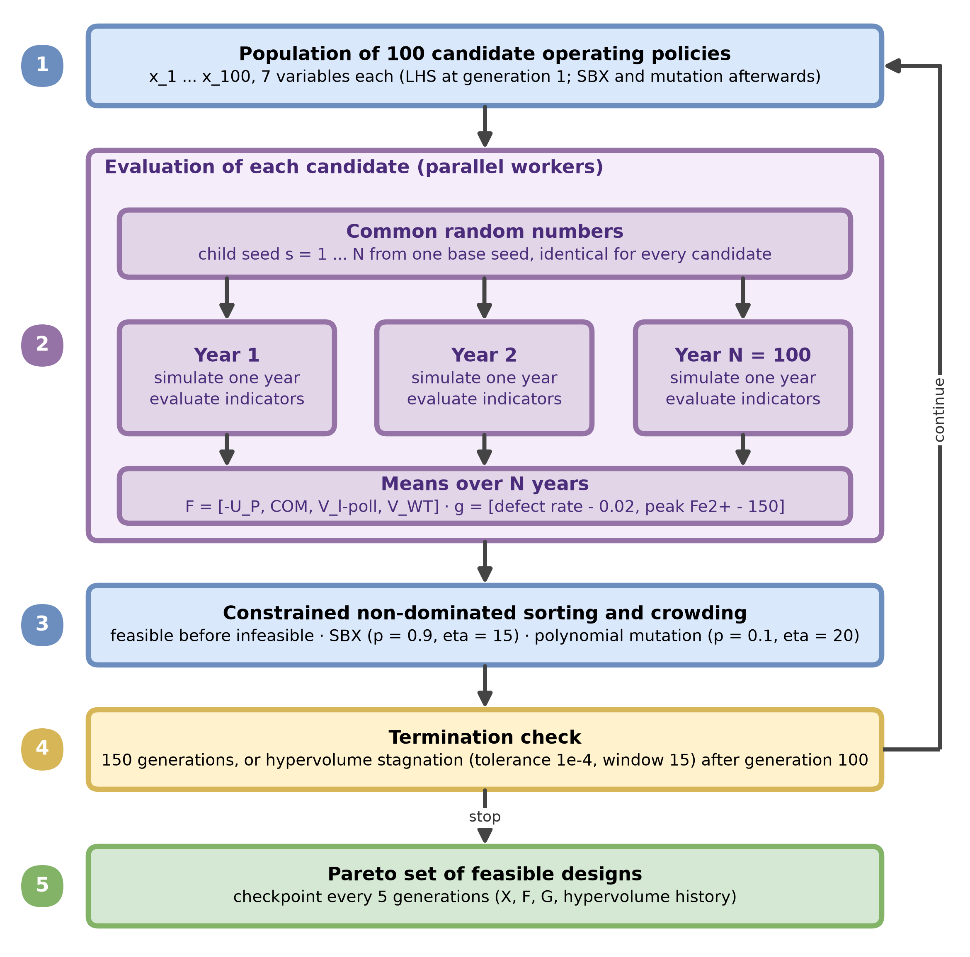
Figure 3. Evaluation of a candidate and search loop of the optimization. Each candidate is simulated for N = 100 random years that use common random numbers; the means over the years give its objectives and constraints; NSGA-II ranks and recombines the candidates until the termination test stops the search, and the feasible non-dominated set is the result. LHS = Latin hypercube sampling; SBX = simulated binary crossover.

Compromise selection and sensitivity analyses
The feasible non-dominated designs of the final population were re-evaluated with 41,379,264 pieces per year, N = 100 years, and the same random numbers, and the designs that were no longer feasible at that scale were discarded. For each objective k, a linear fuzzy satisfaction membership between the nadir and the utopia values of the remaining set is defined by Eq. (7) (Zimmermann, 1978).
 | $$μ_{k}\left(x\right)=\frac{f_{k}^{nadir}-f_{k}\left(x\right)}{f_{k}^{nadir}-f_{k}^{utopia}}$$ | (7)
The compromise design is the one with the highest weighted additive membership, given by Eq. (8).
 | $$μ_{overall}\left(x\right)=\sum_{k}{W_{k}μ_{k}\left(x\right)}$$ | (8)
The weights W_{k} come from the FAHP category weights of the 2019 study: the weight of U_{P} is the sum of the efficiency, energy, and quality weights (0.607), the weight of COM is the economy weight (0.250), and the environment weight is split equally between V_{l-poll} and V_{WT} (0.072 each). Because U_{P} already integrates indicators of all categories, this mapping gives additional weight to the cost, liquid waste, and water objectives, and the Pareto set does not depend on the weights, only the selected design does. The sensitivity of the selection was therefore examined with three alternatives: weights taken from the individual indicators of the 2019 table (0.708 for U_{P}, 0.250 for COM, 0.018 for V_{l-poll}, and 0.024 for V_{WT}), equal weights, and 10,000 weight vectors drawn uniformly from the simplex, for which the share of vectors that select each design and the spread of the selected designs are reported.
The cost of manufacture was calculated with raw-material prices of 2025 (Table 4; Supporting Information SI-4), which are bulk or export market values, except for zinc, which is the annual average of the London Metal Exchange reported by the USGS (2026). Energy, water, labor, and fixed capital keep the values of the 2019 study (Hernandez-Betancur, 2018). The optimization itself was run with the prices of the 2019 study (2016 to 2018), in which the price of ammonium hydroxide was corrected because the original listing converted a price per litre into a price per tonne (Supporting Information SI-4); the Pareto set was therefore found under those prices and then re-evaluated at full-year scale with the prices of 2025. To test how much the prices matter, the Pareto set was also re-evaluated with the same random numbers under the prices of the 2019 study, and the compromise design, the cost saving with respect to the baseline, and the rank correlation (Spearman) of COM across the Pareto set were compared between the two sets of prices. The prices of the 2019 study are marketplace quotes for small lots, whereas the prices of 2025 are bulk or export market values, so the comparison mixes the passage of time with the purchasing scale and is interpreted as a sensitivity analysis, not as a forecast. Because prices do not enter U_{P}, V_{l-poll}, or V_{WT}, only the cost objective changes.
Table 4. Raw-material prices of 2025 (USD per tonne of the commercial product). Zinc: LME annual average reported by the USGS (2026). NaOH: Argus Media (2025) quotes per dry tonne converted to a 50 wt% solution (× 0.5). ZnCl₂, NH₄Cl, and HCl: IMARC Group (2025, 2026a, 2026b). NH₄OH: Intratec (2026). The IMARC and Intratec pages do not state the concentration or grade, so the HCl and NH₄OH values may differ from the cost per tonne of the 37 wt% and 30 wt% solutions of the 2019 study. The prices of the 2019 study, used in the sensitivity analysis, are given in Supporting Information SI-4. Energy, water, labor, and fixed capital keep the values of the 2019 study.
Raw material | Price, 2025 (USD/t)
Zinc, 99.9 wt% | 2,866
ZnCl₂ | 1,296
NH₄Cl | 260
HCl, 37 wt% | 244
NaOH, 50 wt% | 185
NH₄OH, 30 wt% | 173

Comparison of the baseline and the selected design
The compromise design and the baseline design were each evaluated with 1,000 simulated years of 41,379,264 pieces under the same random numbers and with the prices of 2025. For both designs, the means, standard deviations, and 95% confidence intervals of the mean (Student t) of U_{P} (as a percentage of U_{max}), COM, V_{l-poll}, V_{WT}, the coating thickness, and the defect fraction φ_{δ} are reported, together with P_{sustainable}. The scores of the 17 indicators and of the quality indicator, the distributions of the indicators of the critical stages (pickling and fluxing), and the density of U_{P} relative to the sustainability threshold are used to explain where the selected design differs from the baseline.

Results and discussion
[To be written when the optimization has finished. Planned subsections: validation of the re-implemented model against the 2019 study; the Pareto set and its trade-offs (Figure 4); the compromise design and its sensitivity to weights and prices; baseline versus optimized design (indicator profile, critical-stage distributions, and probability of sustainability; Figures 5 to 7 and Table 5); limitations.]

Conclusions
[To be written after the results.]

References
Akamphon, S., Sukkasi, S., & Boonyongmaneerat, Y. (2012). Reduction of zinc consumption with enhanced corrosion protection in hot-dip galvanized coatings: A process-based cost analysis. Resources, Conservation and Recycling, 58, 1–7. https://doi.org/10.1016/j.resconrec.2011.10.001
Arguillarena, A., Margallo, M., Arruti-Fernández, A., Pinedo, J., Gómez, P., Ortiz, I., & Urtiaga, A. (2023). Circular economy in hot-dip galvanizing with zinc and iron recovery from spent pickling acids. RSC Advances, 13(10), 6481–6489. https://doi.org/10.1039/d2ra08195d
Arguillarena, A., Margallo, M., Irabien, Á., & Urtiaga, A. (2022). Life cycle assessment of zinc and iron recovery from spent pickling acids by membrane-based solvent extraction and electrowinning. Journal of Environmental Management, 318, 115567. https://doi.org/10.1016/j.jenvman.2022.115567
Argus Media. (2025). Argus chlor-alkali and derivatives (Issue 25-46, 14 November 2025). Argus Media group. https://view.argusmedia.com/rs/584-BUW-606/images/FER-20251114chlor-alkali.pdf
Chang, D.-Y. (1996). Applications of the extent analysis method on fuzzy AHP. European Journal of Operational Research, 95(3), 649–655. https://doi.org/10.1016/0377-2217(95)00300-2
Costa, P., Altamirano, G., Salinas, A., González-González, D. S., & Goodwin, F. (2019). Optimization of the continuous galvanizing heat treatment process in ultra-high strength dual phase steels using a multivariate model. Metals, 9(6), 703. https://doi.org/10.3390/met9060703
Crișan, C. A., Timiș, E. C., & Vermeșan, H. (2023). PickT: A decision-making tool for the optimal pickling process operation. Materials, 16(16), 5567. https://doi.org/10.3390/ma16165567
Deb, K., Pratap, A., Agarwal, S., & Meyarivan, T. (2002). A fast and elitist multiobjective genetic algorithm: NSGA-II. IEEE Transactions on Evolutionary Computation, 6(2), 182–197. https://doi.org/10.1109/4235.996017
Fresner, J., Schnitzer, H., Gwehenberger, G., Planasch, M., Brunner, C., Taferner, K., & Mair, J. (2007). Practical experiences with the implementation of the concept of zero emissions in the surface treatment industry in Austria. Journal of Cleaner Production, 15(13–14), 1228–1239. https://doi.org/10.1016/j.jclepro.2006.07.024
Hegyi, A., Păstrav, M., & Rus, M. (2015). Environmental and economic aspects of anticorrosion protection by hot-dip galvanized method rebars in concrete. Journal of Applied Engineering Sciences, 5(1), 23–30. https://doi.org/10.1515/jaes-2015-0003
Hernandez-Betancur, J. D., Hernandez, H. F., & Ocampo-Carmona, L. M. (2019). A holistic framework for assessing hot-dip galvanizing process sustainability. Journal of Cleaner Production, 206, 755–766. https://doi.org/10.1016/j.jclepro.2018.09.177
Hernandez-Betancur, J. D. (2018). Detección de los puntos críticos del proceso de galvanizado por inmersión en caliente: un enfoque hacia la sostenibilidad y el desarrollo sostenible [Master’s thesis, Universidad Nacional de Colombia]. https://repositorio.unal.edu.co/handle/unal/63201
IMARC Group. (2026a). Ammonium chloride price trend and forecast. https://www.imarcgroup.com/ammonium-chloride-pricing-report
IMARC Group. (2026b). Hydrochloric acid price index, trend and forecast. https://www.imarcgroup.com/hydrochloric-acid-pricing-report
IMARC Group. (2025). Zinc chloride prices in the USA stand at USD 1,296/MT amid stable industrial demand. https://www.imarcgroup.com/news/zinc-chloride-price-index
International Lead and Zinc Study Group. (2024). The world zinc factbook 2024. ILZSG. https://www.ilzsg.org/wp-content/uploads/SitePDFs/The%20World%20Zinc%20Factbook%202024.pdf
International Organization for Standardization. (2009). Hot dip galvanized coatings on fabricated iron and steel articles — Specifications and test methods (ISO 1461:2009). ISO.
Intratec. (2026). Ammonium hydroxide prices worldwide. https://www.intratec.us/chemical-markets/ammonium-hydroxide-price
Kleywegt, A. J., Shapiro, A., & Homem-de-Mello, T. (2002). The sample average approximation method for stochastic discrete optimization. SIAM Journal on Optimization, 12(2), 479–502. https://doi.org/10.1137/S1052623499363220
Koch, G., Varney, J., Thompson, N., Moghissi, O., Gould, M., & Payer, J. (2016). International measures of prevention, application, and economics of corrosion technologies study. NACE International.
Kong, G., & White, R. (2010). Toward cleaner production of hot dip galvanizing industry in China. Journal of Cleaner Production, 18(10–11), 1092–1099. https://doi.org/10.1016/j.jclepro.2010.03.006
Law, A. M. (2015). Simulation modeling and analysis (5th ed.). McGraw-Hill Education.
Lobato, N. C. C., Villegas, E. A., & Mansur, M. B. (2015). Management of solid wastes from steelmaking and galvanizing processes: A brief review. Resources, Conservation and Recycling, 102, 49–57. https://doi.org/10.1016/j.resconrec.2015.05.025
Lorenz, M., Seitfudem, G., Randazzo, S., Gueccia, R., Gehring, F., & Prenzel, T. M. (2023). Combining membrane and zero brine technologies in waste acid treatment for a circular economy in the hot-dip galvanizing industry: A life cycle perspective. Journal of Sustainable Metallurgy, 9(2), 537–549. https://doi.org/10.1007/s40831-023-00668-3
McKay, M. D., Beckman, R. J., & Conover, W. J. (1979). Comparison of three methods for selecting values of input variables in the analysis of output from a computer code. Technometrics, 21(2), 239–245. https://doi.org/10.1080/00401706.1979.10489755
Reséndiz-Flores, E. O., Altamirano-Guerrero, G., Costa, P. S., Salas-Reyes, A. E., Salinas-Rodríguez, A., & Goodwin, F. (2021). Optimal design of hot-dip galvanized DP steels via artificial neural networks and multi-objective genetic optimization. Metals, 11(4), 578. https://doi.org/10.3390/met11040578
Ruiz-Mercado, G. J., Smith, R. L., & Gonzalez, M. A. (2012). Sustainability indicators for chemical processes: I. Taxonomy. Industrial & Engineering Chemistry Research, 51(5), 2309–2328. https://doi.org/10.1021/ie102116e
Smith, R. L., & Ruiz-Mercado, G. J. (2014). A method for decision making using sustainability indicators. Clean Technologies and Environmental Policy, 16(4), 749–755. https://doi.org/10.1007/s10098-013-0684-5
Tongpool, R., Jirajariyavech, A., Yuvaniyama, C., & Mungcharoen, T. (2010). Analysis of steel production in Thailand: Environmental impacts and solutions. Energy, 35(10), 4192–4200. https://doi.org/10.1016/j.energy.2010.07.003
U.S. Geological Survey. (2025). Interior Department releases final 2025 list of critical minerals. https://www.usgs.gov/news/science-snippet/interior-department-releases-final-2025-list-critical-minerals
U.S. Geological Survey. (2026). Zinc. In Mineral commodity summaries 2026. https://pubs.usgs.gov/periodicals/mcs2026/mcs2026-zinc.pdf
Vyhmeister, E., Ruiz-Mercado, G. J., Torres, A. I., & Posada, J. A. (2018). Optimization of multi-pathway production chains and multi-criteria decision-making through sustainability evaluation: A biojet fuel production case study. Clean Technologies and Environmental Policy, 20(7), 1697–1719. https://doi.org/10.1007/s10098-018-1576-5
Wang, Y. (2018). Study on influence factors of zinc layer thickness via response surface method, Taguchi method and genetic algorithm. Industrial Engineering & Management, 7(1). https://doi.org/10.4172/2169-0316.1000245
World Steel Association. (2025). December 2024 crude steel production and 2024 global crude steel production totals [Press release]. https://worldsteel.org/media/press-releases/2025/december-2024-crude-steel-production-and-2024-global-totals/
Zimmermann, H.-J. (1978). Fuzzy programming and linear programming with several objective functions. Fuzzy Sets and Systems, 1(1), 45–55. https://doi.org/10.1016/0165-0114(78)90031-3
Zitzler, E., & Thiele, L. (1999). Multiobjective evolutionary algorithms: A comparative case study and the strength Pareto approach. IEEE Transactions on Evolutionary Computation, 3(4), 257–271. https://doi.org/10.1109/4235.797969

