XanBus Application Note 1: What’s in a NAME?

What is a NAME?
The XanBus NAME is a unique 8-byte value that is used by all XanBus devices to claim a unique address on the network. The NAME is divided into a number of useful fields that include device function, device instance, manufacturer code and unique number (electronic serial number) as shown in Figure 1. For complete details on the XanBus NAME, see the XanBus Specification.
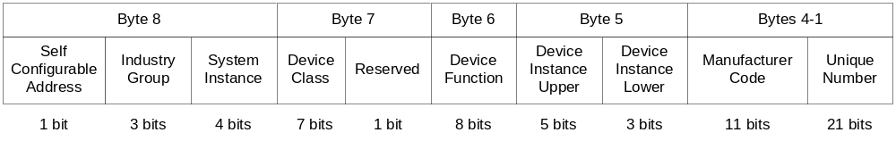
Figure 1: NAME Fields

Where is (are) it (they) Stored?
The NAME is stored in non-volatile storage because some of the fields, such as device instance, are configurable. To support the loader and the concept of factory, OEM and user configurations, there are at least two (2) and there may be up to four (4) versions of the NAME stored in non-volatile storage as shown in Figure 2. Note: In the current implementation, the Loader Software can only access the Loader Section of NVRAM.
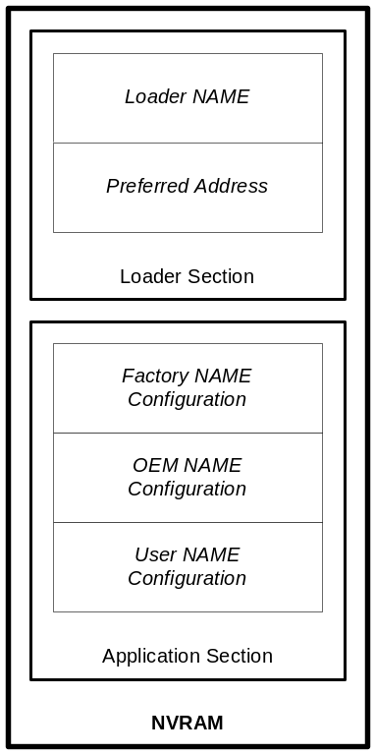
Figure 2: NAME Storage

What’s My NAME When I’m Born?
When a device reaches the end of the production line and is powered-up and tested for the first time, it doesn’t have any NAME(s) (i.e., the NVRAM is empty). The Loader Software creates a non-unique NAME (currently it has no access to the electronic serial number) so it can claim an address and receive an Application Software download from the Diagnostic Tool. This means that, under the current implementation, only one device may be downloaded per Diagnostic Tool.

What’s My NAME Again?
After receiving Application Software download and rebooting, for the first time, the Application Software examines the Loader NAME area of NVRAM and determines that there is no valid Loader NAME. The Application Software, being sentient, knows what its device function is and is able to read its electronic serial number and so it writes a unique NAME into the Loader NAME and Factory NAME Configuration areas of NVRAM. The Application Software then uses its Loader NAME to claim and defend a unique address on the network.

And My Address?
In addition to the NAME(s), the Application Software maintains its claimed address in the Preferred Address area of NVRAM. This is done to reduce conflicts and allow devices to obtain their addresses more quickly the next time they power-up/restart.

So What About the Loader NAME?
The next time, after the Application Software’s first initialization, the device is reset into download mode, presumably for an Application Software update; the Loader Software uses its new unique Loader NAME to claim its Preferred Address. Because the Loader Software is using this new NAME, it will not have address conflicts with other devices on the network.

OK, OK, But What About Those Other NAMEs?
As mentioned earlier, it is possible to configure a device’s NAME by sending a NAME Configuration message via either an SCP (user configuration only) or a Diagnostic Tool. A device’s NAME may need to be configured in order to change its instance if there is more than one of a particular device function on the same network, for example. Changing a device’s User NAME Configuration will also update the Loader NAME and may cause the device to claim and set a new Preferred Address.
Changing a device’s OEM or Factory NAME Configuration does not have the same side effects as changing the User NAME Configuration. However, a device’s OEM and Factory NAMEs are significant when the device receives a Reset Command – OEM/Factory message that causes the device to reset its configuration to OEM or Factory defaults. In this case, the Application Software copies the OEM/Factory NAME Configuration into the User and Loader NAME areas and may reclaim and save a new Preferred Address.

It’s Just that Easy!

