XanBus Application Note 2: ISO Acknowledgment

To ACK or NAK, that is the question.
The ISO Acknowledgment (XanBus::IsoAck) message is utilized extensively throughout XanBus to provide feedback. Whether a response to a request or a command we can only hope that someone is listening at the other end.

ISO 11783 Basics
Some of the expected behaviour is clearly defined for us.

When dealing with an ISO Request (XanBus::IsoReq) ISO 11783-3 states:
A response is always required from a specific destination (not global), even if it is a NACK indicating that the particular PGN value is not supported. A global request shall not be responded to with a NACK when a particular PGN is not supported by a controller.
Besides being two sentence with the same meaning… it is fairly obvious what they are after.

Next:
The second form of acknowledgment, which is in the data field, is a response of a “normal broadcast” or “ACK” or “NACK” to a specific command or request as provided for by the application layer. The type of acknowledgment required for some Parameter Groups is defined in the applications layer.

Woe… “What in the wide, wide, world of sports is going on here?”
-- Blazing Saddles

Oddly enough… if you have ever read my testplan, you would have appreciated that ISO 11783 breaks messages into 5 categories:
- Commands (this includes XanBus configuration messages)
- Requests
- Broadcasts/Responses
- Acknowledgment
- Group Function
Further, ISO indicates (in Annex C) that for commands, unless it is easy to determine that the receiving device has acted upon the command, a response is required. NMEA goes on to blather that:
If the PGN in a Command or Request is not recognized by the destination, it shall reply with the ACK or NACK message.

XanBus, The Other Red Meat
NMEA has one other trick up its sleeve… “Access is Denied”.

XanBus makes use of “Access is Denied” for responding to commands or requests where the originator has no right to the control or information.
Note: XanBus also has a couple messages that you just can’t request as it is either a protocol violation or nonsensical.

The XanBus database “…\Doc\Specifications\XanBusDB.mdb” has defined responses depending on the type of node. See any XanBus guru for help deciphering the information.

For any particular message the database defines the expected behaviour for a device based on whether the device is a transmitter/receiver and if the device is to respond to an ISO Request for the message.
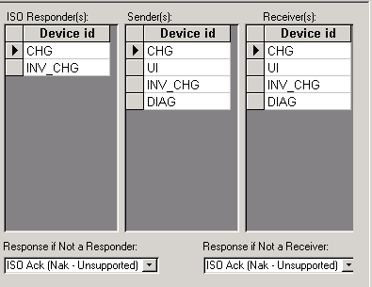
As you can see XanBus defines how the device should respond if it is not a receiver or responder.

Does this really matter?
In simplest of terms…

Yes (as Tequila will only do so much). We have written the testplan and automated test scripts that rely on the security test to be performed first.

In simplest of terms:
// test that we recognize the message
if (!CheckMessage( lptMessage ){
fnSendISOAck( NAK );
return;
}

// test security (.SA vs .DeviceFunction)
if (!fnCheckSecutity( lptMessage )) {
fnSendISOAck( DENY );
return;
}

// test the that the data is valid
if (!fnCheckData( lptMessage )) {
fnSendISOAck( NAK );
return;
}
else {
fnSendISOAck (ACK );
// process the message
}

It’s Just that Easy!

