Software Library Usage Manual
for the
btgdvsubsys Application Programming Interface is automatically updated (do not edit)
of the
btgdvsystem System is automatically updated (do not edit)
Document Number: btgdvdocnumis automatically inserted (do not edit)
Revision: btgdvlatrevis automatically inserted (do not edit)
btgdvseclvlsecurity level is automatically inserted (do not edit)
Last Saved: 2003-10-20is automatically generated (do not edit)
Approvals
(Sub)system Architect |  | Date:
(Sub)system Designer |  | Date:
Program Manager |  | Date:
Technical Champion |  | Date:
Business Champion |  | Date:

Revision History
Revision | Date | Editor | Description
1 | 2003-01-21 | btgdvprepby | Creation
2 | 2003-01-31 | P.Drexel | Updated per latest code.  Fixed spelling and grammar.
3 | 2003-02-06 | P.Drexel | First release to SCP, AGS and Nova teams.
4 | 2003-04-24 | P.Drexel | Added document number  Updated per latest XPAPI source code  Updated per latest VSS structure
5 | 2003-06-27 | P.Drexel | Updated per Nova/Miata feedback.  Significantly reduced number of callback functions.  Significantly reduced number timer API functions.  Separated XanBus-specific PGN handling from application-specific PGN handling.  Added non-volatile storage section.
6 | 2003-07-07 | P.Drexel | Changed links to XEOS directories due to recent IT change.  Added API and Callback function summary appendix.  Added DIAG directory to file structure.  Removed XBPLATFORM_fnSetIdentIndic because the application has to handle the Enable/Disable Configuration message.  Clarified uiStartAt parameter of XBTIMERS_fnSetTxTimer.  Corrected definition of “struct XB_zPGN_ISO_ADDR_CLAIM.”  Corrected uliPGN to uliPgn.  Added XBINIT_fnGetErrorNum function.  Deleted parameter from XBPLATFORM_fnCheckErrors.  Added xb.py to file structure.  Corrected enumeration definitions.  Replaced calls to XBPLATFORM_fnCheckErrors with XBINIT_fnGetErrorNum.
7 | 2003-07-17 | P.Drexel | Updated for coding standard compliance. Matches xbgdefs.h, xbudefs.h, XanBusDB.mdb labeled 0.3.1 and xanbus_headergen.py, xb.py labeled 0.5.1.
8 | 2003-07-24 | P.Drexel | Changed uli prefix to ul.  Changed enumerated types to match latest coding standard.
9 | 2003-10-17 | P.Drexel | Added description of XBINIT_fnSleepCtrl.  Added description of XBINIT_fnResetCfg.  Added description of XBINIT_fnNetCtrl.  Added XB_teNET_CTRL type.  Removed reference to XBADDR_fnBeginClaiming.  Added description of XBADDR_fnAddrState.  Added description of XBPLATFORM_fnRecvXbMsg.  Added XB_ePARAM_TYPE_NAME_CONFIG non-volatile data type.  Added XB_eNODE_CHANGE_ADDRESS node change type.  Updated XanBus non-volatile configuration data sizes to include OEM and User.  Added description of XBMSG_fnClearCommStats.

Entries in this table are created using the “New Revision” button on the “Base” Toolbar. The revision number is incremented automatically. The latest document revision number, on the cover and in the footer, is also updated.
Distribution/Notification
Table 1: Document Distribution List
Name | Title | Location
 | Business Champion
 | Technical Champion
 | Program Manager
 | (Sub)system Architect
 | (Sub)system Designer
 | Verification Engineer
 | Product Manager

Table 2: Document Notification List
Name | Title | Location
 | Director of Engineering
 | VP of Engineering
 | CTO
 | Director of Product Mgt
 | Customer Service Rep
 | Manufacturing Rep
 | Quality Assurance Rep
 | Marketing Rep
 | Sales Rep
 | Customer Rep
 | Electrical Engineer
 | Mechanical Engineer

These tables specify who should receive updated copies of this document (distribution list) and who should be notified that the document was changed (notification list). The above entries are suggestions only and may not apply in all cases. The same person may fulfill more than one role or there may be more than one person who fulfills a particular role. These lists are handy for administrative assistants who may be the one’s distributing and notifying.
Table of Contents
Revision History ii
Distribution/Notification iv
Table of Contents xiv
List of Tables xiv
List of Figures xv
List of Source Code Listings xvi
1 Introduction 1
1.1 Identification 1
1.2 Overview 1
1.3 Scope 1
1.4 Reference Documents 1
1.5 Definitions 2
2 XanBus Software Library Architecture Overview 2
2.1 XBCAN Driver 3
2.2 XBP Stack 4
2.3 XBAPI 5
3 Directory and File Structures 5
3.1 Distribution Directory Structure 5
3.1.1 Common/Inc/xbgdefs.h 8
3.1.2 Tools/CDBCodeGenerator/XanBusDB.mdb 8
3.1.3 Tools/CDBCodeGenerator/xanbus_headergen.py 8
3.1.4 Tools/CDBCodeGenerator/xb.py 8
3.1.5 Tools/CDBCodeGenerator/xbudefs.h 8
3.1.6 Tools/CDBCodeGenerator/xbrxtx.h 8
3.1.7 Tools/CDBCodeGenerator/<device-function>/xbpgntbl.c 9
3.1.8 Tools/CDBCodeGenerator/<device-function>/apprxtx.h 9
3.2 Typical XanBus Application Directory Structure 9
4 API Usage Example 12
5 XBAPI Reference 22
5.1 Data Types 22
5.1.1 XB_tzRECV_DATA 22
5.1.1.1 Description 22
5.1.1.2 Relevant XBAPI Functions 22
5.1.1.3 Definition 22
5.1.1.4 Fields 22
5.1.1.4.1 ulPgn 22
5.1.1.4.2 siGrpFunc 22
5.1.1.4.3 pStruct 24
5.1.1.4.4 ptzPgnInfo 24
5.1.1.4.5 ucSrcAddr 24
5.1.1.4.6 ucDest 24
5.1.1.4.7 ucUseCount 24
5.1.2 XB_tzPGN_ISO_ADDR_CLAIM 24
5.1.2.1 Description 24
5.1.2.2 Relevant XBAPI Functions 24
5.1.2.3 Definition 25
5.1.2.4 Fields 25
5.1.3 XB_teFUNC_CODE 25
5.1.3.1 Description 25
5.1.3.2 Relevant XBAPI Functions 25
5.1.3.3 Definition 25
5.1.4 XB_tePARAM_TYPE 25
5.1.4.1 Description 25
5.1.4.2 Relevant XBAPI Functions 26
5.1.4.3 Definition 26
5.1.5 XB_teNODE_CHANGE 26
5.1.5.1 Description 26
5.1.5.2 Relevant XBAPI Functions 26
5.1.5.3 Definition 26
5.1.6 XB_teNET_CTRL 26
5.1.6.1 Description 26
5.1.6.2 Relevant XBAPI Functions 26
5.1.6.3 Definition 26
5.1.7 XB_teADDR_STATE 27
5.1.7.1 Description 27
5.1.7.2 Relevant XBAPI Functions 27
5.1.7.3 Definition 27
5.2 Non-Volatile Data 27
5.2.1 Preferred Address 27
5.2.1.1 Data Size 27
5.2.1.2 Default Value(s) 27
5.2.2 NAME 28
5.2.2.1 Data Size 28
5.2.2.2 Default Value(s) 28
5.2.3 NAME Configuration 28
5.2.3.1 Data Size 28
5.2.3.2 Default Value(s) 29
5.2.4 Periodic Transmit Timer Configuration 29
5.2.4.1 Data Size 29
5.2.4.2 Default Value(s) 29
5.2.5 Receive Timeout Configuration 30
5.2.5.1 Data Size 31
5.2.5.2 Default Value(s) 31
5.3 API Functions 32
5.3.1 XBINIT_fnInit 32
5.3.1.1 Description 32
5.3.1.2 Prototype 32
5.3.1.3 Parameters 32
5.3.1.3.1 ucMSPerTick 32
5.3.1.4 Result 32
5.3.1.5 Notes 32
5.3.2 XBINIT_fnGetErrorNum 33
5.3.2.1 Description 33
5.3.2.2 Prototype 33
5.3.2.3 Parameters 33
5.3.2.4 Result 33
5.3.2.5 Notes 33
5.3.3 XBINIT_fnGetErrorStr 33
5.3.3.1 Description 33
5.3.3.2 Prototype 33
5.3.3.3 Parameters 33
5.3.3.3.1 ppscSrc 33
5.3.3.3.2 ppscErr 34
5.3.3.4 Result 34
5.3.3.5 Notes 34
5.3.4 XBINIT_fnTick 34
5.3.4.1 Description 34
5.3.4.2 Prototype 34
5.3.4.3 Parameters 34
5.3.4.4 Result 34
5.3.4.5 Notes 34
5.3.5 XBINIT_fnNetCtrl 35
5.3.5.1 Description 35
5.3.5.2 Prototype 35
5.3.5.3 Parameters 35
5.3.5.3.1 teControl 35
5.3.5.4 Result 35
5.3.5.5 Notes 35
5.3.6 XBINIT_fnResetCfg 35
5.3.6.1 Description 35
5.3.6.2 Prototype 36
5.3.6.3 Parameters 36
5.3.6.3.1 eCmd 36
5.3.6.4 Result 36
5.3.6.5 Notes 36
5.3.7 XBINIT_fnSleepCtrl 36
5.3.7.1 Description 36
5.3.7.2 Prototype 36
5.3.7.3 Parameters 36
5.3.7.3.1 ucSleep 36
5.3.7.3.2 callback 36
5.3.7.4 Result 36
5.3.7.5 Notes 36
5.3.8 XBADDR_fnGetName 37
5.3.8.1 Description 37
5.3.8.2 Prototype 37
5.3.8.3 Parameters 37
5.3.8.3.1 ucAddr 37
5.3.8.3.2 ptzName 37
5.3.8.4 Result 37
5.3.8.5 Notes 37
5.3.9 XBADDR_fnGetDevice 38
5.3.9.1 Description 38
5.3.9.2 Prototype 38
5.3.9.3 Parameters 38
5.3.9.3.1 ucAddr 38
5.3.9.3.2 ptDevFunc 38
5.3.9.3.3 pInst 38
5.3.9.4 Result 38
5.3.9.5 Notes 38
5.3.10 XBADDR_fnFindDevice 39
5.3.10.1 Description 39
5.3.10.2 Prototype 39
5.3.10.3 Parameters 39
5.3.10.3.1 pIndex 39
5.3.10.3.2 pAddr 39
5.3.10.3.3 pDevFunc 39
5.3.10.3.4 pInst 39
5.3.10.4 Result 39
5.3.10.5 Notes 39
5.3.11 XBADDR_fnTestPriority 40
5.3.11.1 Description 40
5.3.11.2 Prototype 40
5.3.11.3 Parameters 40
5.3.11.3.1 ucAddr 40
5.3.11.4 Result 40
5.3.11.5 Notes 40
5.3.12 XBADDR_fnGetMyAddr 40
5.3.12.1 Description 40
5.3.12.2 Prototype 40
5.3.12.3 Parameters 40
5.3.12.4 Result 41
5.3.12.5 Notes 41
5.3.13 XBADDR_fnAddrState 41
5.3.13.1 Description 41
5.3.13.2 Prototype 41
5.3.13.3 Parameters 41
5.3.13.4 Result 42
5.3.13.5 Notes 42
5.3.14 XBMSG_fnDestroyRecvStruct 42
5.3.14.1 Description 42
5.3.14.2 Prototype 42
5.3.14.3 Parameters 42
5.3.14.3.1 ptzRecv 42
5.3.14.4 Result 42
5.3.14.5 Notes 42
5.3.15 XBMSG_fnOnLine 42
5.3.15.1 Description 42
5.3.15.2 Prototype 42
5.3.15.3 Parameters 43
5.3.15.4 Result 43
5.3.15.5 Notes 43
5.3.16 XBMSG_fnGetBusState 43
5.3.16.1 Description 43
5.3.16.2 Prototype 43
5.3.16.3 Parameters 43
5.3.16.4 Result 43
5.3.16.5 Notes 43
5.3.17 XBMSG_fnSend 43
5.3.17.1 Description 43
5.3.17.2 Prototype 43
5.3.17.3 Parameters 43
5.3.17.3.1 ulPgn 43
5.3.17.3.2 pzStruct 44
5.3.17.3.3 uiSrcSize 44
5.3.17.3.4 ucDest 44
5.3.17.4 Result 44
5.3.17.5 Notes 44
5.3.18 XBMSG_fnSendEx 44
5.3.18.1 Description 44
5.3.18.2 Prototype 44
5.3.18.3 Parameters 44
5.3.18.3.1 ulPgn 44
5.3.18.3.2 siGrpFunc 44
5.3.18.3.3 pzStruct 44
5.3.18.3.4 uiSrcSize 45
5.3.18.3.5 ucDest 45
5.3.18.4 Result 45
5.3.18.5 Notes 45
5.3.19 XBMSG_fnControlDynamic 45
5.3.19.1 Description 45
5.3.19.2 Prototype 45
5.3.19.3 Parameters 45
5.3.19.3.1 ulPgn 45
5.3.19.3.2 tucOn 45
5.3.19.4 Result 45
5.3.19.5 Notes 45
5.3.20 XBMSG_fnClearDynamic 46
5.3.20.1 Description 46
5.3.20.2 Prototype 46
5.3.20.3 Parameters 46
5.3.20.4 Result 46
5.3.20.5 Notes 46
5.3.21 XBMSG_fnSendIsoAck 46
5.3.21.1 Description 46
5.3.21.2 Prototype 46
5.3.21.3 Parameters 46
5.3.21.3.1 ulPgn 46
5.3.21.3.2 eControl 46
5.3.21.4 Result 47
5.3.21.5 Notes 47
5.3.22 XBMSG_fnIsoReq 47
5.3.22.1 Description 47
5.3.22.2 Prototype 47
5.3.22.3 Parameters 47
5.3.22.3.1 ulPgn 47
5.3.22.3.2 ucDest 47
5.3.22.4 Result 47
5.3.22.5 Notes 47
5.3.23 XBMSG_fnClearCommStats 47
5.3.23.1 Description 47
5.3.23.2 Prototype 47
5.3.23.3 Parameters 48
5.3.23.4 Result 48
5.3.23.5 Notes 48
5.3.24 XBTIMERS_fnSetTxTimer 48
5.3.24.1 Description 48
5.3.24.2 Prototype 48
5.3.24.3 Parameters 48
5.3.24.3.1 ulPgn 48
5.3.24.3.2 ucDest 48
5.3.24.3.3 uiPeriod 48
5.3.24.3.4 uiStartAt 48
5.3.24.4 Result 48
5.3.24.5 Notes 49
5.3.25 XBTIMERS_fnSetPeriodReports 49
5.3.25.1 Description 49
5.3.25.2 Prototype 49
5.3.25.3 Parameters 49
5.3.25.3.1 tucActive 49
5.3.25.4 Result 49
5.3.25.5 Notes 49
5.4 Application Callback Functions 49
5.4.1 XBPLATFORM_fnCheckErrors 49
5.4.1.1 Description 49
5.4.1.2 Prototype 49
5.4.1.3 Parameters 50
5.4.1.4 Result 50
5.4.1.5 Notes 50
5.4.2 XBPLATFORM_fnSetNetIndic 50
5.4.2.1 Description 50
5.4.2.2 Prototype 50
5.4.2.3 Parameters 50
5.4.2.3.1 ucBusState 50
5.4.2.3.2 tucOn 50
5.4.2.4 Result 51
5.4.2.5 Notes 51
5.4.3 XBPLATFORM_fnLoad 51
5.4.3.1 Description 51
5.4.3.2 Prototype 51
5.4.3.3 Parameters 51
5.4.3.3.1 teType 51
5.4.3.3.2 pData 51
5.4.3.3.3 uiSize 51
5.4.3.4 Result 51
5.4.3.5 Notes 51
5.4.4 XBPLATFORM_fnSave 52
5.4.4.1 Description 52
5.4.4.2 Prototype 52
5.4.4.3 Parameters 52
5.4.4.3.1 teType 52
5.4.4.3.2 pData 52
5.4.4.3.3 uiSize 52
5.4.4.4 Result 52
5.4.4.5 Notes 52
5.4.5 XBPLATFORM_fnNodeChange 52
5.4.5.1 Description 52
5.4.5.2 Prototype 52
5.4.5.3 Parameters 53
5.4.5.3.1 teChange 53
5.4.5.3.2 ucAddr 53
5.4.5.3.3 ptzName 53
5.4.5.4 Result 53
5.4.5.5 Notes 53
5.4.6 XBPLATFORM_fnRecvXbMsg 53
5.4.6.1 Description 53
5.4.6.2 Prototype 53
5.4.6.3 Parameters 53
5.4.6.3.1 ptzRecv 53
5.4.6.4 Result 53
5.4.6.5 Notes 54
Appendix A : XanBus API Summary 55
A.1 API Functions 55
A.1.1 Initialize 55
A.1.2 Message Handling 55
A.1.3 Address/NAME 56
A.1.4 Timers 56
A.2 Callback Functions 56
Appendix B : XanBus PGNs – Sorted by PGN 58
Appendix C : Installing and Running Python 2.2 62
Appendix D : Windows® 2000 ODBC Setup 72
List of Tables
Table 1: Document Distribution List iv
Table 2: Document Notification List iv
Table 3: Reference Documents 1
Table 4: Definitions 2
Table 5: Default Periodic Transmit Configuration 29
Table 6: Default Receive Timeout Configuration 31
Table 7: XBINIT_fnNetCtrl Parameter Values 35
Table 8: XBADDR_fnAddrState Results 42
Table 9: Network Status Condition Codes 50

List of Figures
Figure 1: Software Structure 3
Figure 2: XBSL Distribution Relative File Structure 6
Figure 3: XBSL Distribution Relative File Structure (cont’) 7
Figure 4: Typical Applciation Directory Structure 11
Figure 5: Default NAME 28

List of Source Code Listings
Listing 1: Example Application 'main' 12
Listing 2: Example apprxtx.h File 15
Listing 3: Typical Application PGN Receive Function 17
Listing 4: Typical Application PGN Transmit Function 19
Listing 5: Example apprxtx.h File 20

Introduction
This text will not print. It is of style “InstructTextParagraph” and it is meant to provide instructions and tips for creating this document. Please do not delete it. This text will not be spell-checked. To obscure this text, click on the “Tools” menu, select “Options…”, select the “View” tab and uncheck “Hidden text” and then click “OK.” It is possible to print this document with this text. Click on the “Tools” menu, select “Options…”, select the “Print” tab and check “Hidden text” and then click “OK.”
Due to a feature/bug in Word, it is best to edit this document with this text showing. If not, you will have to be aware of the shape of the insertion point and/or the current style in the toolbar. If, when you enter or click into a section, the insertion point indicates italicized text (i.e., the insertion point is leaning over) or the style is “InstructionalText” then tap the “End” key to get to the beginning of the “Body Text.”
This document makes extensive use of fields and document variables which allow certain pieces of information to be inserted in the document automatically. For example, the “btgdvprepby” variable specifies that this document is being prepared by the name you entered on the creation form. To see how document variables are used, click on the “Tools” menu, select “Options…”, select the “View” tab, check “Field codes” and then click “OK.” Occasionally, some/or all of these fields will require updating before the document is printed. To update the fields click the “Update Fields” button in the custom toolbar.
All paragraphs should be written using the “Body Text” style.
All headings, except appendix headings, should use the appropriate level “Heading x” style. Appendix Headings should use the “Appendix Heading x” style.
All bulleted lists within the body text should use the “List Bullet” style.
All numbered lists within the body text should use the “List Number” style.
All figure and table captions should use the “Caption” style. To insert a caption select the table/figure, click the “Insert” menu, select “Caption…”, select the appropriate “Label” (if necessary), enter a colon “:” and the appropriate caption text and click “OK.” The caption will not be centered. Click the center justification icon on the toolbar to center the caption. Do NOT redefine the “Caption” style to include center justification. Word has a bug which prevents caption text from being entered in the Insert Caption Dialog Box when the “Caption” style includes centering.
All tables should be formatted using table auto formatting style “Professional” and “Table” style in that order. Select the table, click on the “Table” menu, select “Table AutoFormat…”, select “Professional” from the “Formats” list and click “OK”, select “Table” from the “Style” popup menu in the formatting toolbar, select the heading row(s) of the table and select “Table Headings” from the style popup menu in the formatting toolbar. Each table should have a single “Normal” blank line after it. Tables should also have the following attributes set to keep the rows of the table organized. Select the entire table, select “Table Properties…” from the “Table” menu, select the “Table” tab from the “Table Properties” dialog box, click the “Center” icon, click the “Row” tab, uncheck the “Allow row to break across pages” checkbox, click “OK.” Select the heading rows of the table, select “Heading Rows Repeat” from the “Table” menu, with the heading rows still selected, select “Paragraph” from the “Format” menu, select the “Line and Page Breaks” tab, check the “Keep with next” checkbox and click “OK.”
All figures should be created using Visio 5.
All figures should be formatted using the style “Figure.”
All references to headings, documents, tables and figures should be done using the “Cross-reference” command in the “Insert” menu. For sections/headings, except appendices, use the “Heading” “Reference type” and the “Heading number (full context)” “Insert reference to:.” For documents use the “Numbered item” “Reference type” and the “Paragraph number (full context)” “Insert reference to:.” For figures and tables, use the “Figure/Table” “Reference type” and “Only label and number” “Insert reference to:.” For document reference numbers and appendix headings, use the “Numbered item” “Reference type” and the “Paragraph number (full context)” “Insert reference to:.”
Do NOT add extra spaces or blank lines.
Do NOT delete any headings. If a heading does not apply, simply insert “None.” or “Not applicable.” as the body text below it. This indicates that you have considered the topic.
Do NOT add any body text to this section.

Identification
Most of this section is generated automatically. Edit only the “Printed Master Location:” line.
“Software Library Usage Manual for the btgdvsubsys Application Programming Interface of the btgdvsystem System”
Document Number: btgdvdocnum
Document Application: Microsoft Word 9.0
Electronic Master Location: /tmp/lo/0000.doc
Printed Master Location:

Overview
Briefly discuss the purpose of the subsystem and identify and describe the role, within the subsystem and (sub)system, of the software to which this document applies.
TBD

Scope
Briefly state the scope and contents of this document. What does this document discuss and what is excluded.
This document describes how to use the XanBus Software Library and, in particular, the XanBus Application Programming Interface (XBAPI). This document does not discuss the significance of particular XanBus messages or how to interpret them. For this information, consult [3] and [5].

Reference Documents
This section lists all of the documents referenced by this document. The list should be arrange numerically by document reference number. The document reference numbers in the first column use style “ReferenceNumber”. They will increment automatically.
This document references the documents shown in Table 3.
Table 3: Reference Documents
Document Reference | Document Title | Document Number
 | XanBus Market Requirements  (see location and hyperlink below) | 501-0068-01-01
 | \\Xbc-doc01\programs\ACTIVE\Corporate\XANBUS\MarketRqmts\XanBusMktReq.doc
 | XanBus Protocol Stack Software v1.0  Program Plan  (see location and hyperlink below) | 539-0044-01-01
 | \\Xbc-doc01\programs\ACTIVE\Corporate\XANBUS\ProgramPlan\Version1\XanBusProgPlanV1.doc
 | External Interface Specification Document for the XanBus Interface to the XanBus Communications Network  (see location and hyperlink below) | 539-5059-01-01
\\Xbc-doc01\programs\ACTIVE\Corporate\XANBUS\Specifications\XanBusSpec.doc
\\Xbc-doc01\programs\ACTIVE\Corporate\XANBUS\Specifications\XanBusSpec.pdf
 | Teleflex-Morse MagicBus™ Communications User’s Manual  (see location and hyperlink below) | Revision 1.43
 | \\Xbc-doc01\programs\ACTIVE\Corporate\XANBUS\Tools\Teleflex (MagicBus)\MagicBus Communications Manual.doc
Access Database of XanBus PGNs
(see location and hyperlink below)
 | \\Xbc-doc01\programs\ACTIVE\Corporate\XANBUS\Specifications\XanBusDB.mdb

Definitions
This section lists all of the acronyms, abbreviations and definitions used throughout this document. The list should be arrange alphabetically by item. Select the cells in the first column, do not include the “Item” cell. Click the “Table” menu, select “Sort…” and click “OK.”
This document refers to the acronyms, abbreviations and definitions shown in Table 4.
Table 4: Definitions
Item | Definition
CAN | Controller Area Network
XBAPI | XanBus Application Programming Interface
XBCAN Driver | XanBus CAN Driver
XBP Stack | XanBus Protocol Stack
XBSL | XanBus Software Library
ISR | Interrupt Service Routine

XanBus Software Library Architecture Overview
As shown in Figure 1, the XanBus Software Library (XBSL) is composed of four major components, namely the
- XanBus Controller Area Network (XBCAN) Driver
- XanBus Driver Shim (XBDS) (necessity depends on driver)
- XanBus Protocol (XBP) Stack and
- XanBus Application Programming Interface (XBAPI).

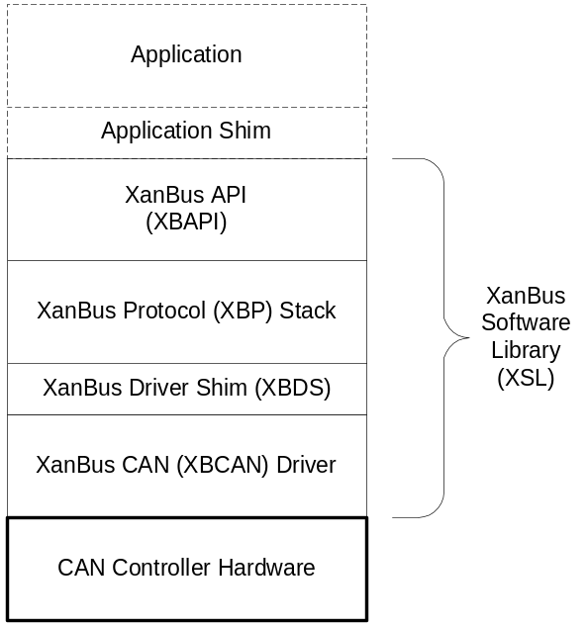
Figure 1: Software Structure
Except for the XBCAN Driver, these components were designed and coded to be hardware platform independent. All four components have been designed and coded to be operating environment independent. There are no assumptions made regarding operating system availability. The minimal hardware/software requirements include
- a compatible, interrupt-driven CAN controller
- 28 Kbytes of ROM
- 2.5 Kbytes of data RAM
- 2 Kbytes of heap RAM
- 0.5 Kbytes of stack RAM (shared with application)
- TBD Bytes of non-volatile RAM
- periodic call to a “tick” function.

The above RAM requirements are based on the Motorola HCS12 implementation.
The following subsections provide an overview of the XanBus components.

XBCAN Driver
The XBCAN Driver is the only component of the software that is hardware platform specific. For each supported platform, the driver software relies on a specific CAN controller architecture (i.e., registers, mailboxes, etc.) and interrupt management structure. The driver software currently supports three platforms, namely the
- Infineon C167CR Microcontroller,
- Motorola HCS12 Series Microcontrollers and
- Vector-CANTech CANCardX PC card via a Vector-CANTech supplied DLL.

The functions of the driver include
- CAN controller configuration
- CAN controller interrupt handling
- CAN frame reception
- CAN frame transmission
- CAN frame buffering

The XBCAN Driver is based on code purchased from Teleflex-Morse’s Marine Division under the trade name MagicBus™. The MagicBus code was designed to run on the C167CR platform and has been ported, by Xantrex, to the HCS12 platform. The port is compliant with the Motorola HCS12 hardware abstraction layer (HAL) architecture.
An XBDS is used to interface the XBP to the Motorola HAL-based driver and the Vector-CANTech driver. The Infineon driver does not require a shim.

XBP Stack
The XBP Stack component’s functionality includes
- network layer support (i.e., addressed messages)
- transport layer support (i.e., multi-packet and fast-packet messages)
- network management (i.e., addressing)
- call down to XBCAN Driver and
- interface up to the XBAPI.

Similar to the XBCAN Driver, the XBP Stack is based on MagicBus™ code. Significant changes, however, have been made in order to decrease RAM usage, increase ROM usage and improve network management and multi-packet transport functionality. The original API for the MagicBus software was parameter-based (see [4]). This meant that messages (Parameter Groups) were sent automatically when parameters (Parameter Group fields) were written into a RAM-based database. This interface has been removed in order to save RAM and provide a more traditional message-based interface where the application “knowingly” sends/receives complete messages (Parameter Groups).
The stack code is not entirely compliant with the Xantrex Coding Standard as it is based on third-party code.

XBAPI
The XBAPI component’s functionality includes
- call down to XBP Stack
- initialization and configuration
- sending and receiving messages
- message reception timeout management
- “tick processing.”

The XBAPI is original Xantrex code and, as such, it is designed to be compliant with the Xantrex coding standard.

Directory and File Structures

Distribution Directory Structure
The root of the XanBus source code is located within the VSS database at $/PD/Common/Protocols/XanBus/Code/. All directory and file references within this section of the document shall be relative to this root.
The relative file structure for the XBSL is shown in the tree diagram in Figure 2 and continued in Figure 3.
Files shown with hatching are “auto-magically” generated . The crosshatched files should not be edited manually.
Files with the file name extension py are Python language script files that are executable within the Python shell (See Appendix A for details on installing and running Python). Python script files are used to control the “auto-magic” generation process.
Source files (c and h extensions) within the “Infineon\C167CR\Driver\” directory shall be compiled by the Keil C166 C Compiler only.
Source files within the “Motorola\S12xxnnnB\HAL” and “Motorola\S12xxnnnB\XB\Shim\” directories shall be compiled by the Hiware HC12 C Compiler (part of the Metrowerks HC12 Tool Suite) only.
Source files in all other directories may be compiled by either compiler.
There were a number of source files, which came as part of the MagicBus library, that are not required to build it. These files have been retained but placed in directories named “unused.” Their position within the current file structure is still consistent with their originally delivered structure.
The following subsections describe files in the tree that are of interest to an application developer.
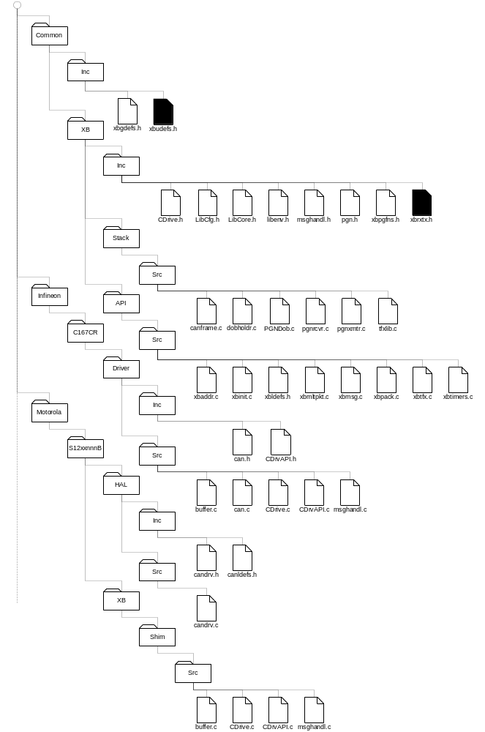
Figure 2: XBSL Distribution Relative File Structure
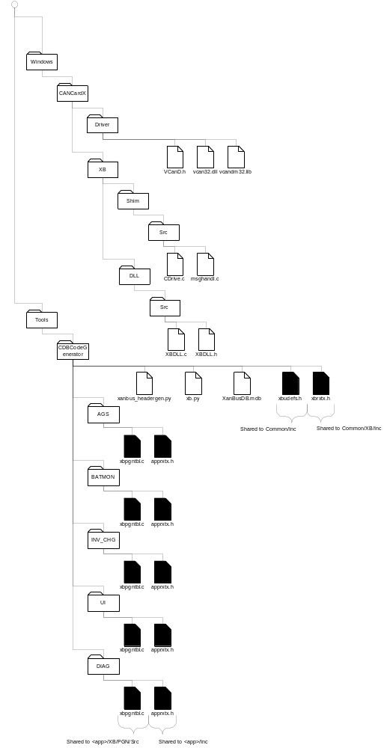
Figure 3: XBSL Distribution Relative File Structure (cont’)

Common/Inc/xbgdefs.h
Any application source file that needs to call a XanBus function shall include xbgdefs.h (XanBus Global Definitions). This file provides the constants, types and functions that are common to all XanBus-based applications.

Tools/CDBCodeGenerator/XanBusDB.mdb
All XanBus message definitions are stored in the Microsoft Access database XanBusDB.mdb. Currently, these definitions are maintained by the XanBus Team. Any changes or additions shall be administered by the XanBus Team.

Tools/CDBCodeGenerator/xanbus_headergen.py
The Python script xanbus_headergen.py is used to generate four source files (see the subsection below) from XanBusDB.mdb. Currently, the generation process is handled by the XanBus Team. Whenever a change is made to XanBusDB.mdb, new files are generated. See Appendix C for instructions on installing Python.

Tools/CDBCodeGenerator/xb.py
The Python script xb.py provides a number of common functions to the xanbus_headergen.py script.

Tools/CDBCodeGenerator/xbudefs.h
Any application source file that needs access to the fields or corresponding definitions of a XanBus message shall include xbudefs.h (XanBus Universal Definitions). This file provides the constants and message structures for all XanBus-defined messages (PGNs). This file is generated from the XanBus PGN database.
Tools/CDBCodeGenerator/xbudefs.h is shared to Common/Inc/xbudefs.h

Tools/CDBCodeGenerator/xbrxtx.h
The XBSL uses xbrxtx.h (XanBus Receive Transmit definitions) internally. However, the first time it is generated, it does need to be edited to fill-in the receive and transmit function prototypes that are internal to XanBus. These functions include, for example, the ISO message handling functions.
Tools/CDBCodeGenerator/xbrxtx.h is shared and branched to Common/XB/Inc/xbrxtx.h. The necessary editing to fill-in the XanBus function names shall be done in advance and shall not be a concern for the application developer.

Tools/CDBCodeGenerator/<device-function>/xbpgntbl.c
To conserve ROM, each device function (e.g., AGS, Inverter/Charger, User Interface) shall have its own xbpgntbl.c (XanBus PGN Table) file. This file is internal to XanBus. It provides information necessary to convert raw PGN data into application-usable C structures and vice-versa. This file is generated from the XanBus PGN database. Each device function that is known to the database shall have its own version of xbpgntbl.c. The current XanBus device functions are
- AGS (Automatic Generator Starter)
- BATMON (battery monitor)
- CHG (Charger)
- DIAG (Diagnostic Node)
- INV (Inverter)
- INV_CHG (Inverter/Charger)
- LOADER and
- UI (User Interface).

Executing xanbus_headergen.py generates an xbpgntbl.c file for each of the above device functions. Each of the generated files will be placed in a corresponding subdirectory with names as listed above.
Tools/CDBCodeGenerator/<device-function>/xbpgntbl.c shall be shared to <application>/XB/PGNs/Src/xbpgntbl.c.

Tools/CDBCodeGenerator/<device-function>/apprxtx.h
To simplify the application coder’s job, each device function shall have its own apprxtx.h (Application Receive and Transmit Functions definition) file. This file shall identify all of the application-specific receive and transmit functions for inclusion into the XanBus API.
Executing xanbus_headergen.py generates an apprxtx.h file for each of the above device functions. Each of the generated files will be placed in corresponding subdirectories with names as listed above.
Tools/CDBCodeGenerator/<device-function>/apprxtx.h shall be shared and branched to <application>/Inc/apprxtx.h. The necessary editing to fill-in the application function names shall be done by the application developer.

Typical XanBus Application Directory Structure
The relative file structure for a typical XanBus-based application is shown in the tree diagram in Figure 4. The diagram only shows XanBus-related files. Of course, a real application will have additional directories and files. The purpose of the diagram is to show from where files should be shared (and branched). The <dev> tag refers to the XanBus device that the application is implementing. For example, if the device is an inverter/charger then <dev> should be INV_CHG. The <mcu-mfg> tag refers to the microcontroller manufacturer. For example, a Motorola HCS12-based application should set <mcu-mfg> to Motorola. The <mcu> tag refers to the manufacturer’s specific microcontroller model. For example, a Motorola HC9S12DP256B-based application should set <mcu> to S12DP156B.
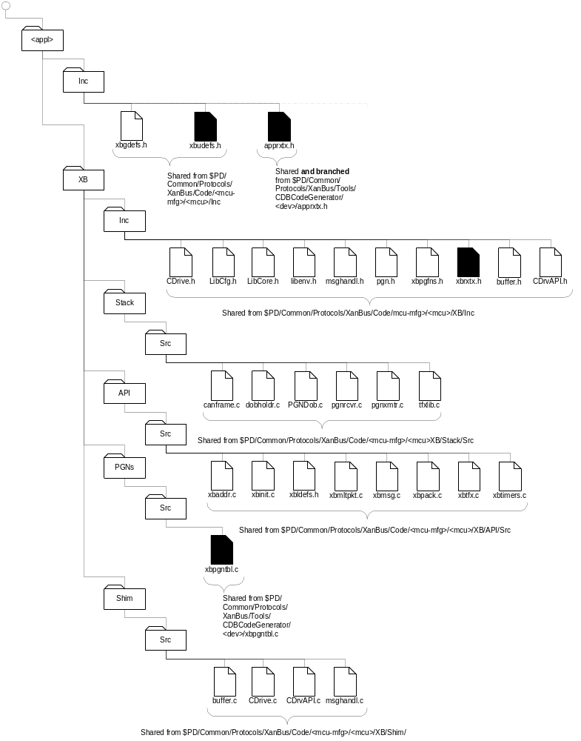
Figure 4: Typical Applciation Directory Structure

API Usage Example
Perhaps the best way to learn how to use the XBAPI within an application is by example. This section shows how to use XBAPI calls to write a trivial application. Listing 1 shows the main function. Only XBAPI relevant code is shown. A real application would likely have other function calls in main. For complete details on the XBAPI, see section 5.
Listing 1: Example Application 'main'
#include “xbgdefs.h”
#include “xbudefs.h”

void main( void )
{
uint16 uiBusReady;

// Initialize XBAPI
if ( !XBINIT_fnInit( BM_TICKS_PER_SEC ) )
{
// Save indication of fatal error and quit
gerr = XBINIT_fnGetErrorNum();

// Failure
return;
}

// Start address claiming
XBINIT_fnNetCtrl( XB_eNET_CTRL_POWERUP );

// Has address claiming started
if ( XBADDR_fnAddrState() == XB_eADDR_IDLE )
{

// Save indication of fatal error and quit
gerr = XBINIT_fnGetErrorNum();

return;
}

// Assume bus is not ready when starting up
uiBusReady = FALSE;

// Clear any timer event
guiTimerEvent = 0;

// No multitasker code, loop forever waiting for events
for ( ; ; )
{
// Handle timer event. This event occurs every milli-second
// Divide down the timer to 10 milli-second ticks to allow
// more time for processing between events
if ( guiTimerEvent > BM_MS_PER_TICK )
{
// Call stack tick processing
XBINIT_fnTick();

// Clear timer event
guiTimerEvent -= BM_MS_PER_TICK;

// Check for unreported errors
gerr = XBINIT_fnGetErrorNum();

if ( gerr != 0 )
{
// Handle error
}
}

// Check for active
if ( !uiBusReady )
{
// If we are now on line
if ( XBMSG_fnOnLine() )
{
// Send request for all address claims to update our tables
XBM_fnSendISOReq( XB_PGN_ADDR_CLAIM );

// Send an Association Status message
XBMSG_fnSend( XB_PGN_ASSOC_STS,
&tzAssocSts, sizeof(tzAssocSts), ucDest );

// Set to bus ready
uiBusReady = TRUE;
}
}
}
}

The first function called, XBINIT_fnInit, initializes the XBSL, which includes
- initializing the XBP Stack
- initializing the XBCAN Driver
- setting the library tick time base
- calling back to the application to get non-volatile NAME, preferred address, etc.

If XBINIT_fnInit returns FALSE then the callback XBPLATFORM_fnCheckErrors is called to ask the application to show the reason the XBINIT_fnInit call failed.
The next function call before entering the main processing loop is XBINIT_fnNetCtrl. Essentially, this function causes the XBAPI to queue an ISO Address Claimed message (PGN ) for the node. No message is transmitted at this point as the tick function has not been called yet.
For the purposes of this example, the global variable guiTimerEvent is incremented by a timer interrupt service routine. For the actual node implementation, a different or more indirect mechanism may be advisable.
The first section of the main loop executes whenever the guiTimerEvent expires. To handle this event, the processing loop calls XBINIT_fnTick. This call lets the XBAPI know that time has passed and it should do its normal housekeeping, which includes transmitting, and receiving actual parameter groups (messages). The very first call to XBINIT_fnTick will cause the transmission of the ISO Address Claimed message queued by the call to XBADDR_fnBeginClaiming.
The second section of the main loop processing executes only when the node is going from an offline state to an online state (e.g., during power up and initialization). If the node “thought” it was offline, it checks to see if it is now online and, if so, the node application performs some special “now” online messaging. This messaging includes transmitting a request for all address claims, XBMSG_fnSendIsoReq( XB_PGN_ADDR_CLAIM ), and sending its association status(es) to all nodes, XBMSG_fnSend( XB_PGN_ASSOC_STS, XB_GROUP_DONT_CARE, &tzAssocSts, sizeof(tzAssocSts), ucDest ).
The node is now up and running. The application may transmit/receive PGNs per the discussion in [3]. All future activity, from a network perspective, is determined by timeouts and the network activity of other nodes. Section 5 discusses the XBAPI in more detail.
In order to create a complete application, the developer must also supply send and/or receive functions for all of the messages (PGNs) that his/her application must support (apprxtx.h). These callback functions are called by the XanBus API to notify the application that data has arrived (receive function) or to request that the application send some data (send function). The XBAPI will call send functions to respond to ISO Requests or to handle periodic timer timeouts.
NOTE: The following PGNs are handled internally by XanBus (xbrxtx.h) and do not require application-defined send/receive functions
- ISO Request PGN
- ISO Transport Protocol Data Transfer
- ISO Transport Protocol – Connection Management – Abort
- ISO Transport Protocol – Connection Management – Broadcast Announce Message (BAM)
- ISO Transport Protocol – Connection Management – End of Message (EOM)
- ISO Transport Protocol – Connection Management – Clear to Send (CTS)
- ISO Transport Protocol – Connection Management – Request to Send (RTS)
- ISO Address Claimed
- ISO Commanded Address
- Periodic Transmit Configuration
- Receive Timeout Configuration
- NAME Configuration
- PGN List – Transmit
- PGN List – Receive and
- Communications Statistics.

A newly generated apprxtx.h file contains a complete, but NULL, list of the required application-defined receive and transmit functions. Listing 2 shows an example for a battery monitor (BATMON).
Listing 2: Example apprxtx.h File
#define XB_mRECV_ISO_ACK NULL
#define XB_mSEND_ISO_ACK NULL

#define XB_mRECV_EXT_TEMP_CFG_UT NULL
#define XB_mSEND_EXT_TEMP_CFG_UT NULL

#define XB_mRECV_EXT_TEMP_CFG_OT NULL
#define XB_mSEND_EXT_TEMP_CFG_OT NULL

#define XB_mRECV_INT_TEMP_CFG_UT NULL
#define XB_mSEND_INT_TEMP_CFG_UT NULL

#define XB_mRECV_INT_TEMP_CFG_OT NULL
#define XB_mSEND_INT_TEMP_CFG_OT NULL

#define XB_mRECV_DC_SRC_CFG_BATT NULL
#define XB_mSEND_DC_SRC_CFG_BATT NULL

#define XB_mRECV_SYS_ID_CFG NULL
#define XB_mSEND_SYS_ID_CFG NULL

#define XB_mRECV_RESET_CMD NULL

#define XB_mRECV_ASSOC_CFG NULL
#define XB_mSEND_ASSOC_CFG NULL

#define XB_mRECV_CLEAR_CMD NULL

#define XB_mRECV_BATT_MON_CFG NULL
#define XB_mSEND_BATT_MON_CFG NULL

#define XB_mRECV_DEV_PEEK_ADDR_REQ NULL

#define XB_mSEND_DEV_PEEK_ADDR_RSP NULL

#define XB_mRECV_DEV_POKE_ADDR NULL

#define XB_mRECV_FILE_DNLD_BLK NULL

#define XB_mRECV_FILE_DNLD_INF NULL

#define XB_mRECV_EN_DIS_CFG NULL
#define XB_mSEND_EN_DIS_CFG NULL

#define XB_mRECV_ASSOC_STS NULL
#define XB_mSEND_ASSOC_STS NULL

#define XB_mSEND_FILE_DNLD_STS NULL

#define XB_mRECV_CTRL_CMD NULL

#define XB_mRECV_CFG NULL
#define XB_mSEND_CFG NULL

#define XB_mRECV_DIAG_INDIC_CMD NULL

#define XB_mRECV_DIAG_CNTCT_CMD NULL

#define XB_mSEND_DIAG_CNTCT_STS NULL

#define XB_mSEND_DIAG_FAN_CMD NULL

#define XB_mRECV_DIAG_MFG_CFG NULL
#define XB_mSEND_DIAG_MFG_CFG NULL

#define XB_mSEND_DC_SRC_STS NULL

#define XB_mSEND_EXT_TEMP_STS NULL

#define XB_mSEND_INT_TEMP_STS NULL

#define XB_mRECV_CHG_STS NULL

#define XB_mRECV_STS NULL
#define XB_mSEND_STS NULL

#define XB_mRECV_SYS_ID_STS NULL
#define XB_mSEND_SYS_ID_STS NULL

#define XB_mSEND_FAULT_LOG_STS NULL

#define XB_mSEND_PROD_INFO_STS NULL

#define XB_mSEND_BATT_MON_BATT_STATS NULL

#define XB_mSEND_BATT_MON_STS NULL

#define XB_mRECV_DATE_TIME_STS NULL

#define XB_mSEND_ACTIVE_FAULTS_STS NULL

#define XB_mSEND_WARN_LOG_STS NULL

#define XB_mSEND_ACTIVE_WARNS_STS NULL

#define XB_mSEND_SW_VER_STS NULL

#define XB_mSEND_STATE_EVT_LOG_STS NULL

#define XB_mSEND_HW_REV_STS NULL

Almost every NULL in the above list must be replace by send or receive function name. Why “almost?” Because, some messages may be optional or are not required for the specific application. If that is the case then leave the #define as NULL. The function names may be any name the developer chooses, however, the prototypes for the functions must follow strict formats.
A receive function prototype must be of the form
void fn_rx( XB_tzRECV_DATA *ptzRecv );

A send function prototype must be of the form
void fn_tx( uchar8 ucDest, tucBOOL tucSolicited );

A typical application-supplied receive function is shown in Listing 3. This particular example handles a XanBus Association Configuration message (PGN ). The function starts by checking the source address of the message. According to [3], association configurations may only be received from UI or DIAG nodes, otherwise they are negatively acknowledged (see end of Listing 3). If the source is a UI or DIAG then the code accesses the data portion, ptzCfg, of the message (see xbudefs.h). The function then proceeds to validate the message contents, change its association configuration, acknowledge (PGN ) the new configuration and broadcast its association status (PGN ).
Listing 3: Typical Application PGN Receive Function
void bma_fnRecvAssocCfg( XB_tzRECV_DATA *ptzRecv )
{
XB_tzPGN_ASSOC_CFG *ptzCfg;
uchar8 ucPort;
uchar8 ucOldId;

// Do not accept a broadcast association config message
// Only accept config message if source is UI or Diag
if ( ( ptzRecv->ucDest != XB_ADDR_GLOBAL )
&& ( CNU_fnDiagOrUI( ptzRecv->ucSrcAddr ) ) )
{
// Convert void pointer to association config pointer
ptzCfg = ptzRecv->pStruct;

// For each port on the BattMon
for ( ucPort = 0; ucPort < BM_N_PORTS; ucPort++ )
{
// Look to see if the assoc id is already in use
if ( ptzCfg->ucAssocID == atzAssocList[ ucPort ].ucAssocId )
{
// If association type and instance matches
if ( ( ptzCfg->eAssocType == atzAssocList[ ucPort ].ucAssocType )
&& ( ptzCfg->ucAssocInst == atzAssocList[ ucPort ].ucAssocInst ))
{
// ACK the configuration
XBMSG_fnSendIsoAck( XB_PGN_ASSOC_CFG, XB_eACK_STS_ACK );

// No change, done
return;
}

// Config would create duplicate, get out and send Nack
break;
}
}

// If new Association Id not found on this unit (no duplicate)
if ( ucPort >= BM_N_PORTS )
{
// For each port on the BattMon
for ( ucPort = 0; ucPort < BM_N_PORTS; ucPort++ )
{
// If association type and instance matches
if ( ( ptzCfg->eAssocType == atzAssocList[ ucPort ].ucAssocType )
&& ( ptzCfg->ucAssocInst == atzAssocList[ ucPort ].ucAssocInst ))
{
// Change the Assoc Id

// If association change was made and saved
if ( bma_fnChangeAssoc( ucPort, ptzCfg->ucAssocID ) )
{
// ACK the configuration
XBMSG_fnSendIsoAck( XB_PGN_ASSOC_CFG, XB_eACK_STS_ACK );

// Recalculate association control flags
bma_fnCheckAssoc();

// Broadcast new association
bma_fnSendOneAssocSts( ucPort, XB_ADDR_GLOBAL, FALSE );

// If association status report is enabled
if ( ucReportAssocSts )
{
// Restart periodic timer so network has time to react
(void) XBTIMERS_fnSetTxTimer( XB_PGN_ASSOC_STS,
XB_ADDR_GLOBAL,
XB_TIMER_NO_CHANGE,
XB_TIMER_NO_CHANGE );
}

// Done
return;
}
else
{
// Could not set new association, get out and send NACK
break;
} // Save change
} // Assoc type matches
} // For each port
} // No duplicate
} // User and not broadcast

// Association not accepted, NACK the configuration
XBMSG_fnSendIsoAck( XB_PGN_ASSOC_CFG, XB_eGRP_FUNC_VALUE_INVALID_DATA, XB_eACK_STS_NAK ); }

A typical application-supplied transmit function is shown in Listing 4. This particular example transmits a XanBus DC Source Status message (PGN ). The function first determines, via the tucSolicited parameter whether this is a solicited (i.e., ISO Request PGN response) or unsolicited (periodic transmission) transmission. If it is solicited then the message count field of the PGN must be set, otherwise it is reset to zero (0). The transmit function then fills-in the data of the message and calls XBMSG_fnSend to transmit it. This example assumes that atzDCSrcSts (the PGN data) is available to bmb_fnSendDCSrcSts locally in its source file or globally in another source file. More elaborate transmit functions might call other application functions to retrieve and build-up the PGN data before calling XBMSG_fnSend.
Listing 4: Typical Application PGN Transmit Function
void bmb_fnSendDcSrcSts( uchar8 ucDest, tucBOOL tucSolicited )
{
uchar8 ucPort;
uchar8 ucMsgCount;
XB_teDC_SRC_ID eDcSrcId;

// Message count field depends on orginator
if ( tucSolicited )
{
// ISO request has message count set
ucMsgCount = BM_N_PORTS;
}
else
{
// Message count is 0 for unsolicited or periodic request
ucMsgCount = 0;
}

// For each port of BattMon
for ( ucPort = 0; ucPort < BM_N_PORTS; ucPort++ )
{
// Get the device attached to this port?
eDcSrcId = BMA_fnDCSrcID( ucPort );

// If association is not Invalid or None
if (( eDcSrcId != XB_eDC_SRC_ID_NONE )
&& ( eDcSrcId != XB_eDC_SRC_ID_INVALID ))
{
// Set the source id
atzDcSrcSts[ ucPort ].eDcSrcId = eDcSrcId;

// Set message count field of message
atzDcSrcSts[ ucPort ].ucMsgCount = ucMsgCount;

// Send a DC Source Status message
XBMSG_fnSend( XB_PGN_DC_SRC_STS,
&atzDcSrcSts[ ucPort ], sizeof(*atzDcSrcSts), ucDest );
}
}
}
Once a receive or transmit function has been coded it should be added to the list as shown in Listing 5.
Listing 5: Example apprxtx.h File
#define XB_mRECV_ISO_ACK NULL
#define XB_mSEND_ISO_ACK NULL

#define XB_mRECV_EXT_TEMP_CFG_UT NULL
#define XB_mSEND_EXT_TEMP_CFG_UT NULL

#define XB_mRECV_EXT_TEMP_CFG_OT NULL
#define XB_mSEND_EXT_TEMP_CFG_OT NULL

#define XB_mRECV_INT_TEMP_CFG_UT NULL
#define XB_mSEND_INT_TEMP_CFG_UT NULL

#define XB_mRECV_INT_TEMP_CFG_OT NULL
#define XB_mSEND_INT_TEMP_CFG_OT NULL

#define XB_mRECV_DC_SRC_CFG_BATT NULL
#define XB_mSEND_DC_SRC_CFG_BATT NULL

#define XB_mRECV_SYS_ID_CFG NULL
#define XB_mSEND_SYS_ID_CFG NULL

#define XB_mRECV_RESET_CMD NULL

#define XB_mRECV_ASSOC_CFG bma_fnRecvAssocCfg
#define XB_mSEND_ASSOC_CFG NULL

#define XB_mRECV_CLEAR_CMD NULL

#define XB_mRECV_BATTMON_CFG NULL
#define XB_mSEND_BATTMON_CFG NULL

#define XB_mRECV_DEV_PEEK_ADDR_REQ NULL

#define XB_mSEND_DEV_PEEK_ADDR_RSP NULL

#define XB_mRECV_DEV_POKE_ADDR NULL

#define XB_mRECV_FILE_DNLD_BLK NULL

#define XB_mRECV_FILE_DNLD_INF NULL

#define XB_mRECV_EN_DIS_CFG NULL
#define XB_mSEND_EN_DIS_CFG NULL

#define XB_mRECV_ASSOC_STS NULL
#define XB_mSEND_ASSOC_STS NULL

#define XB_mSEND_FILE_DNLD_STS NULL

#define XB_mRECV_CTRL_CMD NULL

#define XB_mRECV_CFG NULL
#define XB_mSEND_CFG NULL

#define XB_mRECV_DIAG_INDIC_CMD NULL

#define XB_mRECV_DIAG_CNTCT_CMD NULL

#define XB_mSEND_DIAG_CNTCT_STS NULL

#define XB_mSEND_DIAG_FAN_CMD NULL

#define XB_mRECV_DIAG_MFG_CFG NULL
#define XB_mSEND_DIAG_MFG_CFG NULL

#define XB_mSEND_DC_SRC_STS bmb_fnSendDcSrcSts

#define XB_mSEND_EXT_TEMP_STS NULL

#define XB_mSEND_INT_TEMP_STS NULL

#define XB_mRECV_CHG_STS NULL

#define XB_mRECV_STS NULL
#define XB_mSEND_STS NULL

#define XB_mRECV_SYS_ID_STS NULL
#define XB_mSEND_SYS_ID_STS NULL

#define XB_mSEND_FAULT_LOG_STS NULL

#define XB_mSEND_PROD_INFO_STS NULL

#define XB_mSEND_BATTMON_BATT_STATS NULL

#define XB_mSEND_BATTMON_STS NULL

#define XB_mRECV_DATE_TIME_STS NULL

#define XB_mSEND_ACTIVE_FAULTS_STS NULL

#define XB_mSEND_WARN_LOG_STS NULL

#define XB_mSEND_ACTIVE_WARNS_STS NULL

#define XB_mSEND_SW_VER_STS NULL

#define XB_mSEND_STATE_EVT_LOG_STS NULL

#define XB_mSEND_HW_REV_STS NULL

XBAPI Reference

Data Types
Definitions for the main data structures of concern to a XanBus application may be found in xbgdefs.h (XB Global Definitions) and xbudefs.h (XanBus Universal Definitions). This section discusses the contents of xbgdefs.h. The content of xbudefs.h corresponds to the XanBus PGN Microsoft Access database [5] and the discussion in the XanBus specification [3].

XB_tzRECV_DATA

Description
The XBAPI uses this data type to communicate a received PGN to the application.

Relevant XBAPI Functions
Parameters
XBPLATFORM_fnRecvXbMsg
application receive functions

Definition
typedef struct zRECV_DATA
{
uint32 ulPgn;
sint16 siGrpFunc;
const XB_tzPGN_INFO *ptzPgnInfo;
void *pStruct;
uchar8 ucSrcAddr;
uchar8 ucDest;
uchar8 ucUseCount;
} XB_tzRECV_DATA;

Fields

ulPgn
ulPgn is the parameter group number of the message described by this data type.

siGrpFunc
siGrpFunc is the group function code of the message described by this data type. A group function code allows the same PGN to be used in a number of different but related ways. Most PGNs do not have a group function code in which case siGrpFunc has the value XB_eGRP_FUNC_VALUE_DO_NOT_CARE. An example of a PGN with a group function code is the ISO Connection Management message (PGN ) used for the multi-packet protocol.

pStruct
pStruct is a pointer to the PGN data itself. Upon receiving a PGN, the application should cast pStruct into the PGN structure from xbudefs.h that corresponds with ulPgn.

ptzPgnInfo
ptzPgnInfo is a pointer to XanBus-internal information. The application shall not reference this field.

ucSrcAddr
ucSrcAddr is the source address of this PGN.

ucDest
ucDest is the destination address of this PGN.

ucUseCount
ucUseCount supports a mechanism for maintaining received data after an application’s receive function terminates. If upon termination ucUseCount is not zero then XanBus shall not release the memory occupied by the received data. However, the application shall be responsible for freeing the memory itself with a subsequent call to XBMSG_fnDestroyRecvStruct.

XB_tzPGN_ISO_ADDR_CLAIM

Description
The XBAPI uses this data type to provide the application with a node’s NAME.

Relevant XBAPI Functions
XBINIT_fnResetCfg
XBPLATFORM_fnNodeChange

Definition
typedef struct zPGN_ISO_ADDR_CLAIM
{
uint32 ulUniqueNumber; // Unique Number (ISO Identity Number)
uint16 uiManufacturerCode; // Manufacturer Code
uchar8 ucDeviceInstanceLower; // Device Instance Lower (ISO ECU Instance)
uchar8 ucDeviceInstanceUpper; // Device Instance Upper (ISO Func Instance)
XB_teFUNC_CODE eDeviceFunction; // Device Function (ISO Function)
uchar8 ucRsvBit; // Reserved Bit
XB_teDEV_CLASS eDeviceClass; // Device Class
uchar8 ucSystemInstance; // System Instance (ISO Device Class Instance)
uchar8 ucIndustryGroup; // Industry Group
uchar8 ucSelfCfgAddr; // ISO Self Configurable Address
} XB_tzPGN_ISO_ADDR_CLAIM;

Fields
See the NAME section in [3] and the ISO Address Claimed message in [5] for details.

XB_teFUNC_CODE

Description
The XBAPI uses this enumerated type to specify device function codes.

Relevant XBAPI Functions
XBADDR_fnGetDevice
XBADDR_fnFindDevice

Definition
typedef enum eFUNC_CODE
{
XB_eFUNC_CODE_USER_INTERFACE = 128,
XB_eFUNC_CODE_INVERTER_CHARGER = 129,
XB_eFUNC_CODE_INVERTER = 130,
XB_eFUNC_CODE_CHARGER = 131,
XB_eFUNC_CODE_BATTERY_MONITOR = 132,
XB_eFUNC_CODE_AGS = 133,
XB_eFUNC_CODE_DIAGNOSTIC_TERMINAL = 134
} } XB_teFUNC_CODE;

XB_tePARAM_TYPE

Description
The XBAPI uses this enumerated type to indicate, to the application, which non-volatile data it is loading or saving.

Relevant XBAPI Functions
XBPLATFORM_fnLoad
XBPLATFORM_fnSave

Definition
typedef enum ePARAM_TYPE
{
XB_ePARAM_TYPE_ADDRESS, // Node Preferred Address
XB_ePARAM_TYPE_NAME, // Node Name
XB_ePARAM_TYPE_NAME_CONFIG, // Node Name Configuration
XB_ePARAM_TYPE_TX_TIMEOUTS, // Periodic Xmit timeouts
XB_ePARAM_TYPE_RX_TIMEOUTS // Receive timeouts
} XB_tePARAM_TYPE;

XB_teNODE_CHANGE

Description
The XBAPI uses this enumerated type to indicate, to the application, a change in a node’s network availability status.

Relevant XBAPI Functions
XBPLATFORM_fnNodeChange

Definition
typedef enum eNODE_CHANGE
{
XB_eNODE_CHANGE_NEW_NODE, // Node has joined the bus
XB_eNODE_CHANGE_ADDRESS, // Existing node has a new address
XB_eNODE_CHANGE_BUMPED_OFF, // Node must give up its address
XB_eNODE_CHANGE_TIMED_OUT // Node has not reported within the timeout period
} XB_teNODE_CHANGE;

XB_teNET_CTRL

Description
The XBAPI uses this enumerated type to control the operating state of the XanBus protocol.

Relevant XBAPI Functions
XBINIT_fnNetCtrl

Definition
typedef enum eNET_CTRL
{
XB_eNET_CTRL_POWERUP,
XB_eNET_CTRL_SUSPEND,
XB_eNET_CTRL_RESUME
} XB_teNET_CTRL;

XB_teADDR_STATE

Description
The XanBus API uses this enumerated type to return the address claiming state of the XanBus protocol to the application.

Relevant XBAPI Functions
XBADDR_fnAddrState

Definition
typedef enum eADDR_STATE
{
XB_eADDR_IDLE,
XB_eADDR_CLAIMING,
XB_eADDR_BLOCKED,
XB_eADDR_ONLINE
} XB_teADDR_STATE;

Non-Volatile Data
As enumerated in section 5.1.4, the XBAPI has a number of non-volatile data items that shall be maintained, with the assistance of the application, in non-volatile storage. Each of these items shall be configured, by the application, with default values as described in the following subsections.

Preferred Address
A node’s preferred address is the address that it attempts to claim at startup. If the node cannot claim this address, it shall try other addresses until it can successfully claim one. This new address becomes the preferred address. The purpose of having a preferred address is to reduce the system startup time: if the system configuration (number and/or types of nodes) has not changed since the last startup then the nodes shall claim their preferred addresses and there will be no conflicts to resolve.

Data Size
1 8-bit byte

Default Value(s)
0

NAME
A node’s NAME is used to arbitrate the address claiming process and to determine its functionality and instance as described in [3].
A node’s NAME shall only be changed if the node receives a NAME Configuration (PGN ) or Reset Command – OEM/Factory (PGN ).

Data Size
8 8-bit bytes

Default Value(s)
The default value for the NAME is shown in Figure 5. The application shall be responsible for establishing the default NAME upon first initialization before initializing XanBus.
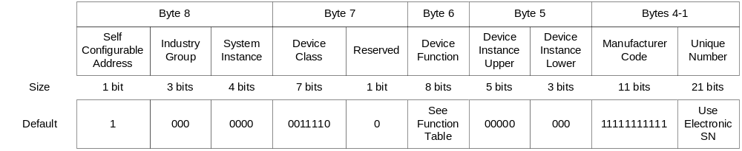
Figure 5: Default NAME
The function table reference refers to section 5.1.3. For example, if the device is a user interface then the default value shall be 128 or 10000000₂.
The electronic serial number (SN) reference refers to the assumption that the device will have an electronic serial number of no less than 21-bits. The 21-bit portion of the electronic serial number that changes most frequently from one serial number device to the next shall be stored in the last NAME field.

NAME Configuration
A node’s NAME Configuration corresponds to the NAME Configuration message (PGN ).

Data Size
8 8-bit bytes per NAME
1 8-bit byte per Concurrent Access Counter per NAME
× 3 Configuration Types (OEM, User and Factory)
24 8-bit bytes

Default Value(s)
See section 5.2.2.

Periodic Transmit Timer Configuration
As described in [3], each node shall be capable of periodically transmitting a certain number of unsolicited messages. For example, by default, each node shall transmit an ISO Address Claimed message (PGN ) every second and a Status message (PGN ) every 250 milliseconds.
A node’s periodic transmissions shall be configured using a Periodic Transmit Configuration message (PGN ). This configuration shall be saved, by the XanBus API, in non-volatile storage. The XanBus API shall manage (i.e., start, stop, expiry) the periodic transmit timers.

Data Size
8 8-bit bytes per configuration record, assuming a word-aligned 16-bit architecture
× 10 maximum records
+1 8-bit byte per Concurrent Access Counter per record set
× 2 Configuration Types (OEM and User)
162 8-bit bytes

Default Value(s)
Table 5 shows the default periodic transmit configuration values for a number of different node functions. The application shall be responsible for establishing the default configuration upon first initialization before initializing XanBus.
Table 5: Default Periodic Transmit Configuration
Record | PGN  4 bytes | Transmit Address  1 byte + filler byte& | Transmit Period  2 bytes  (centiseconds)
0 | * (ISO Address Claimed) | 255 | 100
1 | * (Status) | 255 | 25
2 | † (AGS Status) or  ∞ (Battery Monitor Status) or  ‡ (Charger Status) or  ₤ (Inverter Status) or  ¥ (User Interface Status) | 255 | 50
3 | § (DC Source Status) or  ¥ (Date and Time Status) or  0xFFFFFFFF | 255 | 50 or 0xFFFF
4 | ₤ (AC Output Status – RMS) or 0xFFFFFFFF | 255 | 50 or 0xFFFF
5 | ‡ (AC Input Status – RMS) or  0xFFFFFFFF | 255 | 50 or 0xFFFF
6 | ° (Association Status) or 0xFFFFFFFF | 255 | 50 or 0xFFFF
7 | 0xFFFFFFFF | 0xFF | 0xFFFF
8 | 0xFFFFFFFF | 0xFF | 0xFFFF
9 | 0xFFFFFFFF | 0xFF | 0xFFFF

Receive Timeout Configuration
In a similar fashion to the periodic transmit configurations, each XanBus node shall have a certain number of receive timeout configurations. For example, by default, each node shall expect to receive a Status message within a second and an ISO Address Claimed message with 5 seconds. Additional default timeouts shall be configured on a per function basis (see below). A node’s action upon detecting a receive timeout event shall be application dependent and may be to do nothing.
A node’s receive timeouts shall be configured by a Receive Timeout Configuration message (PGN ). This configuration shall be saved, by the XanBus API, in non-volatile storage. The application, not the XanBus API, shall manage (i.e., start, stop, expiry) the receive timeout timers because it is not possible for the XanBus API to determine, from the PGN alone, whether or not a receive timer has expired. Many of the status-type messages include an association identifier that shall be used by the application to determine whether an expiry has occurred. For example, all DC Source Status messages have the same PGN but a particular inverter/charger shall only be interested in the one that it receives from a similarly associated battery monitor. If another battery monitor stops transmitting its DC Source Status then the inverter/charger shall ignore that receive timeout event.

Data Size
6 8-bit bytes per configuration record, assuming a word-aligned 16-bit architecture
× 10 maximum records
+1 8-bit byte per Concurrent Access Counter per record set
× 2 Configuration Types (OEM and User)
122 8-bit bytes

Default Value(s)
Table 6 shows the default receive timeout configuration values for a number of different node functions. The application shall be responsible for establishing the default configuration upon first initialization before initializing XanBus.
Table 6: Default Receive Timeout Configuration
Record | PGN  4 bytes | Timeout Period  2 bytes  (centiseconds)
0 | * (ISO Address Claimed) | 500
1 | * (Status) | 125
2 | * (Date and Time Status) | 125
3 | * (DC Source Status) | 125
4 | ¥ (AGS Status) or  ∞ (Battery Monitor Status) or  § (Charger Status) or  ° (Inverter Status) or  † (User Interface Status) or  0xFFFFFFFF | 125 or 0xFFFF
5 | ‡ (AC Output Status – RMS) or 0xFFFFFFFF | 125 or 0xFFFF
6 | • (AC Input Status – RMS) or  0xFFFFFFFF | 125 or 0xFFFF
7 | 0xFFFFFFFF | 0xFFFF
8 | 0xFFFFFFFF | 0xFFFF
9 | 0xFFFFFFFF | 0xFFFF

API Functions
Each of the following subsections discusses a particular function supplied by the XBAPI. The prototypes for these functions may be found in xbgdefs.h.

XBINIT_fnInit

Description
Use this function to initialize the XBSL.

Prototype
tucBOOL XBINIT_fnInit( uchar8 ucMSPerTick );

Parameters

ucMSPerTick
This parameter informs the XBAPI on how often its tick function, XBINIT_fnTick, will be called. Currently, the recommended value for ucMSPerTick is no more than 10 milliseconds per tick. NOTE: The value of ucMSPerTick affects the granularity of the protocol timers, for example, the multi-packet transport protocol has a 50-millisecond timer requirement.

Result
This function returns FALSE if it cannot initialize the XBSL, otherwise it returns TRUE.

Notes
This function must be called before all other XBSL functions.
This function must only be called once.
This function must not be called from within an interrupt service routine (ISR).

XBINIT_fnGetErrorNum

Description
Use this function after calling other XBAPI functions to determine what, if any, error occurred. Also, call this function when the XBAPI calls the application-supplied callback XBPLATFORM_fnCheckErrors.

Prototype
uint16 XBINIT_fnGetErrorNum( void );

Parameters
None

Result
0 if there was no error, otherwise a number indicating the nature of the error (see xbgdefs.h).

Notes
This function must not be called from within an interrupt service routine (ISR).

XBINIT_fnGetErrorStr

Description
Use this function after calling other XBAPI functions to determine what, if any, error occurred. Also, call this function when the XBAPI calls the application-supplied callback XBPLATFORM_fnCheckErrors.

Prototype
tucBOOL XBINIT_fnGetErrorStr( schar8 **ppscSrc, schar8 **ppscErr );

Parameters

ppscSrc
If XBINIT_fnGetErrorStr returns TRUE then *ppscSrc will point to a string describing the source of the error, for example, “Pack PG”, “Timer” and “Error source unknown”
If XBINIT_fnGetErrorStr returns FALSE then *ppscSrc will point to the string “None”

ppscErr
If XBINIT_fnGetErrorStr returns TRUE then *ppscErr will point to a string describing the error, for example, “PGN is UNKNOWN,” “CAN Bus in Buss-Off condition” and “Error initializing port”
If XBINIT_fnGetErrorStr returns FALSE then *ppscErr will point to the string “No Error”

Result
This function returns FALSE if there isn’t an error to report, otherwise it returns TRUE.

Notes
This function must not be called from within an interrupt service routine (ISR).
This function shall only be available when DEBUG is enabled.

XBINIT_fnTick

Description
Use this function to provide the XBSL with its tick. It should be called at least as often as specified in the ucMSPerTick parameter to XBINIT_fnInit.

Prototype
void XBINIT_fnTick( void );

Parameters
None

Result
None

Notes
This function must not be called from within an interrupt service routine (ISR).
If the application includes an operating system then the recommended approach is to have a timer ISR send a message to a task, which can then call XBINIT_fnTick.
This function should be called at least as often as was specified in the call to XBINIT_fnInit.
Typically, the application will install an interrupt service routine for one of the microcontroller’s timers and the timer will be configured to periodically expire with a period of 10 milliseconds or less. When the timer expires, the ISR will send a message to a task and the task will call XBINIT_fnTick. This is necessary as XBINIT_fnTick can perform more processing than is acceptable in an ISR.

XBINIT_fnNetCtrl

Description

Prototype
void XBINIT_fnNetCtrl( XB_teNET_CTRL teControl );

Parameters

teControl
teControl determines the XanBus protocol operating state. See Table 7.
Table 7: XBINIT_fnNetCtrl Parameter Values
teControl Value | Meaning
XB_eNET_CTRL_POWERUP | Use this value after initializing the XBAPI to start address claiming and put the protocol in state where it can receive and transmit as required.
XB_eNET_CTRL_SUSPEND | Use this value to disable periodic transmissions in preparation for entering a low power mode, for example.
XB_eNET_CTRL_RESUME | Use this value to enable periodic transmissions after exiting a low power mode, for example.

Result
None

Notes
This function must not be called from within an interrupt service routine (ISR).

XBINIT_fnResetCfg

Description
The application should call this function whenever it receives a valid Reset Command message (PGN ) with an option of XB_eRST_CMD_FACTORY or XB_eRST_CMD_OEM.

Prototype
tucBOOL XBINIT_fnResetCfg( XB_teRST_CMD eCmd );

Parameters

eCmd
eCmd specifies the configuration to reset to, either factory or OEM.

Result
This function returns:
TRUE if the configurations were reset
FALSE otherwise

Notes
This function must not be called from within an interrupt service routine (ISR).

XBINIT_fnSleepCtrl

Description
This function may be used to “sleep” the CAN controller to save power and in preparation for “sleeping” the entire node.

Prototype
void XBINIT_fnSleepCtrl( tucBOOL ucSleep, void callback( void ) );

Parameters

ucSleep
If ucSleep is TRUE then the CAN controller is commanded into sleep mode. Otherwise, the CAN controller will be awakened.

callback
If ucSleep is TRUE, the function specified by callback will be called when the CAN controller is asleep. If ucSleep is FALSE then the value of callback is ignored.

Result
None

Notes
This function must not be called from within an interrupt service routine (ISR).
This function is typically called when the node receives Control Command to power save mode.

XBADDR_fnGetName

Description
This function may be used to retrieve a device’s NAME given its address.

Prototype
tucBOOL XBADDR_fnGetName(uchar8 ucAddr, XB_tzPGN_ISO_ADDR_CLAIM *ptzName);

Parameters

ucAddr
ucAddr is the address of the network node for which the NAME is desired

ptzName
ptzName is a pointer to a location where the retrieved NAME is stored if the function returns TRUE.

Result
This function returns:
FALSE if a NAME corresponding to ucAddr could not be found
TRUE otherwise

Notes
This function must not be called from within an interrupt service routine (ISR).

XBADDR_fnGetDevice

Description
This function may be used to retrieve a device’s function and instance given its address.

Prototype
tucBOOL XBADDR_fnGetDevice( uchar8 ucAddr, XB_teFUNC_CODE *pDevFunc, uchar8 *pInst );

Parameters

ucAddr
ucAddr is the address of the network node for which the function and instance are desired

ptDevFunc
ptDevFunc is a pointer to a location where the device’s function code (see section 5.1.3) will be stored if the function returns TRUE

pInst
pInst is a pointer to a location where the device’s instance will be stored if the function returns TRUE

Result
This function returns:
FALSE if the device function or instance corresponding to ucAddr could not be found
TRUE otherwise

Notes
This function must not be called from within an interrupt service routine (ISR).

XBADDR_fnFindDevice

Description
Use this function to index through a node’s node list for a Xantrex device and return its address, function and instance.

Prototype
tucBOOL XBADDR_fnFindDevice( uchar8 *pIndex, uchar8 *pAddr, XB_teFUNC_CODE *pDevFunc, uchar8 *pInst );

Parameters

pIndex
On entry to the function, pIndex is a pointer to an index indicating where to start searching for a Xantrex device.
On exit from the function, pIndex is a pointer to an index indicating where the search completed if the function returned TRUE, otherwise *pIndex should be ignored.

pAddr
pAddr is a pointer to a location where the device’s address will be stored if the function returns TRUE

pDevFunc
ptDevFunc is a pointer to a location where the device’s function code (see section 5.1.3) will be stored if the function returns TRUE

pInst
pInst is a pointer to a location where the device’s instance will be stored if the function returns TRUE

Result
This function returns:
FALSE if the device function or instance corresponding to ucAddr could not be found
TRUE otherwise

Notes
This function must not be called from within an interrupt service routine (ISR).

XBADDR_fnTestPriority

Description
This function may be used to determine the relative priority of the executing node’s NAME versus other node NAMEs on the network.

Prototype
sint16 XBADDR_fnTestPriority( uchar8 ucAddr );

Parameters

ucAddr
ucAddr is the address of the network node whose NAME will be compared with the executing node’s NAME.

Result
This function returns:
-1 if the executing node’s NAME is lower priority than the one corresponding to ucAddr
0 if the executing node’s NAME is the same priority than the one corresponding to ucAddr
1 if the executing node’s NAME is higher priority than the one corresponding to ucAddr

Notes
This function must not be called from within an interrupt service routine (ISR).
If NAME A’s value, taken as a 64-bit unsigned integer, is less than NAME B’s value then NAME A has a higher priority than NAME B. During address claiming, the node with NAME A would win over the node with NAME B.

XBADDR_fnGetMyAddr

Description
Use this function to get the executing node’s address.

Prototype
uchar8 XBADDR_fnGetMyAddr( void );

Parameters
None

Result
This function returns 254 if the executing node has not successfully claimed an address, otherwise it returns a result within the range zero (0) to 251. 255 is reserved as the broadcast address. 254 is the null address. 253 and 252 are reserved by NMEA.

Notes
None

XBADDR_fnAddrState

Description
This function returns the address claiming status of the XBAPI.

Prototype
XB_teADDR_STATE XBADDR_fnAddrState( void );

Parameters
None

Result
This function returns one of the results shown in Table 8.
Table 8: XBADDR_fnAddrState Results
Result | Meaning
XB_eADDR_IDLE | Failed initial address claiming at power-up
XB_eADDR_CLAIMING | In the process of claiming an address
XB_eADDR_ONLINE | Claimed address, able to send messages
XB_eADDR_BLOCKED | XBAPI suspended

Notes
This function must not be called from within an interrupt service routine (ISR).

XBMSG_fnDestroyRecvStruct

Description
Use this function to free a received message whose use count was incremented and that was not freed by the XBAPI.

Prototype
void XBMSG_fnDestroyRecvStruct( XB_tzRECV_DATA *ptzRecv );

Parameters

ptzRecv
ptzRecv is a pointer to the ISO Request PGN message descriptor to free.

Result
None

Notes
This function must not be called from within an interrupt service routine (ISR).

XBMSG_fnOnLine

Description
Use this function to determine if the node is online and able to send/receive messages.

Prototype
tucBOOL XBMSG_fnOnLine( void );

Parameters
None

Result
This function returns FALSE if the node has not yet successfully claimed an address, otherwise it returns TRUE.

Notes
This function must not be called from within an interrupt service routine (ISR).

XBMSG_fnGetBusState

Description
Use this function to determine the state of the node’s bus connection.

Prototype
uchar8 XBMSG_fnGetBusState( void );

Parameters
None

Result
See Table 9 for return values.

Notes
This function must not be called from within an interrupt service routine (ISR).

XBMSG_fnSend

Description
This function may be used by the application to queue a non-group function message for transmission. Currently, all application messages are non-group function messages.

Prototype
void XBMSG_fnSend( uint32 ulPgn, void *pzStruct, uint16 uiSrcSize, uchar8 ucDest );

Parameters

ulPgn
ulPgn is the parameter group number (PGN) of the message to queue.

pzStruct
pzStruct points to the filled-in data structure for the PGN specified by ulPgn. The structure for each PGN is defined in xbudefs.h.

uiSrcSize
uiSrcSize is the size of the structure, in bytes, pointed to by pzStruct.

ucDest
ucDest is the destination address for this message. If ucDest is 255 then the destination is all nodes. ucDest may not be 254. Some PGNs are broadcast by default and then the value in ucDest is ignored.

Result
None

Notes
This function must not be called from within an interrupt service routine (ISR).

XBMSG_fnSendEx

Description
This function may be used by the application to queue a group function message for transmission. Currently, all application messages are non-group function messages.

Prototype
uint16 XBMSG_fnSendEx( uint32 ulPgn, sint16 siGrpFunc, void *pzStruct, uint16 uiSrcSize, uchar8 ucDest );

Parameters

ulPgn
ulPgn is the parameter group number (PGN) of the message to queue.

siGrpFunc
siGrpFunc is the group function code of the message to queue.

pzStruct
pzStruct points to the filled-in data structure for the PGN specified by ulPgn. The structure for each PGN is defined in xbudefs.h.

uiSrcSize
uiSrcSize is the size of the structure, in bytes, pointed to by pzStruct.

ucDest
ucDest is the destination address for this message. If ucDest is 255 then the destination is all nodes. ucDest may not be 254. Some PGNs are broadcast by default and then the value in ucDest is ignored.

Result
This function returns FALSE if the message was not queued successfully, otherwise it returns TRUE.

Notes
This function must not be called from within an interrupt service routine (ISR).

XBMSG_fnControlDynamic

Description
Use this function to dynamically set whether or not the application “cares” about a PGN. This capability may be useful to improve performance (reduce receive processing time) in a user interface node when it is in a state where only certain messages are significant. This capability only applies to status and statistics PGNs (except for Communications Statistics).

Prototype
void XBMSG_fnControlDynamic( uint32 ulPgn, tucBOOL tucOn );

Parameters

ulPgn
ulPgn is a PGN that the application is interested in receiving.

tucOn
If tucOn is TRUE then the application wants to “see” the PGN. If tucOn is FALSE then the application wants to ignore the PGN.

Result
None

Notes
This function must not be called from within an interrupt service routine (ISR).
This function may be used to temporarily reduce the scope of the messages the node receives to those of interest in its current state. For example, in a particular display state/format, a user interface node may only need to receive and process a small subset of the node-specific status messages.

XBMSG_fnClearDynamic

Description
Use this function to clear the list of PGNs that a node “cares” about. This capability may be useful to improve performance (reduce receive processing time) in a user interface node when it is in a state where only certain messages are significant. This capability only applies to status and statistics PGNs (except for Communications Statistics).

Prototype
void XBMSG_fnClearDynamic( void );

Parameters
None

Result
None

Notes
This function must not be called from within an interrupt service routine (ISR).

XBMSG_fnSendIsoAck

Description
Use this function to send an ISO Acknowledgement to a command or configuration message.

Prototype
void XBMSG_fnSendIsoAck( uint32 ulPgn, XB_teACK_STS eControl );

Parameters

ulPgn
ulPgn is the PGN number to acknowledge.

eControl
eControl specifies whether the acknowledgement is positive (0), negative (1) or deny (2).

Result
None

Notes
This function must not be called from within an interrupt service routine (ISR).

XBMSG_fnIsoReq

Description
The application should call this function when it wants to transmit an ISO Request PGN message in order to request a particular PGN from other nodes.

Prototype
void XBMSG_fnIsoReq( uint32 ulPgn, uchar8 ucDest );

Parameters

ulPgn
ulPgn is the PGN number to request.

ucDest
ucDest is the destination address for the request.

Result
None

Notes
This function must not be called from within an interrupt service routine (ISR).
This call should be used sparingly to avoid using excessive network bandwidth.

XBMSG_fnClearCommStats

Description
The application should call this function when it receives a Clear Command message that specifies XB_eCLR_ITEM_ID_COMM_STATS in the clear command bit mask.

Prototype
void XBMSG_fnClearCommStats( void );

Parameters
None

Result
None

Notes
This function must not be called from within an interrupt service routine (ISR).

XBTIMERS_fnSetTxTimer

Description
Use this function to change the periodicity of or add/remove a periodically transmitted PGN.

Prototype
tucBOOL XBTIMERS_fnSetTxTimer( uint32 ulPgn, uchar8 ucDest, uint16 uiPeriod, uint16 uiStartAt );

Parameters

ulPgn
ulPgn is the PGN to periodically transmit.

ucDest
ucDest is the destination address for this PGN. XB_ADDR_GLOBAL (255) is the broadcast address. XB_ADDR_NULL (254) is an invalid address.

uiPeriod
uiPeriod is the period of the transmission in centiseconds where 1 centisecond = 10 milliseconds. If uiPeriod is zero (0) then the PGN is removed from the list for periodically transmitted PGNs.

uiStartAt
uiStartAt specifies the number of centiseconds before the first timer period begins counting down. For example, setting uiStartAt to zero (0) will stop the timer. Setting uiStartAt to 1 (10 centiseconds) will cause the timer to start on the next tick.

Result
This function returns FALSE if the PGN could not be added, removed or changed, otherwise it returns TRUE.

Notes
This function must not be called from within an interrupt service routine (ISR).
The same PGN may have multiple periodic transmissions if the destination addresses are different. This should be an uncommon scenario. Typically, if more than one node needs to receive a PGN, it should be transmitted to the global address.

XBTIMERS_fnSetPeriodReports

Description
This function may be used to set the reporting enable state of periodically transmitted messages.

Prototype
void XBTIMERS_fnSetPeriodReports( tucBOOL tucActive );

Parameters

tucActive
If tucActive is TRUE then the node will not periodically transmit any messages. Otherwise, if tucActive is FALSE then the node will periodically transmit messages except for ISO Address Claimed (see definition for XanBus Enable Configuration message in Access database).

Result
None

Notes
This function must not be called from within an interrupt service routine (ISR).

Application Callback Functions

XBPLATFORM_fnCheckErrors

Description
The application must provide this function so the XBAPI can communicate error conditions to the application.

Prototype
void XBPLATFORM_fnCheckErrors( void );

Parameters
None

Result
None

Notes
This function should call XBINIT_fnGetErrorStr (see section 5.3.2.1) and indicate the error condition in some way (LCD, LEDs, sound, etc.).
This function may be used in conjunction with a debugger output or serial port output during development.

XBPLATFORM_fnSetNetIndic

Description
The application must provide this function so the XBAPI can communicate network status to the application.

Prototype
void XBPLATFORM_fnSetNetIndic( uchar8 ucBusState, tucBOOL tucOn );

Parameters

ucBusState
ucBusState is the network status for the CAN controller and may take on one of the values shown in Table 9 (see xbgdefs.h).
Table 9: Network Status Condition Codes
Condition | Condition #define | Value
Unknown | XB_BUS_UNKNOWN | 0
Error Active | XB_BUS_ERROR_ACTIVE | 1
Error Passive | XB_BUS_ERROR_PASSIVE | 2
Bus-Off | XB_BUS_BUS_OFF | 3

tucOn
tucOn indicates whether the status in ucBusState should be displayed (TRUE) or not (FALSE).

Result
None

Notes
If there is no hardware support for indicating network status then this function may simply be a stub.

XBPLATFORM_fnLoad

Description
The application must provide this function so that the XBAPI may retrieve XanBus-specific non-volatile data.

Prototype
tuiSTATUS XBPLATFORM_fnLoad( XB_tePARAM_TYPE teType, void *pData, uint16 uiSize );

Parameters

teType
teType specifies the information that the XBAPI wishes to load (retrieve). See section 5.1.4.

pData
pData is a pointer to a location where the data will go.

uiSize
uiSize is the number of 8-bit bytes of data to load into pData.

Result
.

Notes
The XBAPI uses this function in conjunction with XBPLATFORM_fnSave (section 5.4.4) to maintain the node’s non-volatile, XanBus-specific parameters.

XBPLATFORM_fnSave

Description
The application must provide this function so that the XBAPI may save XanBus-specific non-volatile data.

Prototype
tuiStatus XBPLATFORM_fnSave (XB_tePARAM_TYPE teType, void *pData, uint16 uiSize );

Parameters

teType
teType specifies the information that the XBAPI wishes to save. See section 5.1.4.

pData
pData is a pointer to a location where the data is.

uiSize
uiSize is the number of 8-bit bytes of data to save from pData.

Result
If pData was not successfully saved in non-volatile storage then this function should return FALSE, otherwise it should return TRUE.

Notes
The XBAPI uses this function in conjunction with XBPLATFORM_fnLoad (section 5.4.3) to maintain the node’s non-volatile, XanBus-specific parameters.

XBPLATFORM_fnNodeChange

Description
The application must provide this function so that the XBAPI can indicate when a new node has appeared on the network or when an existing node has “fallen off.”

Prototype
void XBPLATFORM_fnNodeChange( XB_teNODE_CHANGE teChange, uchar8 ucAddr, XB_tzPGN_ISO_ADDR_CLAIM *ptzName );

Parameters

teChange
teChange specifies the condition of the node with address ucAddr. See section 5.1.5.

ucAddr
ucAddr is the address of the affected node.

ptzName
ptzName is a pointer to the NAME of the node with address ucAddr.

Result
None

Notes
This function must not be called from within an interrupt service routine (ISR).
This function may be used by a user interface node, for example, to update the node list it shows to the user.

XBPLATFORM_fnRecvXbMsg

Description
The application must provide this function so that the XBAPI may provide the application with ISO Requested XanBus-specific configuration data (i.e., NAME Configuration, Periodic Transmit Configuration and Receive Timeout Configuration). This prevents, for example, an ISO Requested periodic Transmit Configuration message from reconfiguring the requesting node. This function may stubbed-out for nodes that do not perform configurations of other nodes.

Prototype
void XBPLATFORM_fnRecvXbMsg( XB_tzRECV_DATA *ptzRecv );

Parameters

ptzRecv
ptzRecv points to data describing the received message and

Result
None

Notes
This function is only called by the XBAPI when the incoming message is one of NAME Configuration (PGN ), Periodic Transmit Configuration (PGN ) or Receive Timeout Configuration (PGN ) and the message count is not zero (0).

- : XanBus API Summary
  - API Functions
    - Initialize
tucBOOL XBINIT_fnInit( uchar8 ucMSPerTick );

void XBINIT_fnTick( void );

uint16 XBINIT_fnGetErrorNum( void );

tucBOOL XBINIT_fnGetErrorStr( schar8 **ppscSrc, schar8 **ppscErr );

void XBINIT_fnNetCtrl( XB_teNET_CTRL teControl );
tucBOOL XBINIT_fnResetCfg( XB_teRST_CMD eCmd );
void XBINIT_fnSleepCtrl( tucBOOL ucSleep, void callback( void ) );
    - Message Handling
tucBOOL XBMSG_fnOnLine( void );

void XBMSG_fnSendIsoAck( uint32 ulPgn, XB_teACK_STS eControl );

void XBMSG_fnSend( uint32 ulPgn, void *pzStruct, uint16 uiSrcSize, uchar8 ucDest );

void XBMSG_fnIsoReq( uint32 ulPgn, uchar8 ucDest );

void XBMSG_fnDestroyRecvStruct( XB_tzRECV_DATA *ptzRecv );

void XBMSG_fnClearDynamic( void );

void XBMSG_fnControlDynamic( uint32 ulPgn, tucBOOL tucOn );

uchar8 XBMSG_fnGetBusState( void );

uint16 XBMSG_fnSendEx( uint32 ulPgn, sint16 siGrpFunc, void *pzStruct, uint16 uiSrcSize, uchar8 ucDest );

void XBMSG_fnClearCommStats( void );
    - Address/NAME
tucBOOL XBADDR_fnBeginClaiming( void );

uchar8 XBADDR_fnGetMyAddr( void );

sint16 XBADDR_fnTestPriority( uchar8 ucAddr );

tucBOOL XBADDR_fnGetDevice( uchar8 ucAddr, XB_teFUNC_CODE *pDevFunc, uchar8 *pInst );

tucBOOL XBADDR_fnGetName(uchar8 ucAddr, XB_tzPGN_ISO_ADDR_CLAIM *ptzName);

tucBOOL XBADDR_fnFindDevice( uchar8 *pIndex, uchar8 *pAddr, XB_teFUNC_CODE *pDevFunc, uchar8 *pInst );

tucBOOL XBADDR_fnReloadName( void );
XB_teADDR_STATE XBADDR_fnAddrState( void );
    - Timers
void XBTIMERS_fnSetPeriodReports( tucBOOL tucActive );

tucBOOL XBTIMERS_fnSetTxTimer( uint32 ulPgn, uchar8 ucDest, uint16 uiPeriod, uint16 uiStartAt );
  - Callback Functions
tuiSTATUS XBPLATFORM_fnLoad( XB_tePARAM_TYPE teType, void *pData, uint16 uiSize );

void XBPLATFORM_fnSetNetIndic( uchar8 ucBusState, tucBOOL tucOn );

tuiStatus XBPLATFORM_fnSave (XB_tePARAM_TYPE teType, void *pData, uint16 uiSize );

void XBPLATFORM_fnNodeChange( XB_teNODE_CHANGE teChange, uchar8 ucAddr, XB_tzPGN_ISO_ADDR_CLAIM *ptzName );

void XBPLATFORM_fnCheckErrors( void );

void XBPLATFORM_fnRecvXbMsg( XB_tzRECV_DATA *ptzRecv );
- : XanBus PGNs – Sorted by PGN
Use appendices to include, potentially voluminous, supporting information. Use the “Appendix Heading 1” style for each appendix. Each appendix will automatically be lettered and start on a new page. Use the appropriate “Appendix Heading x” style for subheadings.

PGN | PG Name | Destination Address or Group Extension
0 | ISO Reserved | DA
256 - 59391 |  | DA
59392 | ISO Acknowledgement | DA
59648 |  | DA
59904 | ISO Request PGN | DA
60160 | ISO Connection Management | DA
60416 | ISO Data Transfer | DA
60672 |  | DA
60928 | ISO Address Claimed | DA
61184 | ISO Group Function | DA
61440 | ISO Reserved | DA
61441 - 65239 |  | GE
65240 | ISO Commanded Address | GE
65241 - 65279 |  | GE
65280 – 65535 | ISO Group Function | GE
65536 | ISO Reserved | GE
65792 | DC Source Configuration – Under Voltage | DA
66048 | DC Source Configuration – Over Voltage | DA
66304 | DC Source Configuration – Under Current | DA
66560 | DC Source Configuration – Over Current | DA
66816 | DC Source Configuration – Over Ripple Voltage – Peak | DA
67072 | AC Output Configuration | DA
67328 | AC Input Configuration – Under Voltage – RMS | DA
67584 | AC Input Configuration – Under Voltage – Peak | DA
67840 | AC Input Configuration – Under Voltage – Average | DA
68096 | AC Input Configuration – Over Voltage – RMS | DA
68352 | AC Input Configuration – Over Voltage – Peak | DA
68608 | AC Input Configuration – Over Voltage – Average | DA
68864 | APS Configuration – Under Voltage | DA
69120 | APS Configuration – Over Voltage | DA
69376 | OPS Configuration – Under Voltage | DA
69632 | OPS Configuration – Over Voltage | DA
69888 | HVDC Bus Configuration – Under Voltage | DA
70144 | HVDC Bus Configuration – Over Voltage | DA
70400 | External Temperature Configuration – Under Temp | DA
70656 | External Temperature Configuration – Over Temp | DA
70912 | Internal Temperature Configuration – Under Temp | DA
71168 | Internal Temperature Configuration – Over Temp | DA
71424 | Charger Configuration – Bulk | DA
71680 | Charger Configuration – Absorption | DA
71936 | Charger Configuration – Overcharge | DA
72192 | Charger Configuration – Float | DA
72448 | Charger Configuration – Equalize | DA
72704 | Charger Configuration – CVCC | DA
72960 | DC Source Configuration – Battery | DA
73216 |  | DA
73472 |  | DA
73728 | Tunnel | DA
73984 | Inverter Configuration – Load Sense | DA
74240 | Inverter Configuration | DA
74496 | System Identifier Configuration | DA
74752 | Reset Command | DA
75008 | Association Configuration | DA
75264 | AC Input Configuration | DA
75520 | Charger Configuration – Multiple Nodes | DA
75776 | Clear Command | DA
76032 | Battery Monitor - Configuration | DA
76288 | AGS Configuration | DA
76544 | AGS Configuration – Generator | DA
76800 | Charger Configuration | DA
77056 | Periodic Transmit Configuration | DA
77312 | Development – Peek at Address Command | DA
77568 | Development – Peek at Address Response | DA
77824 | Development – Poke at Address Command | DA
78080 | File Download Block | DA
78336 | File Download Information | DA
78592 | Receive Timeout Configuration | DA
78848 | Enable/Disable Command | DA
79104 |  | DA
79360 | Association Status | DA
79616 |  | DA
79872 |  | DA
80128 | Test 1 | DA
80384 | NAME Configuration | DA
80640 | File Download Status | DA
80896 | AGS Configuration – DC Voltage | DA
81152 | AGS Configuration – Battery SOC | DA
81408 | AGS Configuration – AC Current | DA
81664 | AGS Configuration – Contact Closure | DA
81920 | Control Command | DA
82176 | User Interface Configuration | DA
82432 | User Interface Configuration – Splash Image | DA
82688 | User Interface Configuration – Node Labels | DA
82944 | User Interface Configuration – Association Labels | DA
83200 | User Interface Configuration – Faults Text | DA
83456 | User Interface Configuration – Warnings Text | DA
83712 | Configuration | DA
83968 | Date and Time Configuration | DA
84224 | User Interface Configuration – Status Display | DA
84480 | Diagnostic - Indicator Command | DA
84736 | Diagnostic - Contact Command | DA
84992 | Diagnostic - Contact Status | DA
85248 | Diagnostic - Fan Command | DA
85504 | AC Input Configuration – Over Frequency | DA
85760 | AC Input Configuration – Under Frequency | DA
86016 | Diagnostic – Manufacturing Configuration | DA
125952 | Last available addressable PGN placeholder | DA
126464 | NMEA Reserved (PGN List – Transmitted/Received PGNs) | DA
126720 | NMEA Fast-Packet Group Function | DA
126976 | ISO Reserved | GE
126977 | DC Source Status | GE
126978 | Communication Statistics | GE
126979 | AC Input Status – RMS | GE
126980 | AC Input Status – Peak | GE
126981 | AC Input Status – Average | GE
126982 | AC Output Status – RMS | GE
126983 | AC Output Status – Peak | GE
126984 | AC Output Status – Average | GE
126985 | Auxiliary Power Supply Status | GE
126986 | Offline Power Supply Status | GE
126987 | High Voltage DC Bus Status | GE
126988 | External Temperature Status | GE
126989 | Internal Temperature Status | GE
126990 | Charger Status | GE
126991 | Status | GE
126992 | Inverter Statistics | GE
126993 | AGS Status | GE
126994 | System Identifier Status | GE
126995 | Fault Log Status | GE
126996 | Product Information Status | GE
126997 | Battery Monitor – Battery Statistics | GE
126998 | NMEA Reserved | GE
126999 | AGS Status – Generator | GE
127000 | AGS Statistics – Generator | GE
127001 | Inverter Status | GE
127002 | Charger Statistics | GE
127003 | Battery Monitor Status | GE
127004 | User Interface Status | GE
129033 | Date and Time Status | GE
129034 | Test 2 | GE
129035 | Active Faults Status | GE
129036 | Warning Log Status | GE
129037 | Active Warnings Status | GE
129038 | Software Version Status | GE
129039 | State/Event Log Status | GE
129040 | Hardware Revision Status | GE
130816 - 131071 | NMEA Reserved (Fast-Packet Group Function) | GE

- : Installing and Running Python 2.2
Use the following procedure to install the Python script language interpreter and supporting files. Python is used to “auto-magically” generate some of the XanBus code from the XanBus PGN database.
- Start Windows Explorer (not Internet Explorer).
- Navigate to the \\Xeos\Xeosdata\PC&Sall\prgrams\Active\Corporate\XanBus\Tools\Python\ directory.
- Double-click the self-extracting Python installer file “Python-2.2.1.exe” The following “Python 2.2.1 Installation” dialog will appear.
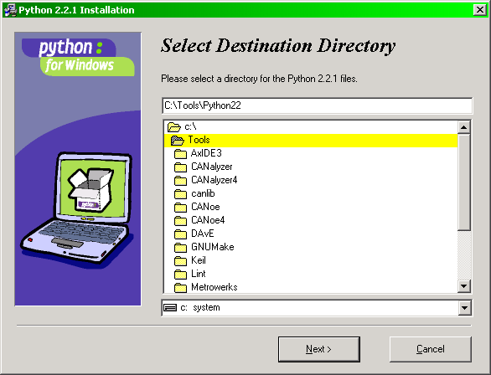

- Select a location on your C: drive for the installation. For example “C:\Tools\Python22”
- Click the “Next” button. The dialog changes to the one shown below.
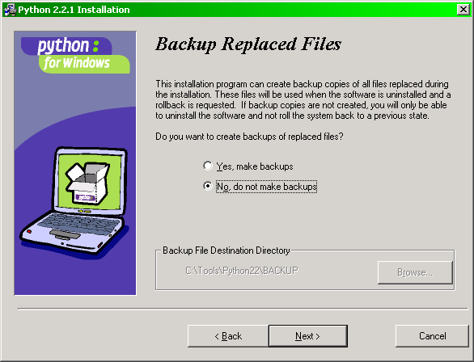

- Click in the “No, do not make backups” radio button.
- Click the “Next” button. The dialog changes to the one shown below.
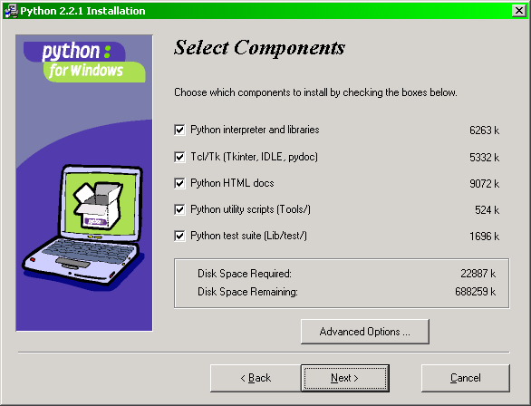

- Make no changes to the default selections. Click the “Next” button. The dialog changes to the one shown below.
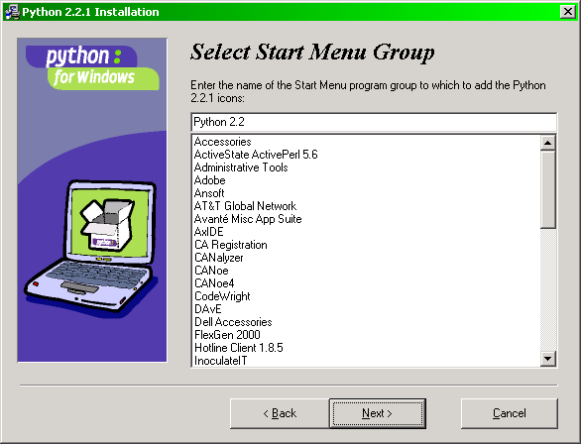

- Make no changes to the “Start Menu Group” name. Click the “Next” button. The dialog changes to the one shown below.
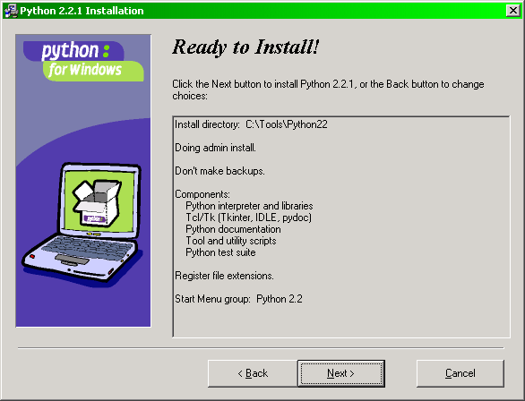

- The dialog disappears and the progress dialog shown below appears.
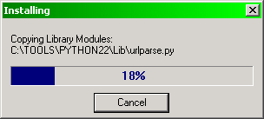

- After copying all the files, the installer displays the dialog below.
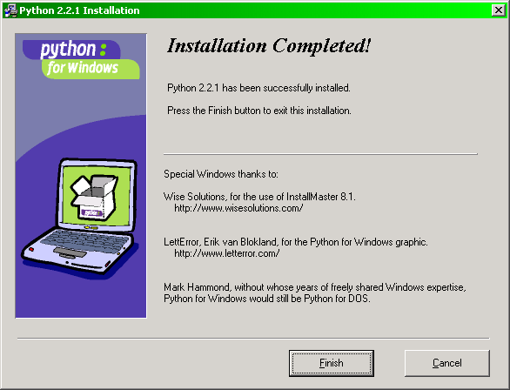

- Click the “Finish” button. That completes the base Python installation. To access the database through ODBC, Python requires two additional packages.
- Double-click the self-extracting installer file “egenix-mx-base-2.0.3.win32-py2.2.exe” The following “Setup” dialog will appear.
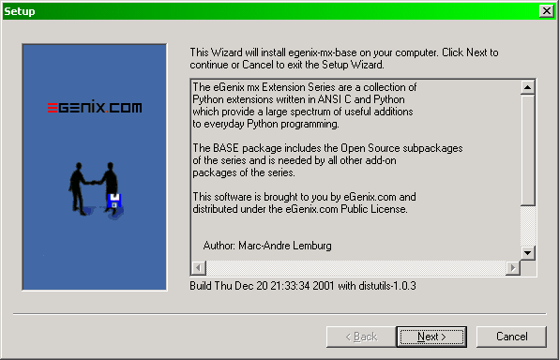

- Click the “Next” button. The dialog changes to the one shown below.
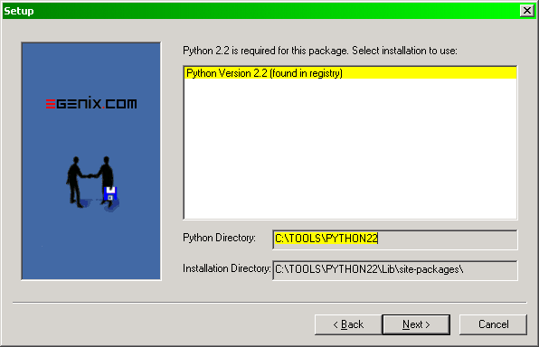

- Click the “Next” button. The dialog changes to the one shown below.
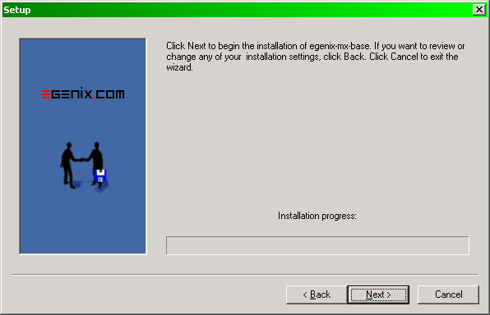

- Click the “Next” button to actually initiate the installation. The dialog changes to the one shown below.
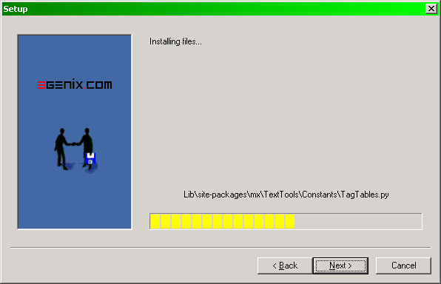

- After copying all the files, the installer displays the dialog below.
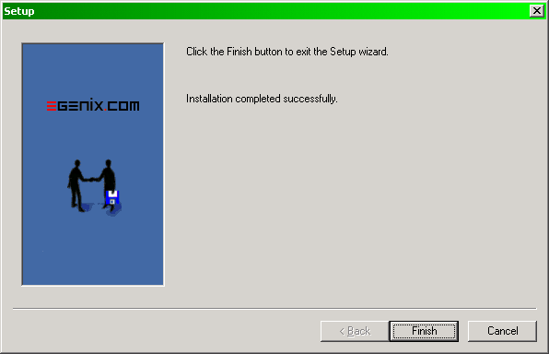

- Click the “Finish” button.
- Double-click the self-extracting installer file “egenix-mx-commercial-2.0.5.win32-py2.2.exe”
- Repeat steps 14 through 18.
- Right-click the “My Computer” icon on your Windows desktop
- Select “Properties” from the pop-up menu to display the “System Properties” dialog.
- Click the “Advanced” tab as show below.
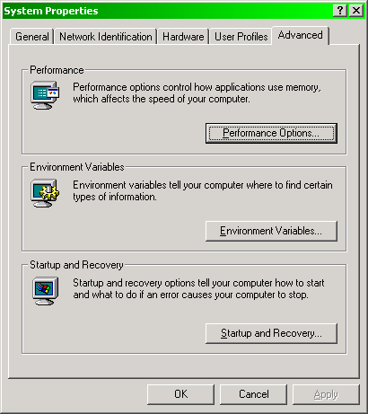

- Click the “Environment Variables…” button to display the “Environment Variables” dialog below.
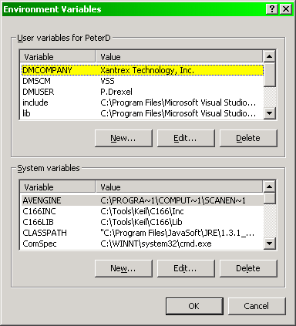

- Scroll down to and select the “Path” variable in the “System variables” pane.
- Click the “Edit…” button in the “System variables” pane to display the “Edit System Variables” dialog shown below.
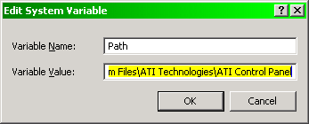

- Tap the “End” key to move to the end of the “Variable Value” text box.
- Type ;C:\Tools\Python22 (this must match the install directory from step 4) into the text box as shown in the “Edit System Variables” dialog below.
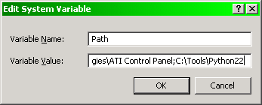

- Click the “OK” button.
- Click the “OK” button in the “Environment Variables” dialog.
- Click the “OK” button in the “System Properties” dialog.
- DONE.

Use the following procedure to execute Python scripts. Be sure that the XanBus PGN database file is writable before executing a script that accesses the database.
- Open a DOS command prompt window as shown below.
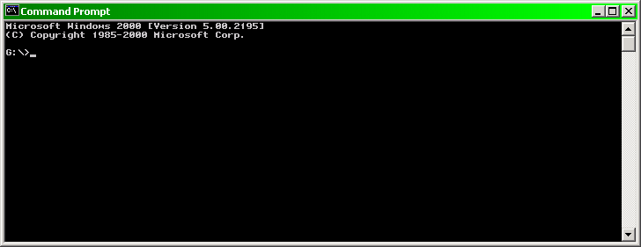

- Change to the directory where the Python script resides. Enter python <script-name>.py to execute the script. The example below shows the script named xanbus_headers.py being entered.
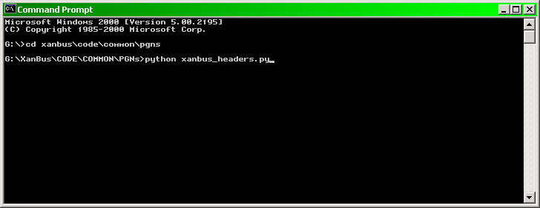
- : Windows® 2000 ODBC Setup
Use the following procedure to establish an ODBC connection to the XanBus PGN database.
- Select “Data Source (ODBC)” from the Windows “Control Panels.”
- Select the “System DSN” tab as shown below.
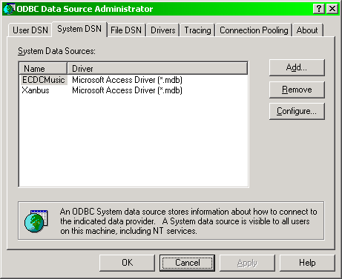

- Click the “Add…” button to popup the “Create New Data Source” dialog below.
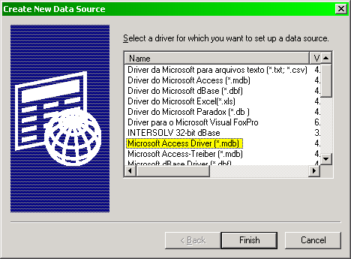

- Select the “Microsoft Access Driver (*.mdb)” entry as shown.
- Click the “Finish” button. The “ODBC Microsoft Access Setup” dialog will pop up as shown below.
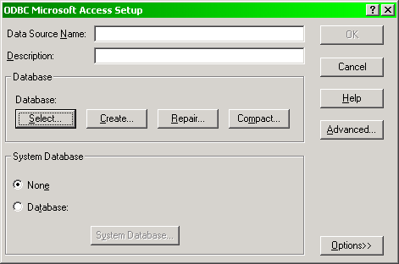

- Type “XanBus” into the “Data Source Name” field.
- Click the “Select…” button. The “Select Database” dialog will pop up as shown below.
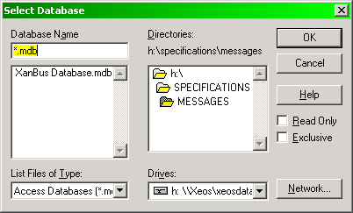

- Use the “Drives” popup menu and “Directories” pane to go to the G:\XanBus\Specifications\ directory on your personal drive.
- Select the file “XanBusDB.mdb” from the “Database Name” pane.
- Click the “OK” button.
- Click “OK” in the “ODBC Data Source Administrator” control panel
- DONE

& Assuming word-aligned, 16-bit architecture
* All nodes
† AGS only
∞ Battery Monitor only
‡ Charger and Inverter/Charger only
₤ Inverter and Inverter/Charger only
¥ User Interface only
§ Battery Monitor, Charger, Inverter and Inverter/Charger only
° AGS, Battery Monitor, Charger, Inverter and Inverter/Charger only. Association Status is only broadcast when a node is anonymously or invalidly associated and there is a user interface present.
* All nodes
¥ User Interface and AGS only
∞ User Interface and Battery Monitor only
§ User Interface, AGS, Charger and Inverter/Charger only
° User Interface, AGS, Inverter and Inverter/Charger only
† User Interface only
‡ User Interface, Inverter and Inverter/Charger only
• User Interface, Charger and Inverter/Charger only

