Join Multiple Tabel

select pd.id_tx_detail, pd.id_transaksi, o.nama_obat,

k.category_name, dto.efeksamping, dto.keterangan, pd.jmlh_obat, o.harga as harsat,

o.satuan, pd.harga as total

from penjualan_detail as pd

join obat as o on pd.id_obat = o.id_obat

join kategori as k on o.category_id = k.category_id

join detailobat as dto on o.id_obat = dto.detail_id_obat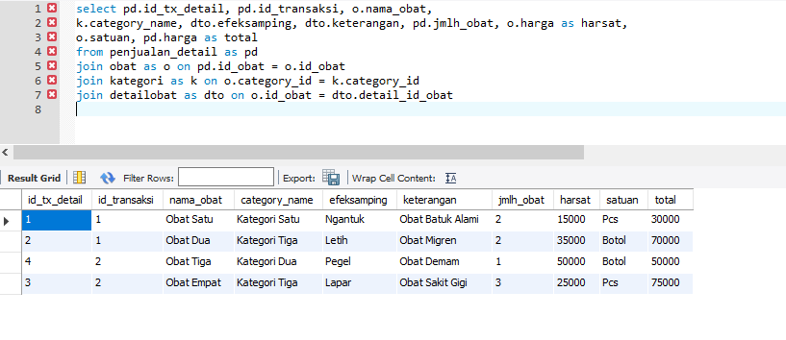

select pd.id_tx_detail, pd.id_transaksi, o.nama_obat,

k.category_name, dto.efeksamping, dto.keterangan, pd.jmlh_obat, o.harga as harsat,

o.satuan, pd.harga as total

from penjualan_detail as pd

join obat as o on pd.id_obat = o.id_obat

join kategori as k on o.category_id = k.category_id

join detailobat as dto on o.id_obat = dto.detail_id_obat

where pd.id_transaksi = 1

order by total desc

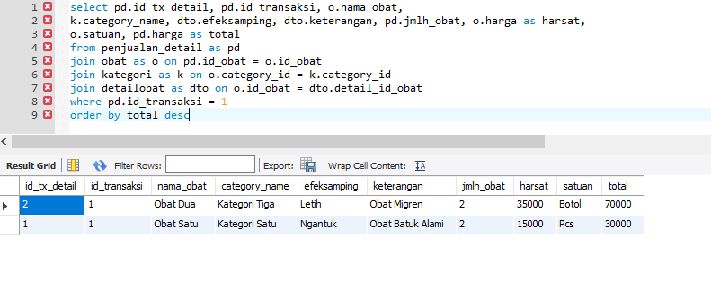

select pd.id_tx_detail, pd.id_transaksi, o.nama_obat,

k.category_name, dto.efeksamping, dto.keterangan, pd.jmlh_obat, o.harga as harsat,

o.satuan, pd.harga as total

from penjualan_detail as pd

join obat as o on pd.id_obat = o.id_obat

join kategori as k on o.category_id = k.category_id

join detailobat as dto on o.id_obat = dto.detail_id_obat

where category_name like "%Kategori Tiga"

order by total

