1. SELECT nama_obat, id_pemasok, nama_pemasok, alamat from obat join pemasok on obat.id_pemasok = pemasok.id where alamat ="Jakarta" ORDER BY nama_pemasok ASC

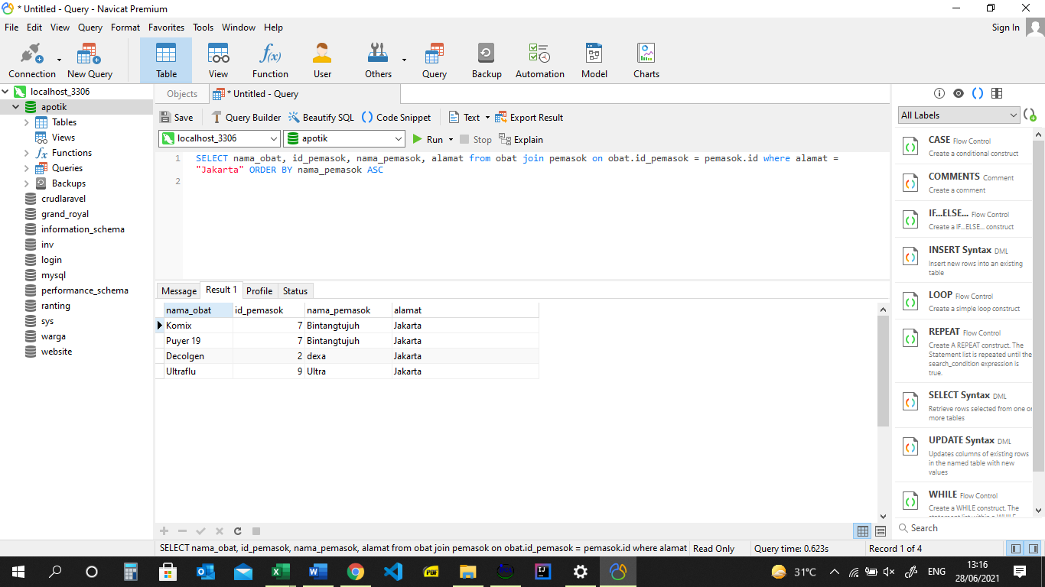

1. select username, level, nama_karyawan, alamat from username join karyawan on username.id_karyawan = karyawan.id WHERE alamat LIKE "%Tangerang%" AND Level = "Kasir"

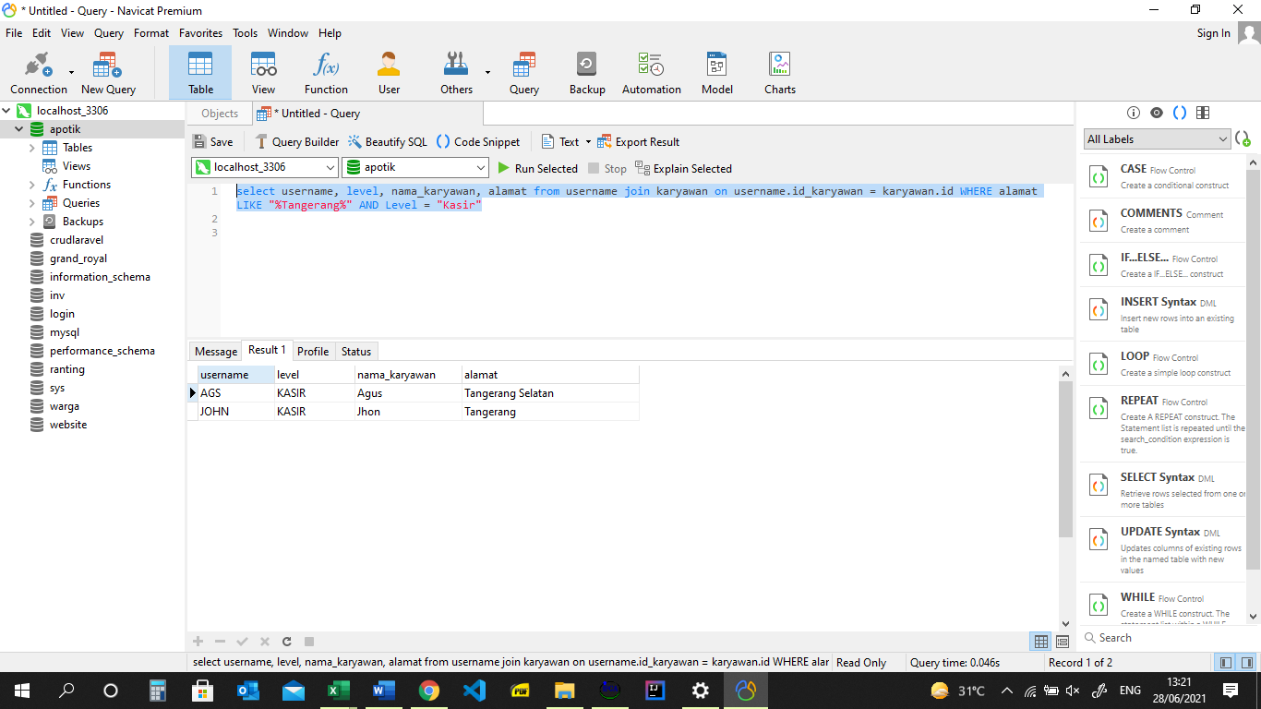

1. Select tgl_transaksi, total_transaksi, id_obat,jumlah, harga from transaksi JOIN detailtransaksi ON transaksi.id = detailtransaksi.id_transaksi ORDER BY tgl_transaksi DESC

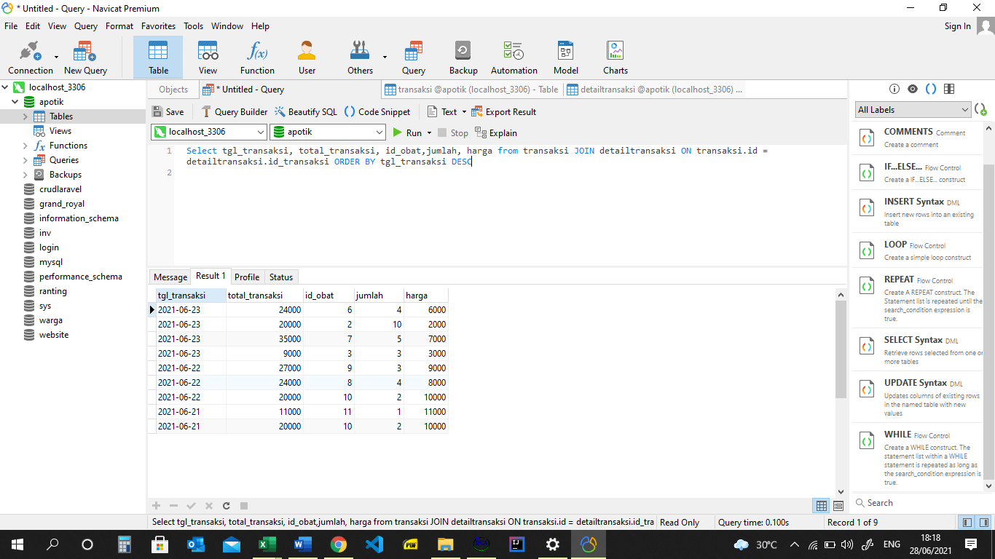

1. Select tgl_transaksi, total_transaksi, id_obat,jumlah, harga from transaksi RIGHT JOIN detailtransaksi ON transaksi.id = detailtransaksi.id_transaksi ORDER BY tgl_transaksi DESC

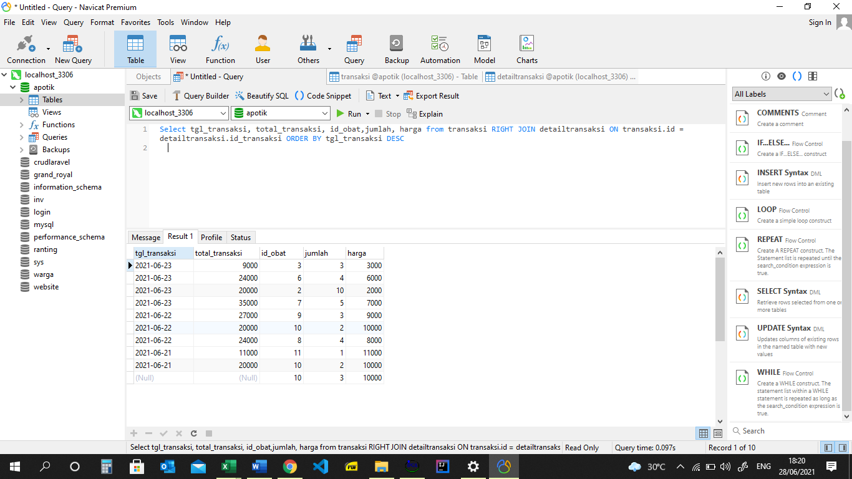

1. Select tgl_transaksi, total_transaksi, id_obat,jumlah, harga from transaksi LEFT JOIN detailtransaksi ON transaksi.id = detailtransaksi.id_transaksi ORDER BY tgl_transaksi DESC

