
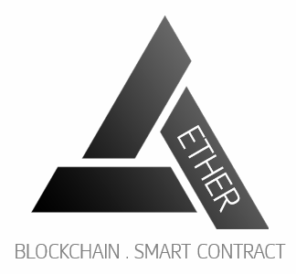

IS480 Project Proposal
Project AETHER

Team AETHER

Version Number 1
Date

Team Members:
- Clarence Neo (clarenceneo.2016@smu.edu.sg) – Lead Front-end Developer and Deputy Back-end Developer
- Dion Goh Chin Bin (dion.goh.2016@smu.edu.sg) –Lead Quality Assurance and Deputy Project Manager
- Fu Chuanyi (chuanyi.fu.2016@smu.edu.sg) – Lead Back-end Developer and Deputy Integration Developer
- Jordy Nelson Samuel (jnsamuel.2016@smu.edu.sg) – Lead System Architect and Deputy Back-end Developer
- Leong Yong Sheng, Justin (ysleong.2016@ smu.edu.sg) – Project Manager and Business Analyst
- Lim Yue Feng (yuefeng.lim.2016@smu.edu.sg) – Lead Integration Manager and Deputy Front-end Developer

Faculty Supervisor:
- Name

Sponsor and/or Clients (if any):
Organization: SMU tBank
Department
- Prof Alan Megargel (alanmegargel@smu.edu.sg) – Sponsor/Client

Project Overview
Please include all necessary information you know at this time to help us evaluate the scope, viability, plan, risks, etc. Do NOT exceed 2 pages excluding the front page. No appendix. Any diagrams, schedule, learning outcome, etc must be placed in the IS480 wiki. Do not write anything in this section.

Project Description:
Summary of the goal: What are you building {brief, about 3 sentences}? You may include the X factor. For example, building an e-commerce site selling books using a variant of K-nearest neighbor data mining technique to recommend books. Be SPECIFIC. Don’t say you are going to write a game! What game? It is good to do product comparison but put the details in the IS480 wiki.

Project AETHER is an IS480 Project aimed at building a blockchain powered KYC-as-a-service application for SMU tBank. The KYC (know your customer) service will generate a digital identity via an authorized “KYC Agent” eg; a 7-11 store, which will enable SMU tBank customer on-boarding and account creation to be carried out online rather than face-to-face with the bank staff. The blockchain powered digital identity replaces the physical presence KYC verification. The project will be built on Ethereum Blockchain Architecture. Smart Contracts will be written to perform the customer digital identity creation and verification. Two factor authentication (2FA), including Facial Recognition, will be used as a security measure for existing user verification. For teaching purposes, a gamification module will also be built to facilitate in class lab exercises for financial technology related courses. It will be used to gauge the students understanding blockchain and its applications in finance.

Motivation:
Why? What is the reason for doing this? This section could be merged with project description. Do not repeat the description; do not use vague adjectives (best, user friendly, commercial quality, scalable, interactive, one stop, efficient, improve productivity, etc.). Each of these adjectives must be quantify, otherwise, you will lose credibility. Do not claim everything, it does not solve all problems.

Blockchain distributed ledger technology has become more prevalent in the market than before. It is going to play an integral role in the future of Banking Industry. As SMU tBank is an academics platform for students to simulate real world banking operations and technology scenarios, it is an advantage to leverage on SMU tBank to integrate blockchain features to gain exposure and grasp the depth of latest technology.

Stakeholders:
Sponsor | Prof Alan Megargel,  Senior Lecturer of Information Systems  Project Head, T-bank and Special Projects
User | New SMU tBank customers  Students taking financial technology related courses
Advisors/Practitioners/Mentors | Are there other parties involved in the project? What is their relationship to the project? What interest do they have to the project? Remove this if not applicable.

Deliverables:
Outcomes: What is delivered (deployed) to the sponsor? Is it a proof of concept? Or release for live usage?
Value Statement: What does the sponsor get out of this?

Project Aether is a web application designed to ease the process for potential SMU tBank customers on-boarding and account creation by leveraging on Blockchain/Ethereum technologies rather than the traditional method. Aether is a solution that can potentially improve the accuracy and efficiency of the Banking Account creation process yet improving the current security measures. Other deliverables will include a User Guide, Lab Guide and an Admin Guide.

Scope:
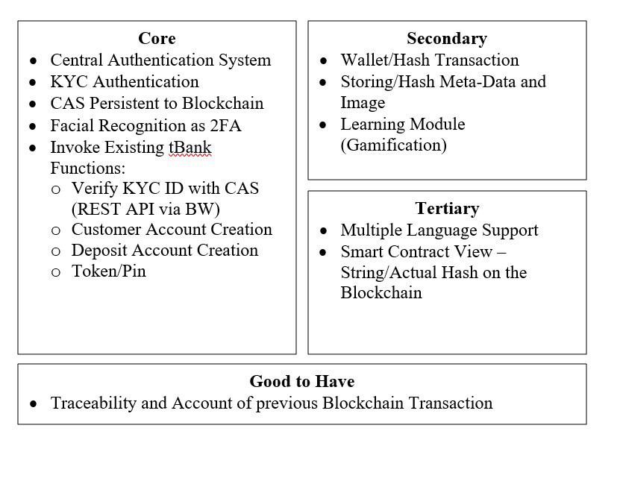
Briefly explain the scope, constraints and assumptions here.

List the functions; storyboard, use case diagram, process diagram, UI mockup/paper prototype, design diagram in the IS480 wiki. Use the diagrams only if it helps explain the scope. Use architecture diagram if necessary to show interface to 3rd party tools/frameworks, existing system API, concurrent team dependencies, etc.

Project Plan
This plan describes the resource, schedule and major risks. The plan provides a basic execution description of the project based on current knowledge of the project.

Project milestone:
Define the work breakdown structure with key milestones. Use a project timeline.
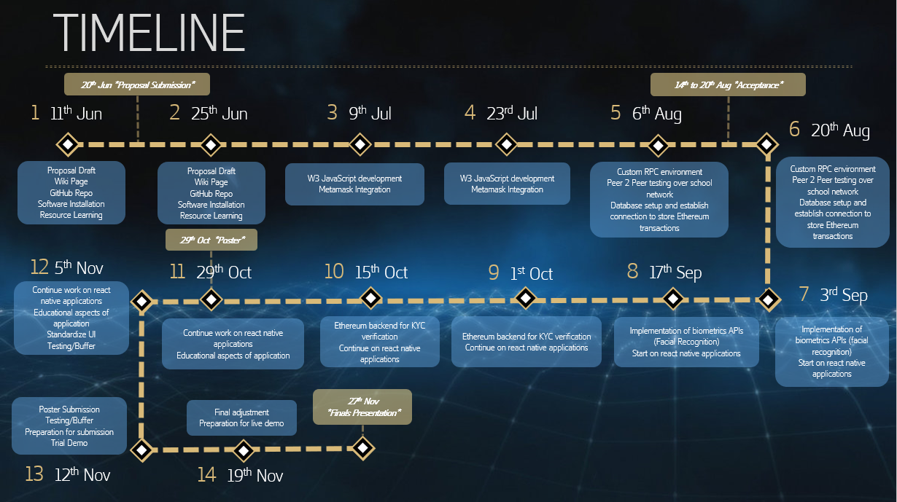
Define the iteration breakdown with functions/features list and user testing. List specific dates for your milestones! You should plan to demo your system during project acceptance, midterm and finals, include user testing, deployment and releases. Each milestone should have clear goals/functions. Note that each module should map to the priority scope

Risks:
Identify assumptions and risks particular to this project, stakeholders, schedule, team, technology constraints, etc. Do not put generic risk, such as “requirement may change”, unless it is specific to the sponsor. List mitigation steps.

Risk Type | Risk Event | Likelihood | Potential Impact | Mitigation Plan
Technical | Unfamiliarity with the Blockchain technology and e-Wallet system | High | High | All team members will undergo a Udemy blockchain course to gain familiarity on how the technology works and the grasp the technical concepts of using an Ethereum blockchain to improve existing applications.
Human | Team Members unavailable due to internships (overseas or local) and work commitments | High | Low | Regular group discussion will take place weekly after members’ working hours. Overseas members will be kept up to date on the progress and allocated respective tasks by the Project Manager.  The project codes are segmented into front and back end. Each segment will be handled by minimally two members, to make it clear who will take over in case of unavailability.
Resource | Scalability Issues when dealing with a large number of transactions, processed by a small number of nodes. | High | High | The team will be deploying on an enterprise server with sufficient ram to handle additional mining of new blocks. The team will also be researching on Ethereum’s upcoming proof-of-stake functionality to reduce need for mining.

Resource and reference:
What do you need? Training on programming (list books, web pages, hardware, software, gadgets, contact, client time, tester time, supervisor time, training course, money, trips), etc. Described the technology that you will be using (programming language, frameworks, APIs, platforms, OS, etc).

:
Video/Tutorials/Documentation | - Udemy - Ethereum Blockchain Developer: Build Projects Using Solidity (Web3,Truffle4,Metamask)  - GoEthereum Documentation  - tBank Documentation
Project Management/Version Management | - Google Sheets  - GitHub/SourceTree
Design/Prototyping | - Loop11  - Adobe Photoshop  - MS Powerpoint
Frontend Development | - Javascript  - HTML  - CSS  - jQuery  - Twitter Bootstrap
Backend Development | - Java  - Solidity(Smart Contracts) - REMIX  - Dreamfactory(REST API)  - Tracking.js (Facial Recognition)
Web/Local Servers | - Amazon Web Services (EC2 Server)  - MySQL Database
Services/Middleware | - TIBCO BusinessWorks and TIBCO EMS

Learning outcome:
The team is responsible for defining the learning object in the IS480 team wiki pages. This section is not required in this proposal.

To be assigned by course coordinator
A team wiki will be provided once the team name is provided to the course coordinator

