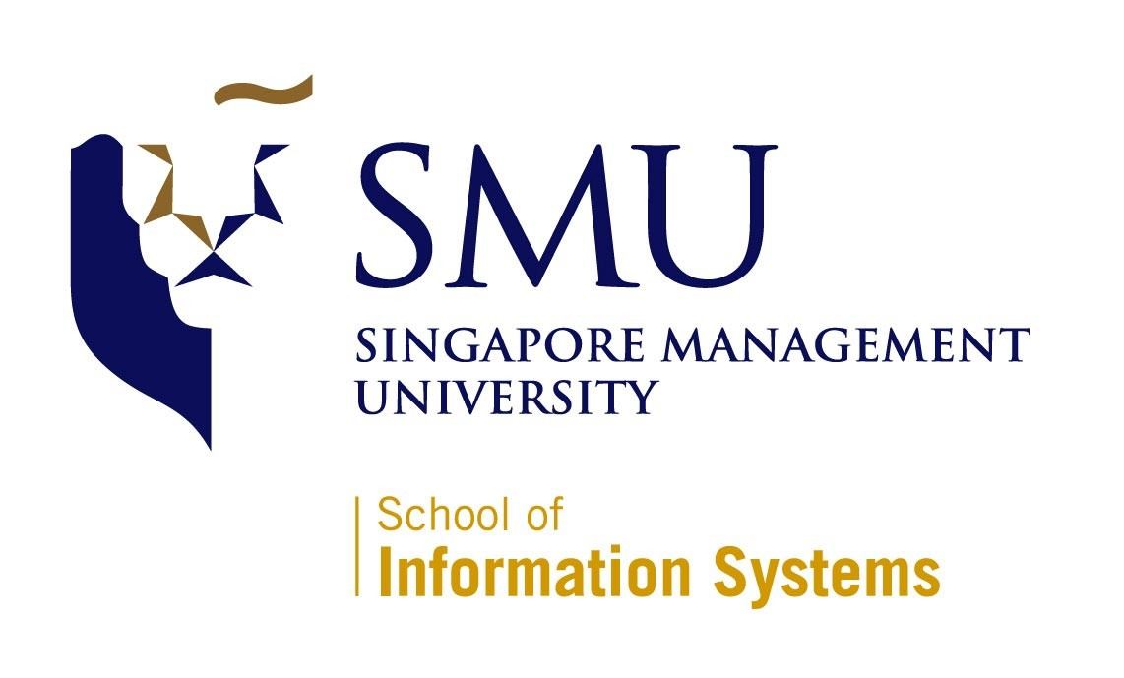
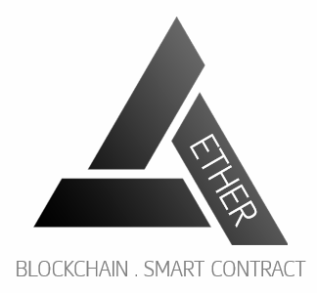

IS480 Project Proposal
Project AETHER

Team AETHER

Version Number 1
Date

Team Members:
- Clarence Neo (clarenceneo.2016@smu.edu.sg) – Lead Front-end Developer and Deputy Back-end Developer
- Dion Goh Chin Bin (dion.goh.2016@smu.edu.sg) –Lead Quality Assurance and Deputy Project Manager
- Fu Chuanyi (chuanyi.fu.2016@smu.edu.sg) – Lead Back-end Developer and Deputy Integration Developer
- Jordy Nelson Samuel (jnsamuel.2016@smu.edu.sg) – Lead System Architect and Deputy Back-end Developer
- Leong Yong Sheng, Justin (ysleong.2016@ smu.edu.sg) – Project Manager and Business Analyst
- Lim Yue Feng (yuefeng.lim.2016@smu.edu.sg) – Lead Integration Manager and Deputy Front-end Developer

Faculty Supervisor:
- Name

Sponsor and/or Clients (if any):
Organization: SMU tBank
Department
- Prof Alan Megargel (alanmegargel@smu.edu.sg) – Sponsor/Client

Project Overview

Project Description:
Project AETHER is an IS480 Project aimed at building a blockchain powered KYC-as-a-service application for SMU tBank. The KYC (know your customer) service will generate a digital identity via an authorized “KYC Agent” eg; a 7-11 store, which will enable SMU tBank customer on-boarding and account creation to be carried out online rather than face-to-face with the bank staff. The blockchain powered digital identity replaces the physical presence KYC verification. The project will be built on Ethereum Blockchain Architecture. Smart Contracts will be written to perform the customer digital identity creation and verification. Two factor authentication (2FA), including Facial Recognition, will be used as a security measure for existing user verification. For teaching purposes, a gamification module will also be built to facilitate in class lab exercises for financial technology related courses. It will be used to gauge the students understanding blockchain and its applications in finance.

Motivation:
Blockchain distributed ledger technology has become more prevalent in the market than before. It is going to play an integral role in the future of Banking Industry. As SMU tBank is an academics platform for students to simulate real world banking operations and technology scenarios, it is an advantage to leverage on SMU tBank to integrate blockchain features to gain exposure and grasp the depth of latest technology.

Stakeholders:
Sponsor | Prof Alan Megargel,  Senior Lecturer of Information Systems  Project Head, T-bank and Special Projects
User | New SMU tBank customers  Students taking financial technology related courses

Deliverables:
Project Aether is a web application designed to ease the process for potential SMU tBank customers on-boarding and account creation by leveraging on Blockchain/Ethereum technologies rather than the traditional method. Aether is a solution that can potentially improve the accuracy and efficiency of the Banking Account creation process yet improving the current security measures. Other deliverables will include a User Guide, Lab Guide and an Admin Guide.

Scope:
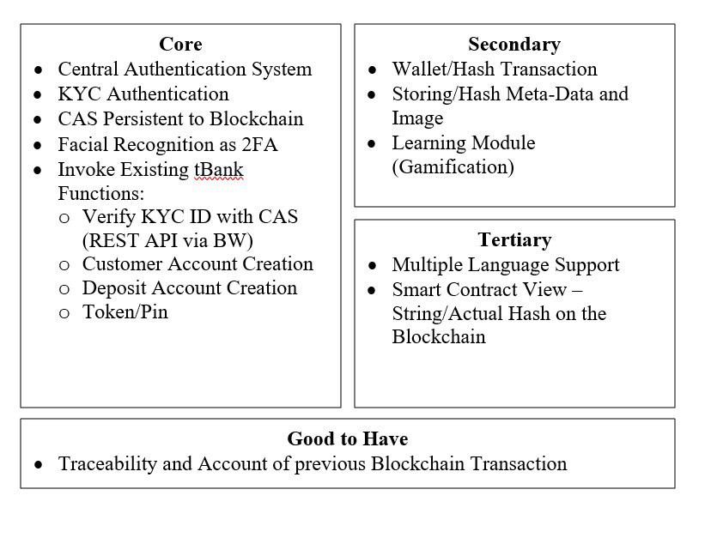

Project Plan

Project milestone

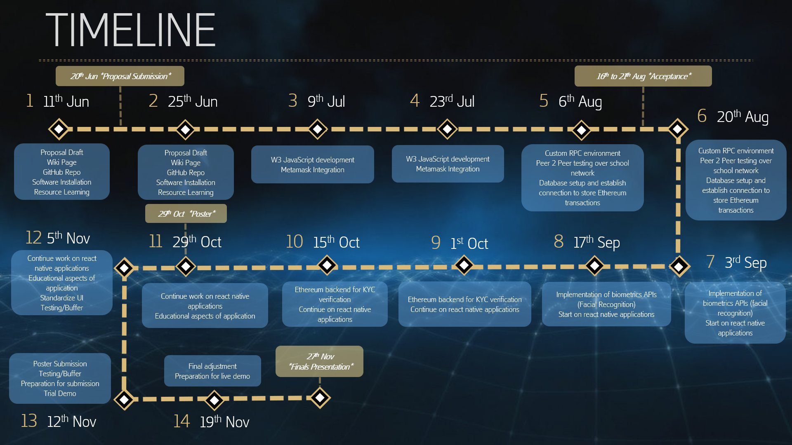

Risks:

Risk Type | Risk Event | Likelihood | Potential Impact | Mitigation Plan
Technical | Unfamiliarity with the Blockchain technology and e-Wallet system | High | High | All team members will undergo a Udemy blockchain course to gain familiarity on how the technology works and the grasp the technical concepts of using an Ethereum blockchain to improve existing applications.
Human | Team Members unavailable due to internships (overseas or local) and work commitments | High | Low | Regular group discussion will take place weekly after members’ working hours. Overseas members will be kept up to date on the progress and allocated respective tasks by the Project Manager.  The project codes are segmented into front and back end. Each segment will be handled by minimally two members, to make it clear who will take over in case of unavailability.

Resource and reference:
Video/Tutorials/Documentation | Udemy - Ethereum Blockchain Developer: Build Projects Using Solidity (Web3, Truffle4, Metamask), GoEthereum Documentation, tBank Documentation
Project Management/Version Management | Google Sheets, GitHub/SourceTree
Design/Prototyping | Loop11, Adobe Photoshop, MS Powerpoint
Frontend Development | Javascript, HTML, CSS, jQuery, Twitter Bootstrap
Backend Development | Java, Solidity(Smart Contracts) – REMIX, Dreamfactory(REST API), Tracking.js (Facial Recognition)
Web/Local Servers | Amazon Web Services (EC2 Server), MySQL Database
Services/Middleware | TIBCO BusinessWorks and TIBCO EMS

To be assigned by course coordinator

