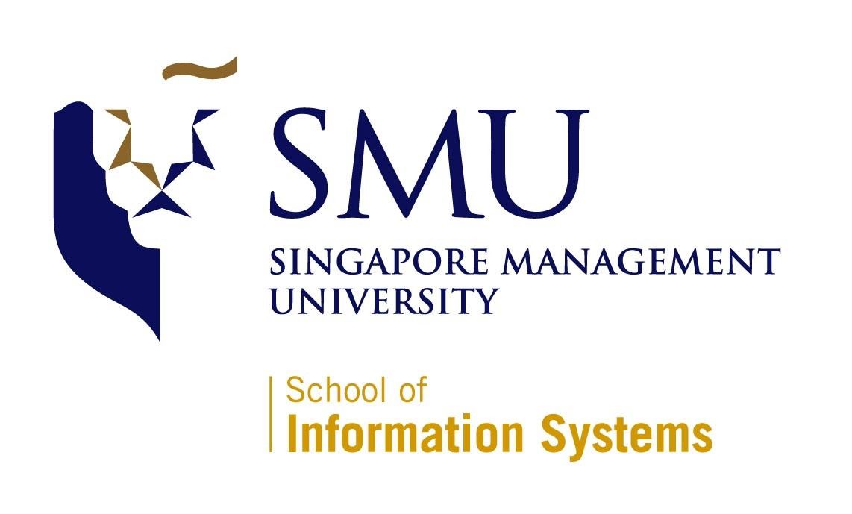
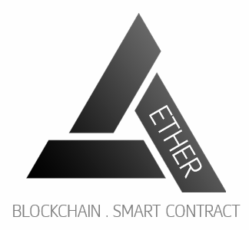

IS480 Project Proposal
Project AETHER

Team AETHER

Version Number 1
Date

Team Members:
- Clarence Neo (clarenceneo.2016@smu.edu.sg) – Lead Front-end Developer and Deputy Back-end Developer
- Dion Goh Chin Bin (dion.goh.2016@smu.edu.sg) –Lead Quality Assurance and Deputy Project Manager
- Fu Chuanyi (chuanyi.fu.2016@smu.edu.sg) – Lead Back-end Developer and Deputy Integration Developer
- Jordy Nelson Samuel (jnsamuel.2016@smu.edu.sg) – Lead System Architect and Deputy Back-end Developer
- Leong Yong Sheng, Justin (ysleong.2016@ smu.edu.sg) – Project Manager and Business Analyst
- Lim Yue Feng (yuefeng.lim.2016@smu.edu.sg) – Lead Integration Manager and Deputy Front-end Developer

Faculty Supervisor:
- Name

Sponsor and/or Clients (if any):
Organization: SMU tBank
Department
- Prof Alan Megargel (alanmegargel@smu.edu.sg) – Sponsor/Client
Project Overview

Project Description:
With eliminating the time-consuming process of customer on-boarding and account creation process in mind, our team aims to utilise blockchain technology and smart contracts to empower KYC-as-a-service application (Know Your Customer) for SMU tBank through a web application. To replace the traditional method of account creation by being present in a bank branch, our project is about building a web application that can be incorporated to authorised “KYC Agents” such as convenience stores that are strategically located, to reduce the waiting time and increase the efficiency to generate the consumer’s digital identity. Our project will be leveraging on Ethereum Blockchain and smart contracts to perform consumer’s digital identity creation and verification with Facial Recognition technology as our secondary factor of authentication (Main authentication method will be the agent’s visual authentication). We will also be revamping SMU tBank’s existing web pages. For teaching purposes, a gamification module will also be built to facilitate in class lab exercises for financial technology related courses. It will be used to gauge the students understanding blockchain and its applications in finance.

Motivation:
Blockchain distributed ledger technology has become more prevalent in the market than before. It is going to play an integral role in the future of Banking Industry. As SMU tBank is an academics platform for students to simulate real world banking operations and technology scenarios, it is an advantage to leverage on SMU tBank to integrate blockchain features to gain exposure and grasp the depth of latest technology.

Stakeholders:
Sponsor | Prof Alan Megargel,  Senior Lecturer of Information Systems  Project Head, T-bank and Special Projects
User | New SMU tBank customers  Students taking financial technology related courses

Deliverables:
Project Aether is a web application designed to ease the process for potential SMU tBank customers on-boarding and account creation by leveraging on Blockchain/Ethereum technologies rather than the traditional method. Aether is a solution that can potentially improve the accuracy and efficiency of the Banking Account creation process yet improving the current security measures. Other deliverables will include a User Guide, Lab Guide and an Admin Guide.

Scope:
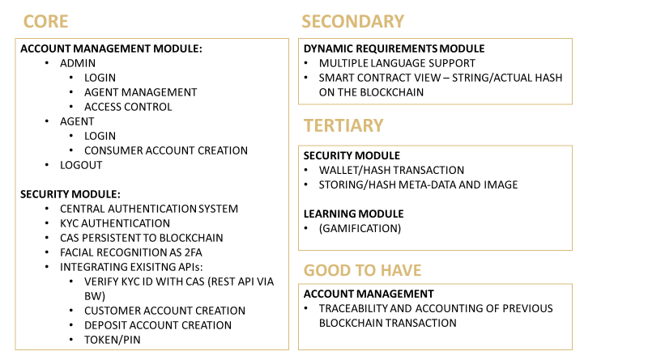

Project Plan

Project milestone
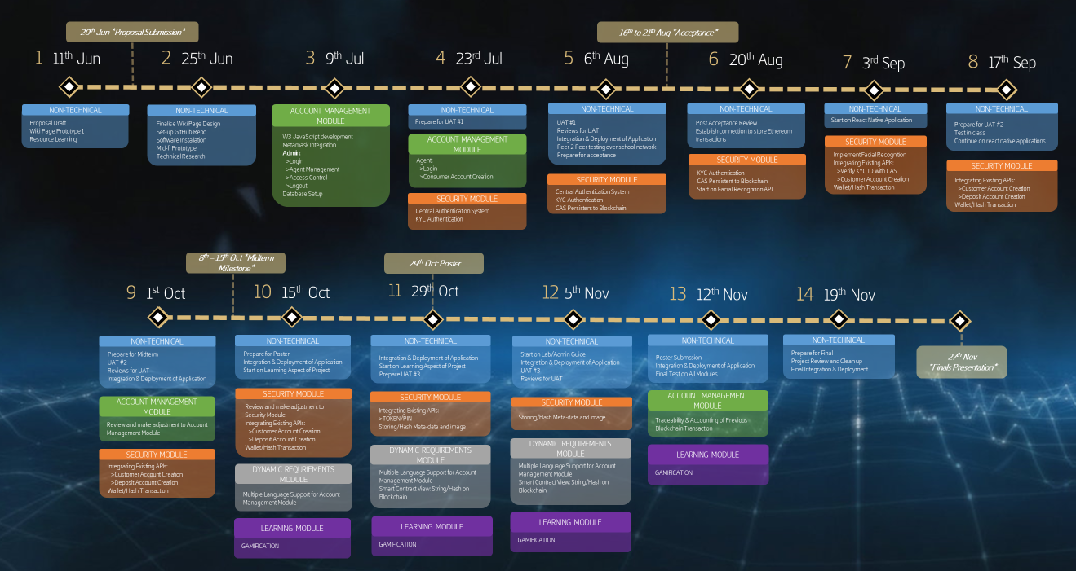

Risks:

Risk Type | Risk Event | Likelihood | Potential Impact | Mitigation Plan
Technical | Unfamiliarity with the Blockchain technology and e-Wallet system | High | High | All team members will undergo a Udemy blockchain course to gain familiarity on how the technology works and the grasp the technical concepts of using an Ethereum blockchain to improve existing applications.
Human | Team Members unavailable due to internships (overseas or local) and work commitments | High | Low | Regular group discussion will take place weekly after members’ working hours. Overseas members will be kept up to date on the progress and allocated respective tasks by the Project Manager.  The project codes are segmented into front and back end. Each segment will be handled by minimally two members, to make it clear who will take over in case of unavailability.

Resource and reference:
Video/Tutorials/Documentation | Udemy - Ethereum Blockchain Developer: Build Projects Using Solidity (Web3, Truffle4, Metamask), GoEthereum Documentation, tBank Documentation
Project Management/Version Management | Google Sheets, GitHub/SourceTree
Design/Prototyping | Loop11, Adobe Photoshop, MS Powerpoint
Frontend Development | Javascript, HTML, CSS, jQuery, Twitter Bootstrap
Backend Development | Java, Solidity(Smart Contracts) – REMIX, Dreamfactory(REST API), Tracking.js (Facial Recognition)
Web/Local Servers | Amazon Web Services (EC2 Server), MySQL Database
Services/Middleware | TIBCO BusinessWorks and TIBCO EMS

To be assigned by course coordinator

