Atlas-Projected Integration and Stage-Resolved Analysis of Wolbachia-Infected Drosophila Embryos, Primary Cell Lines, and Cell Lines
Review notes (delete before sharing)
Bold text is new or changed relative to the previous draft. Figures 1–4 are unchanged; Figures 5–9, Table 1, and Figure S1 are new.
Terminology: the previous draft called the stable cell lines "primary cell lines". This version calls the stable cell lines "cell lines" and uses "primary cell lines" for the early cell lines (one library per lineage), which are newly added here. The atlas-projection sections (Figures 1–4) still cover only the 13 embryo and cell-line libraries.
Infection status: ubkhc and Dsim-Merrill23 derive from infected lineages and lost their infections in culture; both Dsim6B lines derive from wRi-infected D. simulans w− flies, and the uninfected Dsim6B line was cured with doxycycline. I rewrote the titer section and the Wolbachia paragraphs of the Discussion to match, and removed the natural-versus-transinfected hypothesis.
Judgment calls to check: (1) Polycomb evidence uses reference maps (embryo H3K27me3, S2 and BG3 chromatin states), not marks measured in these cells; (2) depth-matched z-scores in the rank test come from a narrow null and overstate precision, so the text reports rho values and permutation p-values instead; (3) Dsim6B-wMel expresses white and lacks plasmatocyte genes that Dsim6B expresses, although both derive from D. simulans w− flies; how wMel was introduced into Dsim6B-wMel, and whether the two lines diverged after they split, should be stated before the infection comparison is interpreted; (4) the four literature citations in the Discussion (Brückner 2004, Munier 2002, Simcox 2008, Zhang 2008) should be checked against the original papers; (5) the Discussion treats JupiterGFP, ubkhc, and Dsim-Merrill23 as the three lineages whose natural infection went into culture without intervention (two lost it); check that this matches the lab records.

Results
To determine whether transcriptional differences between Wolbachia-infected Drosophila embryos and their derived cell lines reflect genuine biological divergence rather than a batch artifact of joint clustering, we projected every cell from both sample types onto a single, externally fixed reference embedding built from the Flysta3D-v2 developmental atlas, rather than re-clustering embryo and cell-line transcriptomes jointly. Reference projection (scanpy.tl.ingest) fits the principal-component and UMAP embedding once, on the atlas alone, and maps each query cell into that fixed coordinate space via its nearest neighbors in atlas PCA space; because no query sample can influence the placement of another, this removes the shared "joint fit" axis that a batch-correction step would otherwise need to correct for. The resulting dataset comprised 35,921 cells from 13 sequencing libraries across nine experimental conditions: five cell-line conditions (Dsim-Merrill23, Dsim6B, Dsim6B-wMel, JW18wMel, and ubkhc; 17,590 cells, two replicates each) and four whole-embryo conditions, each the parental source of one or more of the cell lines above (Dsim-Merrill23-wRi-embryos, Dsim-w-wRi-embryos, JupiterGFP-wMel-embryos, and ubkhc-wMel-embryos; 18,331 cells, one replicate each). Every cell received a transferred cell-type label at three resolutions (atlas-level annotation, tissue, and germ-layer) together with a nearest-neighbor confidence score. Two of the five cell lines (JW18wMel and Dsim6B-wMel) carry Wolbachia. ubkhc and Dsim-Merrill23 derive from infected lineages but lost their infections in culture, and we cured Dsim6B of wRi with doxycycline (see below).
We first confirmed that reference projection removed the dataset-driven clustering seen under joint re-integration: cells from embryo and cell-line samples overlapped extensively on the shared embedding rather than separating by sample of origin (Figure 1A), and biological replicates of the same condition generally co-localize (Figure 1D), consistent with projection reflecting cell-intrinsic similarity rather than sample identity. Cell-line cells occupied a visibly narrower region of the embedding than embryo cells (Figure 1A), concentrated within the CNS-like and hemolymph-like regions in particular (Figure 1B–C).
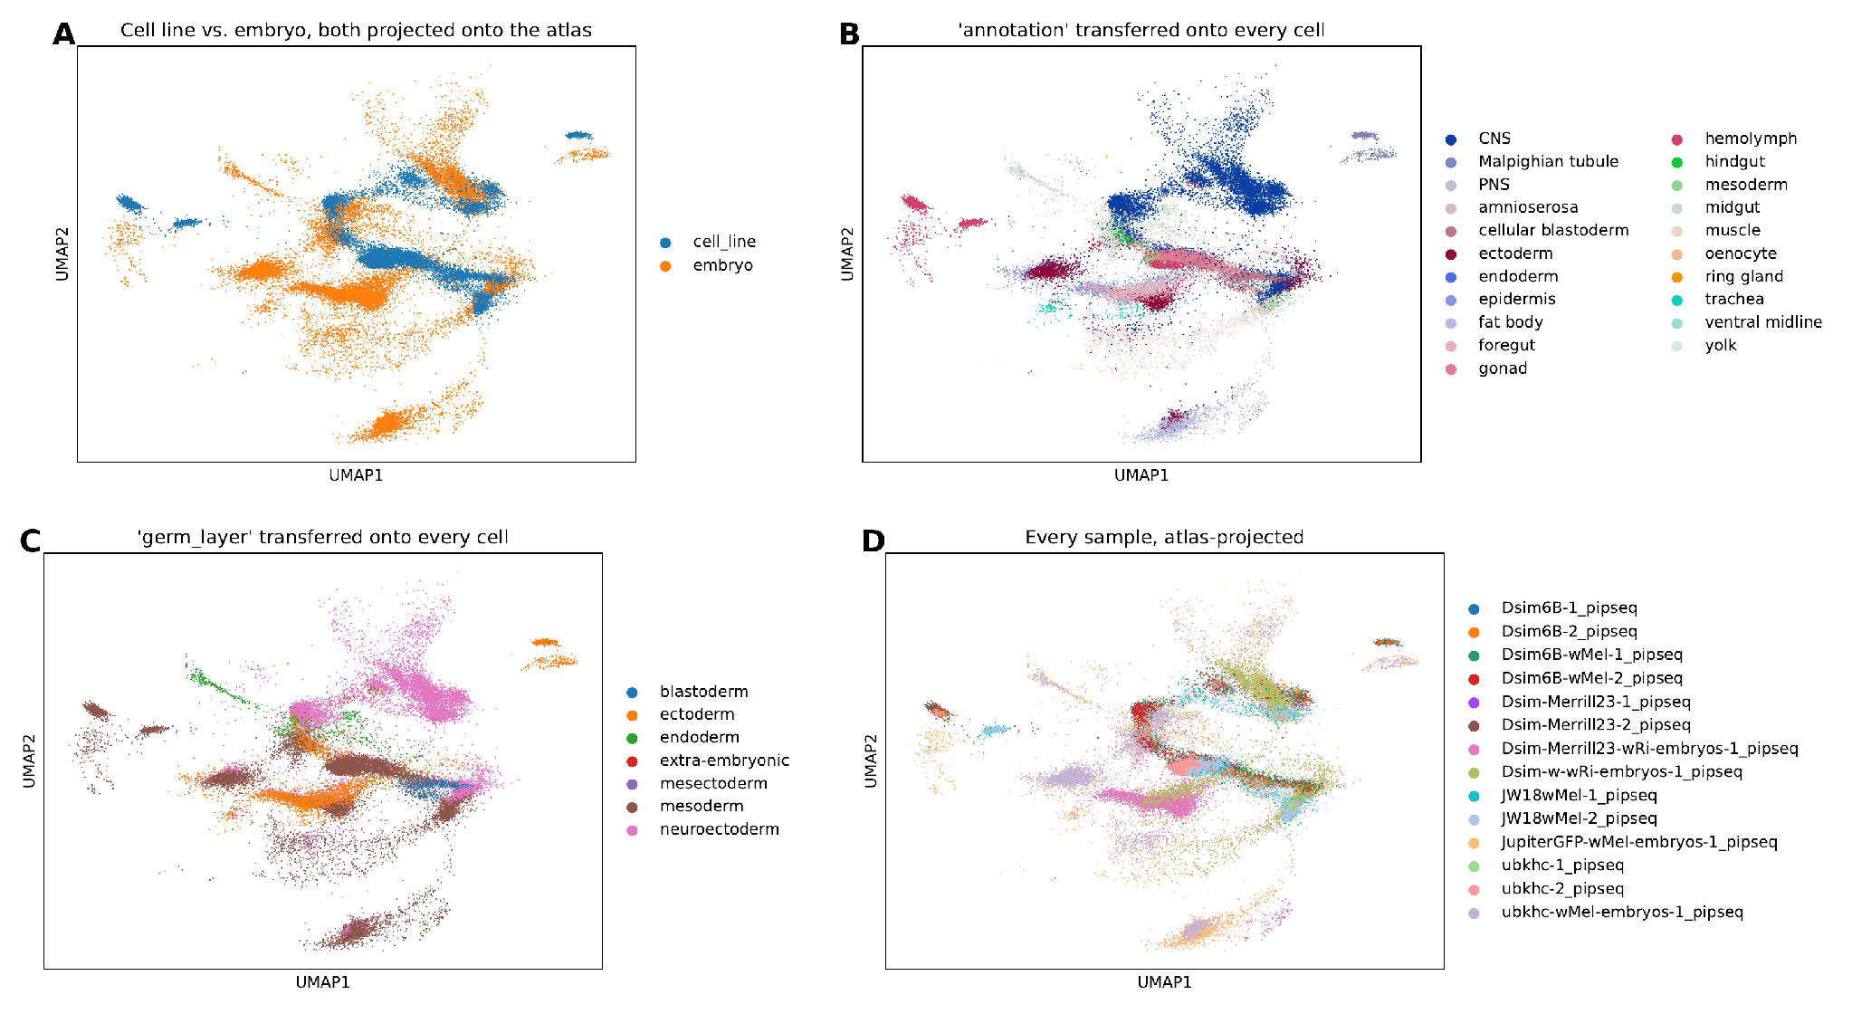
Figure 1. Atlas-projected embedding, colored four ways. (A) Sample type (cell line, blue; embryo, orange). (B) Transferred atlas_annotation. (C) Transferred atlas_germ_layer. (D) Individual sequencing library.

Cell lines converge on a narrow subset of embryonic cell identities
Whole-embryo conditions were compositionally heterogeneous, each spanning 7–16 of the 21 possible atlas cell types with no single type exceeding approximately 65% of cells (mean Shannon diversity H′ = 2.26 at the atlas_annotation resolution; Figure 2). Every cell-line condition, by contrast, was dominated by a small subset of the same three identities, hemolymph-like, gonad-like, and CNS-like, which together accounted for 78–96% of cells in each cell line (mean H′ = 2.08; Figure 2).
The reduction in diversity was more pronounced at the coarser germ-layer resolution (mean H′ = 1.18 for cell lines versus 1.40 for embryos), consistent with cell lines collapsing onto a small number of transcriptional states rather than merely sub-sampling the same diversity present in the parental embryo. This convergence was independent of genetic background and Wolbachia infection: all five cell lines, spanning two host species (D. simulans and D. melanogaster) and both infected (JW18wMel, Dsim6B-wMel) and uninfected (ubkhc, Dsim6B, Dsim-Merrill23) cell lines, showed the same hemolymph/gonad/CNS-dominated profile. Marker-based scoring (below) supports the hemolymph-like identity but not the CNS-like label: neural marker states made up at most 3.3% of cell-line cells, which suggests that proliferative cell-line cells project onto the atlas CNS population by nearest-neighbor similarity rather than by neural identity.
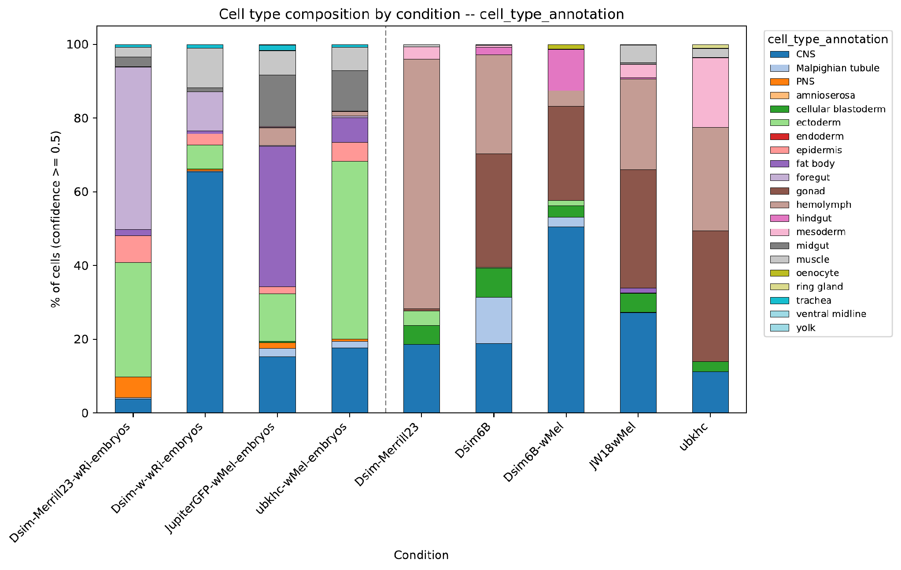
Figure 2. Cell-type composition by condition (atlas_annotation, confidence ≥ 0.5), embryo conditions at left of the dashed line and cell-line conditions at right.

Pseudobulk transcriptomes cluster by culture status rather than by genetic background
Hierarchical clustering of pairwise pseudobulk correlations across all nine conditions produced a top-level split that separated all four embryo conditions from all five cell-line conditions; genetic background and Wolbachia strain structured only the sub-clusters within each group (Figure 3A). The mean pairwise Spearman correlation was 0.835 among cell lines and 0.825 among embryos, compared with 0.705 between a cell line and any embryo condition, regardless of species or Wolbachia strain. Notably, a cell line's pseudobulk profile did not correlate most strongly with that of its own parental embryo: Dsim6B, for example, correlated more strongly with Dsim-Merrill23-wRi-embryos (ρ = 0.840) than with its own parental Dsim-w-wRi-embryos (ρ = 0.785). Culture status was therefore a stronger determinant of pseudobulk transcriptome similarity than either species or the specific embryo from which a cell line was originally derived.

Embryo, but not cell-line, pseudobulk profiles are tissue-specific
Correlating each condition's pseudobulk profile against reference pseudobulk profiles for each atlas tissue (computed from embryo cells only) showed that embryo conditions peaked sharply at the tissue matching their dominant annotation, Dsim-Merrill23-wRi-embryos against foregut (ρ = 0.99) and JupiterGFP-wMel-embryos against fat body (ρ = 0.98), for example, whereas cell-line conditions showed uniformly moderate correlations (ρ = 0.57–0.85) with no clear peak against any single reference tissue (Figure 3B). This pattern corroborates the composition analysis above at the pseudobulk level: embryo transcriptomes are recognizably tissue-specific, whereas cell-line transcriptomes resemble a blend that does not closely match any single reference tissue.
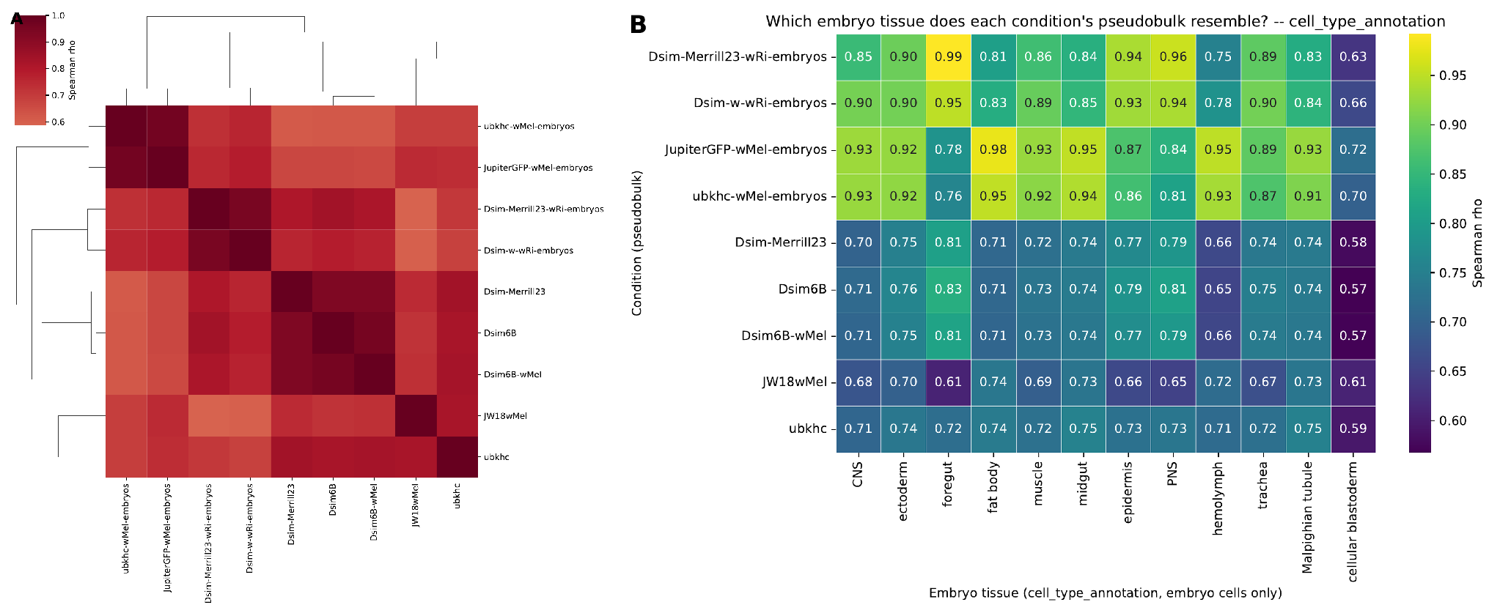
Figure 3. Pseudobulk transcriptome comparisons across conditions. (A) Hierarchical clustering of pairwise Spearman correlations between pseudobulk profiles for all nine conditions. (B) Spearman correlation between each condition's pseudobulk profile (rows) and the reference pseudobulk profile of each atlas tissue computed from embryo cells only (columns).

Embryos, primary cell lines, and cell lines occupy discrete transcriptional states
To follow each lineage through culture, we added one primary-cell-line library per lineage (5,892–6,156 cells each) and grouped samples into four lineages: in D. melanogaster, JupiterGFP-wMel embryos, wMel_JupiterGFP primary cell lines, and JW18wMel, and ubkhc-wMel embryos, wMel_Ubkhc primary cell lines, and ubkhc; in D. simulans, Dsim-w-wRi embryos, wRi_Dsimw- primary cell lines, and Dsim6B plus Dsim6B-wMel, and Dsim-Merrill23-wRi embryos, wRi_Merrill23 primary cell lines, and Dsim-Merrill23. We mapped D. simulans genes to their 1:1 D. melanogaster orthologs so that all lineages share one annotation. Within each lineage, we built an embedding from within-sample highly variable genes, excluding ribosomal, mitochondrial, heat-shock, and immediate-early genes. The three stages still separated completely (Figure 5A): in every sample except the 224-cell Dsim-Merrill23 embryo library, at least 99.4% of each cell's nearest neighbors came from the same stage (94.6% for that library). Because no intermediate cells connected the stages, a continuous pseudotime could only restate this three-step separation, so we analyzed the stage transitions with pseudobulk differential expression instead, treating the four lineages as biological replicates (PyDESeq2; design ~ lineage + stage).

Stage transitions are shared across species and lineages
The embryo-to-primary-cell-line transition changed 4,484 genes (2,125 up and 2,359 down in primary cell lines; adjusted p < 0.05), and the primary-to-cell-line transition changed 3,720 genes (287 up and 3,433 down in cell lines). All four lineages agreed in direction for 81% and 84% of these genes, respectively, and a species-by-stage interaction affected only 195 genes in the primary-to-cell-line step. Primary cell lines were sequenced more deeply than embryos or cell lines, so we repeated the analysis after downsampling every cell to 2,000 UMIs; this retained 89–97% of significant genes per contrast, with log2 fold-change correlations of at least 0.99, so sequencing depth did not drive these differences.
Gene set enrichment analysis separated the two transitions (Figure 5B). Relative to embryos, primary cell lines up-regulated proteasome, endosomal transport, DNA repair, and Toll and Imd signaling genes and down-regulated translation and developmental programs (axon guidance, nervous system, eye, and imaginal disc development). Relative to primary cell lines, cell lines up-regulated peptide biosynthesis, ribosome biogenesis, DNA replication, and mitosis (normalized enrichment scores 3.0–5.5; FDR < 0.05) and down-regulated antibacterial defense and differentiation terms (neuroblast differentiation, muscle cell fate commitment, stem cell development).
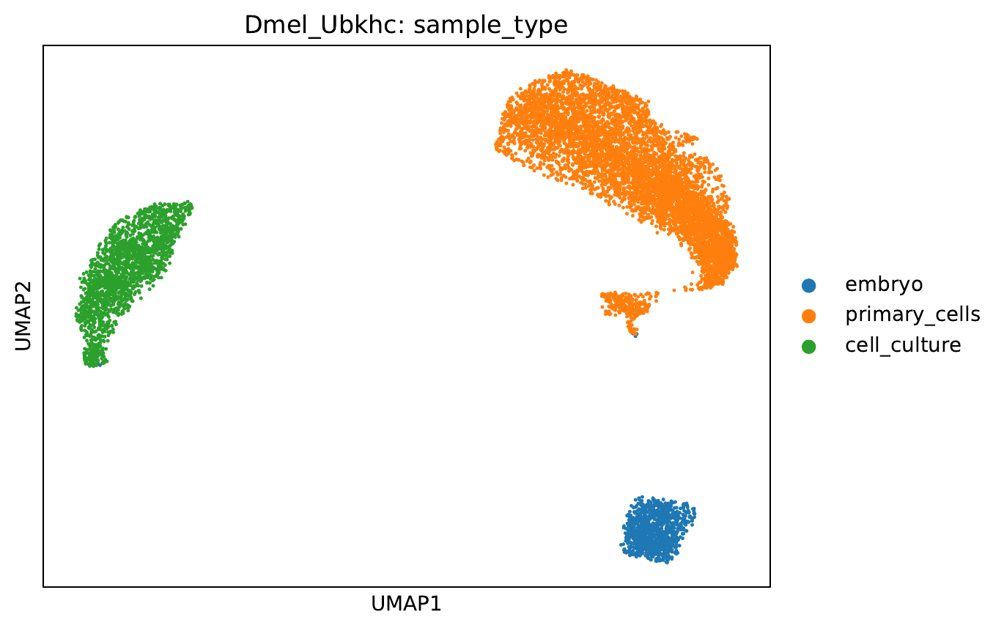
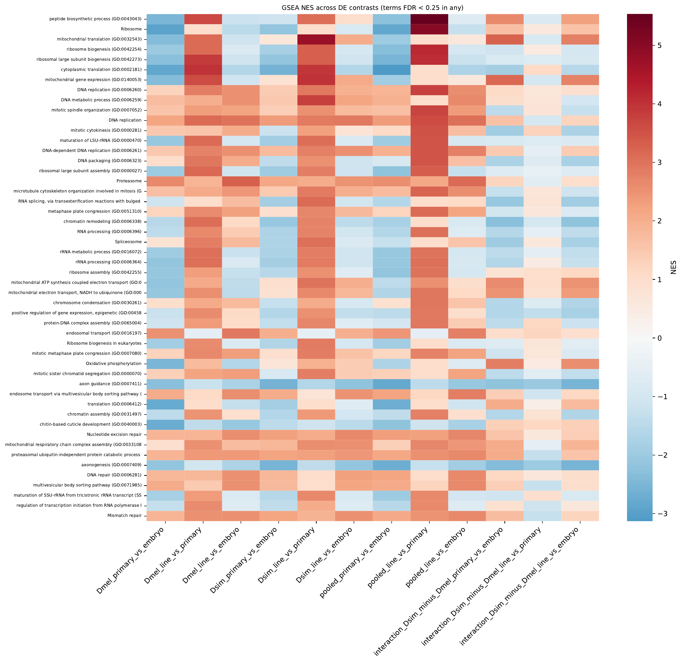
Figure 5. Stage structure and shared stage transitions. (A) Per-lineage embedding for Dmel_Ubkhc colored by stage (embryo, primary cell line, cell line); the other three lineages show the same complete separation. (B) Normalized enrichment scores for GO Biological Process and KEGG terms across per-species, pooled, and species-interaction contrasts (terms with FDR < 0.25 in any contrast).

Marker-based cell states reveal a proliferative, plasmatocyte-like cell-line identity
Because the atlas labels come from intact embryos, we also scored every cell for curated marker modules (plasmatocyte, crystal cell, lamellocyte, fat body, neural, neuroblast, muscle, epidermis, germline, proliferation, and antimicrobial peptides; Figure 6). Proliferating cells made up 0.5–6.2% of embryo cells and 0.1–10.5% of cells in primary cell lines but 27–66% of cell-line cells. An antimicrobial-peptide program marked 17–69% of cells in primary cell lines and was absent from embryos and cell lines, which suggests that dissociation and culture trigger an injury or immune response that established cell lines no longer carry. Plasmatocyte-like cells made up 62% of ubkhc, 35% of Dsim-Merrill23, and 32% of the Dsim_w cell lines, whereas JW18wMel was 54% unassigned and 25% neuroblast-like. Crystal-cell states, present in 12–13% of cells in primary cell lines, fell to 0–1.4% in cell lines.
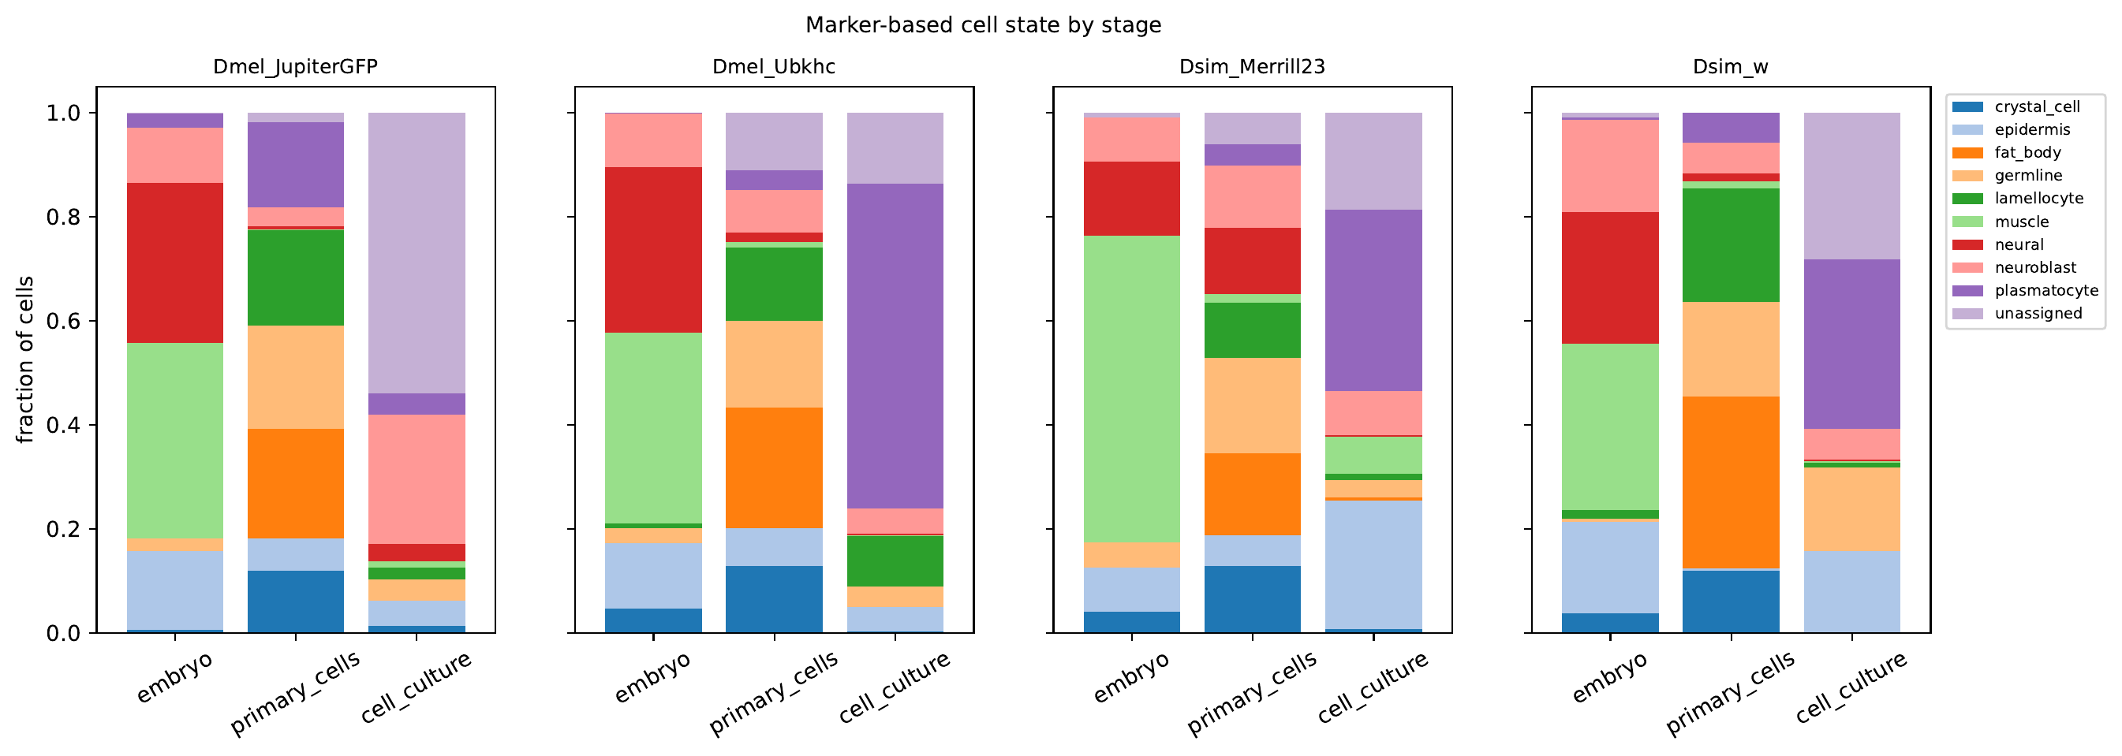
Figure 6. Marker-based cell state by stage for each lineage. Each cell is assigned to the identity module with the highest z-scored module score (z > 0.5; otherwise unassigned).

Proliferating cells in primary cell lines already shift toward the cell-line transcriptome
To ask whether any primary-cell-line subpopulation resembles the cell lines, we compared the most proliferative 5% of cells in each primary cell line with the remaining cells and correlated their per-gene expression shift with the pseudobulk log2 fold change between cell lines and primary cell lines (Spearman ρ), using only genes outside the highly variable set. We compared each ρ with 200 random equal-sized sets of cells from the same primary cell line and, separately, with random sets matched on per-cell sequencing depth. Proliferative cells shifted toward the cell line in both D. melanogaster lineages and in Dsim_w (ρ = 0.25–0.32; permutation p ≤ 0.01; Figure 7). The shift persisted after we removed 415–476 cell-cycle, ribosome-biogenesis, translation, and chromatin genes (ρ = 0.24–0.31) and after we also removed mitochondrial and respiration genes (ρ = 0.25–0.32), and it exceeded depth-matched random sets in all three lineages. In Dsim-Merrill23, proliferative cells did not shift toward the cell line (ρ = −0.11), although they exceeded depth-matched sets. Cells with the lowest antimicrobial-peptide scores did not shift toward the cell line (ρ = −0.13 to 0.16), so reduced injury signaling alone does not explain the effect. Cells selected for global similarity to the cell-line centroid had low sequencing depth (median UMIs 0.34–0.81 times the rest of the primary cell line) and shifted away from the cell line, a depth artifact; we therefore do not treat them as precursors.
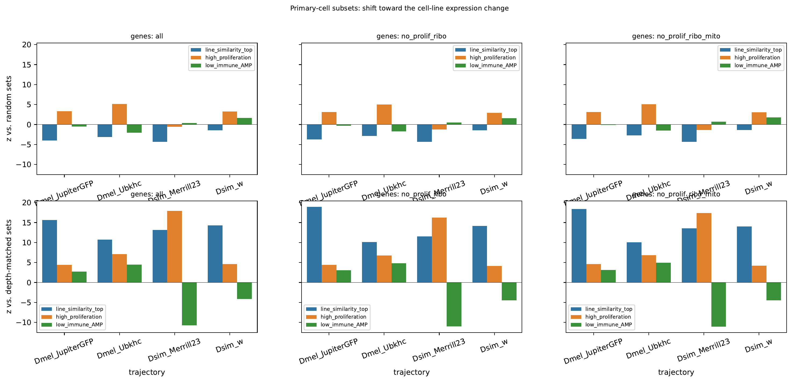
Figure 7. Primary-cell-line subsets tested for a shift toward the cell-line expression change. Bars show z-scores against random equal-sized sets of cells from the same primary cell line (top) and depth-matched random sets (bottom) for three gene sets: all non-highly-variable genes, without proliferation and ribosome-biogenesis genes, and additionally without mitochondrial genes. Candidate sets: top 5% by similarity to the cell-line centroid, top 5% by proliferation score, and bottom 5% by antimicrobial-peptide score.

Cell lines lose tissue programs rather than gain new ones
Of the genes expressed in every primary cell line (log2 CPM ≥ 3), 166 were absent (log2 CPM < 1) from every cell line, whereas no gene showed the reverse pattern, and only 46 genes rose consistently in all four lineages (Table 1). The cell lines silenced the Hox genes lab, Dfd, Scr, Antp, Ubx, abd-A, and Abd-B (for example, Antp log2 fold change −8.4, Ubx −8.3, abd-A −8.7) and homothorax (−7.4), together with positional and lineage transcription factors (sna, wor, ase, pros, esg, Dll, ey, cas, gcm, and svp, −10.3). They lost the crystal-cell program (lz −8.5, PPO1 −12.2, PPO2 −11.0), paracrine ligands (dpp −4.0, Actβ −6.8, Ilp6 −2.8, wg, upd1, vn), and ecdysone-response genes (Hr3 −4.3, ImpL1 −5.8, E93 −3.9) while retaining EcR. They also silenced the pro-apoptotic genes grim (−6.4) and sickle (−6.1) and the Bcl-2 family gene Buffy (−3.1). The consistently gained genes were mostly mitotic regulators (stg +2.0, CycB +1.3, Incenp, BubR1), while the endocycle switch fzr decreased (−2.1).
Table 1. Selected genes from the shared stage transitions. Values are pooled log2 fold changes (PyDESeq2, four lineages as replicates, design ~ lineage + stage); every line-versus-primary value shown has adjusted p < 0.05. The full gene panel is in results/pseudotime/mechanisms/pathway_panels.csv.
Gene | Program | Primary vs embryo | Line vs primary
Pvr | Receptor tyrosine kinase | −0.2 | +1.3
Pvf2 | PVR ligand | +2.2 | +1.2
Egfr | Receptor tyrosine kinase | −2.3 | −6.3
htl | Receptor tyrosine kinase | −1.0 | −6.8
sty | MAPK feedback target | −2.0 | +1.7
pnt | MAPK feedback target | 0.0 | +1.5
kek1 | MAPK feedback target | −0.9 | +1.4
Orct2 | PI3K growth effector | −0.4 | +1.9
stg | Mitosis (Cdc25) | −1.7 | +2.0
fzr | Endocycle switch | +0.3 | −2.1
Antp | Hox | −3.0 | −8.4
Ubx | Hox | −3.7 | −8.3
abd-A | Hox | −3.3 | −8.7
hth | Hox cofactor | −4.9 | −7.4
svp | Temporal/lineage TF | −0.5 | −10.3
lz | Crystal-cell TF | +3.2 | −8.5
PPO1 | Crystal-cell effector | +4.0 | −12.2
dpp | Paracrine ligand | −2.0 | −4.0
Actβ | Paracrine ligand | −0.1 | −6.8
Hr3 | Ecdysone response | −6.5 | −4.3
Eip93F (E93) | Ecdysone response | +2.5 | −3.9
grim | Pro-apoptotic (H99) | −3.2 | −6.4
skl | Pro-apoptotic (H99) | −2.5 | −6.1
Buffy | Bcl-2 family | −2.0 | −3.1

Silenced developmental regulators are Polycomb targets in embryos and in established cell lines
To test whether the silenced genes are Polycomb targets, we measured the fraction of each gene body covered by embryonic H3K27me3 domains and by Polycomb-repressed chromatin in S2 and BG3 cells (modENCODE 9-state model, state 6); all eight Hox genes were marked in all three maps. Genes switched off in every cell line were strongly enriched for Polycomb marking relative to unchanged genes (Figure 8): 19.8% versus 1.3% for embryonic H3K27me3 (odds ratio adjusted for gene length and primary-cell-line expression, 9.3), 7.8% versus 0.16% for the BG3 Polycomb state (40), and 7.5% versus 0.08% for the S2 Polycomb state (72; all p < 0.001). Consistently down-regulated genes showed weaker enrichment (adjusted odds ratios 5.7–13), and marking rose steadily with the size of the decrease. Most silenced genes were not marked; these were mainly injury- and fat-body-response genes that primary cell lines induce. The 20 genes marked in all three maps included developmental regulators such as Antp, abd-A, Abd-B, svp, lz, fkh, disco, dac, sv, Drgx, and Dr, and marked down-regulated genes included SoxN, mirr, grh, kn, TfAP-2, Kr, hth, pros, esg, dpp, hh, and Wnt4. These loci were therefore Polycomb targets before culture and sit in Polycomb chromatin in two unrelated established cell lines.
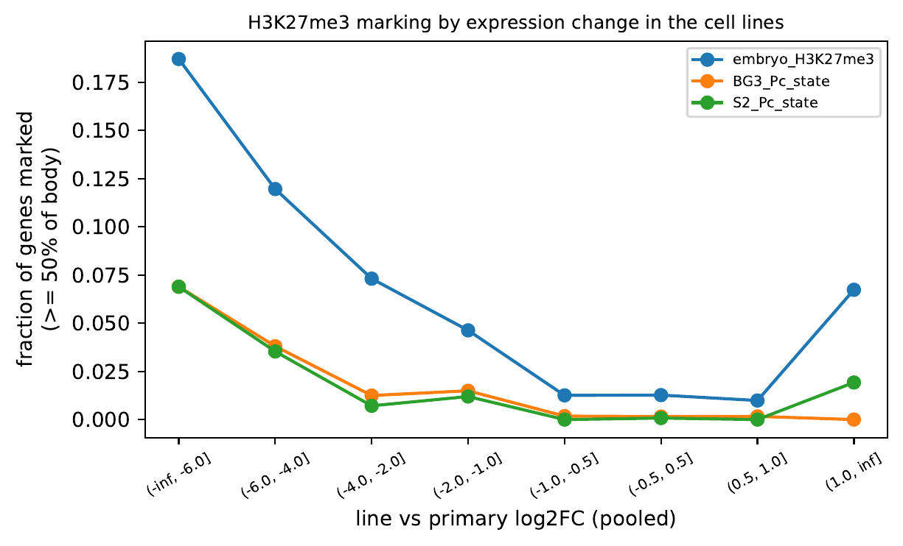
Figure 8. Fraction of genes with at least 50% of the gene body in H3K27me3 (embryo) or Polycomb-state chromatin (BG3, S2), binned by pooled log2 fold change between cell lines and primary cell lines. Only genes expressed in every primary cell line are included.

Cell lines replace EGFR with PVR as their dominant receptor tyrosine kinase
The cell lines lost nearly every receptor tyrosine kinase expressed in primary cell lines, including Egfr (−6.3), htl (−6.8), Drl-2 (−6.7), otk (−6.0), sev (−4.1), and btl (−2.6). Pvr, the PDGF/VEGF receptor homolog, was the only receptor tyrosine kinase that increased (+1.3 in all four lineages), and its ligand Pvf2 rose in primary cell lines (+2.2) and stayed expressed in cell lines. Classic MAPK feedback targets increased despite the loss of EGFR (sty +1.7, pnt +1.5, kek1 +1.4, CG6006 +1.4, all four lineages; Mkp3 +1.0, pooled), as did the PI3K growth effector Orct2 (+1.9, all four lineages). Within single cells, Pvr expression correlated weakly with a MAPK target score after controlling for sequencing depth (ρ positive in 16 of 18 samples, up to 0.24, and 0.06–0.24 in cell lines except the 126-cell ubkhc-1 library; Figure 9), and Pvr-positive cells in primary cell lines had slightly higher MAPK scores than Pvr-negative cells in three of four lineages (p < 0.001). Pvr did not correlate with proliferation, and the most proliferative cells in primary cell lines were not consistently Pvr-high, so PVR signaling marks established cell lines rather than the proliferative cells in primary cell lines that resemble them.
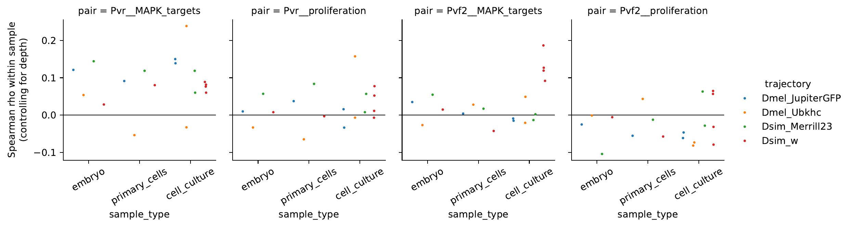
Figure 9. Within-sample Spearman correlations, controlling for per-cell UMI depth, between Pvr or Pvf2 expression and the MAPK target score (sty, pnt, kek1, Mkp3, aos, CG6006) or the proliferation score, by stage and lineage.

Wolbachia titer differs across transferred cell types, but the pattern reflects three uninfected cell lines
Wolbachia titer differed significantly across the 20 transferred atlas cell types represented in the dataset (Kruskal–Wallis test, H = 3942.46, df = 19, p < 0.0001; Figure 4A). Given the sample size (n = 35,921 cells), this threshold was readily exceeded even for small effects, so we examined the underlying pattern directly. Infection frequency (titer > 0) exceeded 96% in nearly every differentiated tissue category (ectoderm, foregut, midgut, muscle, fat body, PNS, trachea, epidermis, yolk) but fell markedly in categories that were disproportionately composed of cell-line cells: hemolymph (42% infected), mesoderm (37%), ring gland (37%), Malpighian tubule (41%), cellular blastoderm (54%), and gonad (60%). Stratifying mean titer jointly by cell type and condition showed that this pattern came from three uninfected cell lines (Figure 4B): ubkhc and Dsim-Merrill23, which lost their wMel and wRi infections during culture, and Dsim6B, which we cured of wRi with doxycycline. In these cell lines, Wolbachia genes accounted for at most 0.02% of UMIs, consistent with ambient RNA, compared with 1.0–3.7% in embryos, 0.3–3.3% in primary cell lines, 4.9–5.3% in JW18wMel, and 3.0–3.2% in Dsim6B-wMel. The cell-type effect on titer therefore reflects which cell lines are infected rather than cell identity. Dsim6B-wMel, JW18wMel, and all four embryo conditions remained 96–100% infected across nearly every cell type.
Dsim6B-wMel and Dsim6B offered a direct comparison of an infected cell line with a doxycycline-cured cell line of the same origin, since both derive from wRi-infected D. simulans w− flies (two libraries each). The two cell lines differed at 4,783 genes (adjusted p < 0.05). The infected cell line up-regulated the pro-apoptotic genes reaper (+4.4) and hid (+3.2), the JAK/STAT stress genes upd3 (+1.4) and Socs36E (+1.4), and apoptosis, autophagic cell death, Hippo regulation, and glutathione metabolism terms, and it down-regulated ribosome biogenesis, mitosis, and fatty acid β-oxidation (Figure S1). Infection-associated changes barely tracked the cell-line-versus-primary-cell-line program (ρ = 0.06–0.08). However, Dsim6B-wMel expressed white (log2 CPM 6.2 versus 0–0.3 in Dsim6B and about 1.4 in the D. simulans w− embryo and primary cell line) and had lost plasmatocyte and basement-membrane genes that Dsim6B expresses (Hml, Pxn, Col4a1, vkg), so the two cell lines differ in cell identity, and possibly genotype, as well as infection. Doxycycline also inhibits mitochondrial translation, so the cured line may carry treatment effects in addition to the loss of Wolbachia.
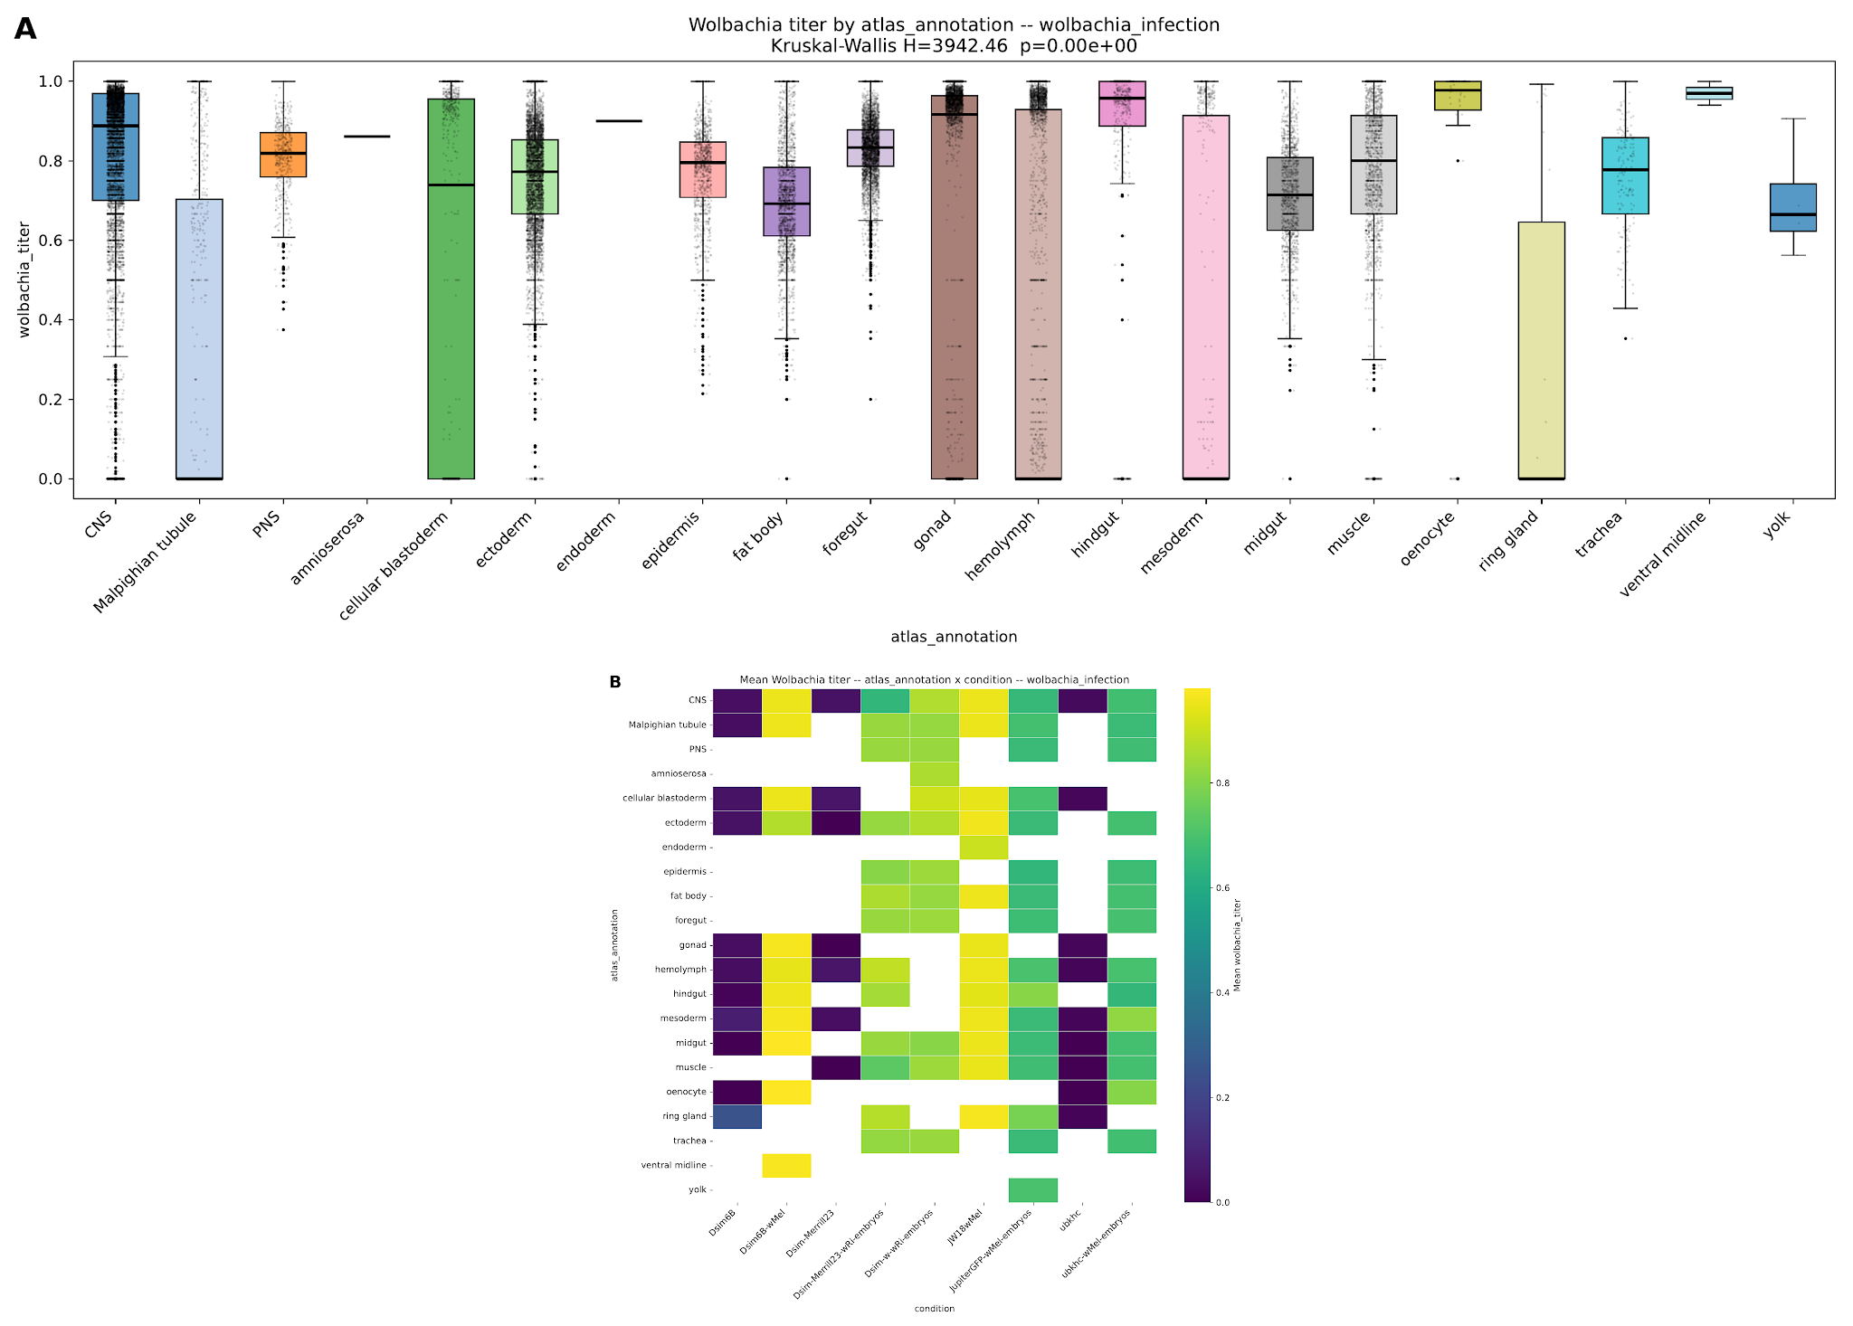
Figure 4. Wolbachia titer by transferred cell type and condition. (A) Distribution of Wolbachia titer across all 35,921 cells, grouped by transferred atlas_annotation (Kruskal–Wallis test, H = 3942.46, df = 19, p < 0.0001). (B) Mean Wolbachia titer for each combination of transferred cell type and condition; blank cells indicate the combination was not observed. ubkhc and Dsim-Merrill23 lost their infections in culture; Dsim6B was cured with doxycycline.

Discussion
Considered together, these results suggest a model in which immortalization from a dissociated embryo culture proceeds by selection of a narrow, pre-existing proliferative population rather than by preservation or reprogramming of a single parental tissue. Embryo samples retained the full range of dissociated embryonic cell types, while every cell line examined here, independent of host species or Wolbachia infection, converged on the same hemolymph-dominated, proliferative profile. Three observations support selection specifically. Cell lines resembled one another more than their own parental embryo and matched no single embryonic reference tissue. The primary-to-cell-line transition was shared across four lineages in two species, with 84% of changed genes moving in the same direction in every lineage. Most directly, the most proliferative cells in three of four primary cell lines already carried part of the cell-line expression shift, beyond cell-cycle and ribosome genes and independent of sequencing depth. Because each stage is a separate snapshot, these data cannot show that those cells gave rise to the cell lines; a passage time course or lineage tracing would test this.
The shared cell-line program suggests three mechanisms that could stabilize this outgrowth. First, the cell lines silenced developmental transcription factors and Hox genes, and the silenced regulators were Polycomb targets in the embryo and remain in Polycomb chromatin in S2 and BG3 cells. Established cell lines therefore appear to keep, rather than erase, the developmental repression laid down in the embryo, while losing the inducible injury, immune, and fat-body programs that primary cell lines switch on. Second, the cell lines silenced grim and sickle, which sit in the H99 pro-apoptotic locus that becomes epigenetically silenced in late embryos (Zhang et al. 2008), and Buffy, a change that could make cells resistant to the apoptotic signals of dissociation and passage. Third, the cell lines replaced EGFR with PVR as their dominant receptor tyrosine kinase while maintaining MAPK target expression and Pvf2 ligand. PVR signaling supports hemocyte survival (Brückner et al. 2004), Pvf2 overexpression drives hemocyte overproliferation (Munier et al. 2002), and oncogenic Ras is an established route to new Drosophila cell lines (Simcox et al. 2008), so an autocrine Pvf2/PVR/Ras-MAPK loop could substitute for the tissue signals, including Dpp, Activin, Wingless, insulin-like peptides, and ecdysone, that the cell lines lost. The single-cell data support this loop only weakly and do not show it in the proliferative cells in primary cell lines, so we treat it as a feature of established cell lines rather than a driver of outgrowth. Measuring H3K27me3 directly in these cell lines (for example by CUT&Tag), and testing whether Pvr knockdown or MEK inhibition slows cell-line growth, would test the Polycomb and PVR hypotheses.
This dataset provides little evidence that Wolbachia infection status determines which cell type dominates that selection process: the same hemolymph-dominated composition was observed in infected cell lines (Dsim6B-wMel, JW18wMel) and uninfected cell lines (Dsim6B, Dsim-Merrill23, ubkhc) alike. Infection was, however, often lost during immortalization. Of the three lineages whose natural infection entered culture without intervention, two lost it: ubkhc lost wMel and Dsim-Merrill23 lost wRi, whereas JW18wMel kept wMel. Both lineages that lost infection still carried Wolbachia at the primary-cell-line stage (0.3% and 1.2% of UMIs), so the loss occurred after the primary-cell-line stage, during cell-line establishment or later passage. Selection for rapidly dividing cells could dilute Wolbachia if bacterial replication does not keep pace with host division, which would link the proliferative selection described above to infection loss. A passage time course in the infected primary cell lines, measuring titer and host proliferation together, would test this. Among infected cells, cell-line populations also showed a more saturated, near-binary titer distribution than the graded titer observed in embryos, suggesting that whatever process establishes a stable cell line may also fix infection status into an all-or-nothing state rather than preserving the continuous, spatially graded titer present in the embryo. Finally, the infected Dsim6B-wMel cell line re-expressed reaper and hid and down-regulated growth programs relative to the doxycycline-cured Dsim6B line, the opposite of the apoptosis silencing seen across all cell lines. This would suggest that Wolbachia partly counteracts the growth program of immortalized cells, which could also explain why infected lineages lose infection as proliferative cells take over. The two lines, however, differ in cell identity and white expression, and the cured line carries possible doxycycline effects, so an independently cured Dsim6B-wMel subline would provide a cleaner comparison.

Supplementary figure
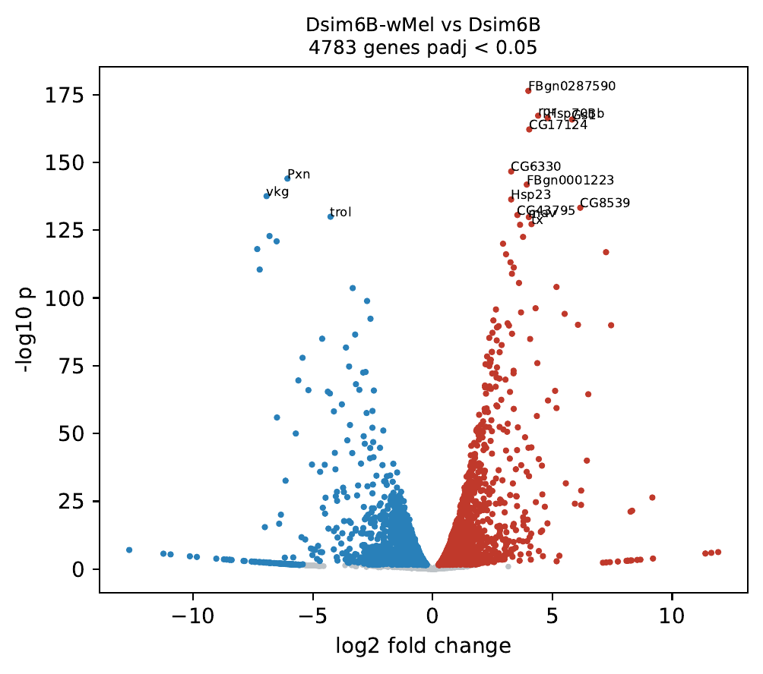
Figure S1. Pseudobulk differential expression between Dsim6B-wMel and Dsim6B (two libraries each; PyDESeq2, design ~ infection). Red, higher in Dsim6B-wMel; blue, higher in Dsim6B; adjusted p < 0.05.

References to verify
Brückner K, Kockel L, Duchek P, Luque CM, Rørth P, Perrimon N (2004). The PDGF/VEGF receptor controls blood cell survival in Drosophila. Dev Cell 7:73–84.
Munier AI, Doucet D, Perrodou E, et al. (2002). PVF2, a PDGF/VEGF-like growth factor, induces hemocyte proliferation in Drosophila larvae. EMBO Rep 3:1195–1200.
Simcox A, Mitra S, Truesdell S, et al. (2008). Efficient genetic method for establishing Drosophila cell lines unlocks the potential to create lines of specific genotypes. PLoS Genet 4:e1000142.
Zhang Y, Lin N, Carroll PM, et al. (2008). Epigenetic blocking of an enhancer region controls irradiation-induced proapoptotic gene expression in Drosophila embryos. Dev Cell 14:481–493.
Kharchenko PV, Alekseyenko AA, Schwartz YB, et al. (2011). Comprehensive analysis of the chromatin landscape in Drosophila melanogaster. Nature 471:480–485.

