Atlas-Projected Integration of Wolbachia-Infected Drosophila Embryos and Primary Cell Lines
Results
Lum et al. 2027. Data and code: results/integrated/, results/trajectory_analysis/ (Snakemake rules integrate, embryo_to_cellline_trajectory, titer_by_annotation_atlas).

Results
To determine whether transcriptional differences between Wolbachia-infected Drosophila embryos and their derived primary cell lines reflect genuine biological divergence rather than a batch artifact of joint clustering, we projected every cell from both sample types onto a single, externally fixed reference embedding built from the Flysta3D-v2 developmental atlas, rather than re-clustering embryo and cell-line transcriptomes jointly. Reference projection (scanpy.tl.ingest) fits the principal-component and UMAP embedding once, on the atlas alone, and maps each query cell into that fixed coordinate space via its nearest neighbors in atlas PCA space; because no query sample can influence the placement of another, this removes the shared "joint fit" axis that a batch-correction step would otherwise need to correct for. The resulting dataset comprised 35,921 cells from 13 sequencing libraries across nine experimental conditions: five primary cell-line conditions (Dsim-Merrill23, Dsim6B, Dsim6B-wMel, JW18wMel, and ubkhc; 17,590 cells, two replicates each) and four whole-embryo conditions, each the parental source of one or more of the cell lines above (Dsim-Merrill23-wRi-embryos, Dsim-w-wRi-embryos, JupiterGFP-wMel-embryos, and ubkhc-wMel-embryos; 18,331 cells, one replicate each). Every cell received a transferred cell-type label at three resolutions (atlas_annotation, atlas_tissue, and atlas_germ_layer) together with a nearest-neighbor confidence score.
As a check on this approach, we first confirmed that reference projection removed the dataset-driven clustering seen under joint re-integration: cells from embryo and cell-line samples overlapped extensively on the shared embedding rather than separating by sample of origin (Figure 1A), and biological replicates of the same condition did not always co-localize (Figure 1D), consistent with projection reflecting cell-intrinsic similarity rather than sample identity. Cell-line cells nonetheless occupied a visibly narrower region of the embedding than embryo cells (Figure 1A), concentrated within the CNS-like and hemolymph-like regions in particular (Figure 1B–C) — a compositional difference we characterize quantitatively below.
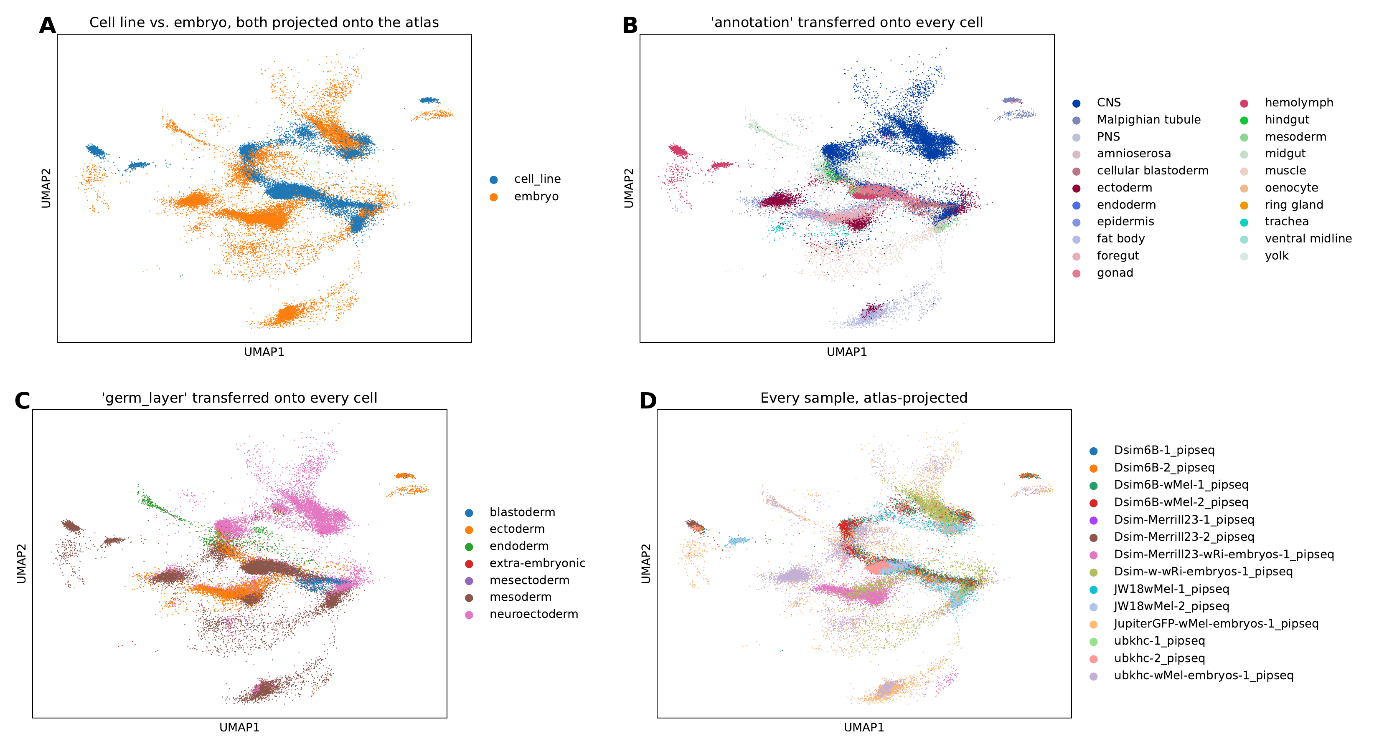
Figure 1. Atlas-projected embedding, colored four ways. (A) Sample type (cell line, blue; embryo, orange). (B) Transferred atlas_annotation. (C) Transferred atlas_germ_layer. (D) Individual sequencing library.

Primary cell lines converge on a narrow subset of embryonic cell identities
Whole-embryo conditions were compositionally heterogeneous, each spanning 7–16 of the 21 possible atlas cell types with no single type exceeding approximately 65% of cells (mean Shannon diversity H′ = 2.26 at the atlas_annotation resolution; Figure 2). Every cell-line condition, by contrast, was dominated by a small subset of the same three identities — hemolymph-like, gonad-like, and CNS-like — which together accounted for 78–96% of cells in each line (mean H′ = 2.08; Figure 2).
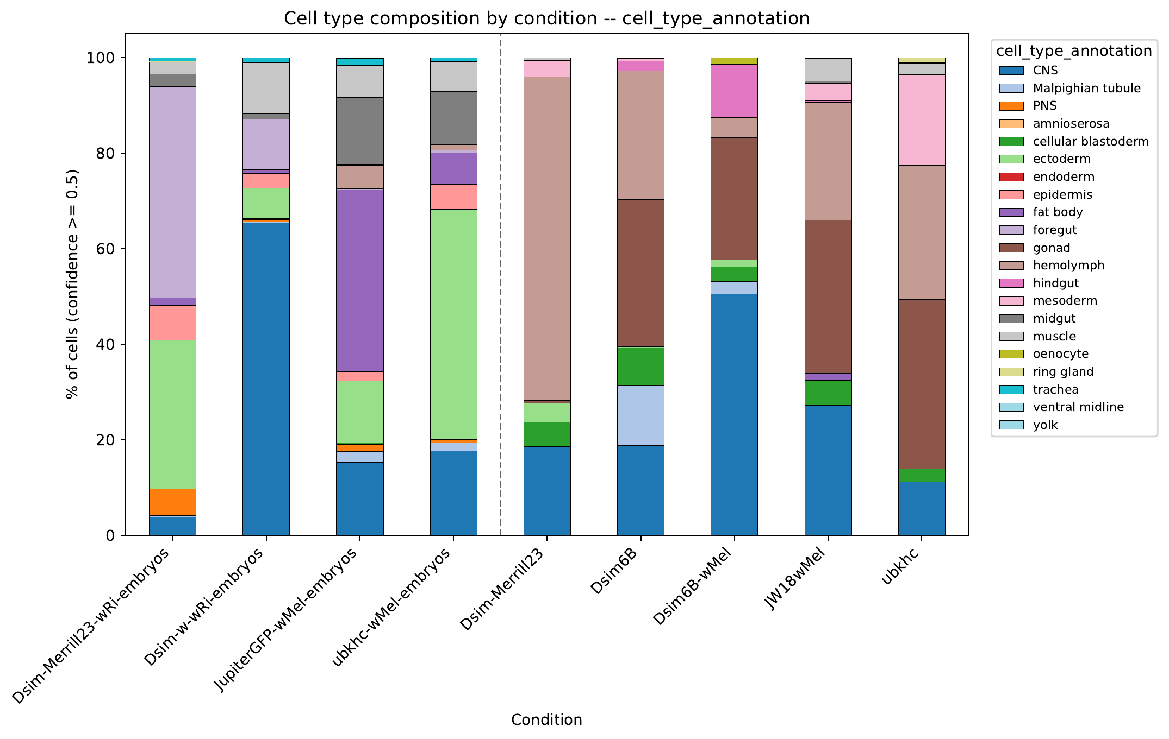
Figure 2. Cell-type composition by condition (atlas_annotation, confidence ≥ 0.5), embryo conditions at left of the dashed line and cell-line conditions at right.
The reduction in diversity was more pronounced at the coarser germ-layer resolution (mean H′ = 1.18 for cell lines versus 1.40 for embryos), consistent with cell lines collapsing onto a small number of transcriptional states rather than merely sub-sampling the same diversity present in the parental embryo. This convergence was independent of genetic background and Wolbachia strain: all five cell lines, spanning two host species (D. simulans and D. melanogaster) and both natural (wRi, wMel) and transinfected (wMel in a D. simulans background) infections, showed the same hemolymph/gonad/CNS-dominated profile.

Pseudobulk transcriptomes cluster by culture status rather than by genetic background
Hierarchical clustering of pairwise pseudobulk correlations across all nine conditions produced a top-level split that separated all four embryo conditions from all five cell-line conditions; genetic background and Wolbachia strain structured only the sub-clusters within each group (Figure 3A). The mean pairwise Spearman correlation was 0.835 among cell lines and 0.825 among embryos, compared with 0.705 between a cell line and any embryo condition — a gap that held regardless of species or Wolbachia strain. Notably, a cell line's pseudobulk profile did not correlate most strongly with that of its own parental embryo: Dsim6B, for example, correlated more strongly with Dsim-Merrill23-wRi-embryos (ρ = 0.840) than with its own parental Dsim-w-wRi-embryos (ρ = 0.785). Culture status — whether a sample was maintained in vitro or sampled directly from an embryo — was therefore a stronger determinant of pseudobulk transcriptome similarity than either species or the specific embryo from which a line was originally derived.

Embryo, but not cell-line, pseudobulk profiles are tissue-specific
Correlating each condition's pseudobulk profile against reference pseudobulk profiles for each atlas tissue (computed from embryo cells only) showed that embryo conditions peaked sharply at the tissue matching their dominant annotation — Dsim-Merrill23-wRi-embryos against foregut (ρ = 0.99) and JupiterGFP-wMel-embryos against fat body (ρ = 0.98), for example — whereas cell-line conditions showed uniformly moderate correlations (ρ = 0.57–0.85) with no clear peak against any single reference tissue (Figure 3B). This pattern corroborates the composition analysis above at the pseudobulk level: embryo transcriptomes are recognizably tissue-specific, whereas cell-line transcriptomes resemble a blend that does not closely match any single reference tissue.
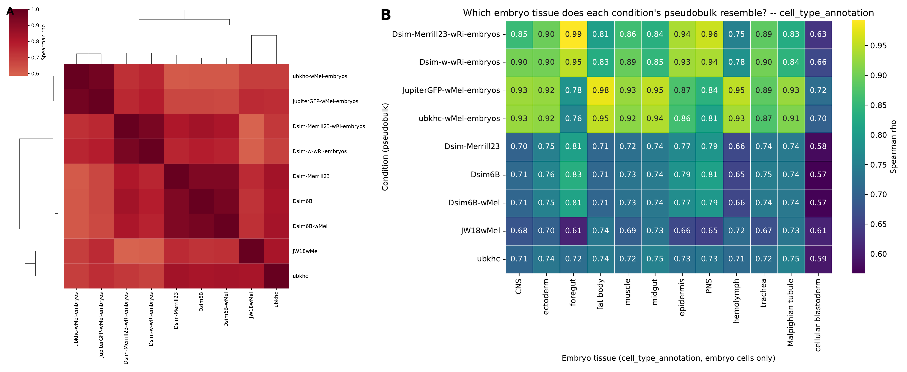
Figure 3. Pseudobulk transcriptome comparisons across conditions. (A) Hierarchical clustering of pairwise Spearman correlations between pseudobulk profiles for all nine conditions. (B) Spearman correlation between each condition's pseudobulk profile (rows) and the reference pseudobulk profile of each atlas tissue computed from embryo cells only (columns).

Wolbachia titer differs across transferred cell types, but the pattern is confounded with condition
Wolbachia titer differed significantly across the 20 transferred atlas cell types represented in the dataset (Kruskal–Wallis test, H = 3942.46, df = 19, p < 0.0001; Figure 4A). Given the sample size (n = 35,921 cells), this threshold was readily exceeded even for small effects, so we examined the underlying pattern directly. Infection frequency (titer > 0) exceeded 96% in nearly every differentiated tissue category (ectoderm, foregut, midgut, muscle, fat body, PNS, trachea, epidermis, yolk) but fell markedly in categories that were disproportionately composed of cell-line cells: hemolymph (42% infected), mesoderm (37%), ring gland (37%), Malpighian tubule (41%), cellular blastoderm (54%), and gonad (60%). Stratifying mean titer jointly by cell type and condition indicated that this pattern was driven primarily by three specific cell lines — Dsim6B, Dsim-Merrill23, and ubkhc — each of which carried a large titer-negative subpopulation spanning nearly every cell type it contained, including CNS, a category that was otherwise uniformly high-titer (Figure 4B). Dsim6B-wMel, JW18wMel, and all four embryo conditions remained 96–100% infected across nearly every cell type.
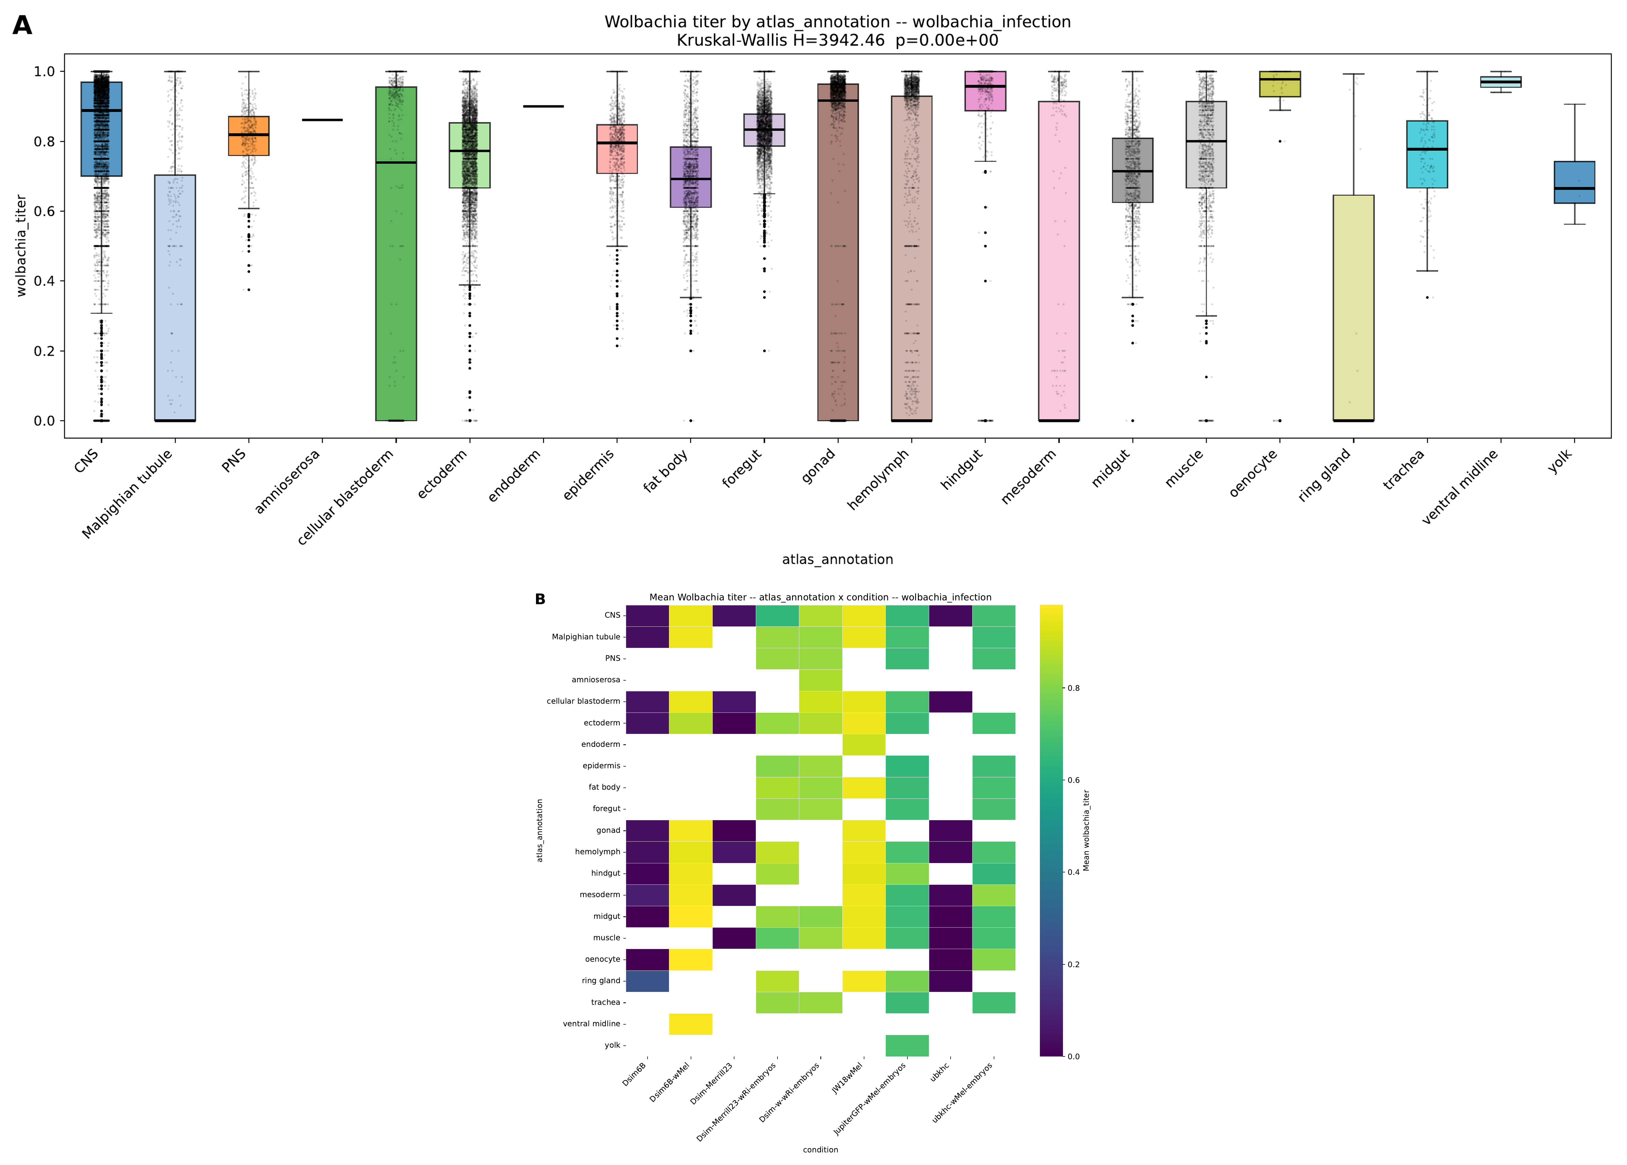
Figure 4. Wolbachia titer by transferred cell type and condition. (A) Distribution of wolbachia_titer across all 35,921 cells, grouped by transferred atlas_annotation (Kruskal–Wallis test, H = 3942.46, df = 19, p < 0.0001). (B) Mean wolbachia_titer for each combination of transferred cell type and condition; blank cells indicate the combination was not observed.
Because these same three lines were also disproportionately composed of hemolymph-, gonad-, and mesoderm-like cells (see above), the pooled cell-type effect on titer is confounded with condition and cannot be attributed to cell identity alone; isolating a cell-type-specific effect, if one exists, would require testing within individual conditions. Among cells that were infected, cell-line cells showed higher, more saturated titer (median ≈ 0.9–1.0) than infected embryo cells (median ≈ 0.7–0.85), which retained more graded, intermediate titer values.

Discussion
Considered together, these results suggest a model in which immortalization from a dissociated embryo culture proceeds by selection of a narrow, pre-existing proliferative population rather than by preservation or reprogramming of a single parental tissue. Embryo samples retained the full range of dissociated embryonic cell types, while every cell line examined here — independent of host species or Wolbachia strain — converged on the same hemolymph-, gonad-, and CNS-dominated profile. Two further observations are consistent with a selection model specifically, rather than a tissue-of-origin model: pseudobulk transcriptomes clustered by culture status before genotype, with cell lines resembling one another more than they resembled their own parental embryo, and no cell line's pseudobulk profile correlated strongly with any single embryonic reference tissue. Under standard primary-culture conditions, we suggest that a limited subset of cell types drives this convergence. These cells carry an intrinsically proliferative, blood-cell-like or stem/gonad-like transcriptional program. They continue dividing while terminally differentiated types are lost over serial passage. The result is a convergent culture identity that overrides the specific tissue or genetic background from which a line originated.
This dataset provides little evidence that Wolbachia infection status determines which cell type dominates that selection process: the same hemolymph/gonad/CNS-convergent composition was observed in lines that remained fully infected (Dsim6B-wMel, JW18wMel) and in lines with substantial titer loss (Dsim6B, Dsim-Merrill23, ubkhc) alike. Where infection status did track with a clear difference was in the persistence of titer through immortalization rather than in cell-type outcome. The two lines that remained uniformly infected were both laboratory-established wMel transinfections, whereas the three lines with a titer-negative subpopulation distributed across nearly every cell type they contained all carried naturally occurring infections (wRi in the two D. simulans lines, wMel in ubkhc). Among infected cells, cell-line populations also showed a more saturated, near-binary titer distribution than the graded titer observed in embryos, suggesting that whatever process establishes a stable line may also fix infection status into an all-or-nothing state rather than preserving the continuous, spatially graded titer present in the embryo. Together, these observations are consistent with a hypothesis in which immortalization does not select for or against Wolbachia by cell identity, but naturally occurring infections are more prone to partial titer loss during or after that process than transinfected strains. Distinguishing an effect of immortalization itself from a pre-existing difference in how stably wRi versus wMel are maintained in culture would require a passage-number-matched time course — for example, paired qPCR measurements of a natural and a transinfected line sampled at matched passage numbers.

Limitations
Several features of the dataset limit the strength of the conclusions above. Embryo conditions were each represented by a single sequencing library, compared with two replicates per cell-line condition, so embryo-level statistics reflect a single sample rather than biological replication. Cell-line replicates also showed substantial disagreement at the fine-grained annotation level — the two replicates of Dsim-Merrill23, for instance, were 66% and 88% dominated by CNS-like and hemolymph-like identities, respectively — although this disagreement was attenuated at the coarser germ-layer resolution, suggesting that composition claims are more robust when reported at that level. The Flysta3D-v2 atlas is a developmental reference and does not contain a category corresponding to an established cell line; the "generic" or mixed-identity profile observed for cell-line pseudobulk transcriptomes therefore partly reflects the absence of a matching reference category rather than necessarily indicating that cultured cells lack a coherent identity altogether. The Kruskal–Wallis test reported above evaluated the effect of cell type alone, pooling all conditions together, and did not control for condition; as shown, condition is a substantial confound, and a within-condition test or a model incorporating both terms would be needed to isolate a cell-type-specific effect on titer. The wolbachia_titer values analyzed here are a normalized per-cell metric computed upstream of this pipeline rather than a direct measurement of Wolbachia genome copy number (e.g. by qPCR), and this definition should be confirmed before the exact infection percentages reported above are cited elsewhere. Finally, the proposed relationship between infection origin (natural versus transinfected) and titer persistence through immortalization is drawn from five cell lines with no accompanying passage-history data, and should be regarded as a hypothesis generated by this dataset rather than a result established by it.

