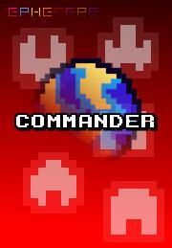Commander is a stylish and lovely tower defense made with passion and care to bring an epic experience to 8-bit era enthusiasts. Beyond the visuals and the gorgeous classical music, Commander is a breakthrough in the genre with an innovative game mechanism that let you modify the path taken by the enemies, bringing more strategy and fun than ever.

« The scattering lights, varied colors and brilliant design results in a wonderfully engaging experience that can only be likened to a trippy experience. » - crudepixel.com

« Really loving this, so much style! » - indiegames.com

« A game which breaks beyond the me-too mold to provide a thoroughly innovative and enjoyable experience which captivates players with its terrific sense of style and design. » - teamkobun.com

*Commander* is a fast-paced tower defense set in a distant future where evil aliens are trying to annihilate the human race by throwing asteroids at their colonies! As the commander, you must strategically place turrets on the battlefield to protect the capital of each colony. You will buy, upgrade and sell turrets as in any other tower defense game but you will also be able to drive spaceships, blow up planets and do all sort of crazy things to help you save the world. What do you want more? Lasers, missiles, particle effects, nice classical music, retro sound effects, cute colorful pixels and a lot of fun!

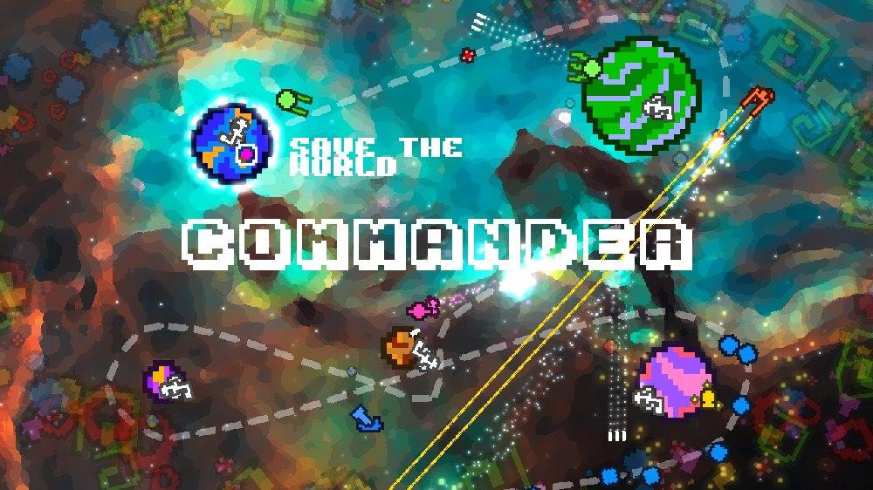

|  |  |
| --- | --- |
| **Trailer (older)** <http://youtu.be/1GY3aLNunaE?hd=1> | **Ingame (newer)** <http://youtu.be/QQau1GvSROw?hd=1> |

**Screenshots (old):** <http://commander.ephemeregames.com>

**Prototype:** <http://commander.ephemeregames.com/setup.exe>, use product key **9676 5155 9738 4424**.

***Commander* is a unique product on many levels**:

* It has distinctive take on the 8-bit graphical style that is so popular right now by mixing colorful pixelated graphics with smooth and glowing particles effects;
* It combines frenetic gameplay with classical music that will get you in the zone in a relaxed way;
* It adds game mechanisms that are never seen before in a tower defense like the shifting path that will change the battlefield over time or on demand and the control of spaceships to do extra damage;
* It engage you in an epic story about aliens, war for survival and mysterious men in black;
* It runs in HD resolution at 60 fps on Windows and Xbox 360;

To sum this up, ***Commander* takes the tower defense genre to the next level**.

**Release date**

*Commander* will be released on Windows and the Xbox Live Indie Games marketplace in the fourth quarter of 2011.

**System Requirement (Windows)**:

* A decent CPU and graphic card which supports DirectX 10;
* 300 mb of space on your hard drive;
* 512 mb of free memory;
* A screen which supports a 1280×720 resolution;
* A keyboard and a middle-wheel mouse;
* XNA 4.0 distributable and .Net Framework 3.0 which are included in the installer.