Jodi Yip

December 15, 2018

Sport Radar: 206 Final Project

For my final project I used the Sport Radar API to get data about the football players in the Seattle Seahawks and the New England Patriots. I was originally going to do only the Seattle Seahawks but I wanted more interactions using the API so I also cached data about the New England Patriots. I cached the height, weight, position, and player name from the HTML file. I had to apply for the API by registering for an account. They sent me an API key that I added to the URL. I used BeautifulSoup to open the HTML file. I referenced code from Project 2.

Goals:

1. Find how many players are within each weight range
2. Calculate the average height for each position

I created a bar graph about the weight ranges for players in the Seattle Seahawks and the New England Patriots. I noticed all the player’s weight are within 175 pounds to 350. I sectioned my data using 25-pound intervals. I changed the bar graph into a light purple, added x-axis and y-axis labels and a title for the graph.

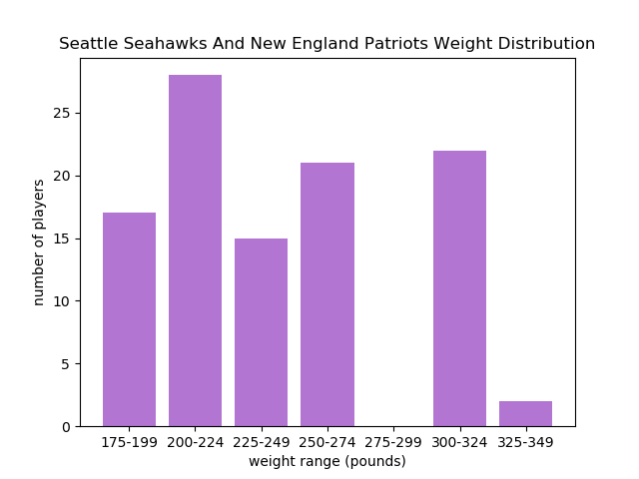

The second bar graph I created is the average height based on position for the players in the Seattle Seahawks and the New England Patriots. I changed the y-axis minimum to 60 inches so the graph can be more exact. I changed the color to a gold color. In addition, I tilted the labels on the x axis so the words are not overlapping.

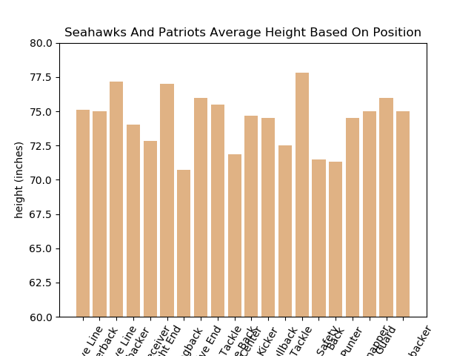

Problems:

Initially, I wanted to do a different API. However, I couldn’t access the data because it was private so I decided to use Sports Radar. I had trouble with the SQLite database. I initially created a database filled with only the height, weight, and player name. While I was making the graphs, I also wanted to include the position data. I did not know that we had to delete the SQLite database file from our folder in order to create a new file. It took me a while to realize that nothing was wrong with my code but rather tactical problems within my folder.

I had another problem with fitting my entire graph and all the words into the image. The only way to see all the labels and numbers is by expanding the window. You can click the button “configure subplot” button and adjust the space on the sides.

Social Media Report:

My report displays on terminal when you run the code. My program is called Sport Analysis. The report gives you numerical data displayed on the graph. It is separated into 2 sections in respect to the 2 graphs: weight distribution and average height. The report also tells that the data is added into the SQL database.

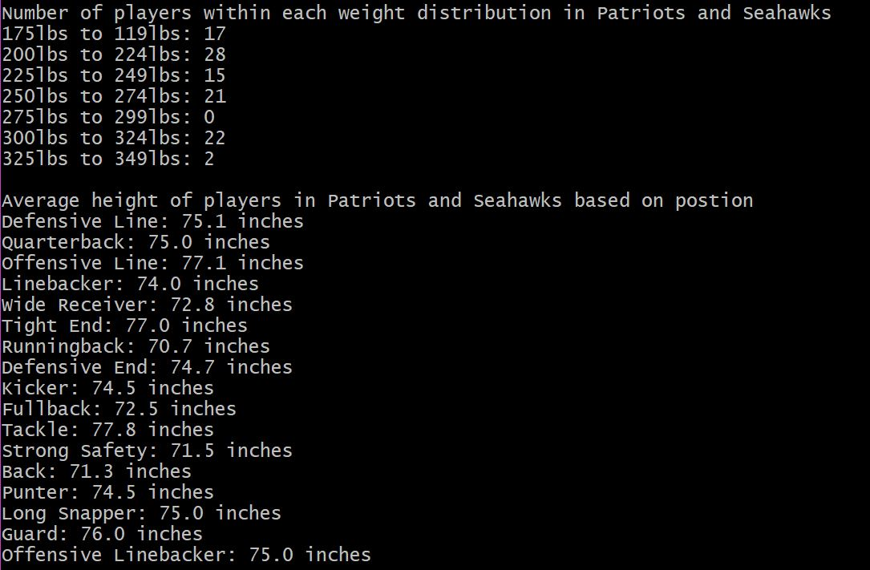

Instructions to Running Code:

Open “sportradar.py” file on terminal. Type in “Yes” to display 2 bar graphs and data report on terminal. Stretch window to see entire graph, especially for average height graph! Remember to type capital ‘Y’ in Yes.

Open “sportradar.sqlite” file in DB Browser for SQLite. Click on “Browse Data” to see all data points.

Function Documentation:

getPlayerData(soup):

Inputs a soup parameter which is the HTML file with the data. The function places tuples into a list. Each individual tuple contains the player name, player height, player weight, and player position. All tuples are placed into the list. Returns a list of tuples.

rangeOfWeight(soup):

Inputs a soup parameter which is the HTML file with the data. Uses getPlayerData to find the weight of each player. Counts the number of players in a certain weight range. Adds the weight distribution into a dictionary. The key the weight range and the value is the number of players within each range. Outputs a dictionary.

removeDuplicate(dup):

Takes in a list. Loops through the list and deletes the duplicated values. Returns a list.

listOfPosition(soup):

Inputs a soup parameter which is the HTML file with the data. Makes a list of all the player positions and deletes duplicated positions. Returns a list of positions.

averageHeightforPosition(soup):

Inputs a soup parameter which is the HTML file with the data. Finds the position and height of the player. Adds the heights of all players in the same position. Divide the total height by the number of players within each position. Creates and returns a dictionary with the player position as the key and the position’s height average as the value.

createTableofData(soup, conn, cur):

Takes in a soup parameter which the HTML file with the data, a connection variable which connects to the SQLite file, and a cur variable. Creates a table called PlayerSize with the columns: name as a text, height as an integer, weight as an integer, and position as a text. Takes data from the list of tuples received from the getPlayerData function. Inserts name, height, weight and position data into the database table.

createBarGraphofWeights(soup):

Inputs a soup parameter which is the HTML file with the data. Sets the x-values to the range of weights. Set the y-values to the number of players within each range. Labels the x-axis as “weight range (pounds)”. Labels the y-axis as “number of players”. Titles the graph “Seahawks and Patriots Weight Distribution”. Saves the image into the same folder as the file. Outputs a bar graph.

createBarGraphofAvgHeight(soup):

Inputs a soup parameter which is the HTML file with the data. Sets the x-values as the player positions. Sets the y-values as the average height for each position. Rotates the x-value position titles to a 60-degree angle. Labels the x-axis as “positions”. Labels the y-axis as “height (inches)”. Titles the graph “Seahawks And Patriots Average Height Based on Position”. Sets the y-axis minimum to 60 and the y-axis maximum to 80. Saves the image into the same folder as the file. Outputs a bar graph.

main():

Creates variables to connect to the SQLite database. If user says “Yes”, outputs 2 bar graphs and prints data information on the terminal. If user says “No”, outputs as message on terminal and exits program.

Resources Documentation

|  |  |  |  |
| --- | --- | --- | --- |
| Date | Issue Description | Location of Resource | Result |
| 12/14/2018 | Matches position acronyms with American football positions | [Wikipedia](https://en.wikipedia.org/wiki/American_football_positions) | Used position titles in dictionary |
| 12/14/2018 | ylim() function that sets the boundaries for the y axis | [Stack Overflow](https://matplotlib.org/api/_as_gen/matplotlib.pyplot.ylim.html) | Set the min and max on average height bar graph |
| 12/13/2018 | Change color of bar graph in bar() function | [The Python Graph Gallery](https://python-graph-gallery.com/3-control-color-of-barplots/) | Changed colors of bar graph |
| 12/13/2018 | .keys() and .values() function and what it returns | [Tutorials Point](https://www.tutorialspoint.com/python/dictionary_keys.htm) | Used to return data from dictionary when creating bar graphs |
| 12/13/2018 | Demo examples of bar graphs using matplotlib | [Matplotlib](https://matplotlib.org/examples/api/barchart_demo.html) | Referenced example code when making bar graphs |