**!Reach Out Watch Out!**

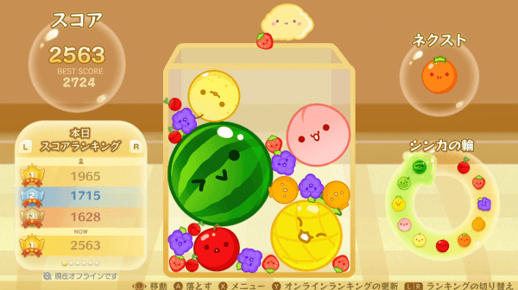

(Watermelon Game, Suika Game)<https://suika-game.app/ko>

🔹**Game Name :** Reach out Watch out!!

🔹**Genre:** Puzzle

🔹**Target Audience:** Professor Doran and Our Classmates

🔹**Team Members:**

* Dahye Chung
  + Programming
* Chaeyeon Lee
  + (UI , Score) Programming
* Subi Lee
  + Game Art Design

🔹**Project Plan**

We are recreating the currently popular Nintendo game <Watermelon Game, Suika Game> with our own creative design and additional features.

🔹**About Game**

The <Suika Game (Watermelon Game)> is a popular puzzle game that can be enjoyed for free on the Nintendo Switch and online via web browsers. Originally released in 2021, the Suika Game has recently become known as one of the most challenging games in Japan, leading to a resurgence in popularity among "idol fandoms, streamers, and VTubers." The web browser version of the Watermelon Game is a slightly simplified version of the Nintendo Switch edition, with a more straightforward scoring and physics system, making it easily accessible and enjoyable even for beginners.

🔹**How to Play**

A game where fruits of the same color collide to form one fruit, ultimately creating a watermelon.When you start the game, you can drop fruits from above, just like playing Tetris. The goal of the Suika Game is to merge these fruits together to continuously create larger fruits. There are a total of 11 different fruits in the game, and when two of the same kind meet, they combine into the next tier. Your task is to keep combining these fruits to create a giant watermelon.

For example, two plums meet to become a strawberry, two strawberries meet to become a peach, and later, two melons meet to become a watermelon. Never go over the box. Fruits fall randomly from above, and the player can adjust their location.

Fruit scores are earned the moment fruits meet and combine. For example, when two cherries meet to become a strawberry, you get 2 points. When two grapes meet to become a tangerine, you get 12 points. The primary objective of the Suika Game is to achieve the highest possible score.

🔹**Design Concept**

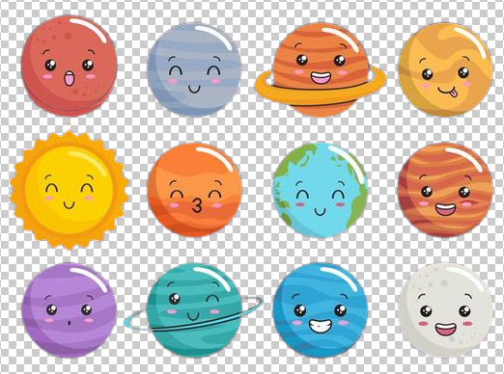

Planets

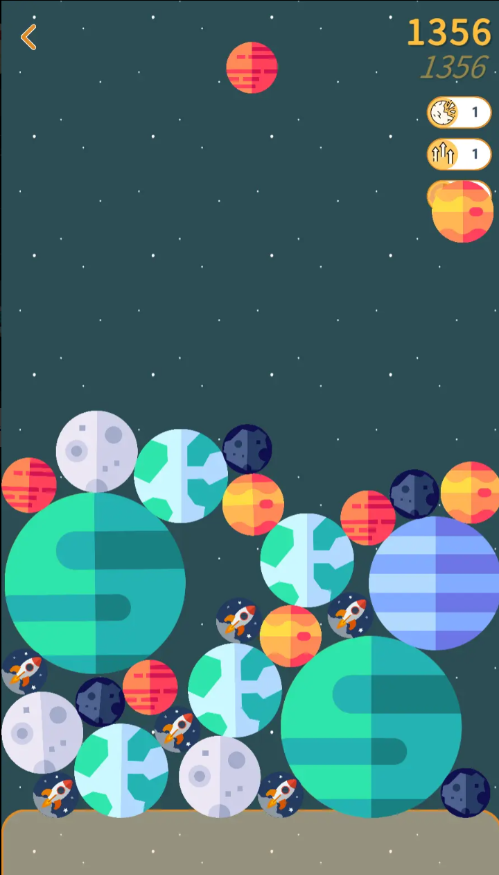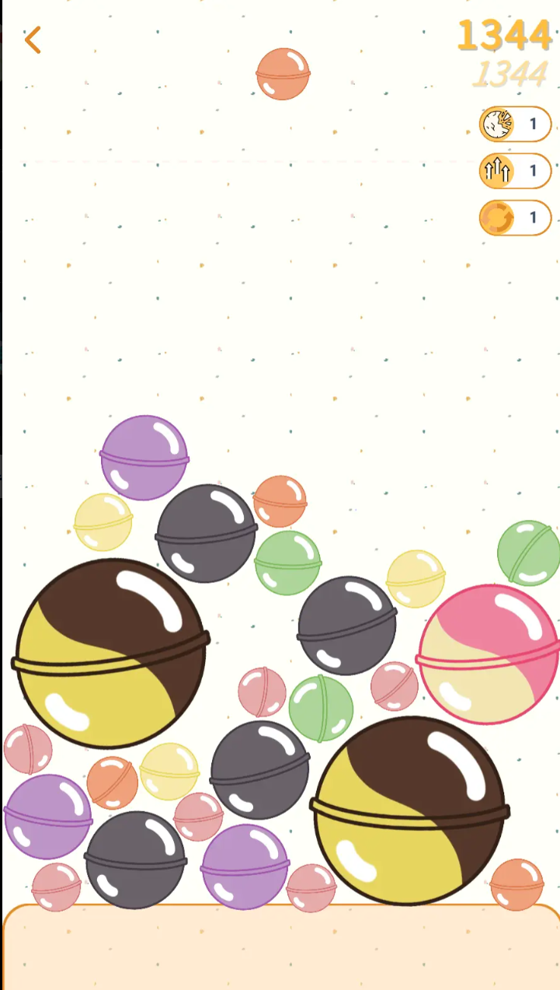

🔹**Score Plan**

| Asteroid | 1 |
| --- | --- |
| Mercury | 3 |
| Mars | 6 |
| Venus | 10 |
| Earth | 15 |
| Neptune | 21 |
| Uranus | 28 |
| Saturn | 36 |
| Jupiter | 45 |
| Moon | 55 |
| Sun (Final Boss) | 66 |

🔹**Development Plan**

Nov 10 - Game Design Document

Nov 17 - Basic prototype with scene transfer

Nov 24 - Game over with Score

Dec 1 - Final Decoration

Dec 8 - Final Presentation