TripAlogue — Product Requirements Document
Nov 10, 2026 · @Jody Hunt

1. Overview
TripAlogue turns a dated itinerary plus piles of timestamped photos and videos into a finished, chapter-by-chapter travelogue video, and it is built in six phases so each component reaches real users for usability testing before the next one depends on it.
Problem. After a multi-day trip, people hold hundreds of photos and clips spread across a phone, a camera and Google Photos. General video editors make them sort, trim and animate every item by hand. Slideshow tools are fast but ignore the story's structure: where you were, on which day, and why it mattered.
Vision. The itinerary is the spine of the story. Each itinerary entry becomes a chapter, media falls into the right chapter automatically by timestamp, and the user spends their time on presentation choices, not on sorting. An inset map keeps viewers oriented: it shows where this chapter's moments happened and how far along the whole trip the story is.
Platform. TripAlogue is a web application. Projects and original media live in the cloud, open in any modern desktop browser, and can be shared with the people who were on the trip. That is the foundation for multi-author collaboration: co-travelers build one travelogue together. Collaboration is designed into the data model from Phase 0 and ships in Phase 7.

Goals
- A user goes from itinerary plus media to a playable draft travelogue with no manual sorting for items that carry correct timestamps.
- Every media item carries editable presentation cues: inclusion, duration, placement, entrance, animation, exit and annotations. Separate narration and music audio can play alongside the visuals and mix with the sound already in video clips.
- The user can export the finished orchestration as an MP4 video that matches the in-app preview.
- The presentation can show an inset map of the current chapter's places and its position in the itinerary, in preview and in export. Each major component is usable and testable on its own, so feedback shapes the next phase.
- Several travelers contribute media to one travelogue from the start, and co-edit it together once Phase 7 ships.

Non-goals (v1)
- Full non-linear video editing: multi-track compositing, colour grading, keyframe curves.
- Professional audio editing: multitrack effects, EQ, noise removal, beat-matching. v1 audio is limited to placing, trimming, fading, ducking and setting the volume of narration, music and clip sound.
- Photo editing (crop is allowed through placement; filters and retouching are not).
- Social hosting, comments or a public gallery; v1 exports a file.
- Editing or deleting media inside the source library; TripAlogue only reads sources.
- Native desktop or mobile apps. The editors target desktop browsers; phone browsers are for uploading, viewing and commenting.
- Full offline editing. Short connection drops are tolerated (Section 7); working offline for hours is not a v1 goal.
The workflow is tailored to travel but not limited to it: any multi-event experience with dates and places (a wedding weekend, a festival, a school year) fits the same model.

2. Users and use cases
The primary user is a returning traveller who wants a polished story video without learning a video editor; two secondary personas stretch the model beyond travel.
Persona | Who | What they need most | Typical volume
Traveller-storyteller (primary) | Took a 5 to 14 day trip; shares with family and friends | Speed: a good draft in under an hour, light polish after | 200 to 1,500 items, 5 to 20 chapters
Family archivist | Builds yearly or holiday recaps from several family members' devices | Merging media from several sources and fixing wrong camera clocks | 500 to 3,000 items, several sources
Event creator | Documents multi-day events (weddings, festivals, tours), sometimes for clients | Fine control over cues, captions and export quality | 300 to 2,000 items, 1080p or 4K export
Co-traveler group (collaboration) | 2 to 6 friends or family who shared a trip, each with their own phone or camera | One place to pool everyone's media, split up chapters, and edit together | 1,000 to 5,000 items from 2 to 6 contributors
Volumes are planning assumptions to size tests and performance targets, not research findings.

Key use cases
- Plan the story. Enter or paste an itinerary (dates, places, descriptions) and see it as a chapter timeline.
- Bring in media. Upload from any computer, invite co-travelers to upload theirs, or pick albums from Google Photos; items land in chapters by timestamp.
- Fix the sort. Find unassigned or misplaced items, correct a camera's clock offset, or set a timestamp by hand.
- Shape the presentation. Reorder, delete, shorten, move and resize items; choose how each appears, animates and disappears; add captions.
- Preview. Play the whole travelogue or one chapter at any point, with all its sound.
- Export. Render an MP4 to share or archive.
- Narrate and score. Record or import spoken narration and music, place each clip under the photos and videos it belongs with, and balance it against the sound in the video clips.
- Collect from the group. Gather originals from every traveler, see who took what, and find out early whose files lost their capture time or location so they can re-share them.
- Edit together (Phase 7). Co-travelers open the same travelogue, take a chapter each, see each other's changes live, comment, and roll back to an earlier version if needed.

3. Core concepts and data model
Everything users edit is stored as one Travelogue project on the server, with its version history; original media is uploaded once into the project's object storage and never altered. A project exports to, and imports from, a single JSON file plus an archive of originals, for backup and portability.
Entity | Key fields | Created by | Notes
Travelogue | id, title, owner, members, output settings (resolution, frame rate, aspect), default cue profile, schema version | Itinerary editor | The project; stored server-side with version history; exports as one JSON file with a schema version for migration
Chapter | id, order, title, location name, coordinates (latitude, longitude), start date/time, end date/time, time zone, description, optional title card | Itinerary editor | One per itinerary entry; defines a slot on the timeline
Media source | id, type (browser upload, Google Photos selection, cloud-drive picker, upload link), display name, contributor, auth reference, clock offset | Media manager | Third-party OAuth tokens are kept encrypted on the server, never in project data or the browser
Media item | id, source id, storage key of the original, content hash, uploaded by, kind (image, video, audio), captured-at, user timestamp, effective timestamp, location (from GPS metadata or set by the user), width, height, duration, chapter id or Unassigned | Media manager | Effective timestamp = user timestamp, else captured-at plus source clock offset
Cue | item id, included, order (a fractional key, so concurrent reorders never collide), start, duration, in-point and out-point (video), placement rect, entrance, animation, exit, playback speed, volume; for audio items also lane, anchor (a visual item or a chapter time), fade in, fade out and ducking | Presentation editor | One per media item; defaults come from the cue profile
Annotation | item id or chapter id, text, style, position, start, duration | Presentation editor | Captions, location labels, dates
Export job | id, settings, status, progress, output path, log | Video export | Re-runnable from the same project state
Map view settings | enabled, inset corner, size, shape, map style, trip-overview mode, transition animation, hide-precise-locations flag, per-chapter and per-item overrides | Presentation editor | One per travelogue; places come from chapter coordinates and media locations, never stored twice
Audio lane | id, kind (narration, music, clip sound), volume, mute, ducking rule (which lanes it lowers, by how much) | Presentation editor | Three lanes per travelogue by default; clip sound is the audio inside video items, not separate media
Contributor | id, display name, initials and colour, source ids, credit line (optional), upload link id and expiry (Phase 6) | Media manager | A traveler who supplies media; every item is attributed through its source. Holds no account or contact details in v1
Member | user id, role (owner, editor, contributor, viewer), invited by, joined at, linked contributor | Sharing | Contributors may upload and view; viewers may watch and comment; roles are enforced on the server
Operation and version | operation: id, author, time, target entity, change; version: id, time, author, label, operation range | Every editor | Every edit is stored as an operation; versions are restorable points in that log

Assignment rule
An item belongs to the chapter whose date/time range contains its effective timestamp, read in that chapter's time zone. Items that fall in no range, or in a gap between chapters, go to an Unassigned bin. Items that fall in two overlapping chapters go to the earlier one and are flagged. Within a chapter, the default order is by effective timestamp. Audio items follow the same rule, so a voice memo recorded on the trip lands in its chapter; audio with no trip timestamp (narration recorded later, music files) waits in the Unassigned bin until the user places it on a lane.

Default cue profile (proposed values, tuned in usability tests)
- Images: 4 s on screen, fit to frame, 0.5 s fade in and fade out, no motion.
- Videos: the whole clip, however long (the user can trim it from the beginning and/or the end); 1x speed; 0.5 s fades.
- Chapter title card: 3 s, showing chapter title, location and date.
- Audio: narration at full volume; music at 70%; while narration plays, music and clip sound duck by 12 dB with 0.3 s ramps; 1 s fade in and out on music clips.

Built for collaboration from the start
The data model already supports several authors, even though live co-editing ships in Phase 7:
- Every entity has a stable id that never changes or gets reused.
- Order is a fractional key, so two people reordering at once never produce the same position.
- Every change is an operation (the same edit commands undo uses), stored with its author and time.
- Each entity records who last changed it and when, for attribution and conflict display.

4. Workflow and architecture
TripAlogue runs in the browser, backed by a cloud service: the editors and the player run on the user's machine, while the backend stores projects and originals, processes media and renders exports. The same render model runs in both places, so the preview and the export draw the same frames, inset map and audio mix included.
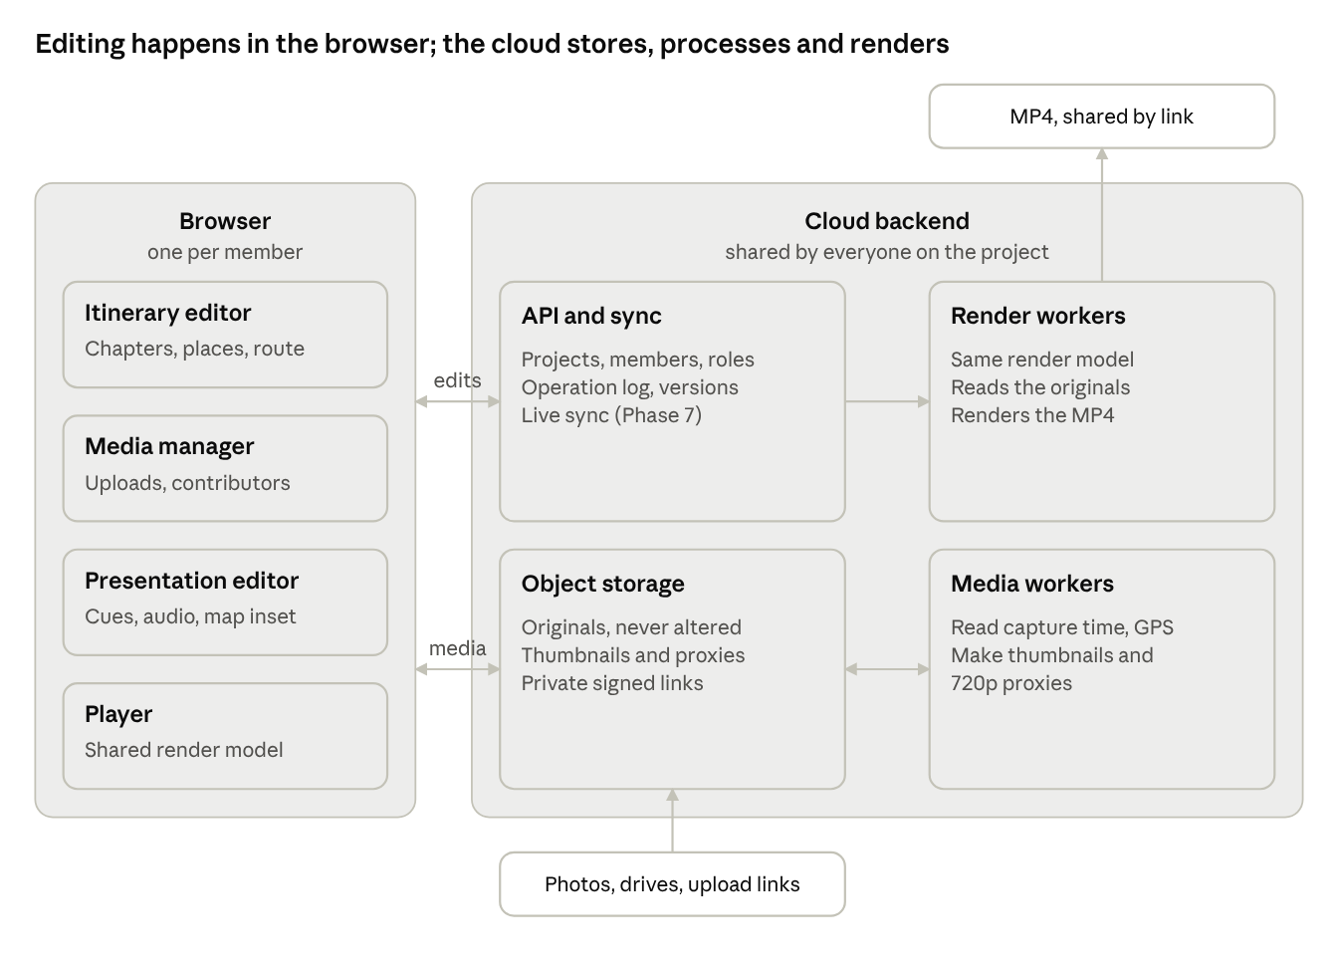
web architecture · browser client, cloud backend, shared render model
The itinerary sets the chapters, media drops into them by timestamp, the presentation editor shapes the cues, and the exporter renders those same cues to MP4.
- Uploads keep originals intact. The browser uploads each file's bytes unchanged, resumably, straight to object storage, and the server reads capture time and GPS from the original. Google Photos, cloud-drive pickers and contributor upload links are adapters feeding the same pipeline.
- Media workers. Server jobs probe every original and make thumbnails and 720p proxies with a keyframe every second. The browser plays proxies; exports use originals.
- One render model, two runtimes. The browser player and the server's render workers run the same code that turns cues into frames and mixes audio. This is what makes the 1-frame parity targets in Section 6 testable.
- Edits as operations. Every change is an operation with an author, saved to the server and sent to anyone else viewing the project. Until Phase 7, one editor at a time holds the edit lock; Phase 7 merges concurrent operations.
Map view. One map component, used in three places. In the itinerary editor it shows chapters as numbered pins joined by the route. In the media manager it shows where each item was taken. In playback and export it is an inset that zooms in on the current chapter's places, with the current item highlighted, and zooms out to the whole route, with finished chapters marked, so viewers see how far through the trip they are.
Audio. Narration and music are media items like photos and videos: imported from files or recorded in the app. In the presentation editor they sit on audio lanes under the visual track, anchored either to a visual item (they move when it moves) or to a time in the chapter. An audio mixer in the shared render model combines narration, music and the clip sound inside videos, applying volume, fades and ducking, so preview and export sound the same.

5. Development sequence
Components are built in the order the user meets them, and every phase ends with something real people can try, so each usability gate tests a working increment rather than a mock-up.
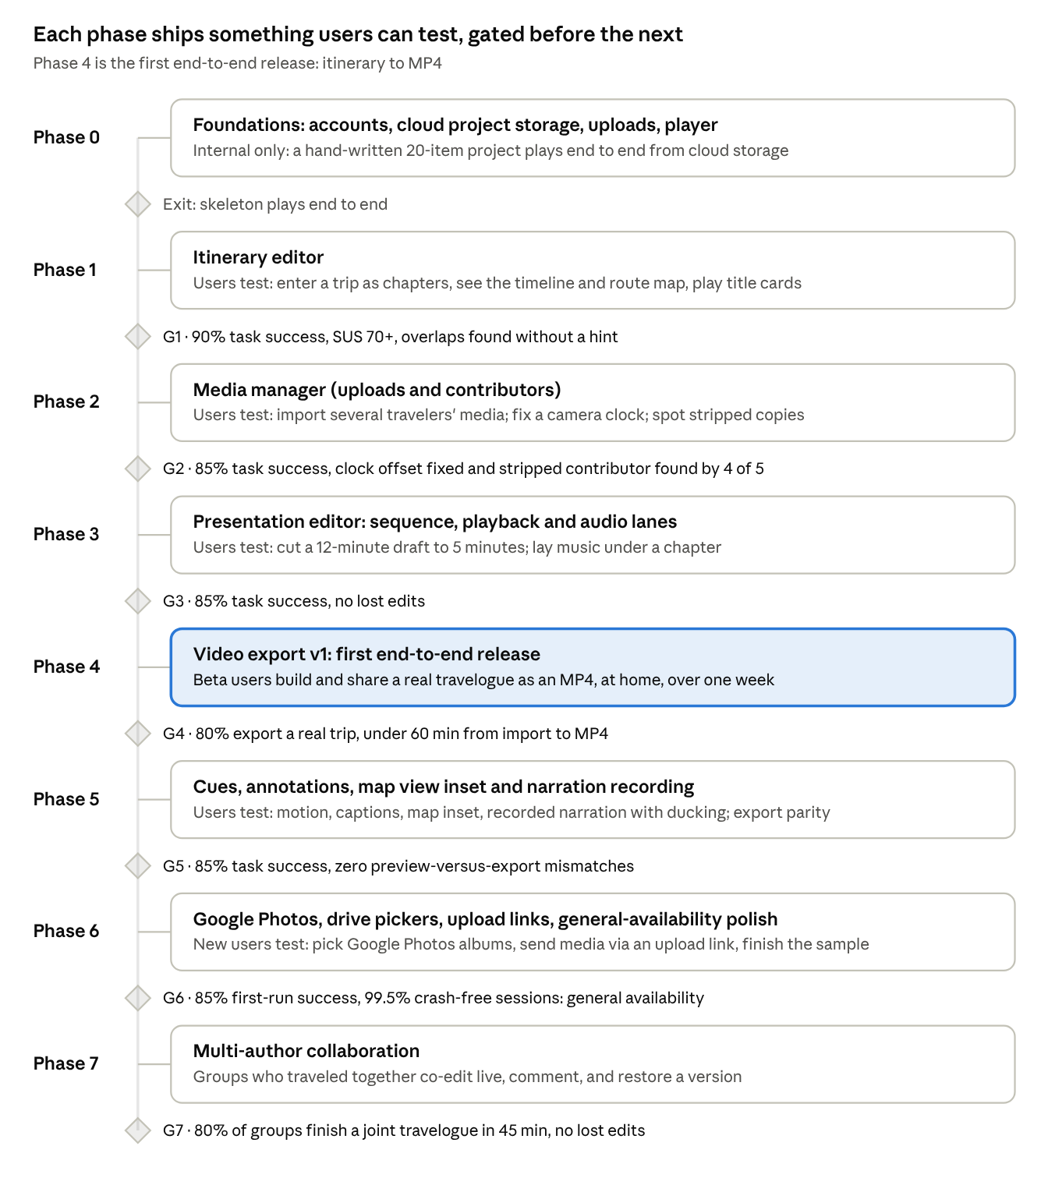
development roadmap · 8 phases, 7 usability gates
Four principles set this order:
- Follow the workflow. Each component consumes the previous one's output (chapters, then assigned media, then cues), so it can be tested with real data from the step before.
- Something playable from Phase 1. Title cards play in the player shell from day one; every later phase adds to a travelogue users can watch.
- Close the loop early. Basic export (Phase 4) ships before advanced cues (Phase 5), so a beta cohort can finish and share real travelogues and tell us which cues they actually miss.
- Defer external dependencies. Plain browser uploads come before Google Photos and cloud-drive pickers (Phase 6), so the core flow is proven without waiting on OAuth review or the Picker API's limits (Section 9).
- Design for collaboration now, ship it last. Accounts, roles and the operation log exist from Phase 0, so Phase 7 adds live co-editing without reworking the data model; until then one editor at a time keeps every earlier test simple.
Phases are sized by scope, not calendar; the team sets durations at Phase 0 planning. A gate that misses its target does not stop the next phase, but its fixes take the first sprint of that phase.

6. Requirements by phase
Requirements are grouped by the phase that delivers them; IDs are prefixed by component (IT itinerary editor, MM media manager, PE presentation editor, VX video export, MV map view, AU audio, CO collaboration, F foundations) and priorities are Must, Should or Could within that phase.

Phase 0 — Foundations (walking skeleton)
Goal: a signed-in user's project saves to the server, loads in the browser and plays, so every later phase plugs into a working shell. Internal test only.
ID | Requirement | Priority
F-1 | Create, open, save and autosave a Travelogue project on the server, with version history and JSON export and import (versioned schema, Section 3) | Must
F-2 | Undo and redo across all edits, at least 100 steps | Must
F-3 | A player shell that renders an ordered list of cues (image or video, duration, fit) to a stage at the project's aspect ratio | Must
F-4 | Media processing jobs: probe originals and make thumbnails and proxies in object storage, always rebuildable from the originals | Must
F-5 | Telemetry hooks for task timing and errors, off by default and opt-in, for usability sessions | Should
F-6 | Accounts: sign in with an email link or Google; each account lists its own and shared projects | Must
F-7 | Resumable uploads of originals straight to object storage, surviving a page reload or a dropped connection | Must
F-8 | Sharing basics: invite by email with a role (owner, editor, contributor, viewer); one editor holds the edit lock at a time and others see who is editing | Must
F-9 | Operation log: every edit is stored on the server as an operation with author and time; it powers version history now and merging in Phase 7 | Must
Exit: the team can hand-write a project with 20 items, import it into an account, and play it end to end in a browser from cloud storage.
Status (11 Nov 2026): Phase 0 is complete as a web app on main: email-link sign-in, browser upload with server-side media processing, project storage behind a web API with an operation log, versions and a single-editor lock. Processing also converts HEIC photos to full-size JPEGs, stands sideways phone photos upright, checks ffmpeg at startup, and can retry failed items from their stored originals. It passes the 23-check web exit test. Still open: a real email provider and a hosted HTTPS test site with cloud object storage (both wait on the hosting decision), and a first test of Google sign-in, which needs a Google OAuth client.

Phase 1 — Itinerary editor
Goal: a user can describe their trip as chapters and see it as a timeline. Testable alone because chapter title cards already play in the player shell.
ID | Requirement | Priority
IT-1 | Create, edit, delete and reorder chapters: title, location name, start and end date (time optional), time zone, description | Must
IT-2 | Default a chapter's time zone from the device, editable per chapter | Must
IT-3 | Flag overlapping chapters and gaps between them; allow out-of-order chapters with a warning | Must
IT-4 | Timeline view: chapters as blocks sized by their duration, with dates on an axis | Must
IT-5 | Auto-generate a title card per chapter; Play runs the title cards in order | Must
IT-6 | Import an itinerary from CSV or pasted lines (date, location, description per line) with a preview before commit | Should
IT-7 | Split a chapter at a date/time and merge two adjacent chapters | Should
IT-8 | Set each chapter's location by place search (geocoding) or by dropping a pin; store its coordinates | Must
MV-1 | Itinerary map: chapters as numbered pins joined in order by a route line; selecting a pin selects its chapter and the reverse | Must
MV-9 | Basic playback inset (preview only): a corner map in Play showing the route with numbered chapter pins; on a title card it shows the whole trip, then flies in to the chapter being played with its neighbours in view; visited chapters marked, the route ahead dashed; travelogue-wide on/off, corner, size and shape. The full inset (MV-3 to MV-8) builds on it in Phase 5 | Should
Acceptance: a first-time user enters a 7-day, 8-chapter itinerary in under 10 minutes; a 20-line CSV imports with every date correct; overlaps are flagged with no false positives on back-to-back chapters; every chapter with a location shows as a pin on the route map.
Usability test (gate G1): participants enter their own most recent trip, split one day into two chapters and fix a planted overlap.
Status (11 Nov 2026): IT-1 to IT-8, MV-1 and the basic playback inset (MV-9) are built and merged to main: chapter cards with per-chapter time zones, a lane timeline, overlap, gap and order checks, paste or CSV import with a preview, split and merge, place search or pin drop, a numbered route map, chapter title cards in Play, a corner map in Play that follows the story, and a side panel that hides so playback can use the whole window. A scripted run of the G1 tasks passes 21 of 21 checks. Place search and map tiles use OpenStreetMap (Nominatim and the public tile server) through a server-side cache for local testing only; the production provider is still open. Next: run G1 with participants.

Phase 2 — Media manager (uploads and contributors)
Goal: media uploaded from any traveler's computer lands in the right chapters with no manual sorting, and the user can fix what the timestamps got wrong.
ID | Requirement | Priority
MM-1 | Upload files or whole folders into a source by drag-and-drop or a folder picker, with per-file progress; support JPEG, HEIC, PNG, MP4 and MOV; store originals unaltered; HEIC/HEIF photos also get a full-resolution JPEG, with their rotation applied and capture time and location kept, for display and download (built ahead of Phase 2) | Must
MM-2 | Read capture time from EXIF and QuickTime metadata; fall back to file modified time and mark the item low-confidence | Must
MM-3 | Assign items to chapters by the rule in Section 3; show per-chapter counts and an Unassigned bin | Must
MM-4 | Set a clock offset per source (for example, camera 1 h behind) with a live preview of how many items move chapter; uploads are grouped into one source per person and camera (from the file's make and model), so a camera's clock can be fixed without moving the same person's phone photos | Must
MM-5 | Set a user timestamp on one or many items; dragging an item into a chapter sets its timestamp inside that chapter | Must
MM-6 | Browse media in a grid grouped by chapter, with thumbnails, kind, time and confidence badges | Must
MM-7 | Resume interrupted uploads after a reload or lost connection; skip files already uploaded (same content hash), checked in the browser before sending with a quick sample hash (size plus 2 MB from the start, middle and end); flag items whose processing failed and offer re-upload | Should
MM-8 | Flag likely duplicates (same file hash, or same time and dimensions across sources) | Could
MM-9 | Read GPS coordinates from EXIF and QuickTime metadata; let the user set, copy or clear an item's location | Must
MV-2 | Media map: show a chapter's items as clustered pins around its chapter pin; flag items taken far from their chapter's location as likely misassigned | Should
MM-15 | Import audio files (MP3, M4A/AAC, WAV) as media items: read duration and any recording time, show a waveform thumbnail, and assign by timestamp like other items | Must
MM-16 | Contributors: name the traveler behind each source; show a contributor badge on every item; filter and count media by contributor | Must
MM-17 | Contributor metadata check: after each import or rescan, report per contributor how many items lack a capture time or a location, and flag signs of a stripped copy (stills at or under 2,048 px on the long edge, 720p video, messaging-app file names); offer a ready-to-send note asking that contributor to re-share originals | Must
MM-18 | Contributor onboarding: an invite email and a one-page guide to uploading originals, with location kept, from a phone or a computer | Should
MM-21 | Invite a traveler as a contributor: they sign in, upload into their own source, and see the project's media, but cannot edit the travelogue | Must
MM-22 | Remove items to a Removed bin (undoable; put back from the bin or a saved version). Items are deleted for good by hand or after 30 days in the bin (configurable): first taken out of the travelogue and every saved version, then their original and derived files are erased, and edits that would bring them back are refused. The owner can delete a whole travelogue and all its media after typing its title | Must
Acceptance: 500 mixed items (about 2 GB) upload in under 10 minutes on a 50 Mbps uplink, and every item is assigned within 1 minute of its upload finishing; every item with valid capture metadata lands in the correct chapter with zero clicks; a source clock offset reassigns items in under 1 second; the contributor check reports every item missing a capture time or location, with no false reports on untouched originals.
Usability test (gate G2): participants bring their own trip media, import it, find and place the unassigned items, correct a planted 1-hour clock error on one source, and identify which of three contributors sent copies stripped of location.
Status (11 Nov 2026): MM-1 to MM-9, MM-15 to MM-18, MM-22 and MV-2 are built on the phase2-media branch, in a new Media view between Itinerary and Play. Capture time and place are read from EXIF and QuickTime metadata, and every item is filed by the Section 3 rule as soon as it is processed. Changing chapter dates, a camera's clock or an item's time moves items in the same undoable step: 500 items across 50 chapters reassign in about 50 ms. Removed items wait in a bin for 30 days before their files are erased, and owners can delete a whole travelogue. A scripted run of the G2 tasks, with removal, deletion and video trimming, passes 36 of 36 checks. Videos now play in full by default and can be trimmed from either end in the Media inspector (the video part of PE-5). Not measured here: the 500-item, 2 GB upload over a 50 Mbps link. Next: run G2 with participants.

Phase 3 — Presentation editor: sequence and playback
Goal: the user turns the auto-sorted draft into a cut they like, using order, inclusion, duration and placement, with narration and music laid on audio lanes under the visuals. Default fades from the cue profile apply but are not yet editable.
ID | Requirement | Priority
PE-1 | Timeline of the whole travelogue, grouped by chapter, each item a clip whose length is its duration | Must
PE-2 | Player: play, pause, scrub, play this chapter, play from selection; preview at 30 fps or better for images and 1080p video | Must
PE-3 | Reorder by drag within and across chapters; moving across chapters asks whether to update the item's timestamp | Must
PE-4 | Exclude and restore items (delete = exclude, recoverable from an Excluded tray) | Must
PE-5 | Change an image's duration by dragging its edge or typing seconds; trim a video's in-point and out-point (a video plays in full until trimmed; the video trim is built early, in the Phase 2 Media inspector) | Must
PE-6 | Move and resize an item on the stage canvas; fit, fill and custom placement; snapping guides at centre and thirds | Must
PE-7 | Reset any item, or a whole chapter, to the cue profile defaults | Must
PE-8 | Multi-select and bulk-edit duration, placement and inclusion | Should
PE-9 | Runtime per chapter and in total, against an optional target length | Should
AU-1 | Audio lanes (narration, music) under each chapter's visual track; drag an audio item onto a lane at any point, running alongside one or many visual items | Must
AU-2 | Anchor an audio clip to a visual item (it moves with that item) or to a time in the chapter; switch between the two | Must
AU-3 | Trim an audio clip's in-point and out-point; set clip volume; mute or solo a lane, including the clip sound inside videos | Must
AU-4 | Preview plays narration, music and clip sound mixed together, with waveforms drawn on the lanes | Must
Acceptance: a 300-item travelogue plays without stalls; an edit shows in the preview in under 200 ms; nothing the user excludes is lost; anchored audio stays in sync with its visual item within 1 frame after any reorder or trim.
Usability test (gate G3): participants cut their own 12-minute auto-draft to about 5 minutes, reposition three portrait photos, and lay a music track under one chapter.

Phase 4 — Video export v1 (first end-to-end release)
Goal: what the user sees in the preview, they can save as an MP4. This closes the loop, so a beta cohort can make and share real travelogues.
ID | Requirement | Priority
VX-1 | Export MP4 (H.264 video, AAC audio): 1080p at 30 fps by default, 720p and 4K options; 16:9 by default | Must
VX-2 | Render matches preview: same order, durations, placement and default fades, within 1 frame | Must
VX-3 | Show progress and time remaining; allow cancel; let the user keep editing while export runs | Must
VX-4 | On failure, name the item that caused it (missing file, unsupported codec) and link to it | Must
VX-5 | Export one chapter or a selected range | Should
VX-6 | 9:16 and 1:1 aspect ratios for phone sharing | Should
VX-9 | Mix narration, music and clip sound into one stereo AAC track as previewed, normalised to a consistent loudness (proposed target: -16 LUFS integrated) | Must
VX-10 | Exports render on server workers from the originals; the user can close the browser and is notified (in the app and by email) when the MP4 is ready to download or share by private link | Must
Acceptance: a 10-minute 1080p travelogue renders in no more than twice its runtime on a standard render worker; the file plays in QuickTime, VLC and the default iOS and Android players; 5 random frames match the preview.
Usability test (gate G4): beta participants build and export a travelogue of a real trip at home over one week, then a debrief interview.

Phase 5 — Presentation cues, annotations, map view and narration
Goal: full control of how each item appears, moves and leaves, plus captions and an inset map that tracks the story through the chapter and the trip, all with export parity.
ID | Requirement | Priority
PE-10 | Entrance per item: cut, fade, slide, zoom; with duration | Must
PE-11 | Ken Burns motion on stills: set start and end frames on the canvas; an "auto" option picks a gentle pan and zoom | Must
PE-12 | Exit per item: cut, fade, slide; with duration | Must
PE-13 | Video playback speed from 0.25x to 4x; per-clip volume and mute | Must
PE-14 | Annotations: caption text, location label, date stamp; style presets; position on stage; timing relative to the item | Must
PE-15 | Edit chapter title cards: text, layout and an optional background item | Should
PE-16 | Crossfade between adjacent items (overlap transition) | Should
PE-17 | Copy and paste cues; save and apply cue presets | Should
VX-7 | Export renders every Phase 5 cue as previewed, within 1 frame | Must
MV-3 | Inset map overlay: choose corner, size (10% to 30% of frame width) and shape; turn it on or off for the travelogue, a chapter or a single item (the travelogue-wide switch, corner, size and shape arrive early with MV-9 in Phase 1) | Must
MV-4 | Chapter view: the inset frames the current chapter's event locations, highlights the location of the item on screen, and draws the path walked so far in the chapter, updating as playback advances | Must
MV-5 | Itinerary progress: the inset zooms out to show every chapter pin and the route, with finished chapters marked, the current chapter highlighted and a "chapter 3 of 8" label | Must
MV-6 | Chapter transitions: at each chapter boundary the map shows the trip view, animates travel along the route to the next chapter, then zooms into it; inset or full frame, with duration | Should
MV-7 | Fallbacks: an item without a location uses its chapter's pin; a chapter without coordinates hides the inset and is flagged in the editor | Must
MV-8 | Map style presets (light, dark, terrain), label language, and the tile provider's attribution shown wherever its terms require | Must
VX-8 | Export renders the inset map and chapter transitions as previewed; map tiles are fetched into project storage before the render starts | Must
AU-5 | Record narration in the app from the playhead while the chapter plays silently; each take is saved as an audio media item, placed and anchored where it was recorded; retake or keep several takes | Must
AU-6 | Automatic ducking: music and clip sound drop while narration plays (defaults in Section 3), adjustable per lane and switchable off per clip | Must
AU-7 | Fade in and fade out on any audio clip; crossfade two adjacent music clips | Must
AU-8 | Music that runs across a chapter boundary; loop or trim a music clip to fit a chapter's length with a fade at the end | Should
AU-9 | Fit visuals to narration: stretch the durations of the anchored visual items so they cover a narration clip's length | Could
PE-18 | Photo credits: an optional on-screen credit ("Photo: Ana") from the item's contributor, on or off per travelogue or chapter | Could
Acceptance: each cue type is set in no more than 3 interactions from a selected item; exported motion, captions and map inset match the preview.
Usability test (gate G5): participants add a Ken Burns pan that reveals a subject, caption three photos, slow one clip, set up the inset map and record a narration for one chapter, then compare preview and export; after watching, they say which chapter they are in and how far through the trip it is.

Phase 6 — Google Photos, cloud-drive pickers, contributor upload links and general-availability polish
Goal: users whose media lives in Google Photos get the same flow, travelers without a TripAlogue account can still send originals through an upload link, and first-run users succeed without help.
ID | Requirement | Priority
MM-10 | Google Photos source through the Picker API: OAuth sign-in, pick items or whole albums, read creation time and dimensions | Must
MM-11 | Store third-party OAuth tokens encrypted on the server; disconnecting a service revokes its tokens | Must
MM-12 | Handle expired access and removed items: flag them, keep their cues, offer to re-pick | Must
MM-13 | Copy each picked item's original into project storage when picked, so the travelogue keeps working if the item later changes or is removed at the source | Must
GA-1 | First-run onboarding with a sample travelogue | Must
GA-2 | Accessibility pass on all editors (Section 7) | Must
GA-3 | Crash reporting and in-app feedback, opt-in | Should
MM-14 | Cloud-drive pickers (Google Drive, Dropbox, OneDrive) to import originals from a shared trip folder | Could
MM-19 | Contributor upload link: a private link per contributor where they upload originals from a phone or computer browser, with no account and no app install; files arrive unaltered in that contributor's source and are checked by MM-17 on arrival | Should
MM-20 | Upload link controls: the organiser sets an expiry, can revoke a link at any time, and sees per-link upload counts; the upload page tells contributors how to send originals with location kept | Should
Acceptance: a Google Photos album of 300 items is picked, imported and assigned in under 5 minutes; a new user finishes the sample travelogue without help; a contributor uploads 100 phone photos through a link in under 10 minutes and they arrive byte-identical to the originals.
Usability test (gate G6): unmoderated first-run test with new participants; release candidate signed off when G6 metrics in Section 8 are met.

Phase 7 — Multi-author collaboration
Goal: co-travelers edit one travelogue at the same time, see each other's work live, discuss it in place, and can always get back to an earlier version.
ID | Requirement | Priority
CO-1 | Real-time co-editing: several editors work in one travelogue at once; changes reach others within 1 s; concurrent edits merge without loss | Must
CO-2 | Presence: show who is in the project and which chapter or item each person has selected | Must
CO-3 | Per-user undo: undo reverts only your own changes, even when others edited in between | Must
CO-4 | Comments and mentions on chapters, items and timeline points; resolve threads; notify the people mentioned | Must
CO-5 | Version history: browse, compare and restore automatic and named versions; a restore is itself undoable | Must
CO-6 | Roles enforced on the server for every operation: owner, editor, contributor (upload only), viewer (watch and comment) | Must
CO-7 | Chapter assignment: give a chapter to an editor; others get a gentle warning before changing it, not a hard block | Should
CO-8 | Activity feed and notifications: new uploads, comments, finished exports | Should
CO-9 | Brief offline edits (up to a few minutes) queue locally and merge on reconnect | Should
Acceptance: three editors changing the same chapter for 10 minutes end with identical screens and no lost edits; 95% of changes appear for others within 1 s; a restored version matches the original snapshot exactly.
Usability test (gate G7): groups of two or three who traveled together build one travelogue in a 45-minute session: split the chapters, edit at the same time, settle a comment thread, and restore an earlier version.

7. Non-functional requirements
The app must stay responsive with 2,000 items and never alter or lose a user's original media; targets below are measured on a baseline laptop of 8 GB RAM and a 4-core CPU from 2021 or later, running a current desktop browser.
Area | Requirement
Performance | Open a 2,000-item project in under 5 s with a warm cache; scroll the media grid and timeline at 60 fps; preview edits show in under 200 ms
Scale | Up to 5,000 items and 50 chapters per project; videos up to 4K source; up to 10 members editing or uploading at once (Phase 7)
Data safety | Originals are stored unaltered and never edited; every change reaches the server within 2 s; a dropped connection queues changes in the browser and syncs on reconnect; version history keeps restorable snapshots
Portability | Any project exports as a JSON file plus an archive of its originals, and imports back into any account
Security and privacy | Sign-in by email link or OAuth, no stored passwords; third-party tokens encrypted on the server; media private to project members by default and served through short-lived signed links; encryption in transit and at rest; owners can delete a project and all its media for good; telemetry opt-in and free of media content; a per-project "hide precise locations" option snaps every map pin to its chapter's location before preview or export
Accessibility | WCAG 2.2 AA for editor chrome; every timeline action reachable by keyboard; captions exported as burned-in text and optionally as an SRT sidecar
Reliability | Export is deterministic: the same project and settings produce the same frames
Compatibility | Exported MP4 plays in common desktop and mobile players without extra codecs
Localisation readiness | All UI strings externalised; dates and times shown in the user's locale; right-to-left layout deferred
Map rendering | The inset map animates at the playback frame rate with no dropped frames at 1080p; tiles for a project are cached in project storage, so render workers never wait on the tile provider; tile requests stay within the provider's usage limits
Audio | Audio stays in sync with video within 1 frame in preview and export; narration recording compensates for input latency; ducking ramps are free of clicks; recorded takes are saved to disk as they are captured, so a crash loses no more than the current take
Upload links | Links carry an unguessable token, use HTTPS only, and expire (default 30 days); files go straight into the project's storage, encrypted at rest; a contributor can upload but never see anyone else's media
Browsers | Editors support the latest two versions of Chrome, Edge, Safari and Firefox on desktop; uploading, viewing and commenting also work in iOS and Android browsers
Uploads | Resumable, in parallel, continuing while the user edits; files of up to 10 GB each; the user can start editing as soon as the first items are processed
Storage and cost | Per-account storage quota with a warning at 80%; originals kept, proxies and thumbnails rebuildable; render minutes metered per account
Collaboration | 95% of changes appear for other members within 1 s; concurrent edits never lose data; every change is attributable to its author (Phase 7)
Availability | Service available 99.5% of each month; backups of project data daily, kept 30 days

8. Usability testing plan and success metrics
Each phase ends with a usability gate; the next phase starts building only once the gate's task-success target is met or its failures are logged as fixes in the next phase's first sprint.

Method
- Rounds: 5 to 6 participants per moderated round (G1 to G3, G5), recruited across the three personas; 15 to 20 participants for the unmoderated beta (G4) and first-run test (G6).
- Real data: from G2 on, participants use their own trip media; a seeded sample trip is kept as a fallback and for regression comparisons.
- Tasks: the scripted tasks listed under each phase in Section 6, plus one open task ("make it yours").
- Capture: screen and think-aloud recording, task timing via the opt-in telemetry hooks (F-5), a post-session System Usability Scale (SUS) questionnaire, and a 10-minute debrief.
- Cadence: a test round in the last week of each phase; findings triaged within 3 working days into fix-now, next-phase or backlog.

Gate targets
Gate | Phase | Task success (no help) | Time target | SUS | Other signal
G1 | Itinerary editor | 90% | 8-chapter trip under 10 min | 70 or higher | Overlap found without hint by 4 of 5
G2 | Media manager | 85% | Import and fix unassigned under 10 min | 70 or higher | Clock offset fixed and stripped contributor found by 4 of 5
G3 | Sequence and playback | 85% | 12-min draft cut to 5 min under 20 min | 70 or higher | No lost edits; music track laid under a chapter by 4 of 5
G4 | Export v1 (beta) | 80% export a real trip | Under 60 min from import to MP4 | 72 or higher | 60% share the video
G5 | Cues and annotations | 85% | Each cue task under 2 min | 75 or higher | Zero preview-versus-export mismatches; 4 of 5 can tell from the inset where a chapter sits in the trip
G6 | GA release candidate | 85% first-run success | Sample travelogue under 15 min | 75 or higher | Crash-free sessions 99.5%
G7 | Collaboration | 80% of groups | Joint travelogue in one 45-min session | 75 or higher | No lost edits; every participant says they could tell who changed what
SUS 68 is the commonly cited average; targets start just above it and rise as the product matures. All targets are proposed and should be confirmed after G1.

Product success metrics (post-launch)
- Share of new projects that reach a finished export within 7 days.
- Median time from first import to first export.
- Share of items needing manual reassignment (lower means the timestamp logic works).
- Exports per active user per quarter.

9. Risks, dependencies and open questions
The biggest external risk is Google Photos access: since 31 March 2025 third-party apps can no longer read a user's whole library and must use the Picker API, where the user selects items or albums (Google: Photos API updates).

Risks
Risk | Impact | Mitigation
Google Photos limited to user-picked items via the Picker API | No background sync; users must pick albums each time | Design MM-10 around "pick an album per chapter"; browser uploads ship first (Phase 2) so the core flow never depends on Google
Wrong or missing timestamps (camera clocks, time zones, messaging apps stripping EXIF) | Media lands in the wrong chapter and users lose trust | Per-source clock offset (MM-4), low-confidence badges (MM-2), Unassigned bin; measured at G2
Preview and export drift apart | Users stop trusting the preview | One shared render model for player and exporter from Phase 0; frame-compare tests in CI (VX-2, VX-7)
Performance with large libraries and 4K video | Laggy timeline, slow import | Server-made proxies and thumbnails (F-4); the browser streams proxies, never originals
Scope creep toward a full video editor | Phases slip | Non-goals in Section 1; any new cue type must pass a G5-style test before it ships
Map tile licence or cost blocks rendering maps into exported video | The map inset works in preview but not in export, or each export carries a per-render fee | Choose the tile provider before Phase 1 ends, with export use confirmed in its terms; keep the map behind a provider adapter so it can be swapped
Photos reveal sensitive places (home, school) through GPS | A shared video exposes where the family lives | "Hide precise locations" option (Section 7); per-item location clear (MM-9)
Users add commercial music they have no rights to share | Shared videos get muted or taken down by sharing platforms | A short note on music rights at import; a later royalty-free music source (Open questions)
Audio drifts out of sync with video over long exports | Narration no longer matches the pictures it describes | One sample-accurate clock in the shared render model; sync checks on a 30-minute test export in CI
Contributors share stripped or downscaled copies (messaging apps, older shared albums, share sheets without full photo data) | Their items land in Unassigned, off the map, or look soft in a 4K export | Contributor check (MM-17) on every import, with a ready-to-send re-share note; setup guide (MM-18) points everyone at originals from the start
Phone browsers may drop location or convert formats when photos are picked for a web upload | Upload links deliver files that fail the contributor check | Test iOS and Android browser pickers before committing to MM-19; offer a "choose from Files" path if the photo picker strips data
Storage, bandwidth and render costs for originals and 4K video | Running costs grow with every trip, before any revenue | Storage quotas; playback from proxies; originals moved to archive storage after export; render minutes metered; decide pricing before the Phase 4 beta
Uploading a whole trip over home or hotel Wi-Fi is slow | Users wait or give up before they see a draft | Resumable background uploads; editing starts as soon as the first items are processed; upload progress per chapter
Real-time co-editing is hard to get right | Lost edits or diverging screens destroy trust in Phase 7 | Operation log and fractional ordering from Phase 0; use a proven merge library rather than writing one; ship last behind its own gate (G7)
Hosting people's photos, faces and locations carries privacy and legal duties | A breach or a data-protection complaint | Private by default; encryption; full deletion; data-processing terms and a privacy review before the Phase 4 beta

Dependencies
- Media decoding and encoding library for HEIC, H.264 and HEVC sources, and H.264 output (for example FFmpeg); check licence terms for distribution.
- Google Cloud project, OAuth consent screen and Picker API approval before Phase 6.
- A geocoding and map tile provider (place search from Phase 1, maps in export from Phase 5) whose terms allow rendering tiles into video.
- A participant panel covering the three personas, recruited before Phase 1 ends.
- Microphone access on the target platform for in-app narration (Phase 5), and audio decoding for MP3, AAC and WAV in the media library chosen above.
- Cloud hosting from Phase 0: application servers, a database, object storage, job workers for media processing and rendering, and email delivery for invites and notifications.
- A real-time sync service and merge library for Phase 7.

Open questions
- ☐ Cloud provider and hosting budget; who pays for storage and rendering (free tier size, paid plans)?
- ☐ Should TripAlogue offer a royalty-free music source, or only music the user supplies?
- ☐ Which map tile provider, and what does a map-enabled export cost under its terms? Local testing uses OpenStreetMap, whose public servers are not for production traffic or video export.
- ☐ How long are originals kept after a travelogue is finished, and may owners move them to cheaper archive storage?
- ☐ Default aspect ratio: 16:9 for TV and laptops, or 9:16 for phones?
- ☐ Are the proposed default cue values (Section 3) and gate targets (Section 8) right? Confirm after G1.
- ☐ Should recorded narration be transcribed into captions automatically, and in which phase?
- ☐ Should Phase 7 allow long offline editing sessions that merge later, or only brief connection drops?

Sources
- Updates to the Google Photos APIs — Google for Developers
- Picker API launch and Library API changes — Google Developers Blog, 18 Sep 2024

