Certificate Refill with a Per-Run PKI: Test Summary
Phase 4 of the simulation service PRD: refresh time against batch size, and the mix zone with the run's own certificate authority
Item | Value
Date | 2026-10-07, batch-size sweep 19:04-19:20 UTC, mix zone 19:20-19:30 UTC
Scenarios | vnap-docker/scenarios/c-its-pki-refill-sweep.toml (--set pki.batch=4, 8, 16, 32) and c-its-pki-mixzone-pki.toml (vnapctl, instance 1, one run at a time)
Images | vnap:r2-p18 (stations with certificate refill and CAM timer rephase), vnap-pki (C-ITS-PKI service)
PKI | one CA per run (root, TLM, EA, AA), butterfly key expansion (IEEE 1609.2.1, original mode), certs-v3; option A: the PKI returns the private keys with the certificates
Health | vnapctl check: PASS in all five runs; no starvation, no retries
Design | Specs/VNAP-Secure-Simulation-Service-PRD.pdf, sections 5.5, 5.6 and 7

1. Purpose
Stations now start with a fixed number of butterfly authorization tickets from their run's own PKI and request a new batch when only a few unused ones are left. The PRD makes the certificate refresh time a measured quantity and expects it to depend on the batch size. This test measures that dependence, finds what limits it, and reruns the random-turn mix zone with the per-run PKI to check that refills work in a realistic setting and change nothing for privacy.

2. Setup

2.1 Batch-size sweep
- Stations: an RSU and four stationary OBUs, all certs-v3. Each OBU starts with 8 tickets and requests a batch when 2 unused ones are left.
- Load: the control client sends a change event to all four OBUs every 3 s, so they change together and run low together. Each batch size ran for 3 minutes (about 60 changes per OBU).
- Batch sizes: 4, 8, 16 and 32, one run each, never two runs at once (issuance is CPU-bound).

2.2 Mix zone with the run's PKI
- Scenario: the random-turn intersection mix zone (four OBUs, 60 s laps, identity change on entering a 40 m zone, 6-12 s silent period, eavesdropper with 15 s link window and timing linkage), with the run's PKI and the default policy: 8 initial tickets, refill at 2, batches of 8. 8 minutes, so every car refills once.

2.3 Measurements
- Refresh time: at the station, from sending the first request for a batch to having the batch installed in the pool (chain checks included; retries would be included too).
- Issue time: at the PKI, the time to produce one batch (butterfly expansion, AT signing, key reconstruction).
- Queue time: at the PKI, the time a request waited behind others (the service answers one request at a time).
- Starvation: a pseudonym change refused because no unused ticket was left.

3. Results

3.1 Batch-size sweep
Batch | Refills | Refresh mean / median / p95 / max (ms) | Issue mean (ms) | Issue per ticket (ms) | Queue mean / max (ms) | Starved
4 | 56 | 619 / 617 / 849 / 3726 | 244 | 60.9 | 323 / 1737 | 0
8 | 29 | 1054 / 981 / 1744 / 1775 | 404 | 50.4 | 579 / 1320 | 0
16 | 16 | 2112 / 2417 / 3284 / 3386 | 794 | 49.6 | 1212 / 2525 | 0
32 | 8 | 4204 / 4958 / 6702 / 6702 | 1599 | 50.0 | 2393 / 4900 | 0

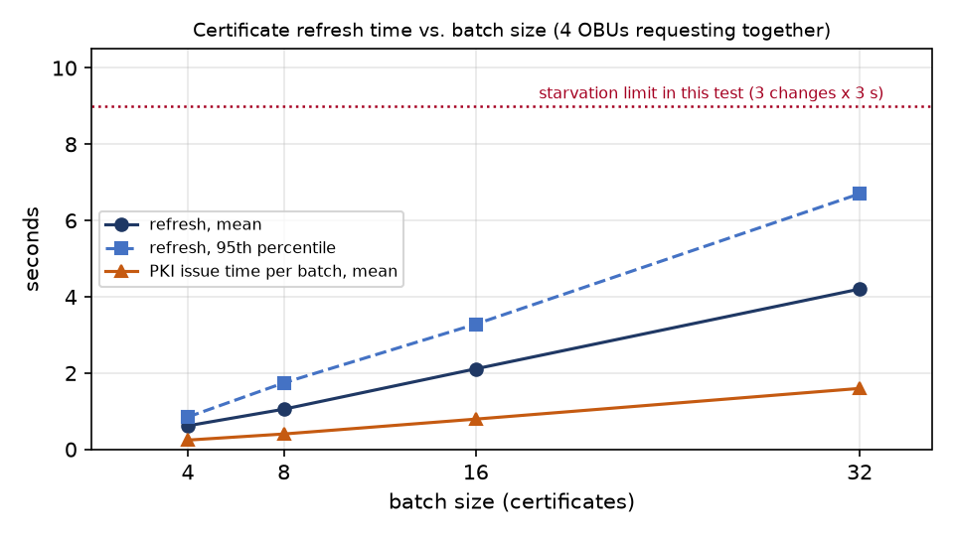
All four runs passed their checks with no starvation and no retries. The batch-4 maximum (3,726 ms) comes from two issuances that took 1.1 and 1.8 s instead of about 0.2 s, in the same second; the other 54 batch-4 refills took 0.24-0.94 s. It looks like a short CPU spike on the VM, not a property of the batch size.

3.2 What determines the refresh time
- Issue time is linear in the batch size: about 50 ms per ticket (61 ms at batch 4, where a fixed part of each request weighs more). Over a whole run the PKI spends the same time per ticket whatever the batch size; the batch size only decides how the work is cut up.
- Waiting dominates when stations ask together: the four OBUs requested within milliseconds of each other and the PKI served them one after another, so the k-th waited for k-1 batches. The mean refresh time was 2.5-2.7 times one batch's issue time and the worst about 4 times: refresh grows with batch size times the number of stations asking at once.
- Starvation limit: a station that requests at refill_at unused tickets can make refill_at more changes; the batch must arrive before the change after that, i.e. within (refill_at + 1) x change interval. Here that is 3 x 3 s = 9 s. The worst refresh reached 6.7 s at batch 32 (74 % of the budget). As a rule of thumb, starvation starts when concurrent requesters x 50 ms x batch size exceeds (refill_at + 1) x change interval: with batches of 32 and these settings, at about six OBUs asking together.

3.3 Mix zone with the run's PKI
Measure | Value
Pseudonym changes | 32 (8 per car, one per zone entry), each with a CAM timer rephase
Refills | 4, one per car at its 6th crossing; refresh 444-539 ms; PKI issue 386-417 ms, queue at most 31 ms
Starvation, retries | 0, 0
Ticket reuse | none: each car used 9 tickets, all different and all issued to it
Tickets shared with other runs | none: 0 of the run's 65 tickets appear among the 991 used in the sweep runs (each run has its own CA)
Eavesdropper links | 25: 4 correct, 21 wrong
by position | 18: 0 correct
by timing | 7: 4 correct (chance coincidences after the rephase)
Timing forced to choose for every change | 9 of 32 correct (28 %; guessing among 4 cars: about 25 %)

The refills happened inside the mix zone, where the cars change identity 1.5 s apart, so their requests reached the PKI 1.5 s apart and hardly waited (at most 31 ms). Unlike the sweep, real traffic spread the requests out.

4. Conclusion
Per-run PKI with certificate refill works as designed: stations never reuse a ticket, no ticket is shared between runs, and with the default policy (8, refill at 2, batches of 8) no station ran out. The refresh time is the PKI's issue time (about 50 ms per ticket) multiplied by the batch size and by how many stations ask at the same moment. Larger batches mean fewer requests but proportionally longer waits; when many stations ask together, they can exhaust their spare tickets before the batch arrives. The refill threshold should therefore be chosen from the expected change rate, the batch size and the number of stations a PKI serves at once, not fixed.
The mix-zone rerun confirms that refills do not affect unlinkability: the eavesdropper's position links were all wrong, its timing links were at chance level, and the results match the vnap:r2-p17 random-turn run.

5. Limitations
- One run per configuration; the percentiles describe single runs.
- Option A: the PKI reconstructs the private keys and returns them, so the station does no key derivation and the PKI does the derivation work; option B (station-side derivation) will move part of the cost and should be measured.
- The PKI service is single-threaded Python (C-ITS-PKI) on the same VM as the stations; a production PKI would be faster and parallel. The absolute times are those of this setup; the proportionality is the finding.
- The sweep synchronizes all changes deliberately (worst case); real pseudonym changes are minutes apart and spread out.
- Validity periods and i-periods are compressed (24 h tickets, a new i-period per batch) to fit runs of minutes.
- The control channel stands in for the backend link and carries the keys unencrypted (simulation only).

6. Recommendations
- Size the refill threshold. Choose refill_at so that (refill_at + 1) x the shortest change interval exceeds the worst expected refresh time (concurrent requesters x issue time per batch), with a margin; expose the estimate in vnapctl as a warning.
- Option B. Implement station-side key derivation and repeat the sweep: the PKI's issue time should fall and the station's installation time rise.
- PKI capacity. Run the PKI with several workers and with 10-50 stations to find where queueing, not issuance, limits refresh time; add request jitter or staggered thresholds as a station-side mitigation.
- Realistic change rates. Repeat with change intervals of minutes and validity periods of hours to confirm that refill is then rarely on the critical path.
- Automation. Add the refresh metrics and the reuse and cross-run checks to automated scoring, with several seeds per configuration.

