The Double-Cumulate Artifacts Bug
Simulation of a AltDensMover population in which the SingleEvaluators were multiplied, icosahedral artefacts appeared.

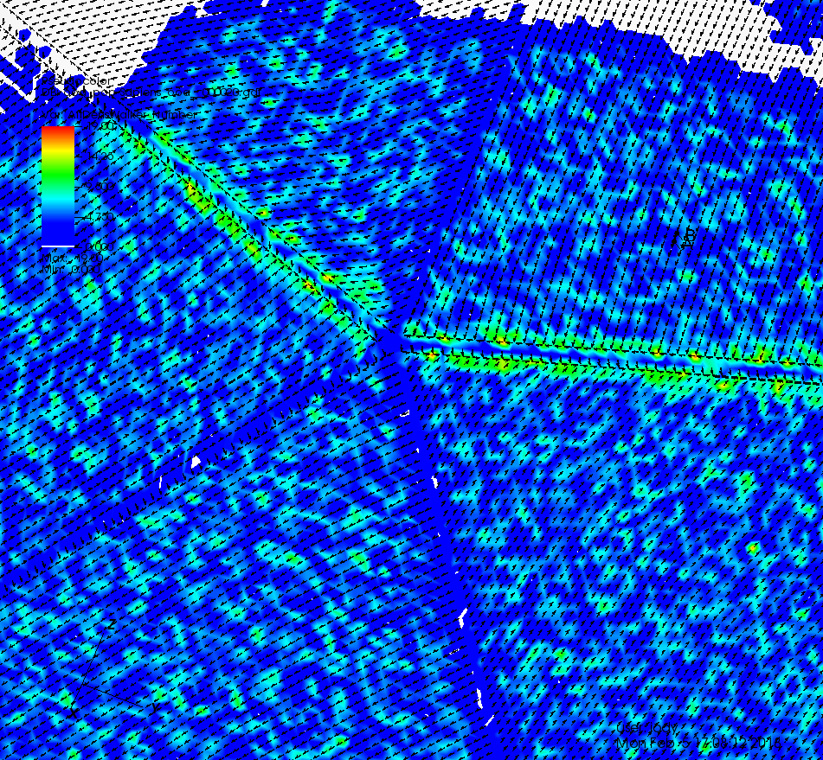
The artifacts remained even when the altitude Evaluator was the only one managed by the MultiEvaluator. It turned out that the environment weights were cumulated twice, giving the last neighbor the highest move probability. Since the neighborhood directions are not randomly distributed (even across an entire face), directional movement towards or away from big edges resulted.
A new tool, Angulator, was implemented to add new data sets, “Angles” and “Directions” to the Geography group of a QDF file.
- Angles[6*c+j] contains the angle between north and the direction towards neighbor j in cell c.
- Directions[3*6*c+3*j + k] is the coordinate of the direction vector to neighbor j in cell c.

To visualize the Directions data, the VisIt plugin was extended to read vector data.
The images obtained for direction 5 clearly show how the “horizontal” big edges act as attractors
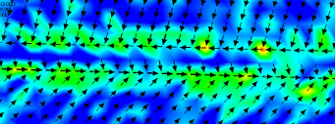

while the other big edges are repulsive
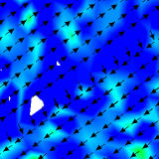 | 