Some Thoughts About Agent Groups
To implement agent groups (herds, tribes) in QHG, we need to find agent behaviors which lead to
the emergence of group behavior.
One way to do this is to look at the possible states and transitions on the group level and then try to
specify agent behaviors for these states.
What follows is just a proposal open for suggestions.

Group States and Transitions
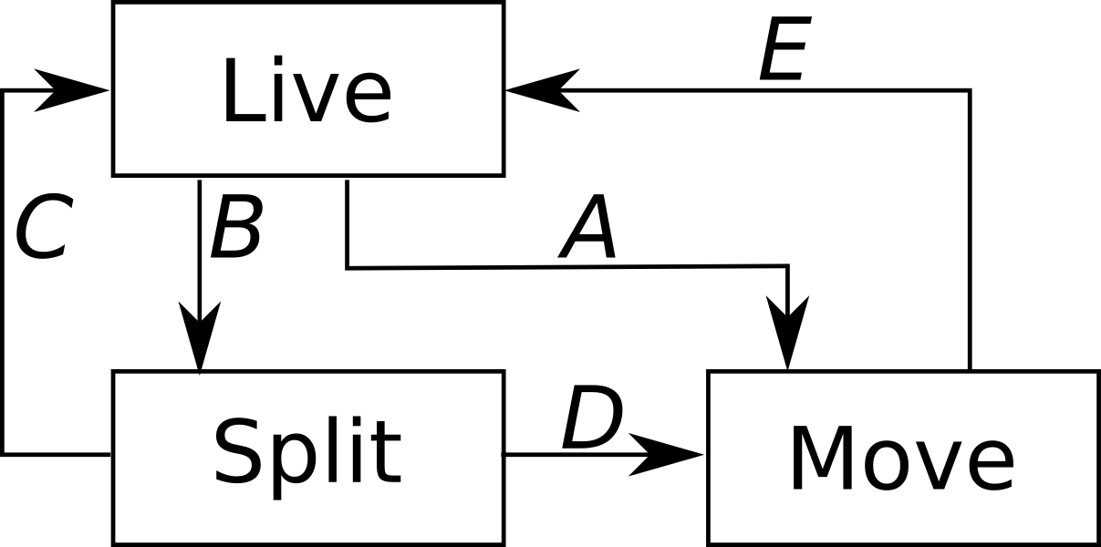

Live:
“Settled” behavior
- eat
- mate
- die
- forage for food in neighborhood, but return to home when done

Split:
Two (or more) groups have to be formed
- decide group membership (alphas, individual, random)
- decide who has to leave (alphas, group, random)

Move:
Travel to find new home
- all agents move in same direction (alphas, group, random)
- decision whether to stop at current location (alphas, group, random)
- if stop: make location the new home
- during move: no mating+birth?

Transitions:
A: Group leaves home because resources are exhausted, or climate change
B: Group splits because home too crowded or not enough resources available
C: Group remains at home after split
D: Group leaves after split to find a new home
E: Group makes new home after move

Some Details
Group
- every group has an ID (assigned by a “GroupManager”)
- group ID is a visible property of agents

Home
- every agent remembers location (Cell ID) of group's home
- when a group settles in a new home, all members must update location

Group Move
- choose a random direction which is used by all members
- alternatively, group decision:
- first collect direction proposals made by all members (may depend on agent state)
- find majority direction
- use this direction for all members

Group Split
- choose group membership randomly for all members
- alternatively, individual decision:
- choose group membership (may depend on agent state)
- children choose same group as mothers

Foraging
- agents have memory of last N locations visited during forage
- when memory full, return home by backtracking
- if agent revisits a location, it can return home from there (backtracking)
- if agent reaches home, foraging is over
- (maybe agents bring back food? → group collection pot?)
- (maybe join an other group?)

Group Death
- when the group size falls below a critical value, agents may individually decide to look for another group
- alternatively, the group may go to move mode, only stopping when it meets another group

