Private and Population-Level Parameters for Hybridization Simulations
All Populations used in the simulations usually have these parameters:

BirthDeath: b0, d0, theta
Fertility: min age, max age, interbirth
OldAge: max age
WeightedMove: move probability
NPPCapacity: NPP->CC ramp function, water bonus, coastal bonus

Generally, all these parameters are population-level parameters; for the Hybridization-Simulations some of them are changed to individual parameters.

There are three main features used in the current implementations for the Hybridization-Simulations:

Corrected Birth Probability
Every agent has its hybridization value, and a saddle function defined by a population-level parameter HybMinProb is used to calculate a correction factor for the birth-probability from the parents' hybridization:
p_{corr} = a+s * (h_{Mother} - 0.5)*(h_{Father} – 0.5)  where  a = 2 * (1 - HybMinProb)  s = 1 - (1 – HybMinProb)/2  p_{corr}(0,0) = p_{corr}(1,1) = 1  p_{corr}(0,1) = p_{corr}(1,0) = HybMinProb | 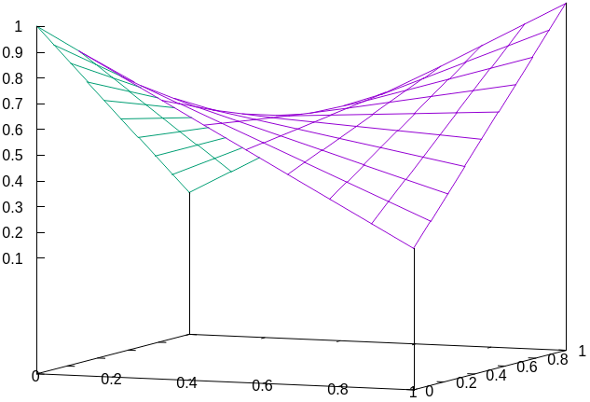
This factor p_{corr} is multiplied to the birth probability, which is in turn used to determine whether a birth takes place or not. The offspring’s hybridization is currently calculated as the average of the parents’ hybridization values, but could be changed to a recombination-dependent calculation.

Private Parameters
The parameters for BirthDeath, Fertility, OldAge and WeightedMove are private, i.e. each agent has a complete set of these values which are used for the various computations. The parents’ parameter values can be combined arbitrarily to produce the childs parameter value. For example, calculating weighted averages based on the hybridization, or use the parameter values of one parent only, etc.

Dual NPP Parameters
There is a set of NPP population-level parameters describing “pure” sapiens and one set describing ”pure” neanderthals. To determine the carrying capacity of a cell, the calculation is done once with the sapiens parameters and once with the neanderthal parameters. The actualy carrying capacity the child sees is the weighted average of the two values.

Currently there are implementations for 3 different models for the Hybridization simulations, which use some or all of the features described above: “BirthProb Only”, “Partially Private”, “NPP-Mix”.

The following table gives an overview of which features are used by these implementations

 | Corrected Birth Probability | Private Parameters | Dual NPP Parameters
“BirthProb Only” | Yes | No | No
“Partially Private” | Yes | Yes | No
“NPP-Mix” | Yes | Yes | Yes

I think for a system as discussed via skype we could use the “NPP-mix” implementation, where the private parameters are inherited from one parent (instead of mixing them).

