**Installing Anaconda**

Requirements for this discord bot involve the use of a software named “Anaconda”

<https://www.anaconda.com/distribution/>

Download the required software along with the Python 3.7 version and nothing more.

After installing it go to the cmd and type in ‘conda’

You should see this 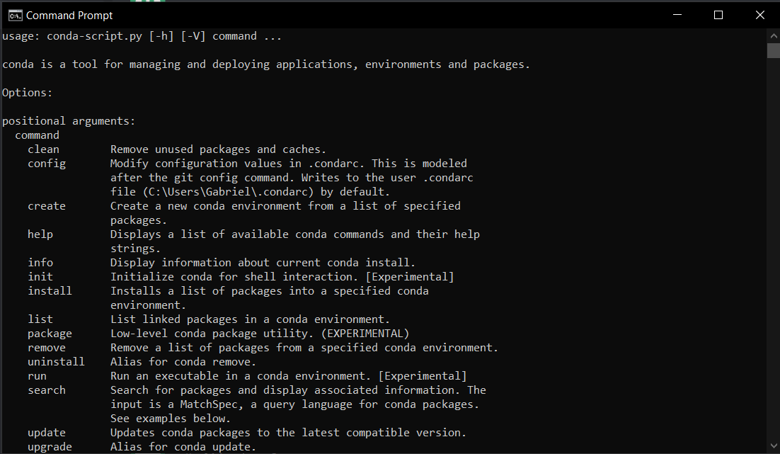

If not then ensure you have installed anaconda to path.

Type the below into the cmd panel in <servername> type in your servername or environment without the “<>” brackets



Afterwards type this in

