You can get cancer from smoking, radiation, viruses, cancer-causing chemicals (carcinogens), obesity, hormones, chronic inflammation and a lack of exercise. Cancer can cause at any age .but if you’re 65 or older there’s a higher chance of cancer. It can be inherited to you by family history because DNA Errors and can be cause by the environment like smokes and even the sun and cell phones and having unsafe sex
There’s different types of cancer here’s the common ones
- Breast cancer
Breast cancer
A cancer that forms in the cells of the breasts.
Prostate cancer
A cancer in a man's prostate, a small walnut-shaped gland that produces seminal fluid.
Basal cell cancer
A type of skin cancer that begins in the basal cells.
Melanoma
The most serious type of skin cancer.
Colon cancer
A cancer of the colon or rectum, located at the digestive tract's lower end.
Lung cancer
A cancer that begins in the lungs and most often occurs in people who smoke.
Leukemia
A cancer of blood-forming tissues, hindering the body's ability to fight infection.
Lymphoma
A cancer of the lymphatic system.

Symptoms:
- Fatigue
- Lump or area of thickening that can be felt under the skin
- Weight changes, including unintended loss or gain
- Skin changes, such as yellowing, darkening or redness of the skin, sores that won't heal, or changes to existing moles
- Changes in bowel or bladder habits
- Persistent cough or trouble breathing
- Difficulty swallowing
- Hoarseness
- Persistent indigestion or discomfort after eating
- Persistent, unexplained muscle or joint pain
- Persistent, unexplained fevers or night sweats
- Unexplained bleeding or bruising

For more information look here: http://www.mayoclinic.org/diseases-conditions/cancer/basics/causes/con-20032378
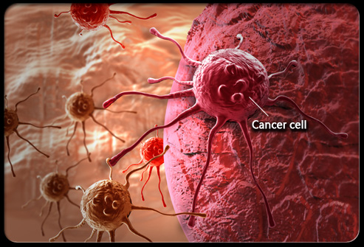
For Symptoms here’s the link: http://www.mayoclinic.org/diseases-conditions/cancer/basics/symptoms/con-20032378

