**EX NO: 2**

**DATE:**

**EXPLORE KALI LINUX AND BASH SCRIPTING**

**AIM:**

**PROCEDURE:**

#### **1. Start Kali Linux and Open the Terminal**

* Launch Kali Linux on your VirtualBox or physical machine.
* Once Kali Linux is booted up, open the **Terminal** .

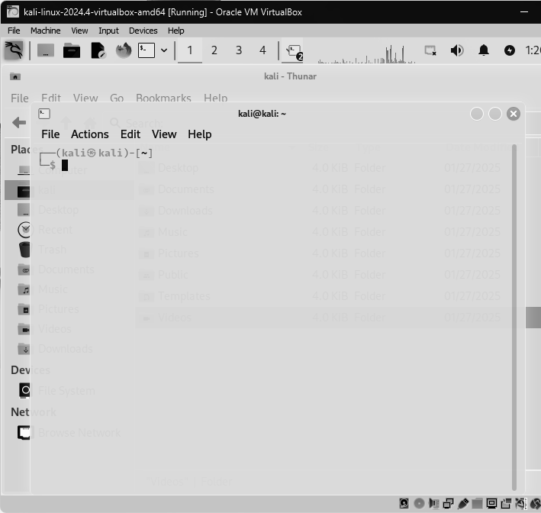

**2. Create a New File in Terminal and Save it as ‘./sh’.**

**Command to create the file: nano joe.sh**

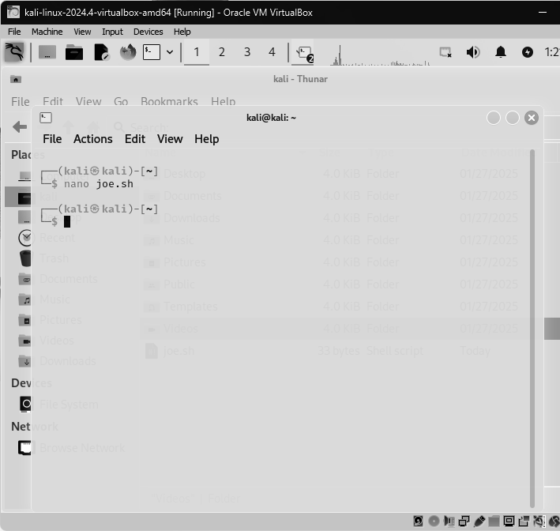

#### **3. Write a Simple Program in the Script**

In the file_name.sh, you can write a simple bash script. For example, a "Hello World" script:  
  
**#!/bin/bash**

**echo "Hello, World!"**

* Save the file and exit the editor (Ctrl+X, followed by Y to save and Enter to confirm).

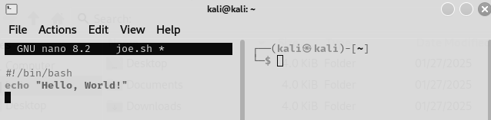

#### **4. Give Execute Permission and Run the Script**

To execute a script, you need to provide it with the necessary permissions. Run the following command to make the script executable: **chmod +x joe.sh**

Now, you can run the script using: **./joe.sh**

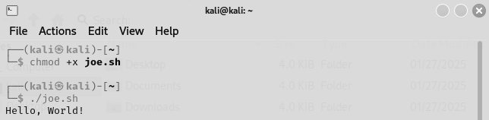

#### **5. Other Commands and Their Usage**

* **mkdir** (Create a Directory): **mkdir folder**

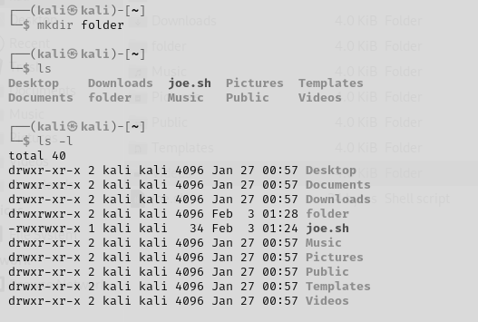

* **ls** (List Files/Directories):

1. **ls**



1. **ls -l**  # Long format with details



1. **ls -a # Show hidden files**

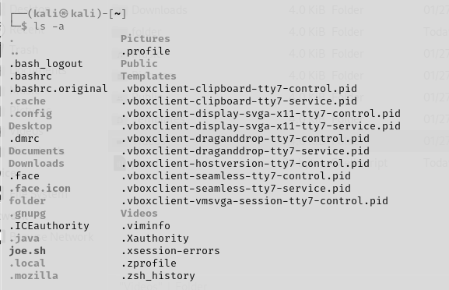

1. **ls -lh # Human-readable file sizes**

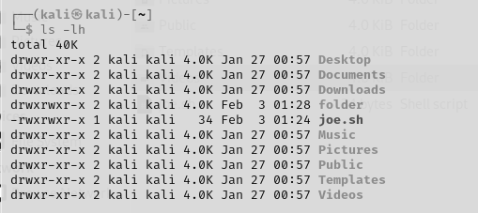

* **cd** (Change Directory):  
    
  **cd ~/Documents** # Go to Documents

**cd ..** # Go up one level

**cd -**  # Go to the last directory

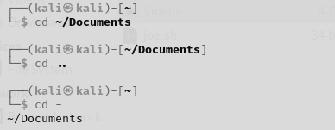

* **pwd** (Show Current Directory):



* **rm** (Remove Files/Directories):  
    
  **rm file.txt**  # Remove file

**rm -r folder** # Remove folder and contents

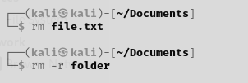

* **cp** (Copy Files/Directories):  
    
  **cp file1.txt file2.txt**  # Copy file1.txt to file2.txt

**cp -r folder1 folder2** # Copy folder1 to folder2

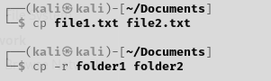

* **mv** (Move/Rename Files):  
    
  **mv file1.txt newname.txt**  # Rename file

**mv newname.txt ~/Documents**  # Move file to Documents

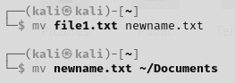

* **whoami** (Show Current User):

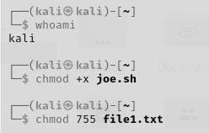

* **chmod** (Change Permissions):  
    
  **chmod +x joe.sh** # Make script executable

**chmod 755 file1.txt**  # Set read/write/execute permissions



* **chown** (Change File Owner): **sudo chown user:user file1.txt**



* **ping** (Check Internet Connection):  
    
   **ping google.com**

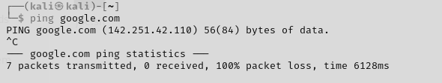

* **ifconfig or ip a** (Show Network Info):  
    
   **ifconfig**

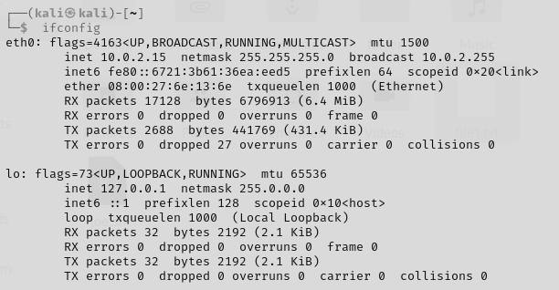

* **wget** (Download a File):

**wget https://example.com/file.txt**

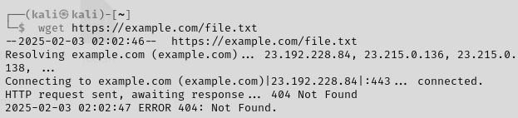

* **curl** (Fetch Data from a URL):  
    
   **curl https://example.com**

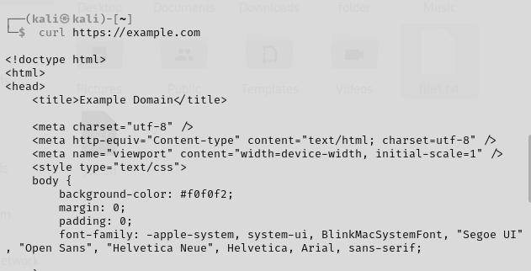

* **netstat** (Show Open Ports):  
    
   **netstat -tulnp**

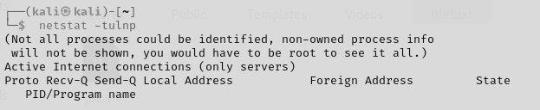

* **find** (Search for Files):  
    
   **find /home -name "file1.txt"**  # Search for 'file.txt' in /home directory

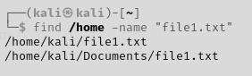

* **grep** (Search Inside Files):  
    
   **grep "error" logfile.log**  # Search for 'error' in logfile.log

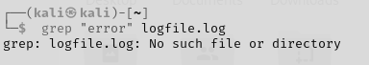

* **locate** (Find Files Quickly):  
    
   **locate file1.txt**  # Quickly locate 'file.txt'



* **jobs** (List Background Jobs):  
    
   **jobs**

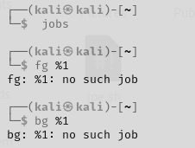

* **echo** (Print Text):  
    
   **echo "Hello"**



* **date** (Show Current Date/Time):  
    
   **date**

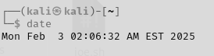

* **history** (Show Command History):  
    
   **history**

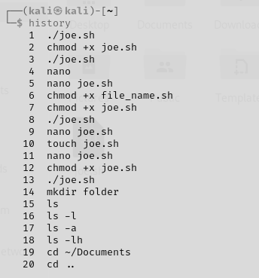

* **alias** (Create an Alias):  
    
   **alias ll="ls -lah"** # Create an alias 'll' for 'ls -lah'



#### **RESULT:**