**EX NO: 3**

**DATE:**

**PERFORM OPEN SOURCE INTELLIGENCE GATHERING USING NETCRAFT, WHOIS LOOKUPS, DNS RECONNAISSANCE, HARVESTER AND MALTEGO**

**AIM:**

To Perform open source intelligence gathering using Netcraft, whois lookups, DNS Reconnaissance, Harvester and Maltego.

**PROCEDURE:**

Step 1: Netcraft is a tool used for finding what infrastructure and technologies are in a site.

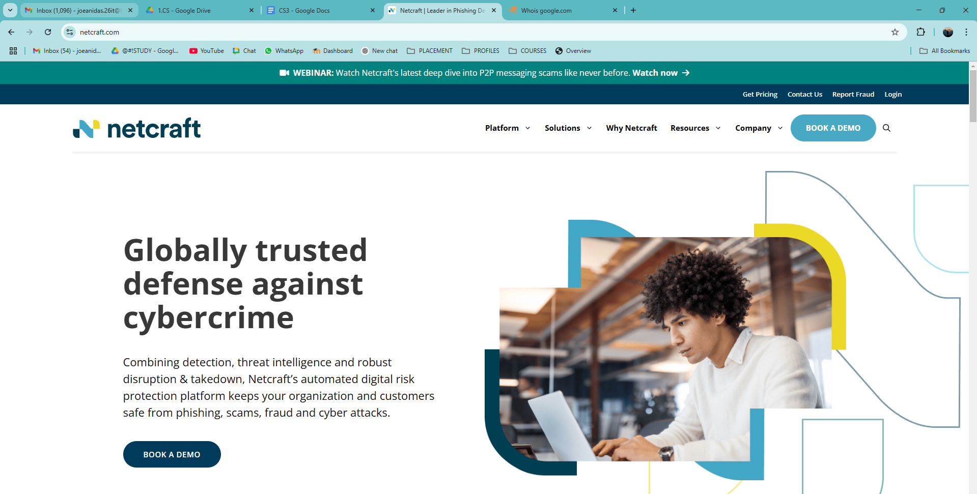

Step 2: The tool can be accessed using Browser and the Infrastructure and technologies of the website can be accessed by giving the URL of the site.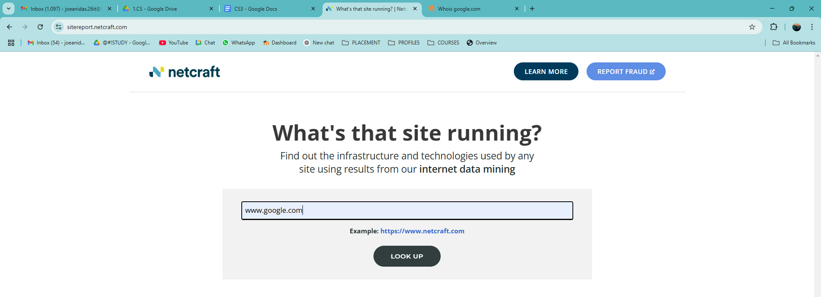

Step 3: The website will display the information such as IP addresses of the website.

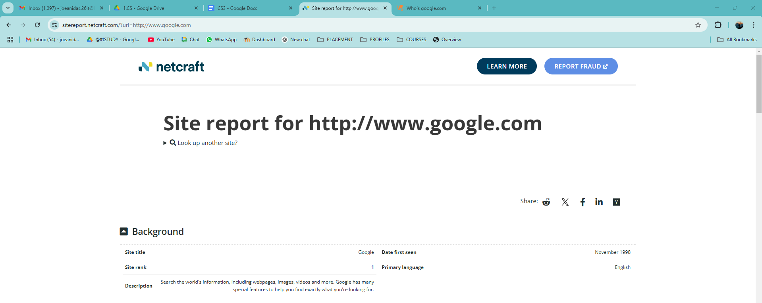

Step 4: Whois is also a tool used to get the all domains and subdomains of a website. The website can be accessed at [https://whois.com](https://whois.com/).

We can enter the name of the website to look for domains.

This tool is used to view the sub domain of the website. The sub domains can be viewed like a tree.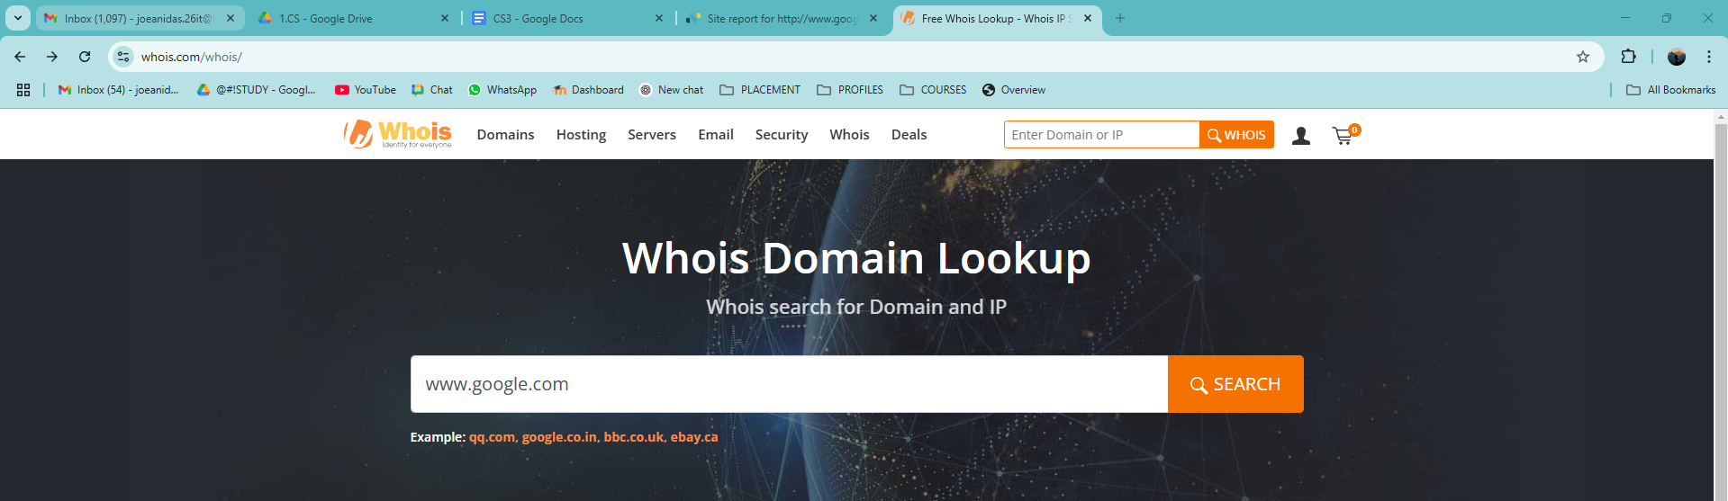

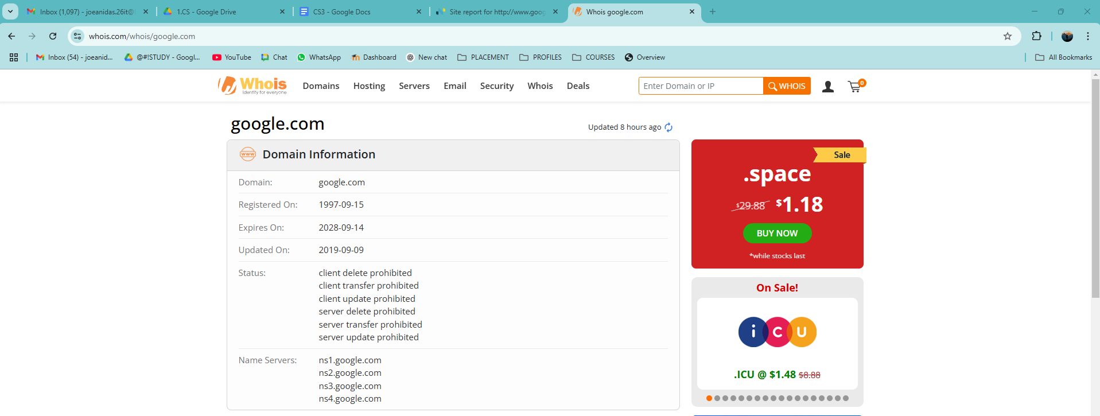

Step 5: Perform the DNS Reconnaissance.

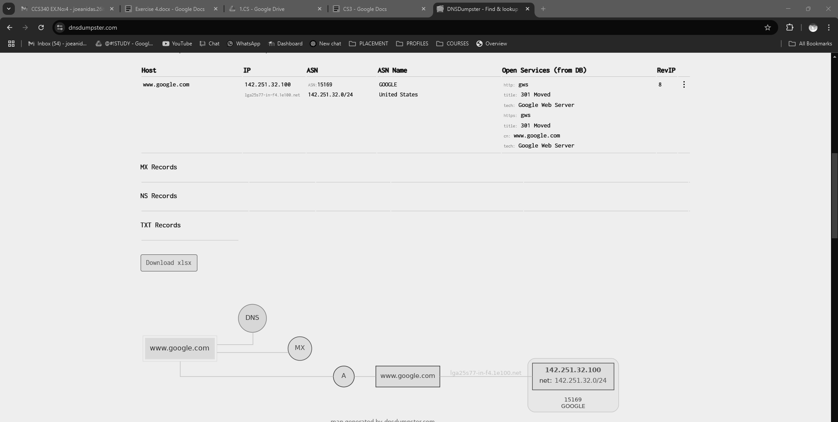

Step 6: Harvester is a tool used in Linux System.

This is used to get the IP addresses of the website The Harvester tool can be used by giving following command: **theHarvester –d <website_name>**

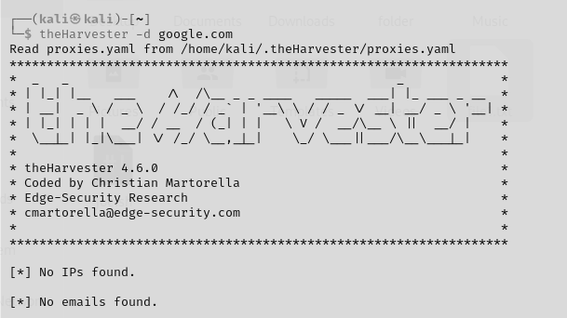

Step 7: You can install and verify Maltego in a single step using:

**sudo apt install maltego -y && maltego**

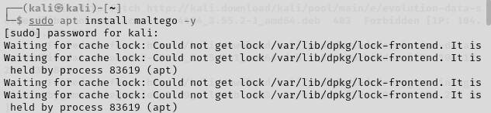

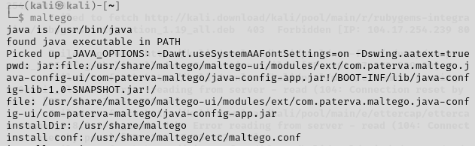



**RESULT:**