**EX NO: 5**

**DATE:**

**INSTALL METASPLOITABLE2 ON THE VIRTUAL BOX AND SEARCH FOR UNPATCHED VULNERABILITIES**

**AIM:**

To Install Metasploitable2 on the Virtual Box and Search for Unpatched Vulnerabilities.

**PROCEDURE:**

Step 1: Install virtual box if not installed

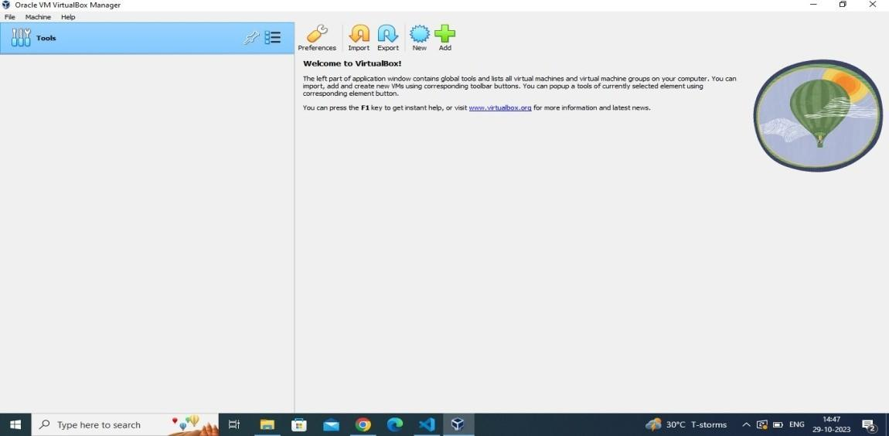

Step 2: Install Metasploitable2 using following link

<https://download.vulnhub.com/metasploitable/metasploitable-linux-2.0.0.zip>



Step 3: Extract metasploitable-linux.zip

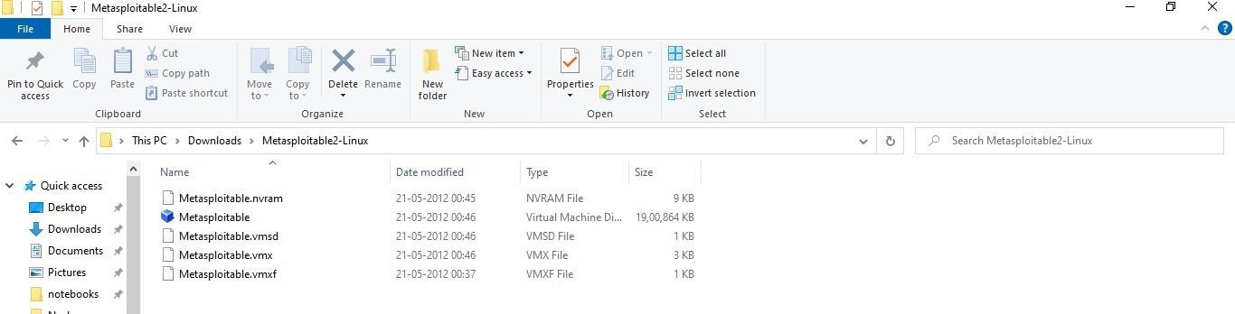

Step 4: Create new instance Click new in virtual box

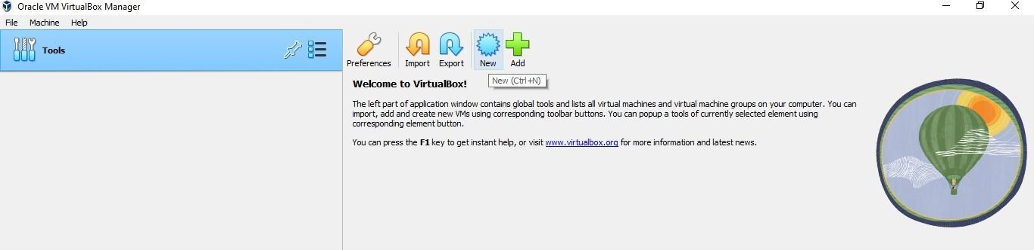

Step 5: Give any name, choose linux In Type and other linux(64 bit) in Version

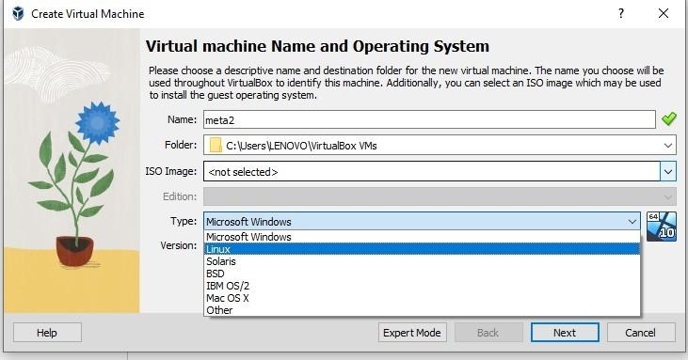

Step 6: Click settings

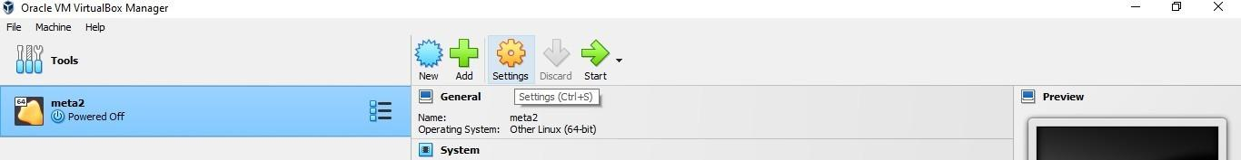

Step 7: Click Storage

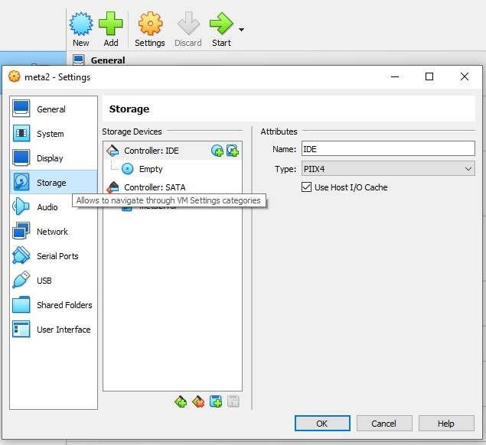

Step 8: Select Created Instance

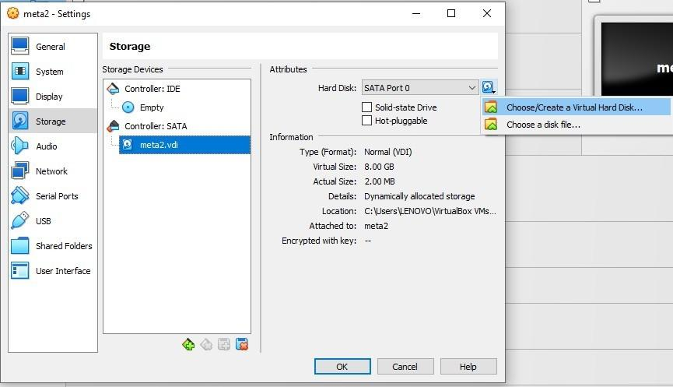

Step 9: Load Metasploitable

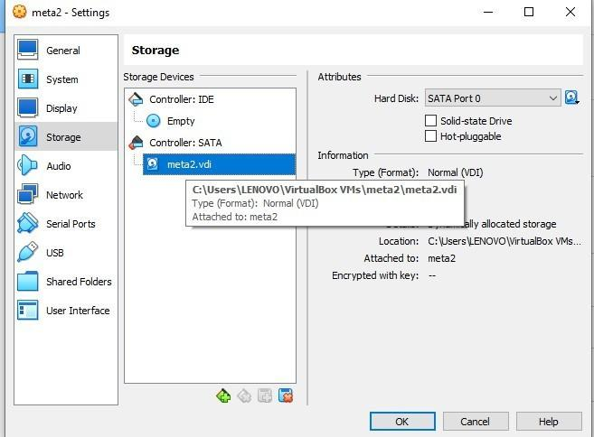







Step 10: Give login and password as msfadmin

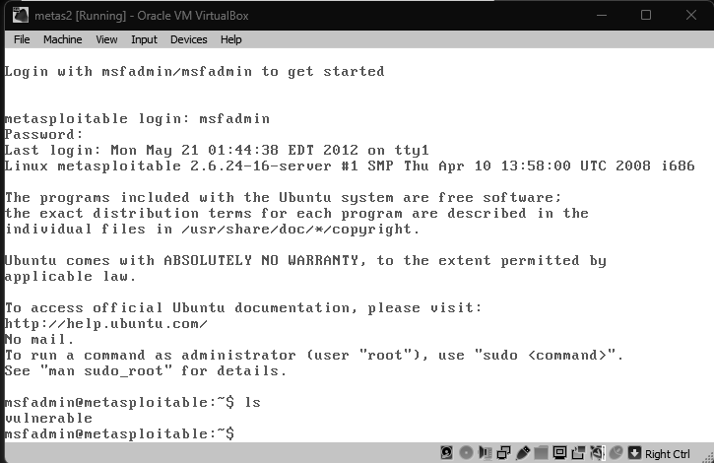



**RESULT:**