**EX NO: 6**

**DATE:**

**USE METASPLOIT TO EXPLOIT AN UNPATCHED VULNERABILITY**

**AIM:**

To use Metasploit to exploit an unpatched vulnerability.

**PROCEDURE:**

Step 1: Login into the metasploit terminal using the credentials and Open metasploitable2 and login, note the ip of the machine



Step 2: Now open kali linux and scan the metasploitable2 machine for open ports and service using nmap

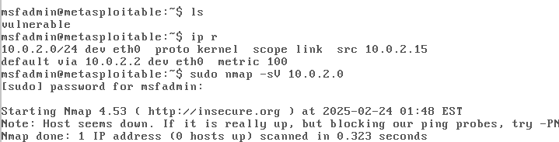

Step 3: Using browser navigate to the ip of metasploitable2 example:http://<ip-metasploitable>

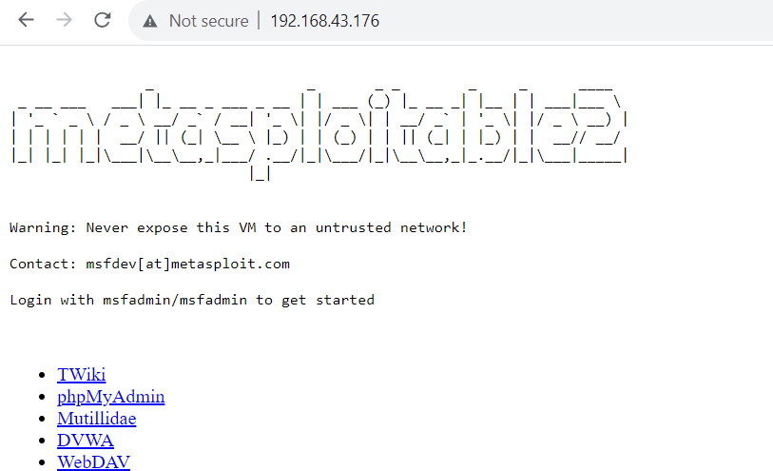

Step 4: Now open inspect element and move to network tab and reload the page,you can find the request and response for the ip

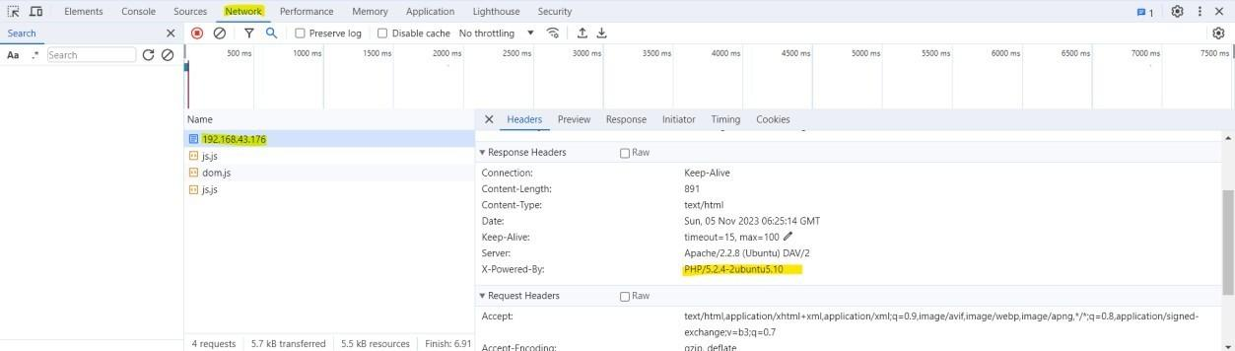

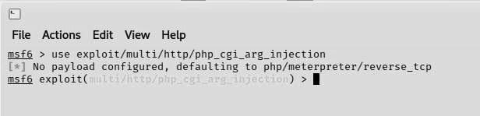

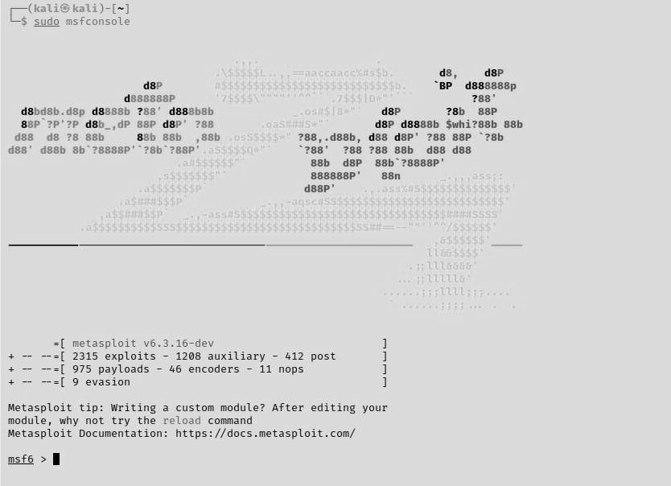

Step 5: Move to kali and by using Metasploit we are going to exploit PHP CGI Argument Injection.

Step 6: Set the host IP as out metasploitable IP



Step 7: Exploit

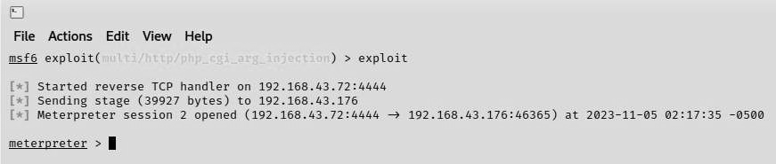

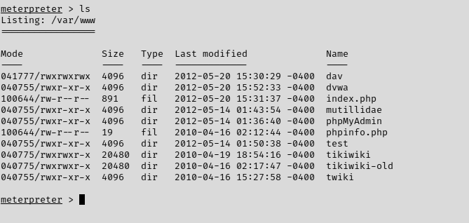

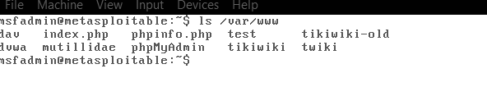

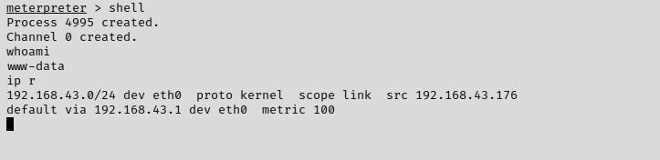

**RESULT:**