**EX NO: 7**

**DATE:**

**INSTALL LINUX SERVER ON THE VIRTUAL BOX AND INSTALL SSH**

**AIM:**

To install Linux server on the virtual box and install ssh.

**PROCEDURE:**

Step 1: Download and Install Virtual Box.

Step 2: Start the Linux shell in the Virtual box and install linux shell to fill the necessary instructions displayed on the screen.

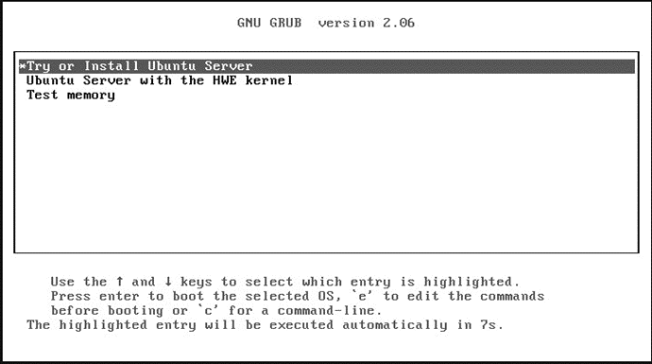

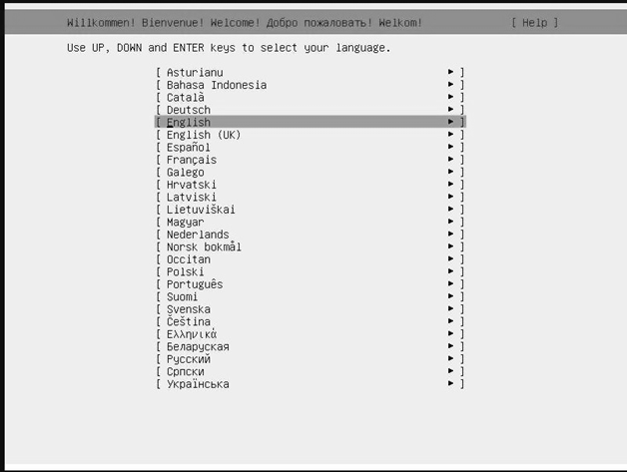

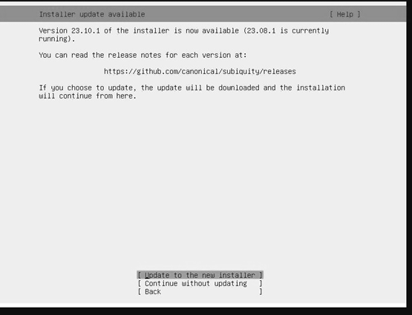

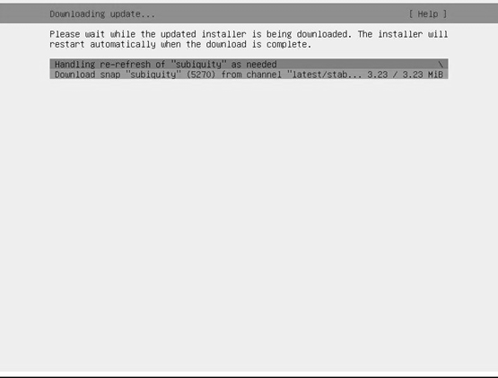

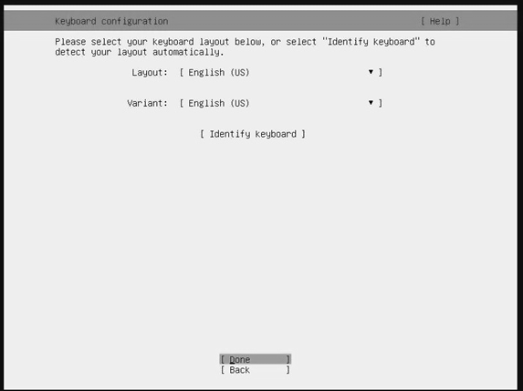

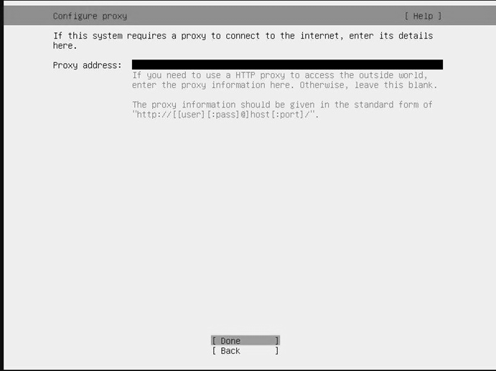

Step 3: Show the Guided storage Configuration and Click ‘Done’.

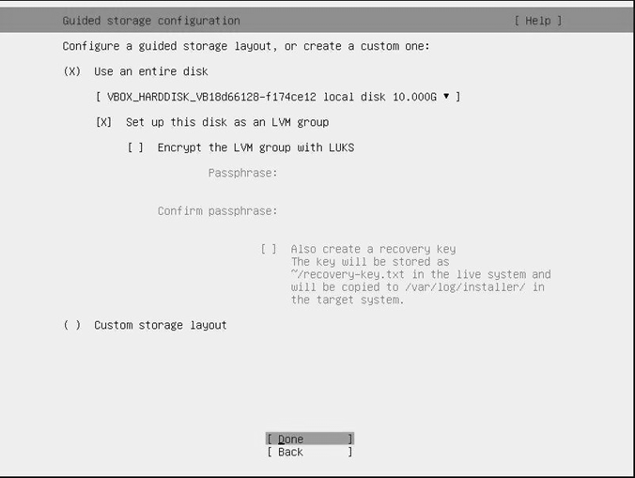

Step 4: Set up the Profile and enter your details such as name, service name, username and Password.

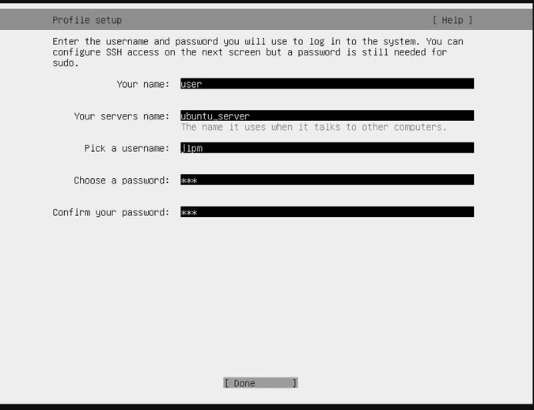

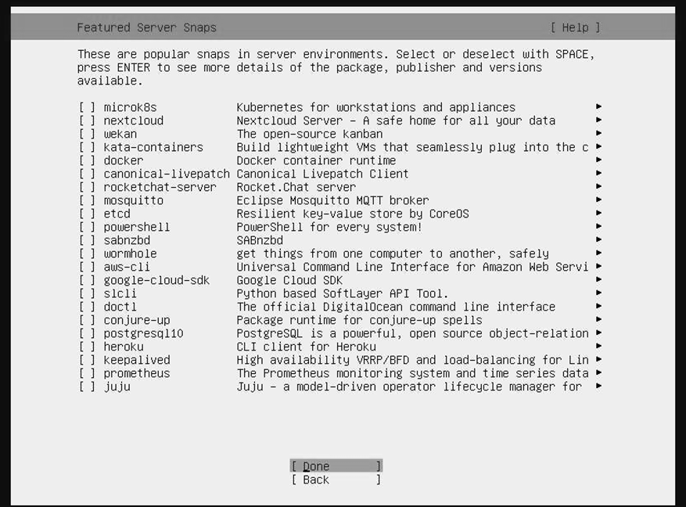

Step 5: Installing System.

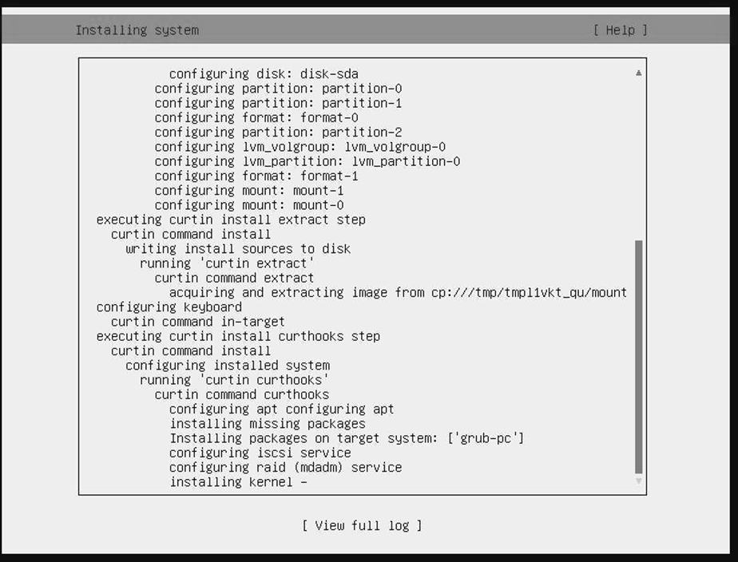

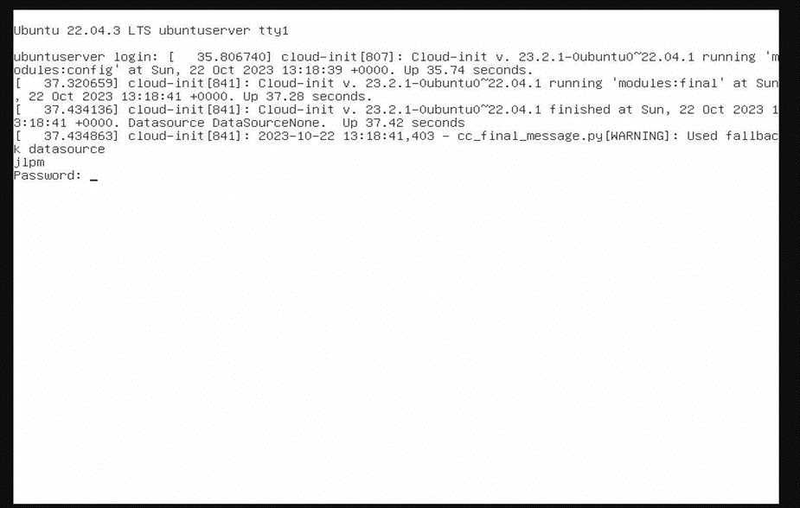

Step 6: Enter user name and password and press enter (note: password will not be visible).

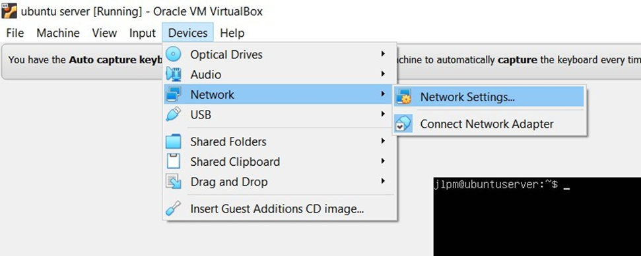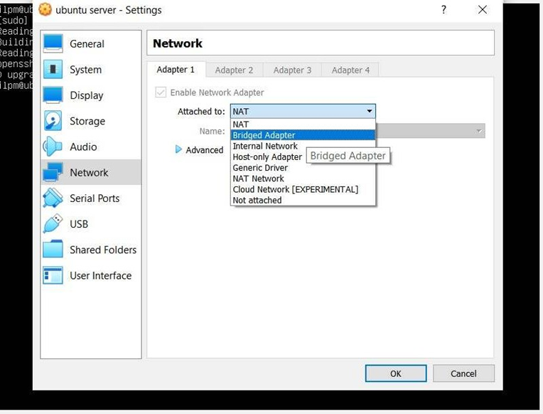

**RESULT:**