**EX NO: 8**

**DATE:**

**USE FAIL2BAN TO SCAN LOG FILES AND BAN IPS THAT SHOW THE MALICIOUS SIGNS**

**AIM:**

To use Fail2Ban to Scan log files and ban IPS that show the malicious Signs.

**PROCEDURE:**

Step 1: Change the Network adapter to Bridged Adapter.

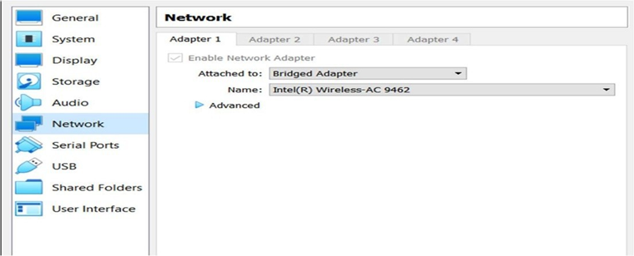

Step 2: Open the ubuntu server and install fail2ban using the below command.



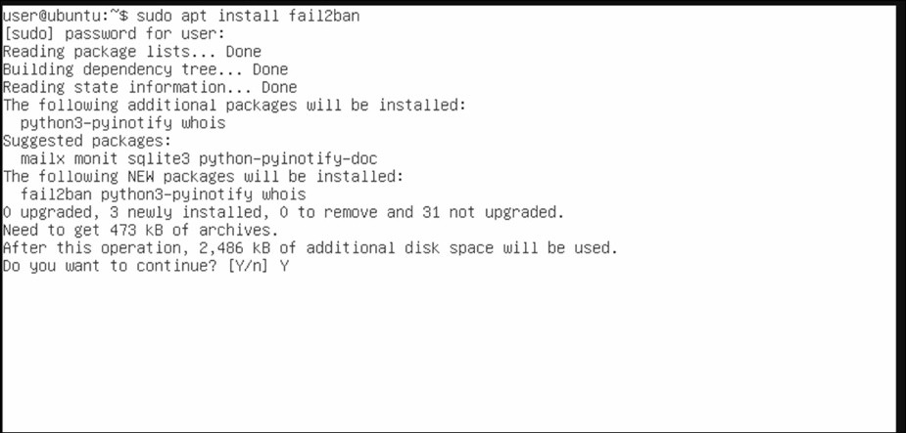

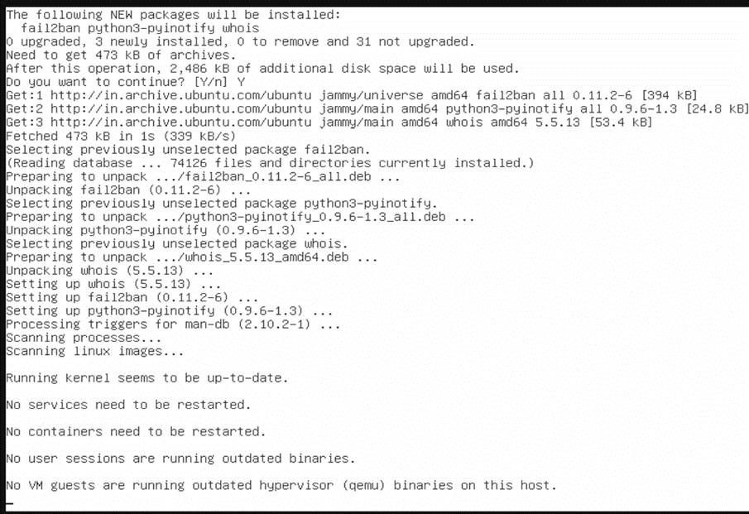

Step 3: Write the below configuration inside the jail.localfile.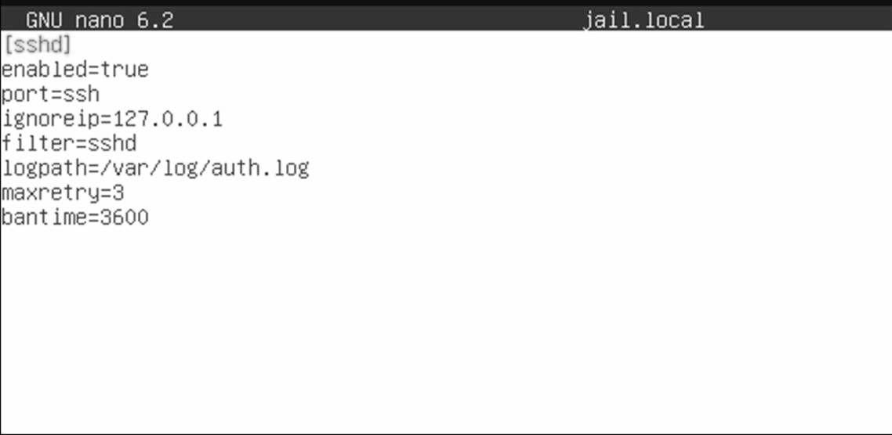

Step 4: After changing the jail.local, restart the fail2ban service.

Step 5: Check the status of fail2ban service.

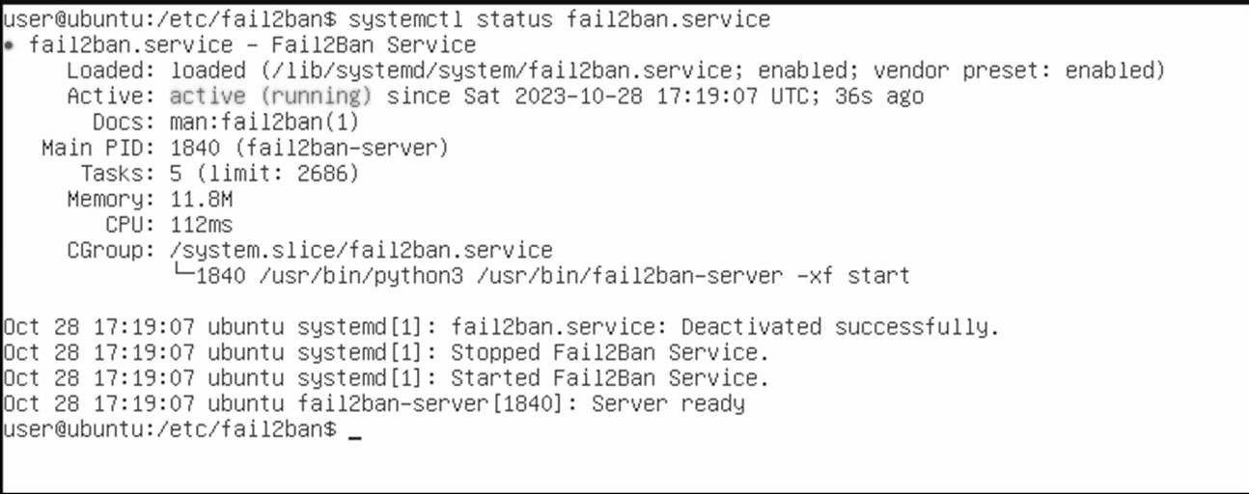

Step 6: Note the IP of the ubuntu server.

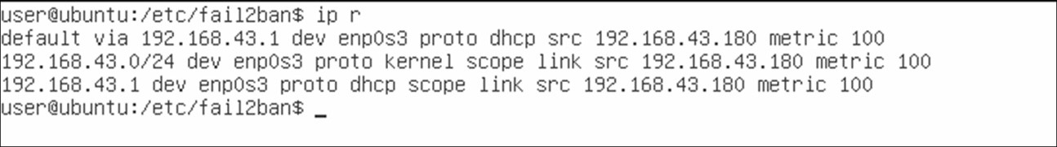

Step 7: Open kali linux and try brute forcing ssh login of ubuntu server using hydra. The brute force attempt is detected by fail2ban and our ip is blocked.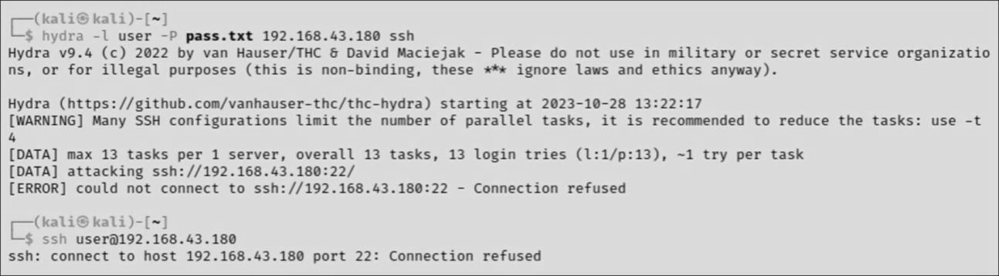

Step 8: Let's disable fail2ban and try brute forcing.



Step 9: Now we are able to perform brute force successfully.

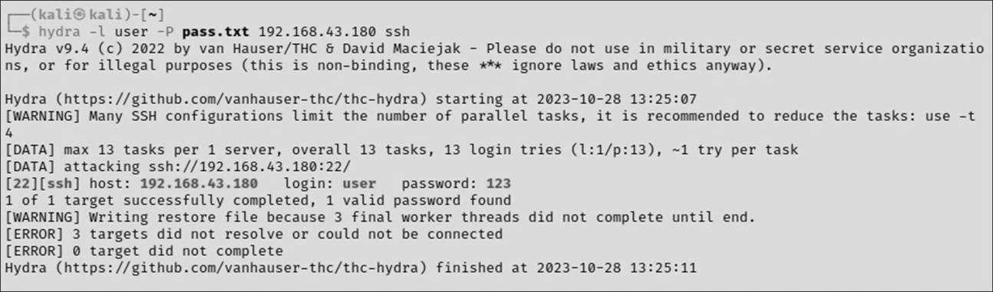

**RESULT:**