**EX NO: 1**

**DATE: 24.01.2025**

**IDENTIFY A SOFTWARE SYSTEM THAT NEEDS TO BE DEVELOPED**

**AIM :**

To identify a software system that needs to be developed.

**What are Case Tools?**

CASE (Computer-Aided Software Engineering) tools are software applications that assist in the development, maintenance, and management of software systems. They support various stages of the software development life cycle (SDLC), including design, coding, testing, and maintenance. CASE tools improve productivity, enhance quality, and provide documentation and process automation for developers.

**Types of Case Tools :**

1. Upper CASE Tools: These tools assist with the early stages of software development, such as system design, requirements gathering, and analysis. Examples include tools for modeling, prototyping, and creating diagrams like UML (Unified Modeling Language).
2. Lower CASE Tools: These tools are used in later stages, such as coding, testing, and maintenance. They include tools for code generation, debugging, and performance analysis.
3. Integrated CASE Tools: These tools combine both upper and lower CASE tools into a unified system, supporting the entire software development lifecycle from analysis through to maintenance.

**What is UML?**

**UML (Unified Modeling Language)** is a standardized visual language used to model the design of software systems. It provides a set of graphical notations to represent the structure, behavior, and interactions within a system. UML is widely used in object-oriented software development and allows developers, analysts, and stakeholders to communicate complex ideas clearly.

### 

### **Why do we need UML?**

1. **Clear Communication**: UML diagrams provide a common language for developers, analysts, and other stakeholders, helping to communicate design ideas and system architecture effectively.
2. **Standardization**: It offers a standardized way of visualizing and documenting software designs, making it easier for teams to work together, especially in large or distributed teams.
3. **Design Validation**: UML helps in visualizing and analyzing system components and their interactions early in the design phase, ensuring that the system meets the required specifications before coding begins.
4. **Documentation**: UML provides detailed documentation that can be referenced throughout the software development lifecycle, making maintenance and future development easier.

**What is ArgoUML?**

**ArgoUML** is an open-source, cross-platform UML (Unified Modeling Language) modeling tool that is used for creating UML diagrams. It is designed to help developers and software engineers visualize, design, and document the structure and behavior of software systems.

### **Key Features of ArgoUML:**

1. **Support for Multiple UML Diagrams**: ArgoUML supports all 14 UML 1.4 diagram types, including class diagrams, use case diagrams, sequence diagrams, activity diagrams, and more.
2. **Cross-Platform**: It is written in Java, making it compatible with multiple platforms, such as Windows, Linux, and macOS.
3. **Ease of Use**: It provides a user-friendly interface that allows users to easily drag and drop components to create diagrams.

**Why Do We Use ArgoUML?**

1. **Open-Source Tool** ArgoUML is a free, open-source UML modeling tool, making it accessible for developers and teams without licensing costs.
2. **Comprehensive UML Support** It supports all standard UML diagrams, including class, sequence, use case, and activity diagrams, helping developers model systems thoroughly.
3. **Cross-Platform Compatibility** ArgoUML is Java-based, ensuring it works across multiple platforms, including Windows, Linux, and macOS.
4. **User-Friendly Interface** ArgoUML offers an intuitive interface, making it easy for developers to create and modify UML diagrams with minimal learning curve.
5. **Extensibility** It provides plugins and customization options, allowing developers to extend its functionality according to their specific needs.

**UML DIAGRAMS:**

UML (Unified Modeling Language) provides a set of **14 standard diagrams**, which are categorized into **two main groups**: **Structural diagrams** (which represent the static aspects of a system) and **Behavioral diagrams** (which represent the dynamic aspects). Here are **9 of the most commonly used UML diagrams**:

### **1. Structural Diagrams**

**a. Class Diagram**

* **Purpose**: Represents the system's static structure, showing classes, attributes, methods, and relationships.
* **Notation**:
  + **Class**: Rectangle divided into three sections (Name, Attributes, Operations).
  + **Relationships**: Solid lines for associations, hollow triangle for inheritance, dashed arrows for dependencies.

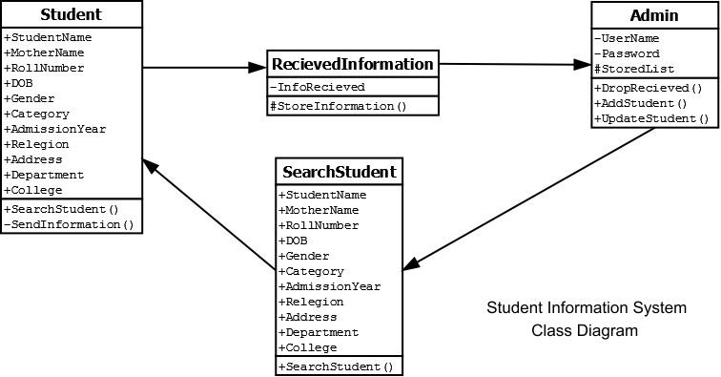

**b. Component Diagram**

* **Purpose**: Shows the physical components of a system and their interactions.
* **Notation**:
  + **Component**: Rectangle with a tab or labeled <<component>>.
  + **Dependency**: Dashed arrow.
  + **Interface**: Circle or ball-and-socket.

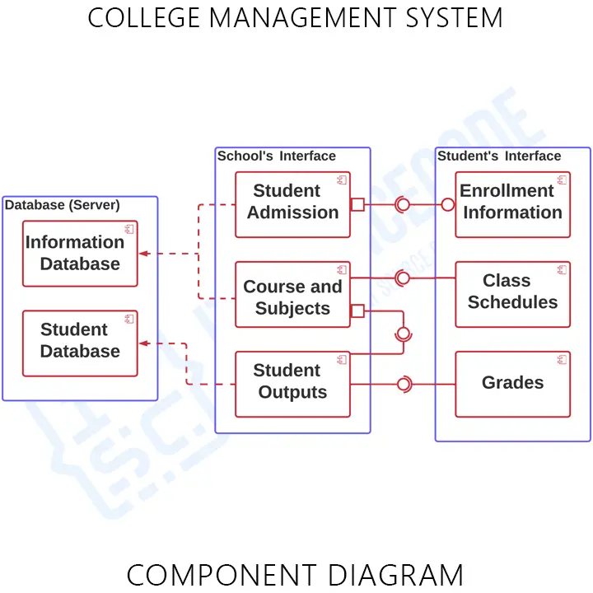

**c. Deployment Diagram**

* **Purpose**: Depicts the physical deployment of software components on hardware nodes.
* **Notation**:
  + **Node**: 3D box representing hardware.
  + **Artifact**: Rectangle labeled <<artifact>>.
  + **Communication Association**: Solid line between nodes.

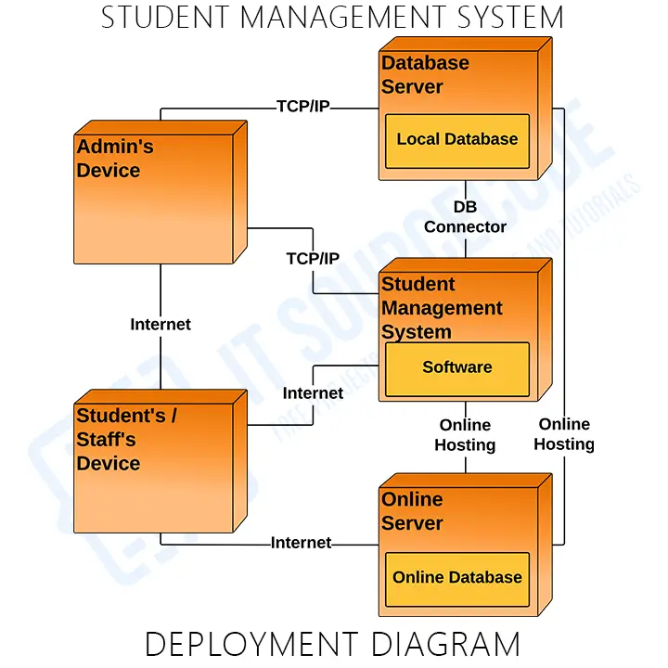

**d. Package Diagram**

* **Purpose**: Groups system classes and components into packages, showing their dependencies.
* **Notation**:
  + **Package**: Rectangle with a small tab at the top.
  + **Dependency**: Dashed arrow between packages.
  + **Contained Elements**: Classes or components inside the package.

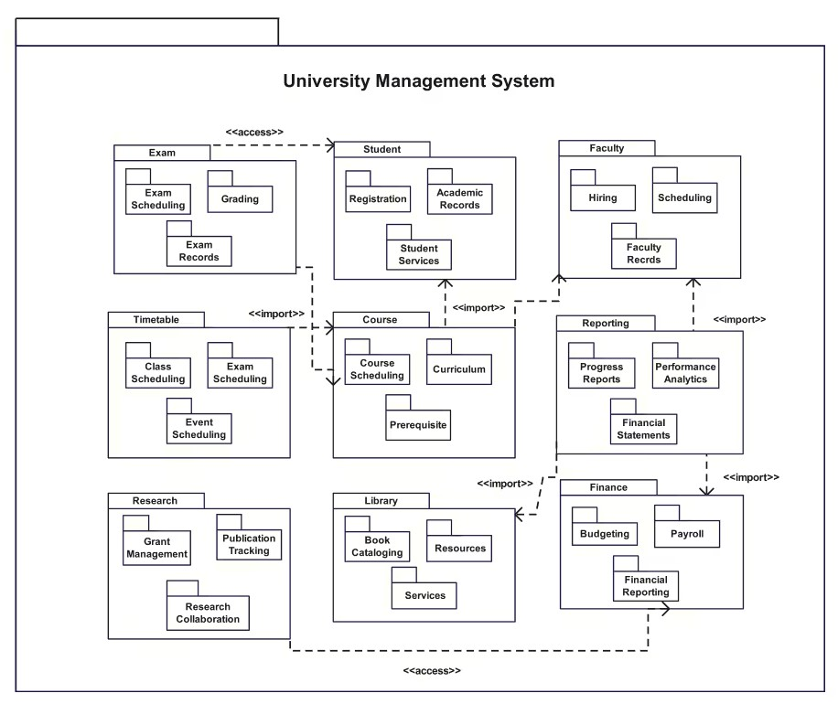

**e. Object Diagram**

* **Purpose**: Captures a snapshot of object instances and their relationships at a specific time.
* **Notation**:
  + **Object**: Rectangle with name and class underlined (e.g., objectName:ClassName).
  + **Links**: Solid lines showing associations.
  + **Attributes/Values**: Included inside the object.

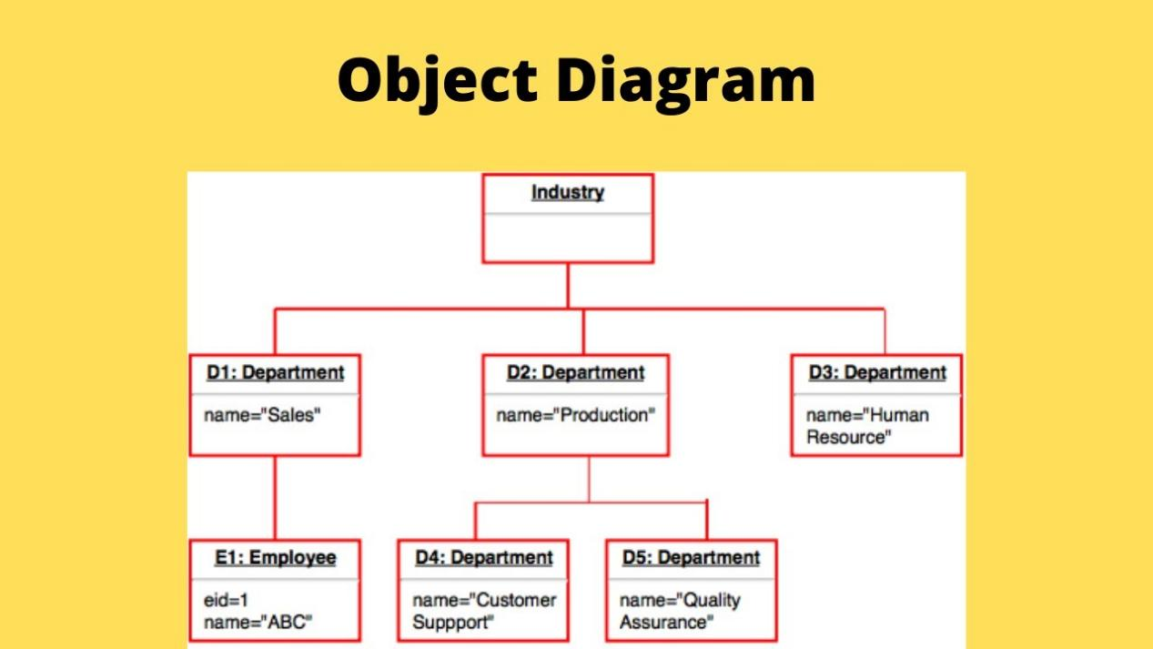

### **2. Behavioral Diagrams**

**a. Use Case Diagram**

* **Purpose**: Highlights system functionalities and interactions with users or systems.
* **Notation**:
  + **Actor**: Stick figure.
  + **Use Case**: Oval with the functionality name.
  + **Relationships**: Solid lines for associations, dashed arrows for <<include>> and <<extend>>.

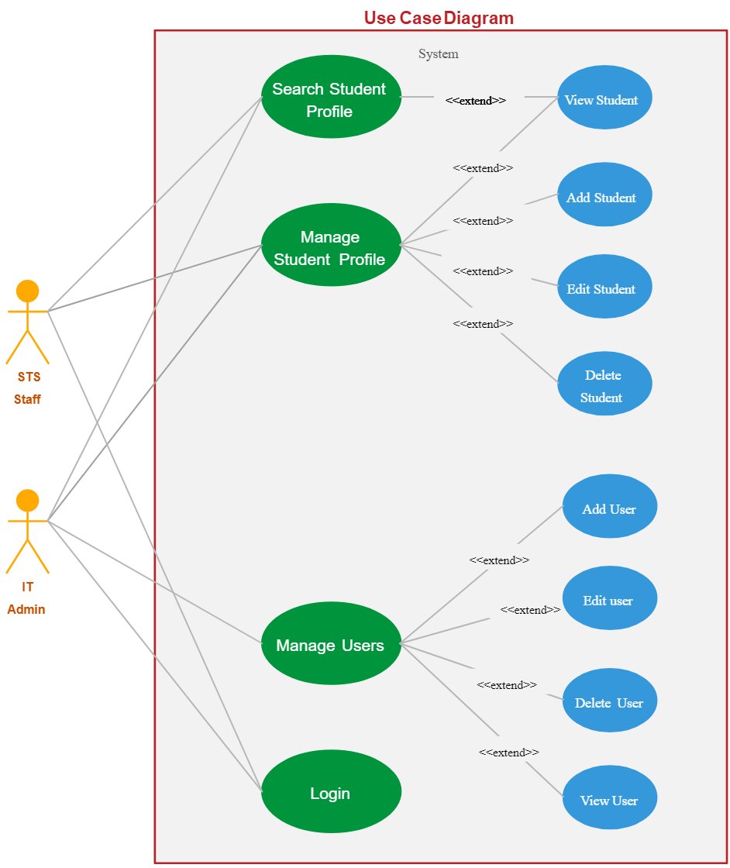

**b. Sequence Diagram**

* **Purpose**: Illustrates the sequence of interactions between objects over time.
* **Notation**:
  + **Lifeline**: Rectangle with a dashed vertical line below.
  + **Messages**: Horizontal arrows between lifelines.
  + **Activation Bar**: Thin vertical rectangle on a lifeline.

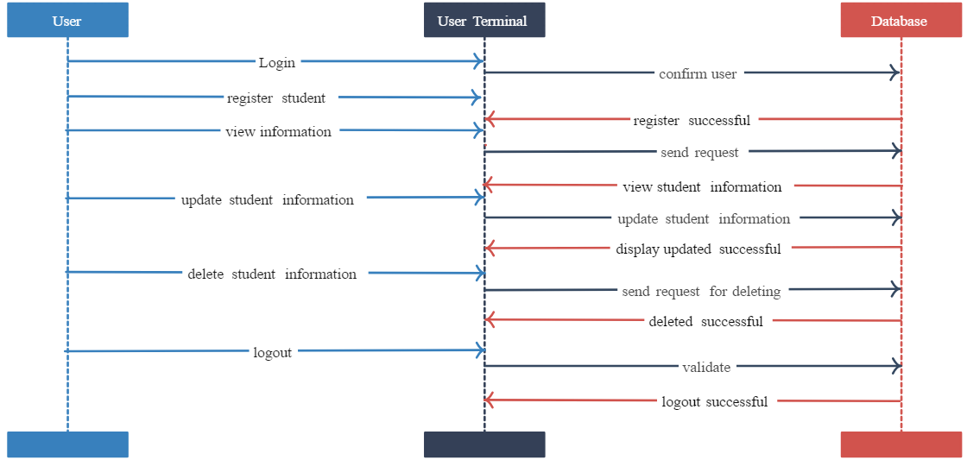

**c. Activity Diagram**

* **Purpose**: Shows workflows and decision-making processes in a system.
* **Notation**:
  + **Action**: Rounded rectangle.
  + **Start/End**: Filled circle for start, filled circle with an outer ring for end.
  + **Decision**: Diamond with arrows for transitions.

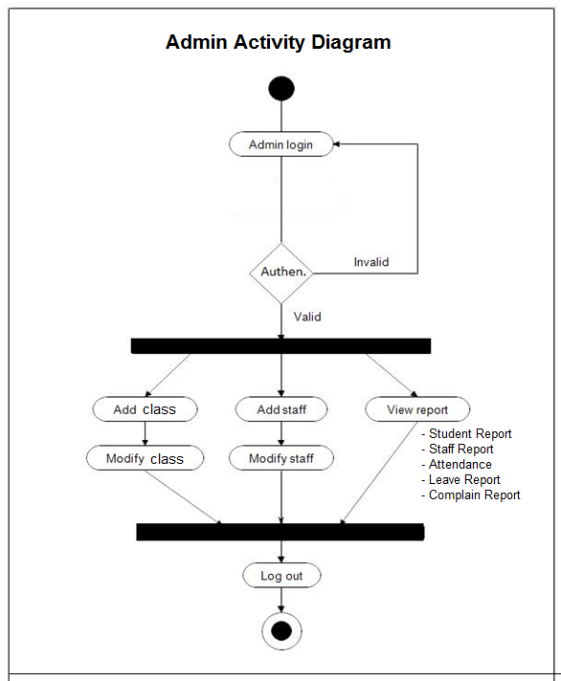

**d. State Diagram**

* **Purpose**: Describes states of an object and transitions based on events or conditions.
* **Notation**:
  + **State**: Rounded rectangle.
  + **Initial/Final State**: Filled circle for start, filled circle with an outer ring for end.
  + **Transitions**: Labeled arrows indicating events or conditions.

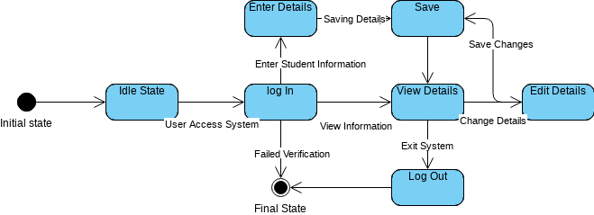

**e. Communication Diagram**

* **Purpose**: Focuses on object interactions and the sequence of messages exchanged.
* **Notation**:
  + **Object**: Rectangle with the object name.
  + **Message**: Numbered arrow between objects.
  + **Links**: Solid lines indicating associations.

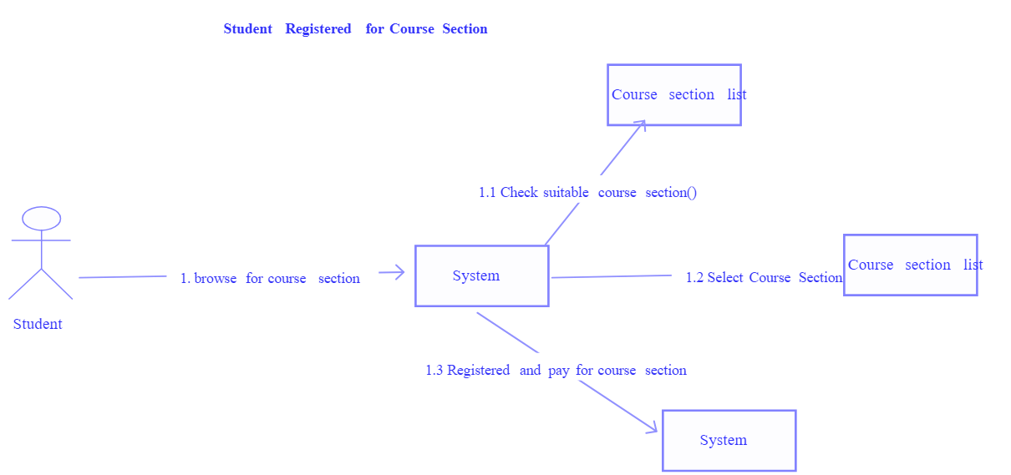

### **What is Implementation in Object-Oriented Software Engineering (OOSE)?**

### Implementation in Object-Oriented Software Engineering (OOSE) is the phase in the software development lifecycle where the designs and models created during earlier phases (such as analysis and design) are converted into executable code. It involves writing, testing, and integrating code to build a functional software system based on the specifications provided.

### **What is Java?**

Java is a high-level, general-purpose, object-oriented programming language designed for creating robust, portable, and secure applications. It is platform-independent due to its **"Write Once, Run Anywhere"** (WORA) philosophy, enabled by the Java Virtual Machine (JVM). Java supports object-oriented principles, making it ideal for modular, reusable, and scalable software development.

### **Why Choose Java for Implementation in Object-Oriented Software Engineering?**

1. **Object-Oriented Nature**
   * Java is inherently object-oriented, which aligns perfectly with Object-Oriented Software Engineering (OOSE) principles. It supports encapsulation, abstraction, inheritance, and polymorphism, enabling the modeling of real-world systems.
2. **Platform Independence**
   * Java's bytecode runs on the JVM, making it platform-independent. This ensures seamless execution across different operating systems, making it suitable for distributed systems.
3. **Robust Library Support**
   * Java provides a rich set of libraries (e.g., Java Collections Framework, I/O, networking, and GUI libraries) that simplify complex tasks, enabling faster development of object-oriented applications.
4. **Scalability and Maintainability**
   * Java's modular design allows for easy scalability and maintainability. Features like packages and interfaces help in organizing code logically, making it easier to update or extend.
5. **Security**
   * Java provides built-in security features such as bytecode verification, sandboxing, and cryptographic APIs, making it a reliable choice for enterprise-level software.
6. **Exception Handling and Debugging**
   * Java's robust exception handling mechanism ensures the stability of object-oriented applications, allowing developers to handle errors gracefully.
7. **Multi-threading**
   * Java supports multi-threading, which is essential for object-oriented systems requiring concurrent operations, such as real-time simulations and server-side applications.
8. **Rich Ecosystem and Community Support**
   * Java has a vast ecosystem of tools, frameworks (e.g., Spring, Hibernate), and a supportive developer community, making it easier to adopt and integrate with existing object-oriented systems.
9. **Portability and Reusability**
   * Java's standard libraries and frameworks promote code reusability, while its platform-independent nature ensures that applications can be ported to different environments without modification.

### **What is Testing?**

Testing is the process of evaluating a software application to ensure it functions as expected and meets specified requirements. It involves identifying and fixing bugs, verifying the software's quality, and ensuring reliability, performance, and security. Testing can be categorized into:

* **Manual Testing**: Performed manually by testers without automation.
* **Automation Testing**: Uses tools and scripts to execute tests, making the process faster and more reliable.

### 

### 

### **What is the Selenium Tool?**

Selenium is a popular **open-source automation testing tool** used for testing web applications across different browsers and platforms. It provides a suite of tools to automate web-based testing, ensuring that web applications function as intended. Selenium supports several programming languages like Java, Python, C#, and JavaScript.

**Selenium Suite Components:**

1. **Selenium IDE (Integrated Development Environment):** A browser extension for recording and replaying test cases.
2. **Selenium WebDriver:** A core component for creating browser-based automation scripts in various programming languages.
3. **Selenium Grid:** Allows parallel testing by running tests on multiple machines and browsers simultaneously.

### **Why Do We Go for Selenium?**

1. **Open-Source and Free**
   * Selenium is free to use, making it an ideal choice for organizations with budget constraints.
2. **Cross-Browser Testing**
   * Selenium supports multiple browsers like Chrome, Firefox, Safari, Edge, etc., ensuring web applications perform consistently across all browsers.
3. **Platform Independence**
   * Selenium tests can run on multiple operating systems (Windows, macOS, Linux), providing platform flexibility.
4. **Language Support**
   * Selenium supports various programming languages (e.g., Java, Python, C#), enabling testers to write scripts in their preferred language.
5. **Integration with Other Tools**
   * Selenium integrates seamlessly with tools like TestNG, JUnit, Jenkins, Maven, and CI/CD pipelines, enabling efficient testing workflows.
6. **Parallel and Distributed Testing**
   * Using Selenium Grid, tests can be executed concurrently on multiple machines and browsers, reducing testing time significantly.
7. **Wide Community Support**
   * Selenium has a large and active user community, providing resources, tutorials, and support for troubleshooting and learning.
8. **Customizable and Flexible**
   * Test scripts in Selenium can be customized to suit complex testing requirements, making it adaptable for large-scale projects.
9. **Reusability and Scalability**
   * Test cases written in Selenium can be reused across different projects, and its framework supports scalable test automation.

### **Advantages of Selenium in Automation Testing :**

* Suitable for **regression testing** and testing frequent updates in web applications.
* Reduces **manual effort** and speeds up testing processes.
* Ensures applications are **browser-compatible** and perform consistently.

### **What is Deployment?**

**Deployment** is the process of making a software application available for use in a specific environment, such as production (live), staging, or testing. It involves installing, configuring, and running the application on servers, devices, or cloud platforms, ensuring it is accessible to end-users or systems. Deployment marks the transition from development to operational status.

### 

### **What is a Student Information System ?**

A **Student Information System** is a software application used by educational institutions to manage and store student-related data. It helps in organizing and automating administrative processes such as enrollment, grades, attendance, scheduling, and communication between students, teachers, and administrators.

### **Objective:**

The **objective** of developing a Student Information System is to streamline and automate the management of student-related data in educational institutions. The system aims to improve the efficiency of administrative tasks, ensure accurate data management, enhance communication between students, faculty, and administrators, and provide real-time access to important academic and personal information.

### **How the Student Information System Works:**

1. **Student Enrollment and Registration**
   * Students can log into the system to register for courses, view available classes, and update their personal details.
   * The system verifies prerequisites and class availability, automatically enrolling students in the selected courses.
2. **Course Management and Scheduling**
   * Administrators and faculty can input course schedules, available slots, and assignments.
   * The system helps students view their course timetable and plan their semester accordingly.
3. **Grade Management**
   * Teachers can record grades, update them, and provide feedback for assignments, exams, and projects.
   * Students can access their academic performance in real-time, tracking progress throughout the semester.
4. **Attendance Tracking**
   * Faculty can mark student attendance for each class session, and the system automatically updates attendance records.
   * The system flags students with low attendance and sends automatic notifications to both students and administrators.
5. **Fee Management**
   * The system tracks student fees, payments, and financial status, allowing students to view outstanding fees and make online payments.
   * Administrators can generate invoices and financial reports for students and the institution.
6. **Communication Module**
   * The system provides a communication platform for students, faculty, and administrators to send messages, announcements, and reminders.
   * Notifications regarding class schedules, upcoming exams, and other relevant updates are automatically sent to students and staff.
7. **Student Profiles**
   * Each student has a profile containing personal information, course history, grades, attendance, and financial status.
   * The profile is accessible to both students and authorized staff members for monitoring and reporting.
8. **Reporting and Analytics**
   * The system generates various reports, such as academic performance, attendance statistics, and financial records, which can be used by administrators for decision-making.
   * Faculty and administrators can analyze trends and take necessary actions based on the data.

### 

### 

### **Expected Results:**

1. **Improved Efficiency**
   * Administrative tasks such as course registration, grade entry, and attendance tracking are automated, reducing manual workload and errors.
2. **Real-Time Data Access**
   * Students and administrators can access real-time data on academic performance, attendance, and financial status, improving transparency and decision-making.
3. **Better Communication**
   * Centralized messaging and notification systems ensure that students and staff stay informed about critical updates, reducing miscommunication.
4. **Enhanced Student Experience**
   * Students have more control over their academic journey, including registering for courses, tracking grades, and managing their finances in a user-friendly system.
5. **Accurate Reporting and Analysis**
   * Administrators can generate accurate and comprehensive reports, enabling informed decision-making and strategic planning for the institution.
6. **Improved Security and Data Privacy**
   * The Student Information System ensures that student data is stored securely and complies with privacy regulations, offering features such as role-based access and data encryption.

**RESULT:**

Thus a software system - Student Information System that needs to be developed is identified successfully.