**EX NO: 3**

**DATE: 07.02.2025**

**IDENTIFY USE CASES AND DEVELOP THE USE CASE MODEL.**

**AIM :**

**USE CASE MODELS:**

**1. User Account Management**

**Actors: Admin, Faculty, Student**

* **Use Cases:**
  + Create new user accounts (Admin)
  + Update user credentials and roles (Admin, Faculty, Student)
  + Delete user accounts (Admin)
* **Relationships:**
  + "Update user credentials" **extends** "Create new user accounts"
  + "Delete user accounts" **includes** "Update user credentials"
* **USE CASE DIAGRAM:**

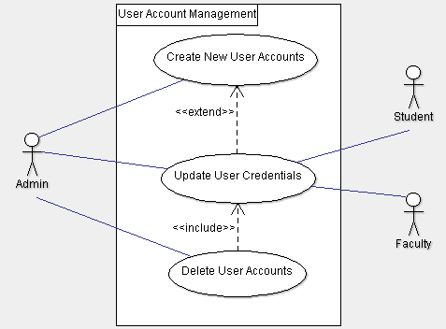

**2. Student, Faculty, and Course Management**

**Actors: Admin, Faculty**

* **Use Cases:**
  + Add new students, faculty, and courses (Admin, Faculty)
  + Update student, faculty, and course details (Admin, Faculty)
  + Remove outdated records (Admin)
* **Relationships:**
  + "Update details" **includes** "Add new records"
  + "Remove outdated records" **extends** "Update details"
* **USE CASE DIAGRAM:**

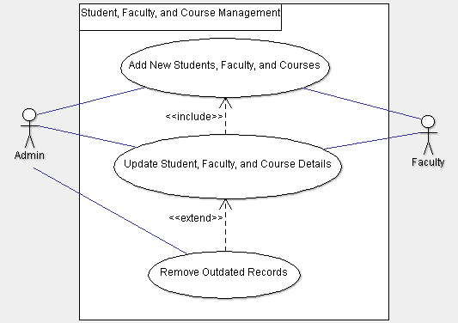

**3. System Configuration and Maintenance**

**Actors: Admin**

* **Use Cases:**
  + Configure system settings (Admin)
  + Set permissions for different roles (Admin)
  + Schedule and perform database backups (Admin)
  + Restore database from backups (Admin)
* **Relationships:**
  + "Restore database" **includes** "Schedule backups"
* **USE CASE DIAGRAM:**

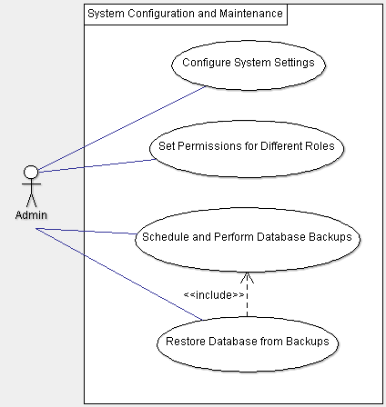

**4. Report Generation**

**Actors: Admin, Faculty**

* **Use Cases:**
  + Generate academic performance reports (Admin, Faculty)
  + Generate attendance records (Faculty)
  + Generate administrative reports (Admin)
* **Relationships:**
  + "Generate administrative reports" **includes** "Generate academic and attendance reports"
* **USE CASE DIAGRAM:**

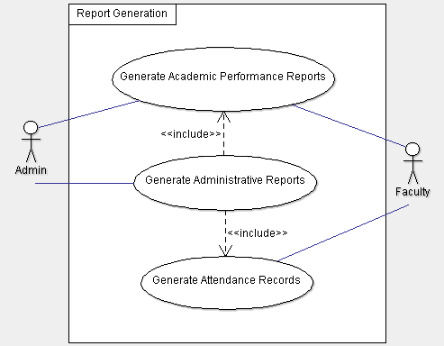

**5. Security Management**

**Actors: Admin, System**

* **Use Cases:**
  + Require strong password policies (System)
  + Enforce session timeouts (System)
  + Assign role-based access control (Admin)
* **Relationships:**
  + "Enforce session timeouts" **extends** "Require strong password policies"
* **USE CASE DIAGRAM:**

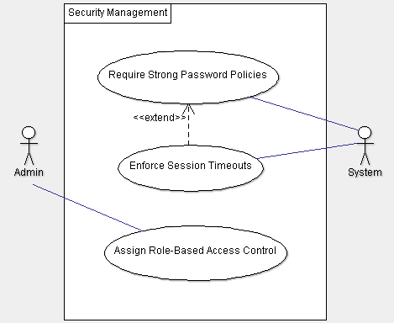

**6. Course Registration**

**Actors: Student, Faculty, Admin**

* **Use Cases:**
  + Select and register for courses (Student)
  + View course schedules (Student, Faculty)
* **Relationships:**
  + "View course schedules" **includes** "Register for courses"
* **USE CASE DIAGRAM:**

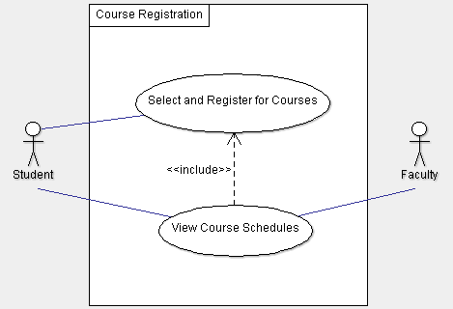

**RESULT:**