**EX NO: 4**

**DATE: 13.02.2025**

**IDENTIFY THE CONCEPTUAL CLASSES AND DEVELOP A DOMAIN MODEL AND ALSO DERIVE A CLASS DIAGRAM FROM THAT.**

**AIM :**

**IDENTIFYING CONCEPTUAL CLASSES:**

Conceptual classes represent real-world entities in the system. Based on the use cases, the key conceptual classes are:

**Core Conceptual Classes**

1. **User**
   * **Attributes:** userID, name, email, password, role
   * **Subclasses:** Admin, Faculty, Student
2. **Course**
   * **Attributes:** courseID, courseName, credits, schedule
   * **Relationships:**
     + Faculty teaches Course
     + Student enrolls in Course
3. **Credentials**
   * **Attributes:** credentialID, username, password, lastUpdated
   * **Relationships:**
     + User updates Credentials
4. **Report**
   * **Attributes:** reportID, reportType, generatedBy, date
   * **Relationships:**
     + Faculty generates Academic Reports
     + Admin generates Administrative Reports
5. **System Configuration**
   * **Attributes:** configID, settingName, value
   * **Functions:** updateConfig(), resetConfig(), viewConfig()
   * **Relationships:**
     + Admin modifies System Configuration
6. **Database Backup**
   * **Attributes:** backupID, date, status
   * **Functions:** scheduleBackup(), restoreBackup(), viewBackupLogs()
   * **Relationships:**
     + Admin schedules and restores Database Backup
     + System maintains Database Backup

**DEVELOPING A DOMAIN MODEL:**

The **Domain Model** visually represents how these conceptual classes relate to each other.

**Relationships:**

**User Management**

* Admin manages User (Student, Faculty).
* User can update their Credentials.

**Course Management**

* Admin and Faculty add and update Course details.
* Student enrolls in Course.

**Report Generation**

* Admin generates Administrative Reports.
* Faculty generates Academic Performance Reports and Attendance Records.

**System Maintenance**

* Admin configures System Settings.
* Admin schedules Database Backups and can restore them.

**DERIVING A CLASS DIAGRAM:**

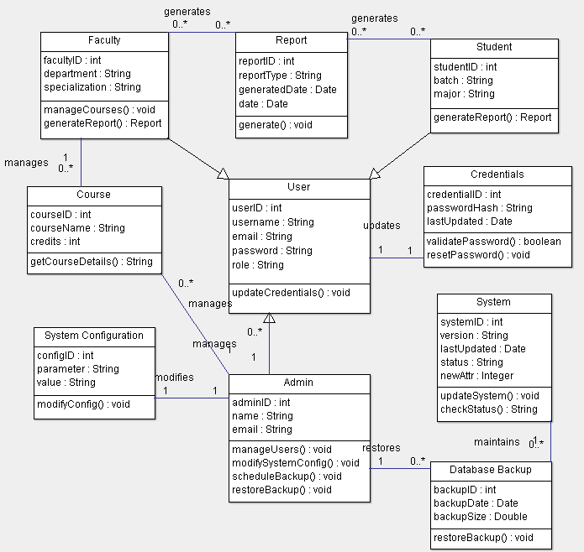

**RESULT:**