**EX NO: 6**

**DATE: 28.02.2025**

**DRAW RELEVANT STATECHART AND ACTIVITY DIAGRAMS FOR THE SAME SYSTEM.**

**AIM :**

**STATECHART AND ACTIVITY DIAGRAMS:**

**1. User Account Management (R1)**

Statechart (User Account Creation)

* States: Not Registered → Account Creation → Activated → Disabled → Deleted
* Transitions: Admin creates, activates, disables, or deletes the account.

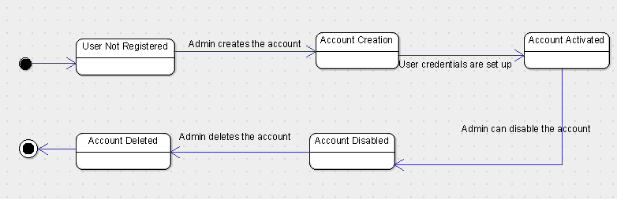

Activity (User Login & Authentication)

* Steps: User enters credentials → System verifies → (Valid) Dashboard OR (Invalid) Retry

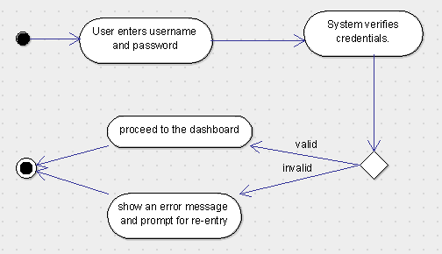

**2. Student, Faculty & Course Management (R2)**

Statechart (Adding a Course)

* States: Not Added → Creation → Created → Deleted
* Transitions: Admin/Faculty adds, creates, or deletes the course.

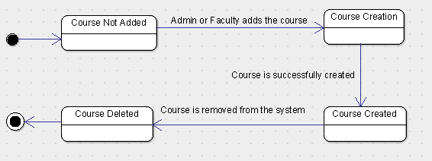

Activity (Updating Student Record)

* Steps: Select student → Edit details → Update system

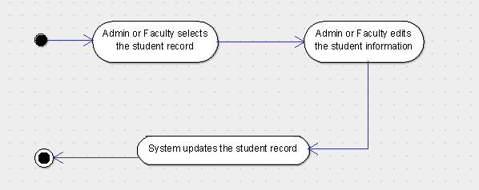

**3. Report Generation (R4)**

Statechart (Generating Student Report)

* States: Not Generated → Generation → Generated
* Transitions: Admin/Faculty requests & system generates the report.

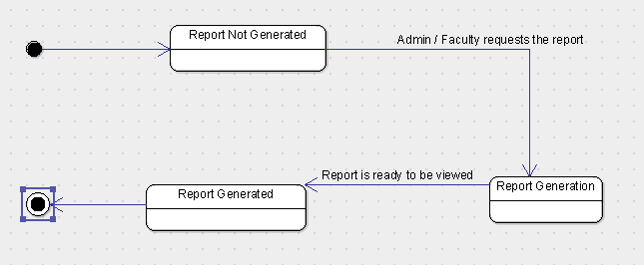

Activity (Viewing Attendance Report)

* Steps: Request report → Fetch data → Display report

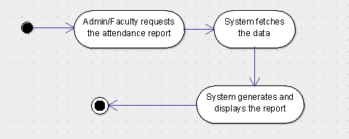

**4. Course Registration (R6)**

Statechart (Student Registration)

* States: Not Registered → Selection → Registered/Failed
* Transitions: Student registers, success or failure.

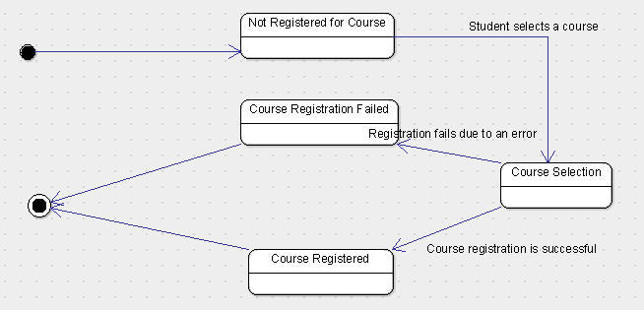

Activity (Viewing Course Schedule)

* Steps: Select option → Fetch & display schedule

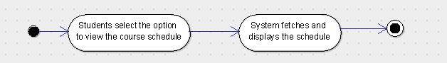

**RESULT:**