Simplilearn

Developing a Backend Admin for Learner’s Academy

Phase 2 Assessment Project1

**Developer:** Mr.X.Joe Maarian

**Email ID:** [joemaarian05@gmail.com](mailto:joemaarian05@gmail.com)

**Project Name:** Backend administrative portal for the Learner’s Academy

**GitHub Link:** <https://github.com/joe-jr07/Simplilearn_Phase2_Project1/tree/WithCss>

## **Description**

### ****Project objective:****

As a Full Stack Developer, design and develop a backend administrative portal for the Learner’s Academy. Use the GitHub repository to manage the project artifacts.

### ****Background of the problem statement:****

Learners Academy is a school that has an online management system. The system keeps track of its classes , subjects, student5s and teachers. It ahs a back-office application with a single administration login.. .

## **The administrator can:**

* Set up a master list of all the subjects for all the classes
* Set up a master list of all the teachers.
* Set up a master of all the classes.
* Assign classes for subjects from the master list.
* Assign teachers to a class for a subject(A teacher can be assigned to different classes for different subjects)
* Get a master list of students (Each student must be assigned to a single class)

There will be an option to view a class report which will show all the information about the class, such as the list of students, subjects and teachers.

The goal of the company is to deliver a high-end quality product as early as possible..

## **The Flow Of Application**.

The project is divided into three sprints

**Sprint1:**

Setup Database and provide master list for all entities

* Classes
* Subjects
* Teachers
* Students

**Sprint2:**

Implement the assignments:

* Student to class
* Subject to class
* Subject to Teacher

**Sprint3:**

* Generate Class Report
* Improvement in navigation
* Clean up

### FlowChart

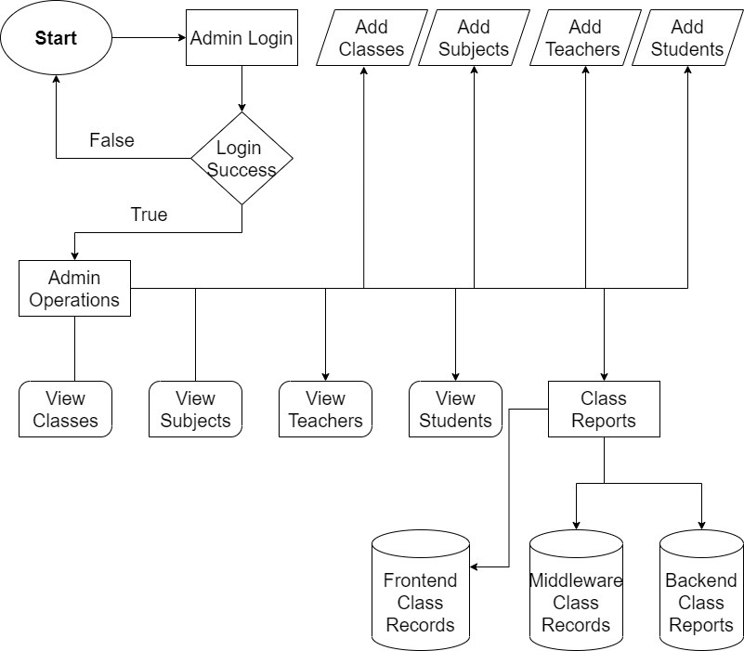

## Resources Used in the Project:

* Eclipse IDE
* JAVA(J2EE)
* Servlets
* JSP
* JDBC
* HTML
* CSS(internal css)
* GitHub